Supplementary figure 1. The change of EP300 protein expression and total score of PANSS scale
The change of EP300 protein expression(ng/ml)

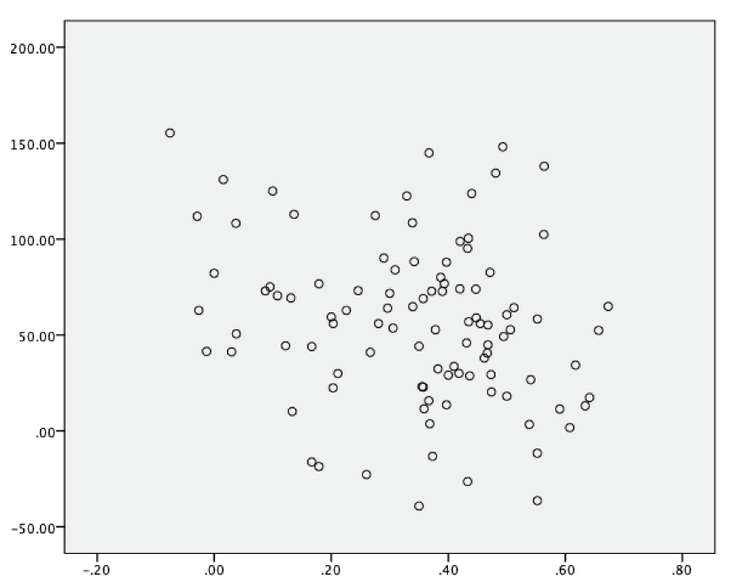

Total score of PANSS scale (%)
Supplementary figure 2. The change of EP300 protein expression and positive symptoms of PANSS scale
The change of EP300 protein expression(ng/ml)

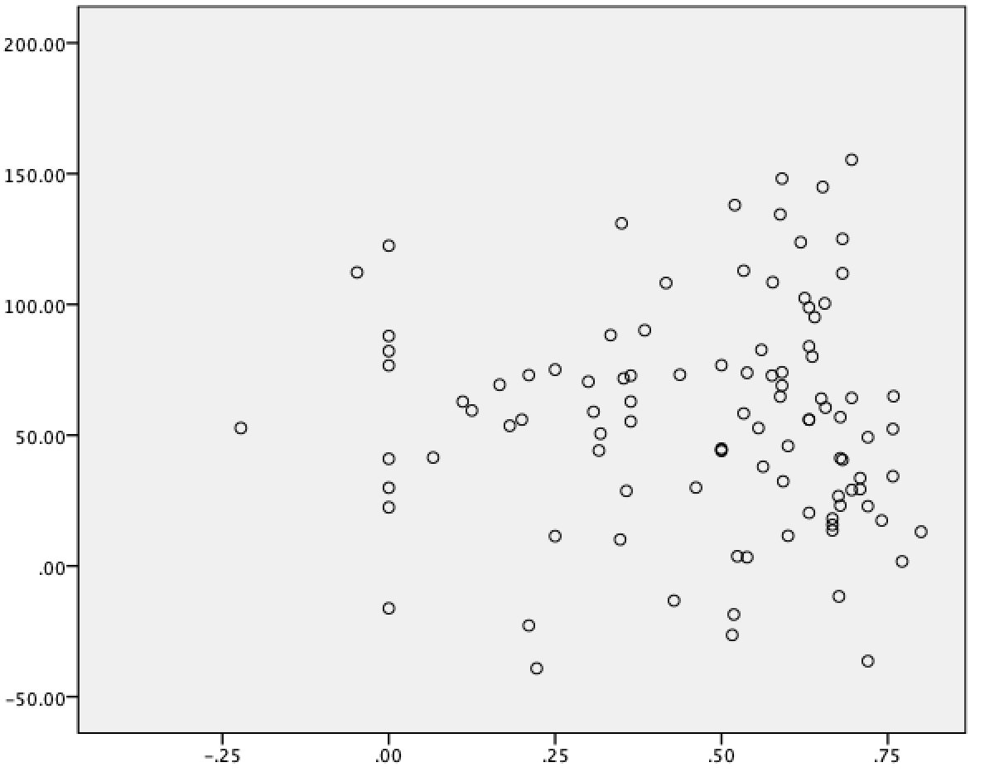
Positive symptoms of PANSS scale (%)

Supplementary figure 3. The change of EP300 protein expression and negative symptoms of PANSS scale
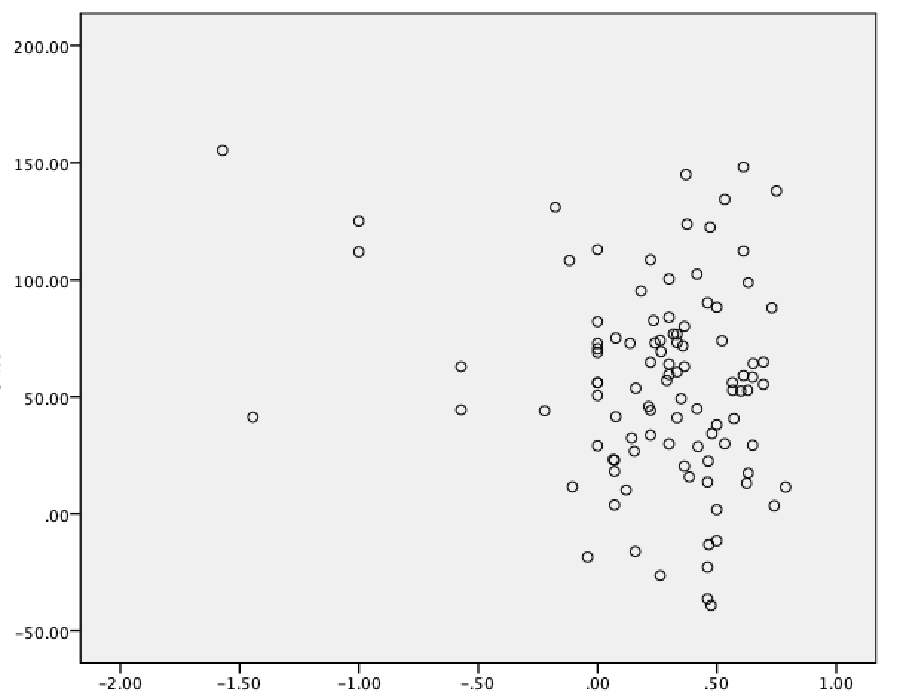
The change of EP300 protein expression(ng/ml)

Negative symptoms of PANSS scale (%)

Supplementary figure 4. The change of EP300 protein expression and general psychiatric symptoms of PANSS scale

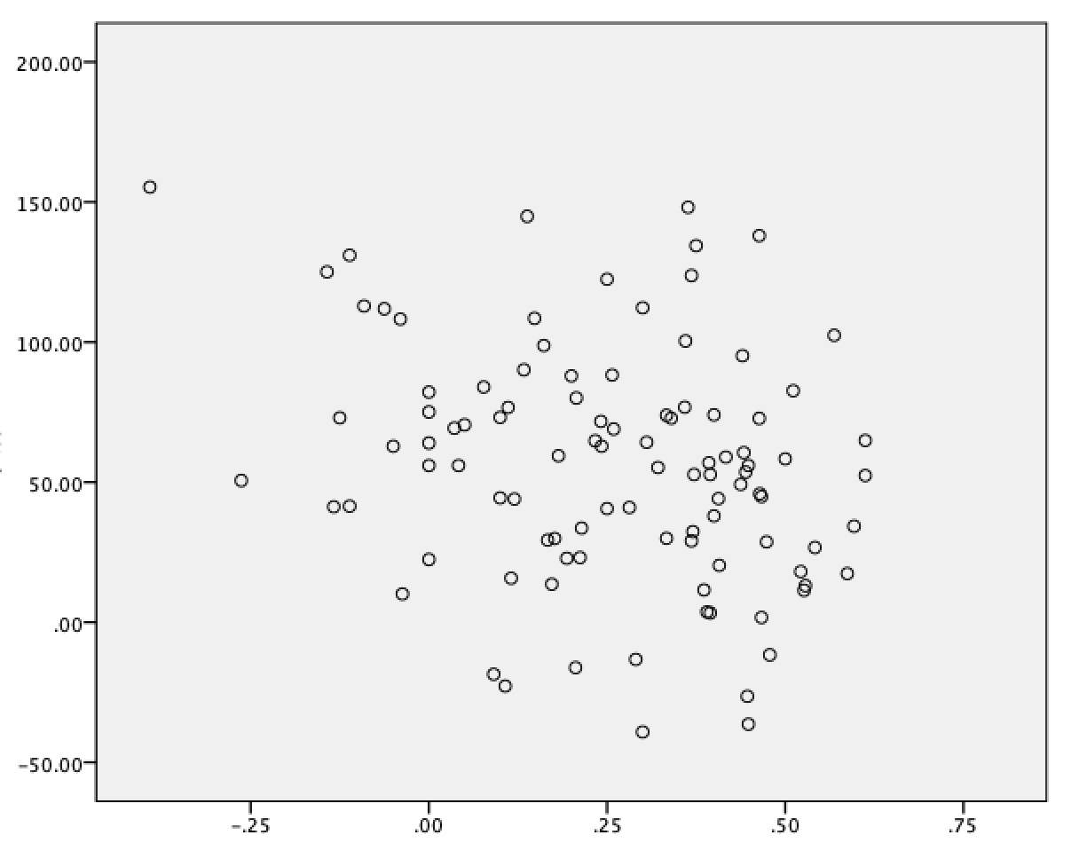
The change of EP300 protein expression(ng/ml)
General psychiatric symptoms of PANSS scale (%)

Supplementary figure 5. The change of EP300 protein expression and lack reaction of PANSS scale
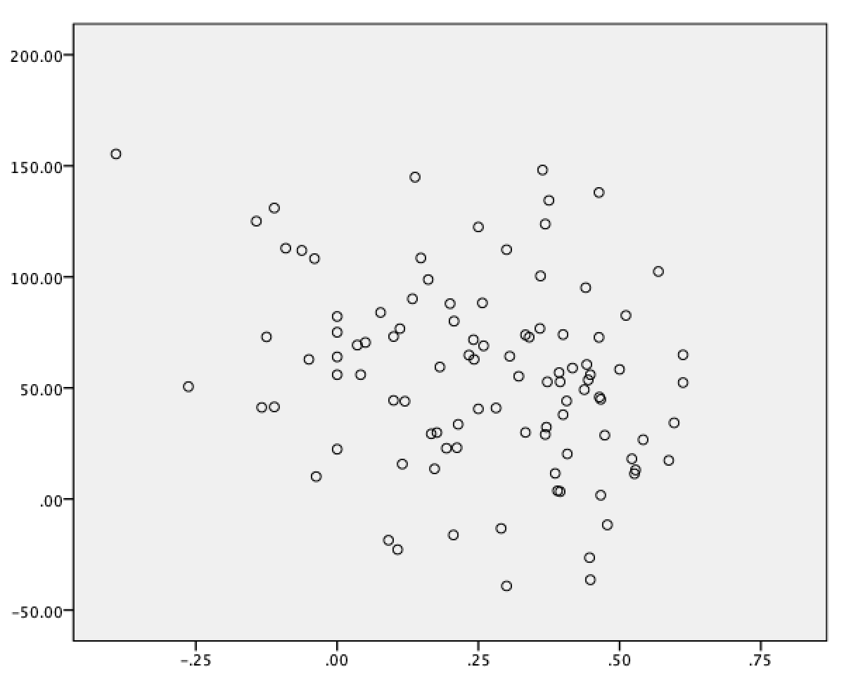
The change of EP300 protein expression(ng/ml)
Lack reaction of PANSS scale (%)

Supplementary figure 6. The change of EP300 protein expression and disturbance of thought of PANSS scale
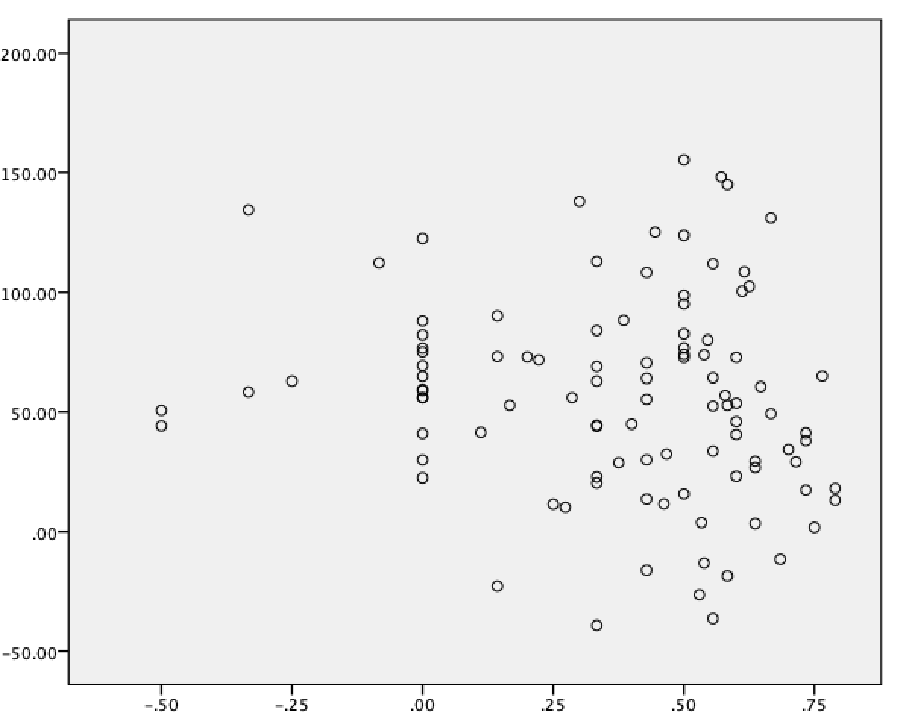
The change of EP300 protein expression(ng/ml)
Disturbance of thought of PANSS scale (%)
Supplementary figure 7. The change of EP300 protein expression and irritability of PANSS scale
The change of EP300 protein expression(ng/ml)

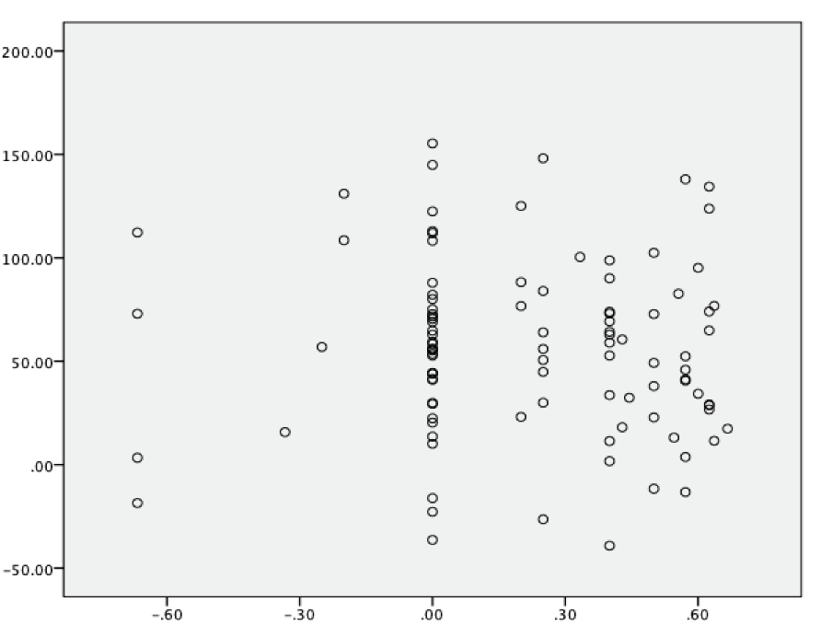
Irritability of PANSS scale (%)

Supplementary figure 8. The change of EP300 protein expression and paranoid aggressive of PANSS scale
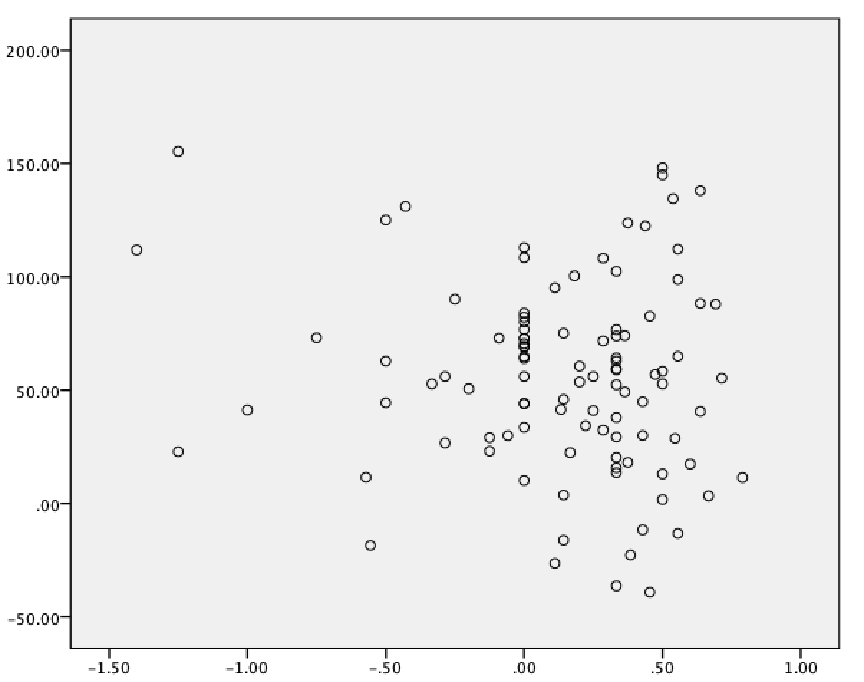
The change of EP300 protein expression(ng/ml)

Paranoid aggressive of PANSS scale (%)

Supplementary figure 9. The change of EP300 protein expression and depression of PANSS scale
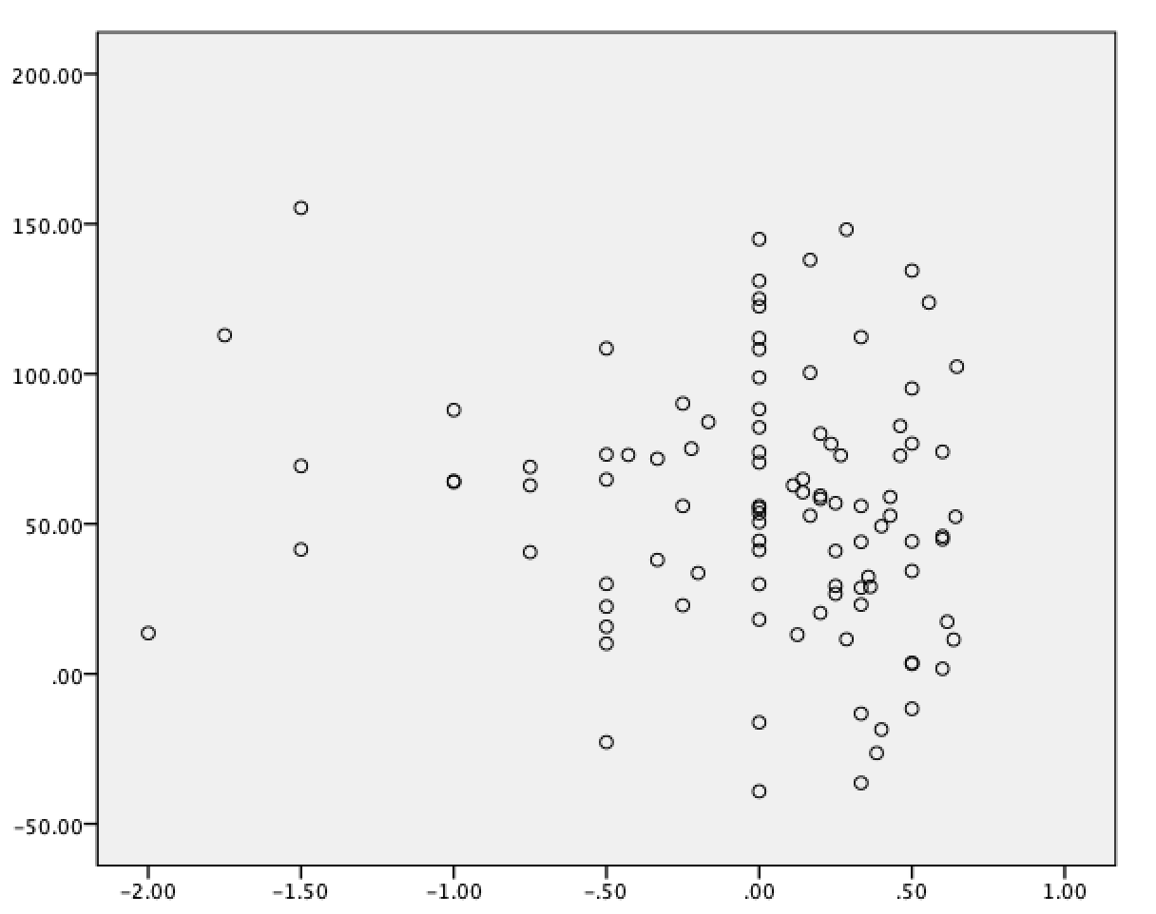
The change of EP300 protein expression(ng/ml)

Depression of PANSS scale (%)

