Combining SERS microfluidic chip with functionalized AuNCAs for early lung cancer prognosis in mice
Yayun Qian¹**, Yuexing Gu², Jialin Deng³, Zhaoying Cai³, Yang Wang³, Ruoyu Zhou³, Dongxu Zhu³, Hongmei Lu⁴, Zheng Wang¹*
¹Department of Pathology, The Affiliated Hospital of Yangzhou University, Yangzhou University, Yangzhou, P. R. China
²Institute of Translational Medicine, Medical College, Yangzhou University, Yangzhou, P. R. China
³Jiangsu Key Laboratory of Integrated Traditional Chinese and Western Medicine for Prevention and Treatment of Senile Diseases, Yangzhou University, Yangzhou, P. R. China
⁴Department of Pathology, Yangzhou Maternal and Child Health Hospital, Yangzhou, P. R. China

*Corresponding author: Zheng Wang, yzdxfsyywz@163.com
**Corresponding author: Yayun Qian, yyqian@yzu.edu.cn

Optimization of experimental conditions
Since the tDNA produced by the EASA reaction serves as the trigger for the CHA reaction, optimization of polymerase and nucleic acid endonuclease concentrations, reaction temperature and reaction time is required (Supporting Information, Fig. S1). As shown in Fig. S1a, the Raman signal intensity gradually increased with increasing polymerase concentration and stabilizes at 0.20 U·µL⁻¹. Similarly, the endonuclease stabilized at 0.30 U·µL⁻¹ (Fig. S1b). In addition, the reaction temperature and reaction time were optimized to 38°C and 120 min, respectively (Fig. S1c and S1d). Therefore, in the next experiments, tDNA was obtained using 0.20 U·µL⁻¹ of polymerase and 0.30 U·µL⁻¹ of endonuclease at 38 °C for 120 min.
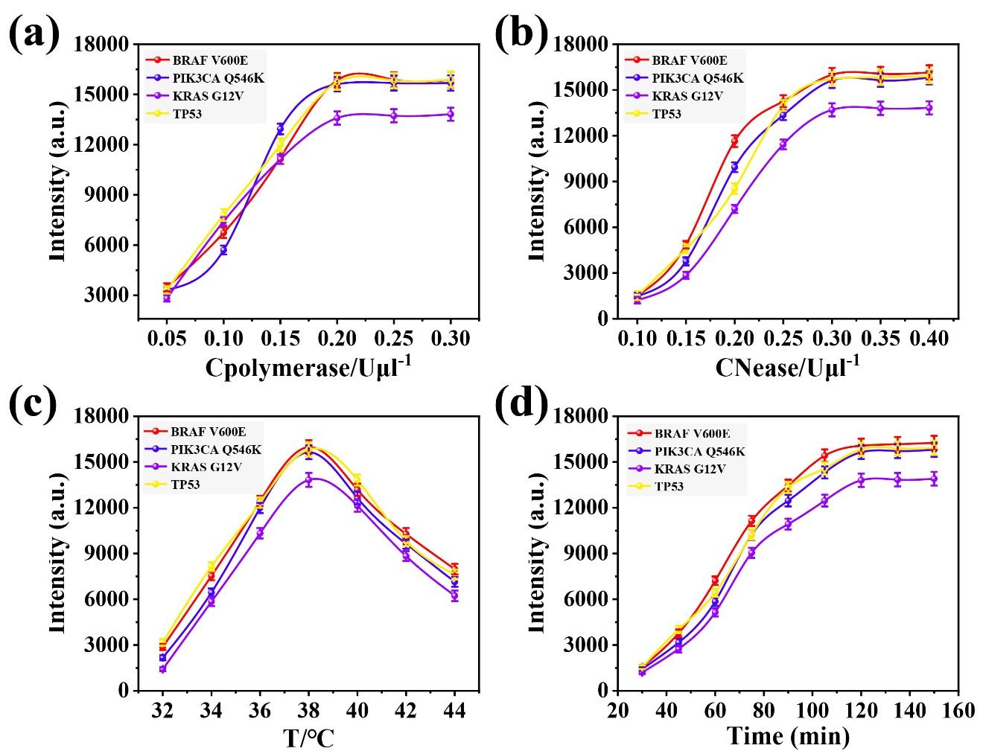
Fig. S1 Enzyme-assisted amplification experimental conditions optimization: Effects of (a) DNA polymerase and (b) endonuclease concentrations on SERS signal. (c) Influence of reaction temperature and (d) time on SERS signal.

Reproducibility assessment of the microfluidic chip
To avoid the influence of different microfluidic chips on detection, it was necessary to analyze the reproducibility of microfluidic chips. Eight batches of microfluidic chips were prepared to detect BRAF V600E, PIK3CA Q546K, KRAS G12V and TP53 at different times. The SERS spectra were shown in Fig. S2a and Fig. S2c. The characteristic peak intensities at 1000 cm⁻¹ and 1330 cm⁻¹ occasionally changed (Fig. S2b and S2d). Therefore, different batches of microfluidic chips do not affect the detection results.
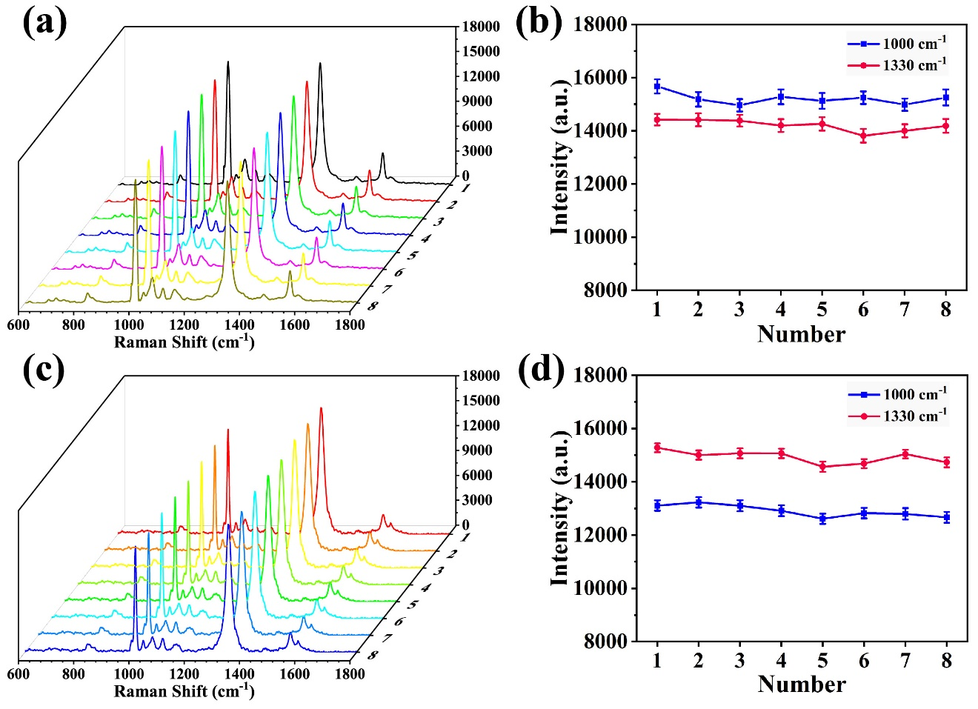
Fig. S2 Reproducibility assessment of Reaction Zone I: (a) Spectra obtained from the detection of BRAF V600E and PIK3CA Q546K using eight different batches of prepared microfluidic chips and (b) scatter plots corresponding to the SERS signal intensities at 1000 cm⁻¹ and 1330 cm⁻¹. Reproducibility assessment of Reaction Zone II: (c) Spectra obtained from the detection of KRAS G12V and TP53 using eight different batches of prepared microfluidic chips and (d) scatter plots corresponding to the intensity of the SERS signal at 1000 cm⁻¹ and 1330 cm⁻¹.

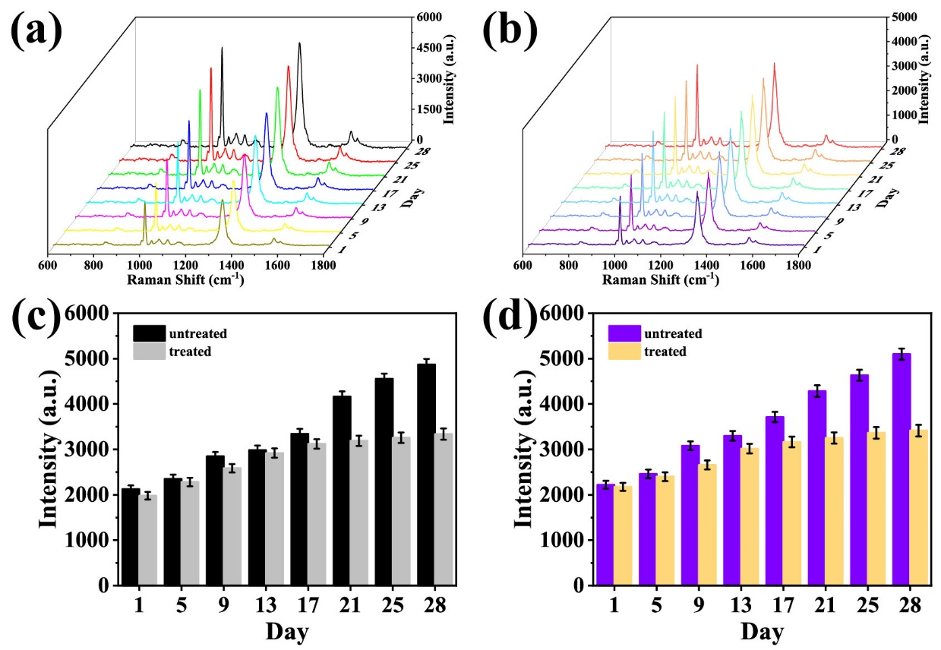
Fig. S3 (a) SERS spectra of KRAS G12V and TP53 in serum from nude mice with lung cancer without cisplatin treatment. (b) SERS spectra of KRAS G12V and TP53 in serum from cisplatin-treated lung cancer nude mice. (c) Histogram of signal intensity at 1000 cm⁻¹ corresponding to untreated and cisplatin-treated. (d) Histograms of signal intensity at 1330 cm⁻¹ corresponding to untreated and cisplatin treatment.

Table S1 Sequences of oligonucleotides used in the experiment
Name | Sequence (5' - 3')
HP₁₋₁ | HS-TTTATGCTACGGACCCAGGACCTGGACTGGCATATGGCATCTGTTGGT CCAGACATGCCAGTCCAGGTCCTGGGTCCGCATCCTCATATCAG
HP₁₋₂ | HS-TCACAGTAATCGTACGTAGATCTGACTAGCTTATCGTACATCTACGTA  CGATTACTGACACCTCAGCA
HP₁₋₃ | HS-CATTACGTTACGAACGTCATACCGGTACACGTACATGACGTTCGTAA  TCGTATCCTCAACT
HP₁₋₄ | HS-GACTCCTGAAGGATCGTGAGTACATGACTTGATCATCAGATCCTTCAG  GACTCCTCA
HP₂₋₁ | TATGTAATGGCATCTGTTGGTCCAGACCGGACCCAGGACCTGGACTGGCAT GTCTGGACCAACAGATGCCATATGCCAGTCCATGATC
HP₂₋₂ | CTACTGACTAGCTTATCGTACCAGTAATCGTACGTAGATGTACGATAAGCT  AGTCAG ATCTACGTACGATTACTG
HP₂₋₃ | TGACTACCGGTACACGTACAACGTTACGAACGTCATGTACGTGTACCGGTA  TGACGTTCGTAATCGT
HP₂₋₄ | GACGTACATGACTTGATCATCCTGAAGGATCGTGATGATCAAGTCATGTAC  TCACGATCCTTCAGGA
MT₁₋₁ | GATTTCTGTGTAGCTA
MT₁₋₂ | GGGTCTTTCAAATGTATGCAATG
MT₁₋₃ | CTACGCCATCAGCTCCAAC
MT₁₋₄ | GGTGGATGGATAGTAGTATGGAAGA
MT₃₋₁ | GATCTCTCAGTACCTA
MT₃₋₂ | GGGTCGCACGAATGTATGCAATG
MT₃₋₃ | CTAGGCCATCAGCTGCAAC
MT₃₋₄ | GGTGGGGTGGTAGTAGTATGGAAGA
Random | ACGGCCTTACGTACGAAC
BRAF  V600E | GATTTCTCTGTAGCTA
PIK3CA  Q546K | GGGTCTTTCGAATGTATGCAATG
KRAS  G12V | CTACGCCAACAGCTCCAAC
TP53 | GGTGGATGGGTAGTAGTATGGAAGA
S₁ | ATGCCAGTCCAGGTCCTGGGTCCGCATCCTCAGCTAGCTACAGAGAAATC
S₂ | ATCTACGTACGATTACTGACACCTCAGCATTGCATACATTCGAAAGACCC
S₃ | TGACGTTCGTAATCGTATCCTCAGCGTTGGAGCTGTTGGCGTAG
S₄ | TCACGATCCTTCAGGATCCCTCAGCTCTTCCATACTATCACCCATCCACC
Table S2 Mean results of SERS and qRT-PCR results of real samples (BRAF V600E and PIK3CA Q546K)
Day | SERS (fM) |  | qRT-PCR (fM) |  | RSD (%)
Day | BRAF V600E | PIK3CA Q546K | BRAF V600E | PIK3CA Q546K | BRAF V600E | PIK3CA Q546K
1 | 0.218 | 0.195 | 0.194 | 0.188 | 4.31 | 5.13
5 | 0.321 | 0.294 | 0.309 | 0.274 | 4.69 | 4.98
9 | 0.472 | 0.398 | 0.444 | 0.376 | 4.96 | 5.24
13 | 0.679 | 0.647 | 0.622 | 0.628 | 4.74 | 5.39
17 | 0.904 | 0.853 | 0.744 | 0.813 | 5.52 | 5.41
21 | 1.217 | 1.154 | 1.125 | 1.014 | 5.27 | 5.61
25 | 1.805 | 1.618 | 1.388 | 1.538 | 5.48 | 5.37
28 | 2.159 | 2.143 | 2.017 | 1.994 | 4.73 | 4.52

Table S3 Mean results of SERS and qRT-PCR results of real samples (KRAS G12V and TP53)
Day | SERS (fM) |  | qRT-PCR (fM) |  | RSD (%)
Day | KRAS G12V | TP53 | KRAS G12V | TP53 | KRAS G12V | TP53
1 | 0.198 | 0.204 | 0.154 | 0.171 | 4.27 | 4.81
5 | 0.284 | 0.312 | 0.237 | 0.281 | 5.09 | 4.75
9 | 0.372 | 0.404 | 0.328 | 0.354 | 5.24 | 5.16
13 | 0.501 | 0.526 | 0.421 | 0.473 | 5.71 | 5.27
17 | 0.773 | 0.829 | 0.654 | 0.748 | 4.87 | 4.98
21 | 0.984 | 1.095 | 0.912 | 0.933 | 4.93 | 5.85
25 | 1.405 | 1.525 | 1.287 | 1.318 | 5.05 | 4.98
28 | 1.795 | 1.893 | 1.624 | 1.743 | 4.84 | 5.23

