Supplementary Table 1 Levels of clinical characteristics during treatment
Characteristics | Time point | TDF plus PegIFN-α | TAF plus PegIFN-α | P-value
 |  | Mean (SD) | Mean (SD)
ALT (U/L) | 0 week | 68.22 (85.74) | 53.48 (51.99) | 0.360
ALT (U/L) | 12 week | 78.78 (47.52) | 77.55 (96.20) | 0.930
ALT (U/L) | 24 week | 78.41 (77.83) | 74.00 (130.30) | 0.828
ALT (U/L) | 36 week | 66.58 (58.07) | 77.33 (94.18) | 0.516
ALT (U/L) | 48 week | 60.84 (46.89) | 53.73 (54.85) | 0.613
AST (U/L) | 0 week | 39.07 (33.19) | 30.64 (15.00) | 0.164
AST (U/L) | 12 week | 51.31 (28.93) | 55.52 (61.91) | 0.633
AST (U/L) | 24 week | 49.00 (30.36) | 48.71 (59.71) | 0.973
AST (U/L) | 36 week | 44.70 (34.84) | 51.42 (45.00) | 0.456
AST (U/L) | 48 week | 42.16 (29.78) | 41.93 (33.99) | 0.979
ALP (U/L) | 0 week | 87.36 (21.51) | 86.97 (30.10) | 0.938
ALP (U/L) | 12 week | 95.78 (21.38) | 94.00 (27.27) | 0.724
ALP (U/L) | 24 week | 88.01 (22.73) | 87.10 (30.07) | 0.863
ALP (U/L) | 36 week | 87.34 (19.70) | 82.58 (24.74) | 0.307
ALP (U/L) | 48 week | 84.21 (20.54) | 83.2 (20.54) | 0.870
γ-GGT (U/L) | 0 week | 35.88 (55.94) | 29.94 (17.89) | 0.552
γ-GGT (U/L) | 12 week | 51.53 (35.46) | 59.83 (46.92) | 0.328
γ-GGT (U/L) | 24 week | 56.72 (45.46) | 54.10 (45.23) | 0.786
γ-GGT (U/L) | 36 week | 56.03 (48.07) | 69.88 (62.13) | 0.268
γ-GGT (U/L) | 48 week | 57.16 (51.44) | 61.53 (59.40) | 0.776
WBC (10^9/L) | 0 week | 5.08 (1.55) | 5.72 (1.91) | 0.064
WBC (10^9/L) | 12 week | 3.18 (0.94) | 3.37 (1.02) | 0.356
WBC (10^9/L) | 24 week | 3.07 (0.79) | 3.27 (0.89) | 0.257
WBC (10^9/L) | 36 week | 3.06 (0.75) | 3.17 (1.07) | 0.561
WBC (10^9/L) | 48 week | 2.99 (0.63) | 3.60 (0.90) | 0.003
RBC (10^9/L) | 0 week | 5.06 (0.53) | 4.91 (0.53) | 0.178
RBC (10^9/L) | 12 week | 4.79 (0.58) | 4.64 (0.58) | 0.232
RBC (10^9/L) | 24 week | 4.65 (0.58) | 4.46 (0.56) | 0.115
RBC (10^9/L) | 36 week | 4.65 (0.58) | 4.34 (0.59) | 0.026
RBC (10^9/L) | 48 week | 4.62 (0.49) | 4.38 (0.61) | 0.110
PLT (10^9/L) | 0 week | 201.09 (54.55) | 221.19 (53.83) | 0.080
PLT (10^9/L) | 12 week | 123.84 (41.06) | 138.60 (37.32) | 0.090
PLT (10^9/L) | 24 week | 123.89 (38.39) | 131.23 (37.08) | 0.373
PLT (10^9/L) | 36 week | 124.27 (38.93) | 127.21 (34.89) | 0.745
PLT (10^9/L) | 48 week | 127.76 (37.27) | 132.40 (34.93) | 0.665
NEU (%) | 0 week | 57.11 (11.08) | 60.19 (7.71) | 0.154
NEU (%) | 12 week | 52.21 (9.72) | 50.59 (8.94) | 0.432
NEU (%) | 24 week | 52.40 (9.78) | 51.80 (9.17) | 0.774
NEU (%) | 36 week | 51.92 (9.92) | 51.53 (9.33) | 0.865
NEU (%) | 48 week | 50.89 (9.81) | 53.94 (9.05) | 0.279

Supplementary Figure 1 Patients screening process
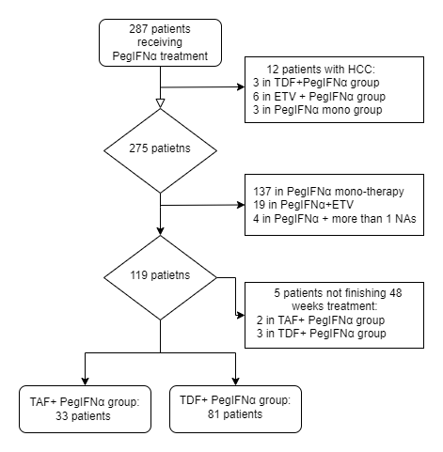

Supplementary Figure 2 Forest plot of subgroup analysis of HBsAg loss rate at 48 weeks between HBsAg-positive and HBeAg-negative patients
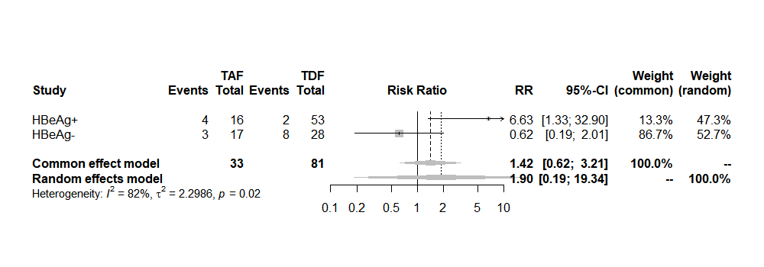
Supplementary Figure 3 Clinical characteristics changes during treatment
(A) Levels of white blood cell at different treatment times in the two groups. (B) Levels of red blood cell at different treatment times in the two groups. (C) Levels of platelet at different treatment times in the two groups. (D) Levels of neutrophil percentage at different treatment times in the two groups.
