A sustained-release nanosystem with MRSA biofilm-dispersing and -eradicating abilities accelerates diabetic ulcer healing

Shan He ¹†, Huangding Wen ¹†, Nannan Yao ², Lu Wang ³, Junqun Huang ⁴, Zhiqing Li ^{1,}*

¹ Department of Burns, Nanfang Hospital, Southern Medical University, Guangzhou 510515, China
² Department of Neurology, Cangzhou Central Hospital, Cangzhou 061000, China
³ Department of Neurology, Hebei General Hospital, Shijiazhuang 050000, China
⁴ Department of Anaesthesia, The Seventh Affiliated Hospital, Southern Medical University, Foshan 528000, China

†S.H. and H.W. contributed equally to this article.

* Correspondence:
Zhiqing Li, M.D., Department of Burns, Nanfang Hospital, Southern Medical University, Guangzhou 510515, China; Email: lizq@smu.edu.cn

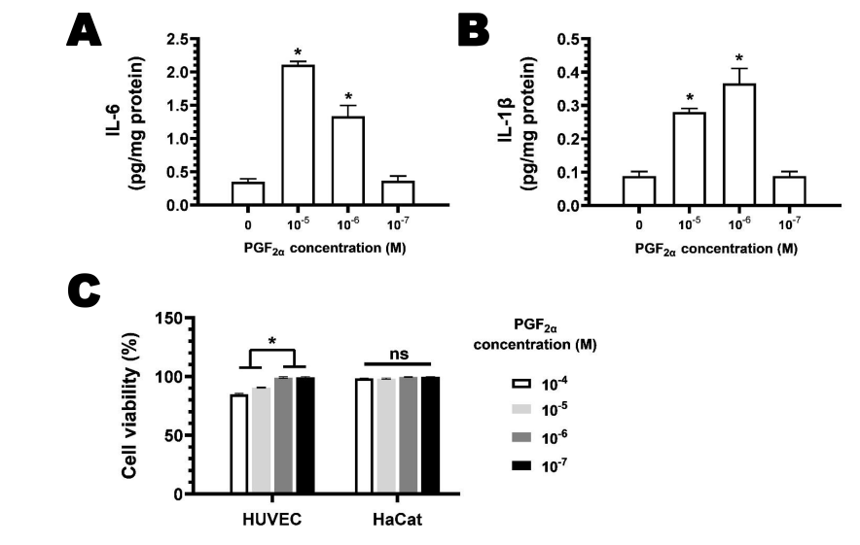

Fig. S1. MRSA infection wound were treated with increasing concentrations of PGF_{2a} (10⁻⁴ – 10⁻⁷ M) for 6 h. The wound exudates were collected and analyzed by specific enzyme-linked immunosorbent assays (ELISA; R&D Systems, Inc., Minneapolis, MN, USA) according to the manufacturer’s instructions to determine concentration of (A) interleukin (IL)-1β and (B) IL-6. Values are presented as mean±SEM. n = 3 (from three mice), *P < 0.05. (C) Cell viability of HUVEC and HaCaT. The cytotoxicity of PGF_{2a} was assessed using a CCK-8 kit. Specifically, HUVEC and HaCaT were seeded in a 96-well plate at a density of 2.0 × 10³ cells per well and cultured for 24 h, then incubated with various concentration. After incubation for 24 h, the cells were washed twice with PBS and 100 μL of CCK-8 solution was added in each well for 2 h co-cultivation. Finally, Cell viability was measured by a microplate reader (Bio-Rad; Model 680, CA, USA) in absorbance mode at 450nm to obtain the optical density. n=6-8, *P < 0.05, n.s.=no significance.

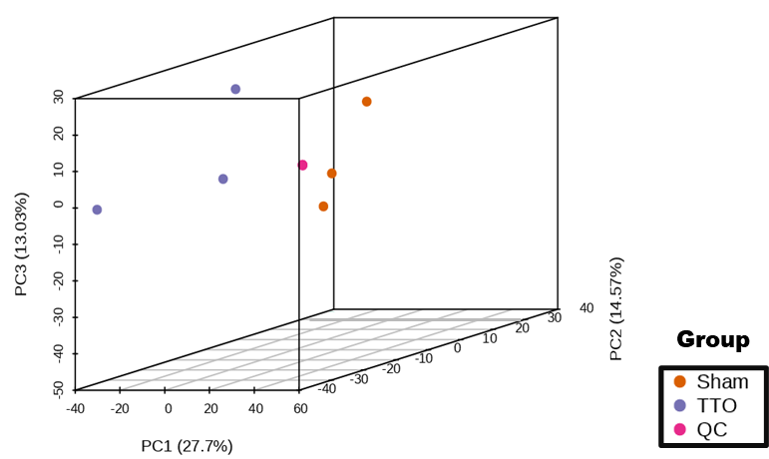

Fig. S2. PCA score plot of mass spectrometry data of each group and quality control samples. PC1 represents the first principal component, PC2 represents the second principal component, PC3 represents the third principal component and percentage represents the principal component interprets the data set. Each point in the figure represents a sample. The same group of samples using the same color.

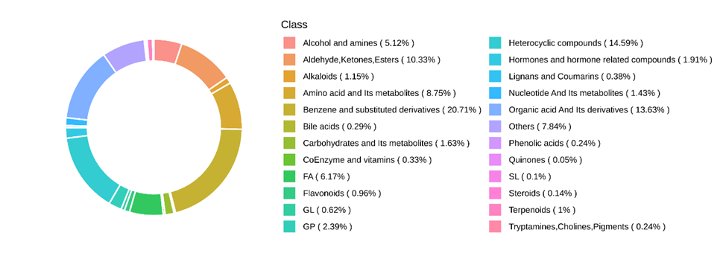

Fig. S3. Circular plot of the metabolite class composition. Each color represents a metabolite category, and the color block area indicates the proportion of that category.

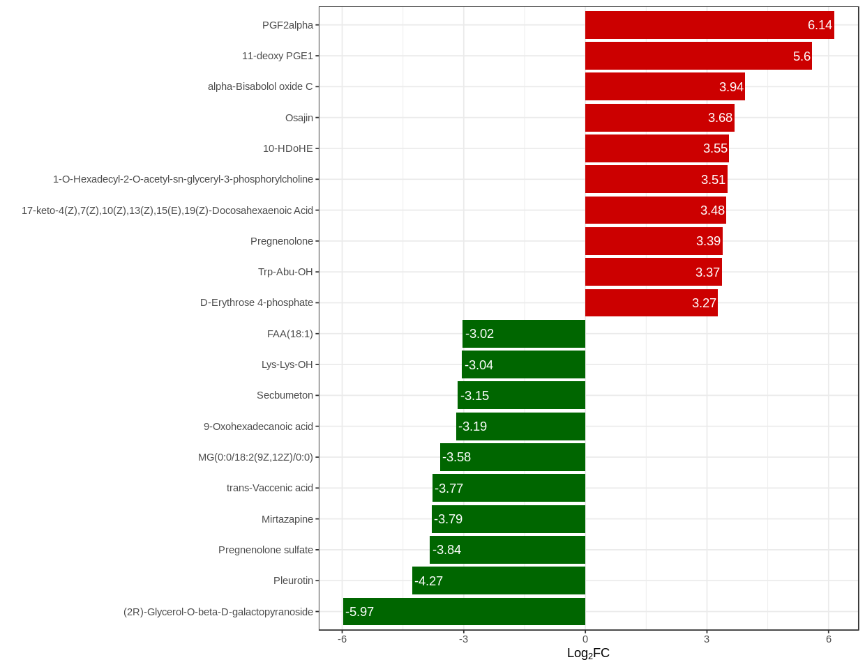

Fig. S4. Differential multiple-fold bars. The abscissa is the log₂FC of the differential metabolite, that is, the difference multiple of the differential metabolite takes 2 as the base of the logarithmic value, and the ordinate takes as the differential metabolite. Red represents upregulated metabolite content, and green represents downregulated metabolite content.

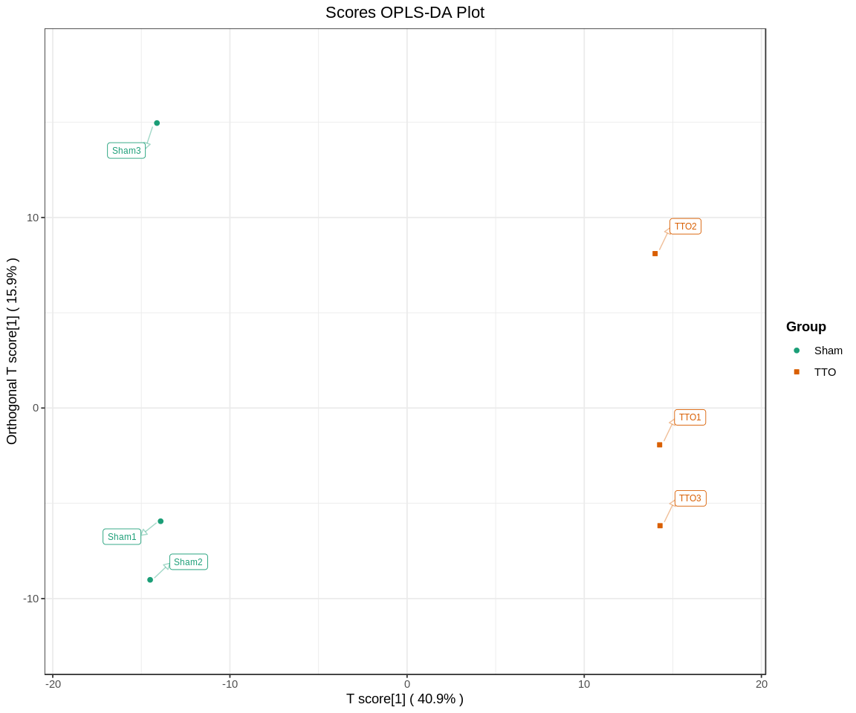

Fig. S5. OPLS-DA score plot. The abscissa represents the score of the predicted component, the ordinate direction shows the gap between the groups, the ordinate represents the orthogonal component, the ordinate direction shows the gap within the group, and the percentage indicates the interpretation rate of the component to the data set.

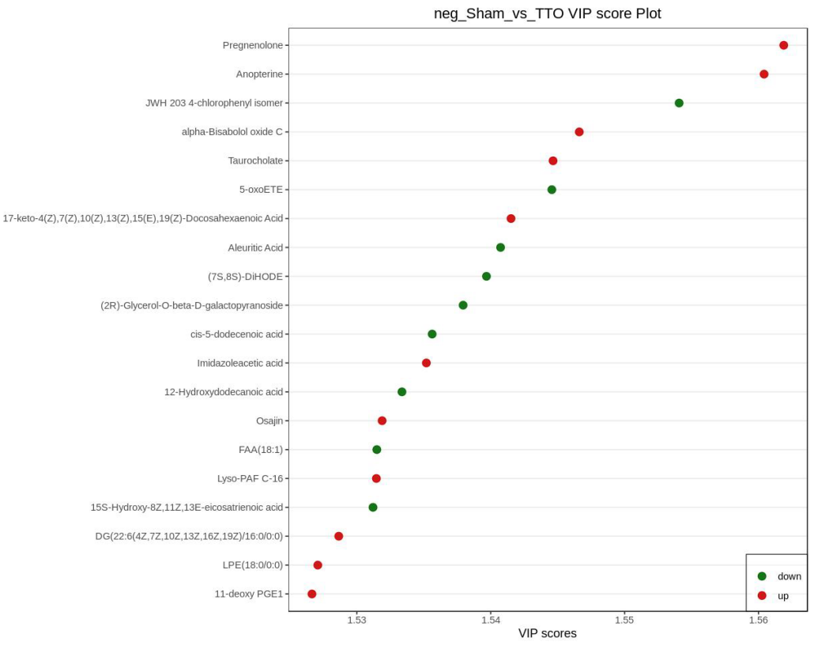

Fig. S6. Plot of the differential metabolite VIP scores. Abscissa represents VIP values, vertical coordinate indicates differential metabolites, red represents upregulated differential metabolites, green represents downregulated differential metabolites, and yellow represents metabolites that differ significantly in the three or more differential comparison groups.

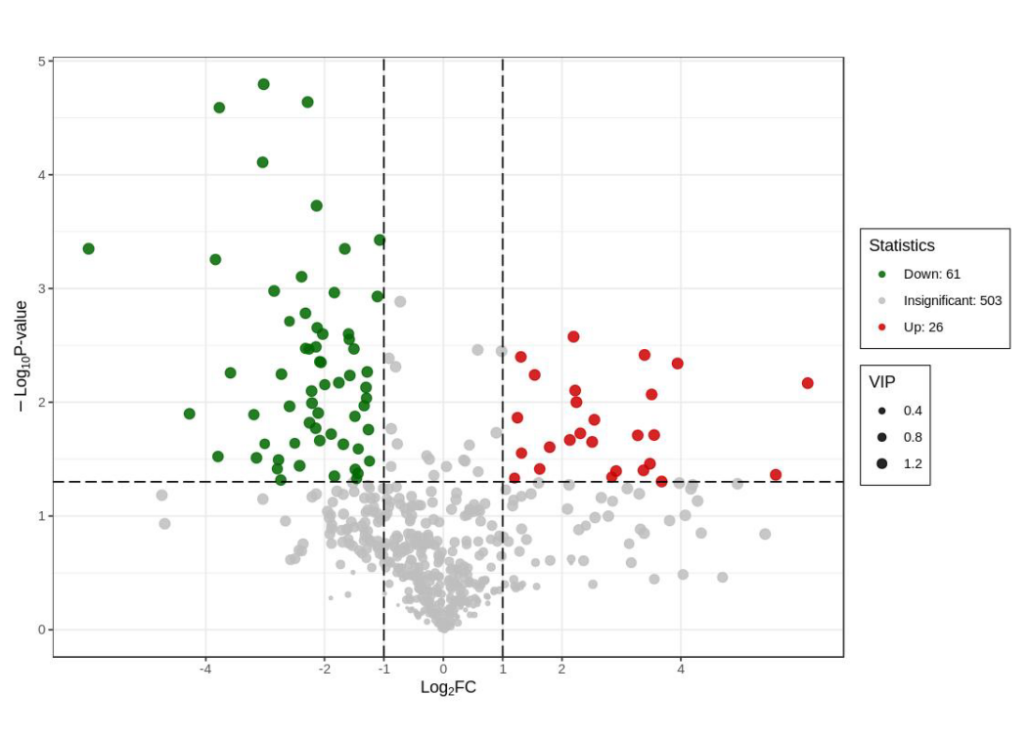

Fig. S7. Volcano plots of the differential metabolites. Each point in the volcano diagram represents a metabolite, the green point represents the downregulated differential metabolites, the red point represents the increased differential metabolites, the gray represents the detected but insignificant metabolites; the abscissa represents the log value (log₂FC) of a metabolite in the two samples, the greater the abscissa, the greater the relative content difference of the substance between the two samples. Under the VIP + FC + P-value triple screening condition: the ordinate represents the difference significance level (- log₁₀P-value), and the size of the dot represents the VIP value.

Fig. S8. Differential metabolite and string diagram. The outermost layer in the figure is the differential metabolite name, the point size represents the log₂FC value of the corresponding different metabolites; different colors represent different categories (Class); the connection represents the size of the Pearson correlation coefficient between the corresponding different metabolites, the red line represents positive correlation, and the blue line represents negative correlation.
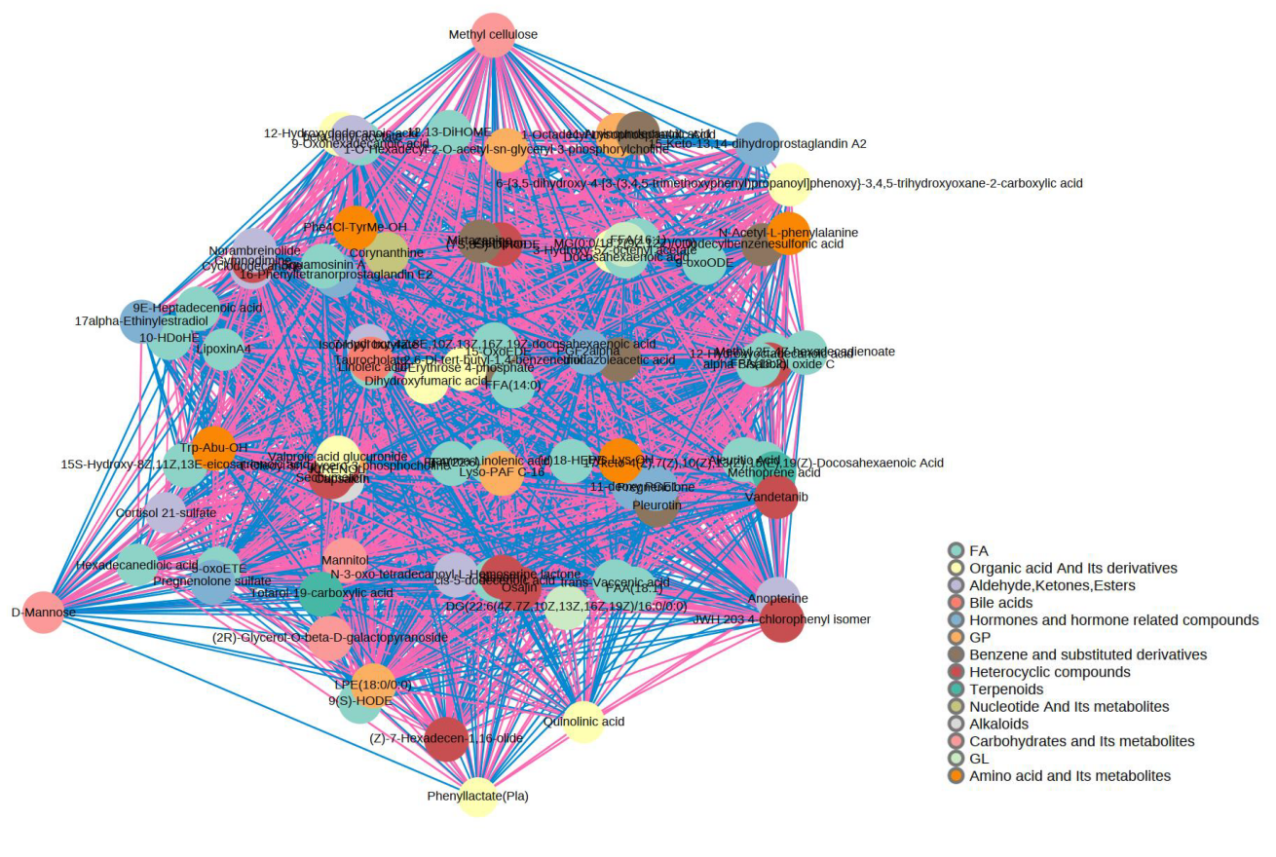

Fig. S9. Network plot of differential metabolite correlations. The dots in the figure represent significant difference metabolites. The size of the dots is related to the connectivity degree, the larger the connection, the larger the dots, that is, the more points (neighbors) connected with it. Pink lines represent a positive correlation, and blue lines represent a negative corelation. The thickness of the line represents the magnitude of the absolute value of the correlation coefficient, the thicker the line, the greater the correlation.

