Table S1. Sequences and oligonucleotides
Gene | Forward Sequence (5′ to 3′) | Reverse Sequence (5′ to 3′)
LINC00886 | AAGAGAAAGCCACAGGAGGGTA | CAGGTAGCAAGACAGAAGCAGAA
β-actin | TGACGTGGACATCCGCAAAG | CTGGAAGGTGGACAGCGAGG
U6 | CTCGCTTCGGCAGCACA | AACGCTTCACGAATTTGCGT
Si-LINC00886-1 | GGUUGAGAACAGCUGCUAUTT | AUAGCAGCUGUUCUCAACCTT
Si-LINC00886-2 | GGGAUAGACAUGUGACCAATT | UUGGUCACAUGUCUAUCCCTT
Si-LINC00886-3 | GCAGAAGAGCGUGUUCCAUTT | AUGGAACACGCUCUUCUGCTT
Si-NC | UUCUCCGAACGUGUCACGUTT | ACGUGACACGUUCGGAGAATT
RAB10 | CTGCTCCTGATCGGGGATTC | TGATGGTGTGAAATCGCTCCT
E2F2 | CGTCCCTGAGTTCCCAACC | GCGAAGTGTCATACCGAGTCTT

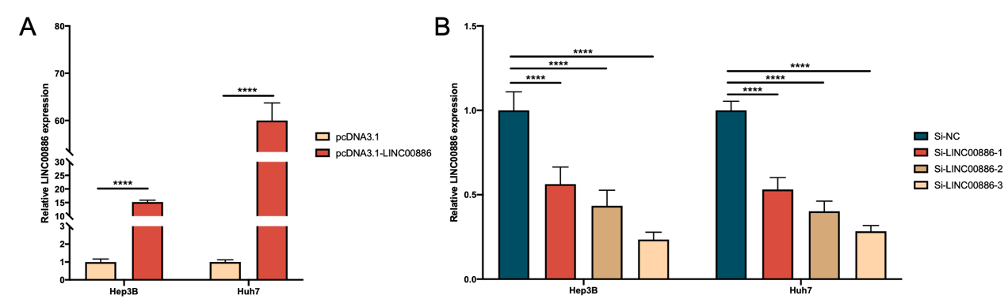
Figure S1. The expression levels of LINC00886. (A and B) LINC00886 expression was analyzed using qRT-PCR after transfection of Hep3B and Huh7 cells with Si-NC, Si-LINC00886, pcDNA3.1 or pcDNA3.1-LINC00886, respectively. ****P<0.0001.

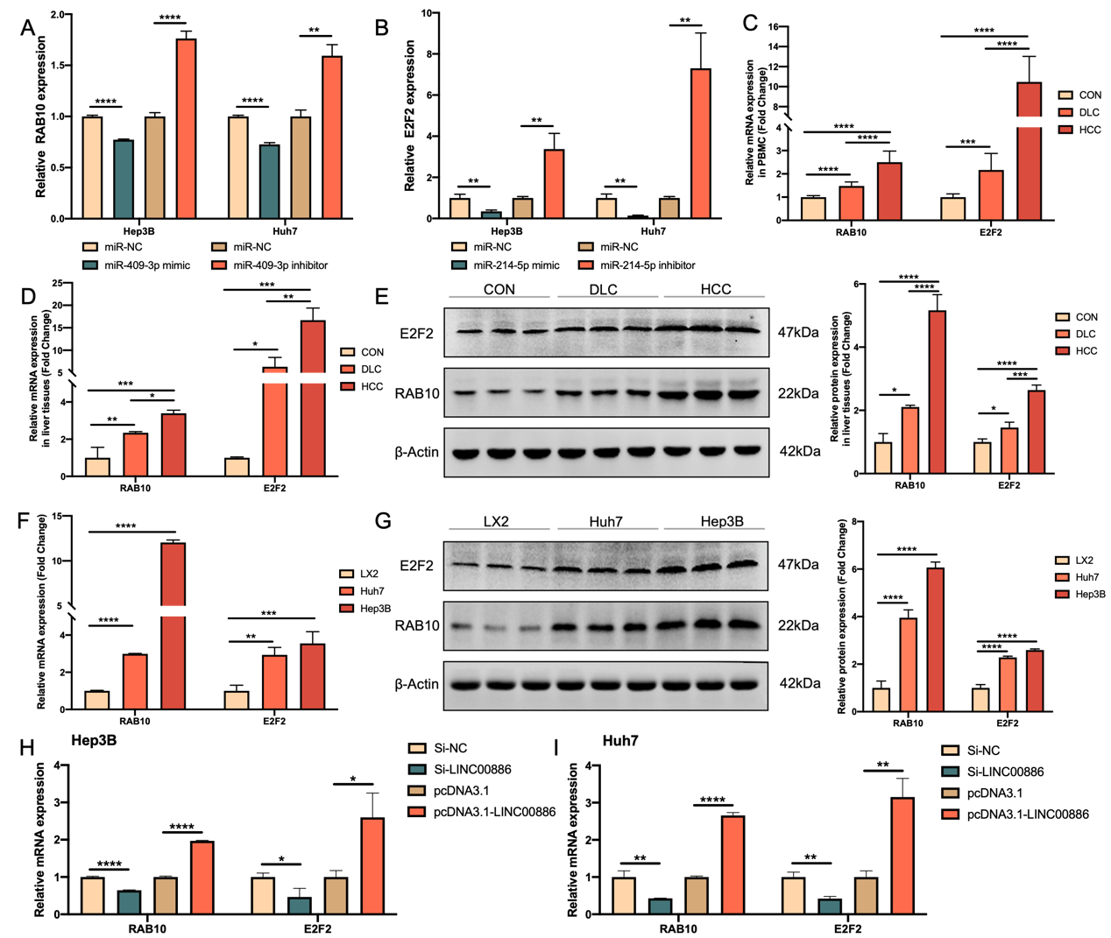
Figure S2. The expression levels of RAB10 and E2F2. (A and B) qRT-PCR was utilized to evaluate RAB10 (A) and E2F2 expression (B) after transfection of Hep3B and Huh7 cells with miR-NCs, miR-409-3p/miR-214-5p mimics, and miR-409-3p/miR-214-5p inhibitors, respectively. Relative RAB10 and E2F2 expression levels were detected utilizing qRT-PCR in PBMC samples (C, n=20 per group). qRT-PCR and Western blotting were utilized to access the mRNA and protein levels of RAB10 and E2F2 in hepatic tissues (D and E, n=5 per group) and HCC cells (F and G). (H and I) qRT-PCR was utilized to access RAB10 and E2F2 expression following HCC cell transfection of Si-NC, Si-LINC00886, pcDNA3.1 or pcDNA3.1-LINC00886, respectively. *P<0.05, **P<0.01, ***P<0.001, ****P<0.0001. HCC, hepatocellular carcinoma; LC, liver cirrhosis; PBMC, peripheral blood mononuclear cell; qRT-PCR, quantitative reverse-transcriptase polymerase chain reaction.

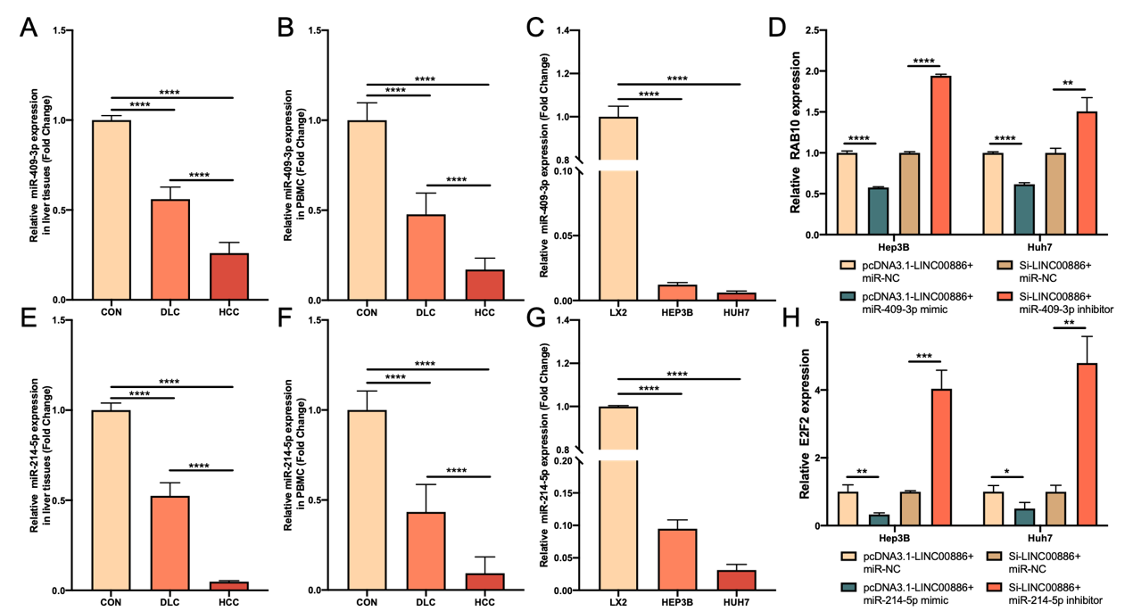
Figure S3. The expression levels of miR-409-3p, miR-214-5p, RAB10 and E2F2. Relative miR-409-3p expression levels were detected utilizing qRT-PCR in hepatic tissues (A, n=5 per group), PBMC samples (B, n=20 per group) and. HCC cells (C). (D) qRT-PCR was utilized to analyze RAB10 after introduction of Si-LINC00886+miR-NC, pcDNA3.1-LINC00886+miR-NC, Si-LINC00886+miR-409-3p inhibitors or pcDNA3.1-LINC00886+miR-409-3p mimics into HCC cells. Relative miR-214-5p expression levels were detected utilizing qRT-PCR in hepatic tissues (E, n=5 per group), PBMC samples (F, n=20 per group) and. HCC cells (G). (H) qRT-PCR was utilized to analyze E2F2 after introduction of Si-LINC00886+miR-NC, pcDNA3.1-LINC00886+miR-NC, Si-LINC00886+ miR-214-5p inhibitors or pcDNA3.1-LINC00886+ miR-214-5p mimics into HCC cells. *P<0.05, **P<0.01, ***P<0.001, ****P<0.0001. HCC, hepatocellular carcinoma; LC, liver cirrhosis; PBMC, peripheral blood mononuclear cell; qRT-PCR, quantitative reverse-transcriptase polymerase chain reaction.

