Supplementary figure 1A
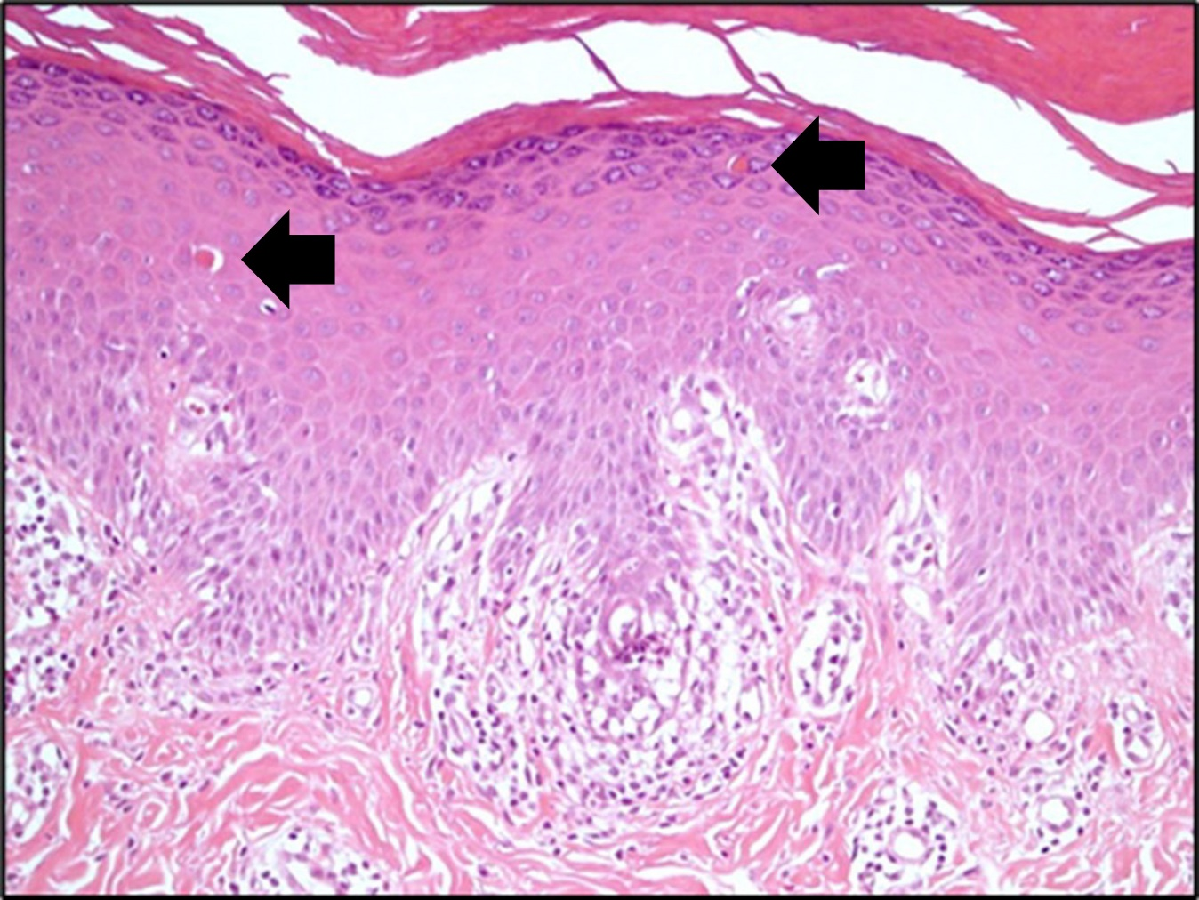

Supplementary figure 1B
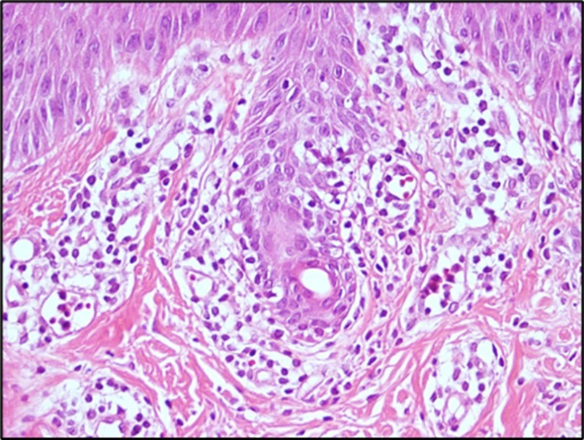

Supplementary figure 2A
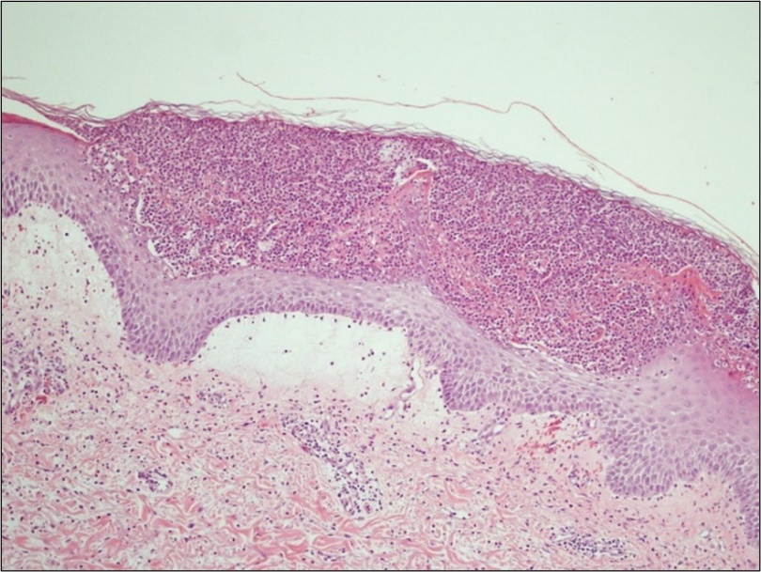

Supplementary figure 2B
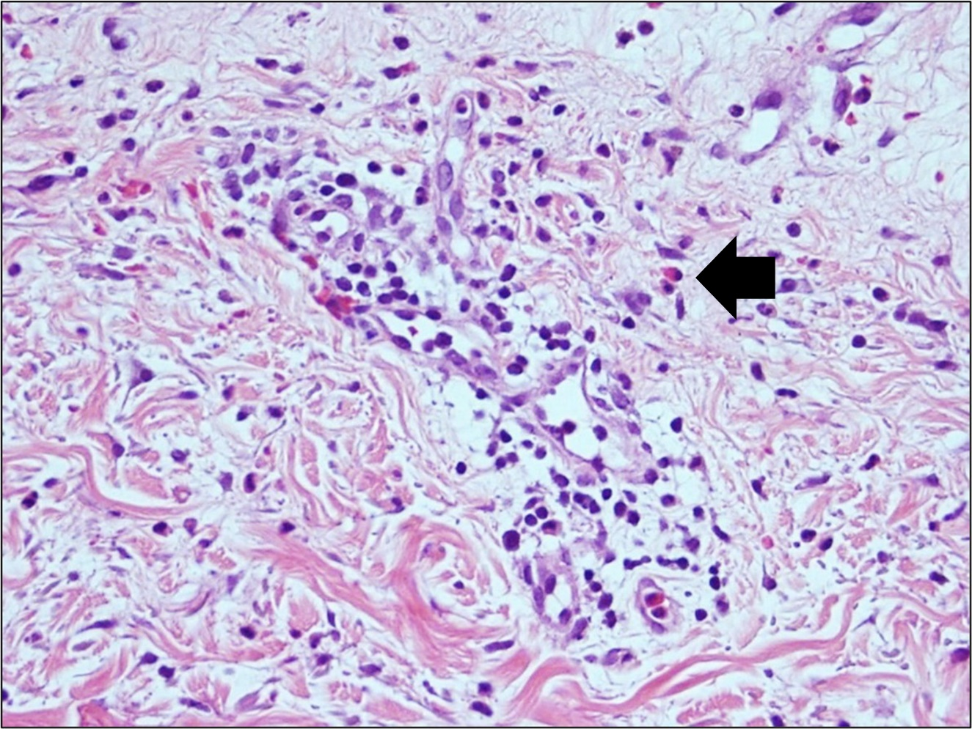

Supplementary figure 2C
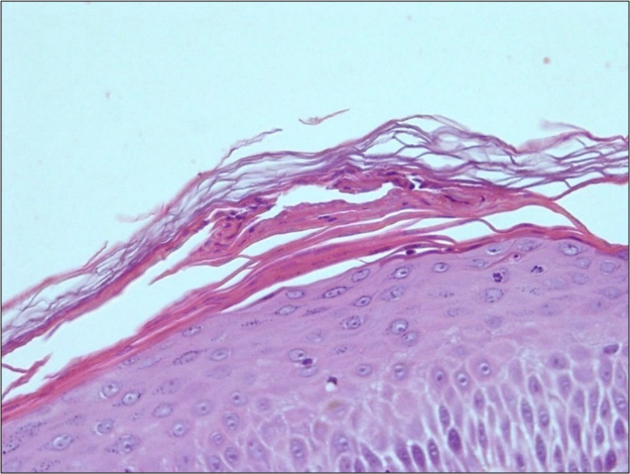

Supplementary figure 2D
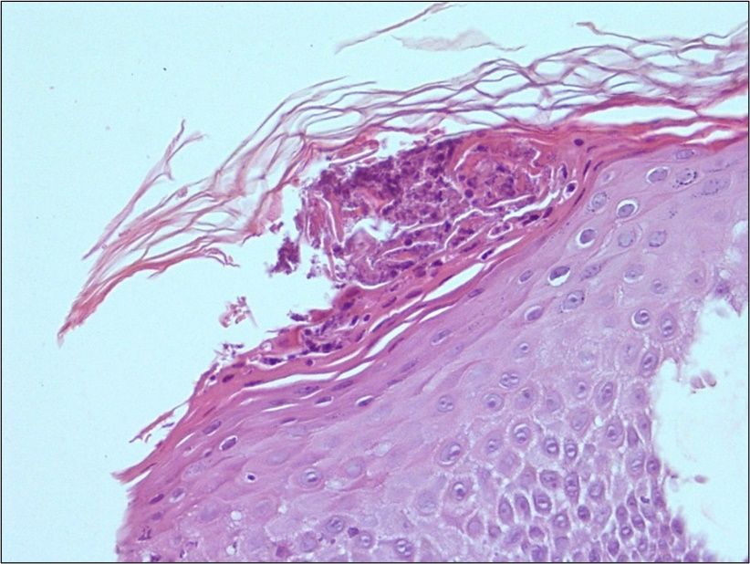

Supplementary figure 3A

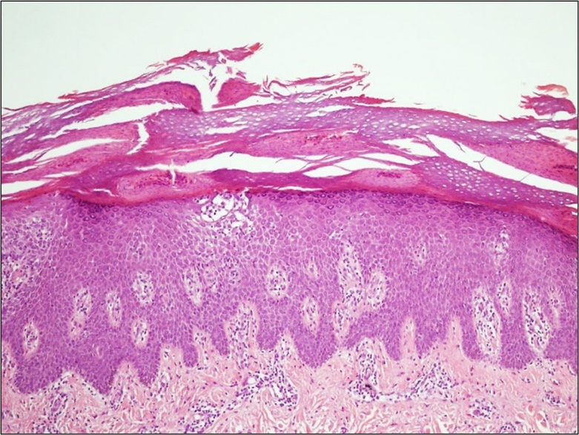

Supplementary figure 3B
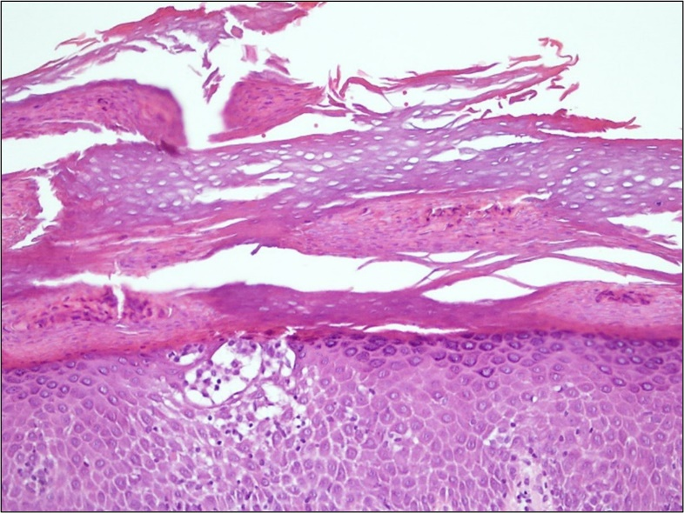

Supplementary figure 3C
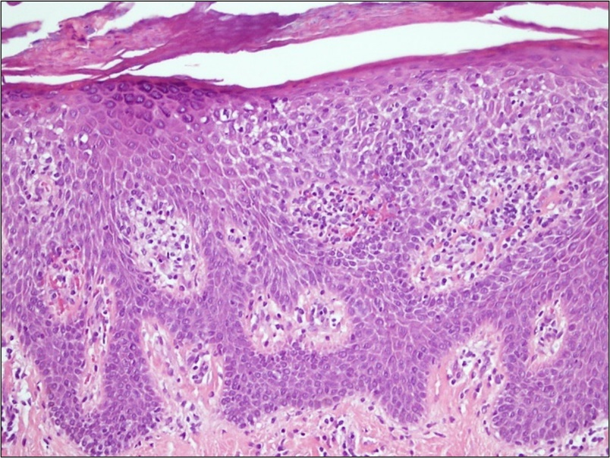

Supplementary figure 3D
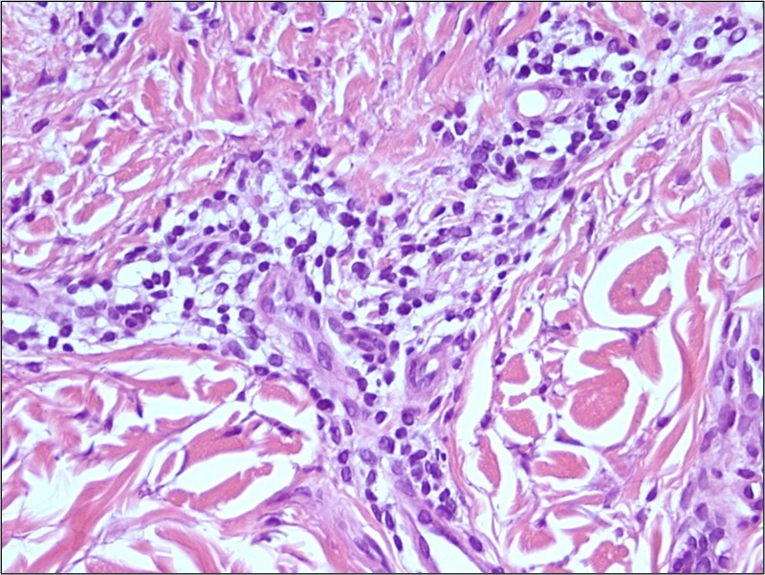

Supplementary figures legend

Supplementary figure 1A Erythema multiforme. Focal lymphocytic infiltration along the interface is associated with basal vacuolization. Two necrotic keratinocytes are evident in the epidermis (arrows) (H&E, 200x)
Supplement figure 1B Erythema multiforme. An interface infiltration by lymphocytes associated with basal vacuolization and intraepidermal extension (H&E, 400x)

Supplementary figure 2A Pustular psoriasis. A subcorneal pustule with papillary dermal edema (H&E, 100x)
Supplementary figure 2B Pustular psoriasis. Mild superficial perivascular and interstitial infiltrations by mixed cells predominantly lymphocytes with some neutrophils, and one eosinophil (arrow). Mild extravasated red blood cells are observed. (H&E, 400x)
Supplementary figure 2C and 2D Pustular psoriasis. Focal parakeratosis and near-complete loss of the granular layers in both figures. Mild intracorneal neutrophils and debris are shown in Fig. 2D. Near-complete loss of the granular layer is observed in both figures (H&E, 400x and 400x).

Supplementary figure 3A and 3B Pityriasis rubra pilaris. Psoriasiform hyperplasia with mild spongiosis and marked hyperkeratosis showing alternating orthokeratosis and parakeratosis. Clusters of Langerhans microgranulomas (arrow) with mild intraepidermal lymphocytes are observed in the upper epidermis (Figure 3B) (A-B; H&E, 100x & 200x, respectively)
Supplementary figure 3C Pityriasis rubra pilaris. Psoriasiform hyperplasia with mild spongiosis and lymphocytic exocytosis. The granular layer disappeared focally. (H&E, 200x).
Supplementary figure 3D Pityriasis rubra pilaris. Mild superficial perivascular lymphocytic infiltration (H&E, 400x)

Supplementary table 1 Relationship between patients with rash and other localized or systemic symptoms
Characteristic |  | Rash with any other symptoms  N=77
Characteristic | Rash without another symptom  N=15  n(%) | With any other symptoms  N=77  n(%) | With localized symptoms*  N=57  n(%) | With systemic symptom**  N=58  n(%)
Type of vaccine  AstraZeneca (N=69)  Sinovac (N=6)  Pfizer (N=12)  Moderna (N=1)  Sinopharm (N=4) | 13 (86.66)  0  1 (6.67)  0  1 (1.67) | 56 (72.72)  6 (7.79)  11 (14.29)  1 (1.30)  3 (3.90) | 41 (71.93)  4 (7.02)  11 (19.30)  1 (1.75)  0 | 44 (75.86)  4 (6.90)  6 (10.34)  1 (1.73)  3 (5.17)
Dose of vaccination  First dose (N=41)  Second dose (N=23)  Third dose (N=27)  Fourth dose (N=1) | 6 (40.0)  7 (46.67)  2 (13.33)  0 | 35 (45.45)  16 (20.78)  25 (32.47)  1 (1.30) | 23 (40.35)  10 (17.55)  23 (40.35)  1 (1.75) | 29 (50.0)  12 (20.69)  16 (27.59)  1 (1.72)
Rash morphology  Urticaria  Injected site reaction  Delayed local reaction  Psoriasis  Eczema | 3 (20.0)  0  0  5 (33.33)  1 (6.67) | 29 (37.66)  16 20.78)  11 (14.29)  1 (1.30)  5 (6.49) | 16 (28.07)  16 (28.07)  11 (19.30)  0  4 (7.02) | 23 (39.66)  14 (24.14)  8 (13.79)  1 (1.72)  2 (3.45)
Any comorbid disease (N=34) | 9 (60.0) | 25 (32.47) | 19 (33.33) | 20 (34.48)
Any dermatologic disease (N=18) | 4 (26.67) | 14 (18.18) | 7 (12.28) | 12 (20.69)
*Localized symptoms include pain, swelling, and redness
**Systemic symptoms included: myalgia, fever, fatigue, chilling, headache, nausea and diarrhea

