Supplement

Supplemental Figure 1: Change in Intraocular Pressure and Medication Burden
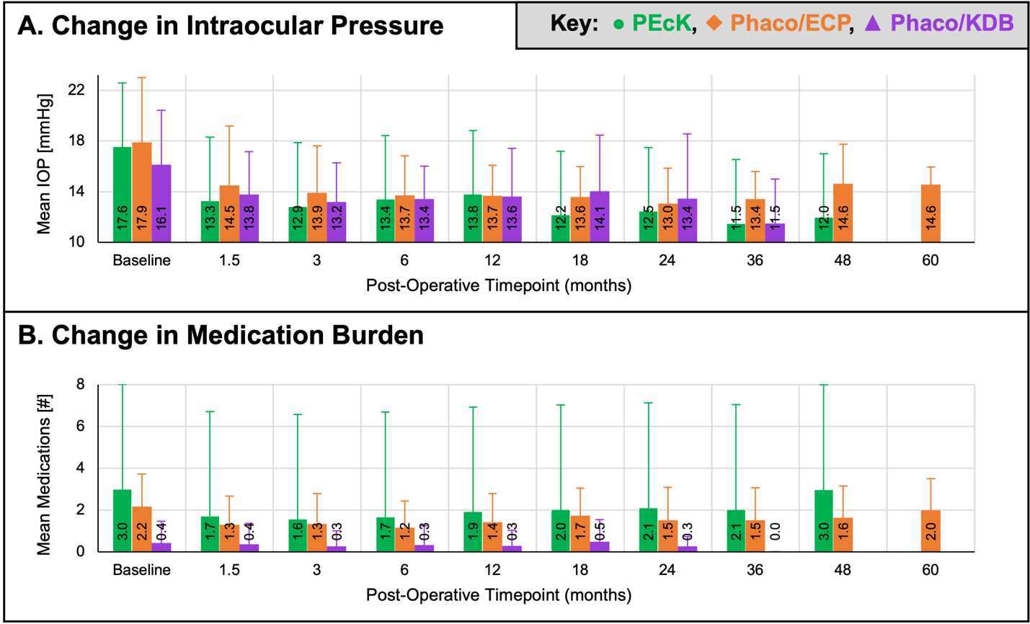Supplemental Figure 1: (A) Mean intraocular pressure (IOP) and (B) mean medication burden plotted at baseline and postoperative timepoints. Tests of the statistical difference in the pattern of change are found in Tables 2 and 3. Phaco/ECP = phacoemulsification and endocyclophotocoagulation (ECP). Phaco/KDB = phacoemulsification and Kahook Dual Blade. PEcK = phacoemulsification, ECP, and KDB.

Supplemental Table 1: Reductions in Intraocular Pressure
Outcome: IOP [mmHg] | PEcK |  | Phaco/ECP |  | Phaco/KDB
Outcome: IOP [mmHg] | Reduction of Baseline Mean | Percent Reduction | Reduction of Baseline Mean | Percent Reduction | Reduction of Baseline Mean | Percent Reduction
6 weeks | 4.3 | 24.4% | 3.4 | 19.0% | 2.4 | 14.6%
3 months | 4.7 | 26.8% | 4.0 | 22.2% | 2.9 | 18.2%
6 months | 4.2 | 23.6% | 4.2 | 23.3% | 2.7 | 16.8%
12 months | 3.8 | 21.4% | 4.2 | 23.5% | 2.5 | 15.5%
18 months | 5.4 | 30.7% | 4.3 | 24.0% | 2.1 | 12.8%
24 months | 5.1 | 29.0% | 4.8 | 27.1% | 2.7 | 16.6%
36 months | 6.1 | 34.4% | 4.5 | 25.1% | 4.6 | 28.7%
48 months | 5.6 | 31.7% | 3.2 | 18.1% | — | —
60 months | — | — | 3.3 | 18.6% | — | —
Supplemental Table 1: Reduction and percent reduction of mean intraocular pressure (IOP) at postoperative timepoints. All bolded text is used to distinguish column and section headers of the table. Phaco/ECP = phacoemulsification and endocyclophotocoagulation (ECP). Phaco/KDB = phacoemulsification and Kahook Dual Blade. PEcK = phacoemulsification, ECP, and KDB.

Supplemental Table 2: Parameters of Generalized Estimating Equations
Term | GEE Model:  IOP |  |  | GEE Model:  Medication Burden |  |  | GEE Model:  logMAR
Term | Est. | SE | P-Value | Est. | SE | P-Value | Est. | SE | P-Value
(Intercept) | 16.10 | 0.53 | <0.001* | 1.64 | 0.31 | <0.001* | 0.19 | 0.07 | 0.011*
Timepoint | -0.66 | 0.07 | <0.001* | -0.10 | 0.03 | <0.001* | -0.03 | 0.01 | <0.001*
PEcK v Phaco/ECP | 0.00 | 0.57 | 0.997 | -0.52 | 0.18 | 0.004* | -0.05 | 0.04 | 0.292
PEcK v Phaco/KDB | -0.38 | 0.58 | 0.511 | -1.71 | 0.17 | <0.001* | 0.03 | 0.06 | 0.604
Basline IOP | — | — | — | 0.01 | 0.01 | 0.608 | 0.00 | 0.00 | 0.578
Basline Medication Burden | 0.26 | 0.13 | 0.041* | — | — | — | 0.03 | 0.02 | 0.074
Stage Mild v Indeterminate | -0.72 | 0.94 | 0.446 | 0.12 | 0.30 | 0.696 | 0.33 | 0.12 | 0.005*
Stage Mild v Moderate | -0.98 | 0.38 | 0.010* | 0.30 | 0.17 | 0.077 | -0.04 | 0.04 | 0.319
Stage Mild v OHTN | 0.55 | 0.77 | 0.470 | -0.27 | 0.24 | 0.256 | 0.05 | 0.12 | 0.676
Stage Mild v Severe | -1.34 | 0.43 | 0.002* | 0.71 | 0.20 | <0.001* | 0.06 | 0.06 | 0.272
Sex Female v Male | -0.79 | 0.33 | 0.017* | 0.22 | 0.14 | 0.129 | 0.03 | 0.04 | 0.444
Prior LTP | -0.39 | 0.39 | 0.318 | 0.54 | 0.19 | 0.004* | -0.07 | 0.04 | 0.039*
Timepoint,  PEcK v Phaco/ECP | 0.26 | 0.11 | 0.018* | 0.07 | 0.04 | 0.089 | 0.02 | 0.01 | 0.021*
Timepoint,  PEcK v Phaco/KDB | 0.30 | 0.16 | 0.067 | 0.06 | 0.04 | 0.126 | 0.00 | 0.01 | 0.785
Supplemental Table 2: Parameters of the regression models from Generalized Estimating Equations (GEEs) modeling change in outcome variables, including intraocular pressure (IOP), number of glaucoma medications, and logarithm of the minimum angle of resolution (logMAR). Longitudinal associations between outcome variables, procedure type, timepoints (baseline, week 6, months 3, 6, 12, 18, 24, 36, 48, and 60), and adjustment co-variates are evaluated while holding all other variables constant. Summary statistics in the form of Wald tests and ANOVA are discussed separately. Adjusted GEE for IOP included co-variates for baseline medication burden, prior laser trabeculoplasty, glaucoma type, and sex. Adjusted GEE for medication burden included co-variates for baseline IOP, prior laser trabeculoplasty, glaucoma type, and sex. Adjusted GEE for logMAR included co-variates for baseline IOP, medication burden, prior laser trabeculoplasty, glaucoma type, and sex. *Asterisk identifies significance defined as p < 0.05. All bolded text is used to distinguish column and section headers of the table. Est. = Estimate. SE = Standard Error. LogMAR = Logarithm of the Minimum Angle of Resolution. Phaco/ECP = phacoemulsification and endocyclophotocoagulation (ECP). Phaco/KDB = phacoemulsification and Kahook Dual Blade. PEcK = phacoemulsification, ECP, and KDB.

Supplemental Table 3: Change in Best Corrected Distance Visual Acuity
Outcome: logMAR | PEcK |  |  | Phaco/ECP |  |  | Phaco/KDB
Outcome: logMAR | N | Mean (SD) | Snellen | N | Mean (SD) | Snellen | N | Mean (SD) | Snellen
Baseline | 128 | 0.4  (0.52) | 20/50 | 78 | 0.33  (0.33) | 20/43 | 65 | 0.38  (0.37) | 20/47
6 weeks | 114 | 0.23  (0.3) | 20/34 | 72 | 0.2  (0.22) | 20/32 | 63 | 0.2  (0.33) | 20/31
3 months | 79 | 0.23  (0.29) | 20/34 | 58 | 0.17 (0.31) | 20/30 | 41 | 0.19  (0.31) | 20/31
6 months | 102 | 0.18  (0.33) | 20/30 | 63 | 0.25  (0.45) | 20/36 | 53 | 0.16  (0.25) | 20/29
12 months | 78 | 0.22  (0.39) | 20/33 | 43 | 0.16  (0.24) | 20/29 | 31 | 0.16  (0.29) | 20/29
18 months | 56 | 0.2  (0.37) | 20/31 | 30 | 0.13  (0.23) | 20/27 | 18 | 0.17  (0.25) | 20/30
24 months | 42 | 0.16  (0.31) | 20/29 | 31 | 0.24  (0.56) | 20/35 | 11 | 0.24  (0.29) | 20/35
36 months | 19 | 0.1  (0.16) | 20/25 | 27 | 0.18  (0.39) | 20/30 | 2 | 0.05  (0.07) | 20/22
48 months | 3 | 0.12  (0.05) | 20/27 | 14 | 0.18  (0.31) | 20/30 | 0 | — | —
60 months | 0 | — | — | 9 | 0.21  (0.26) | 20/33 | 0 | — | —
P-values: Evaluating the pattern of change
Over time, unadjusted | <0.001*
Over time, adjustedª | <0.001*
Comparing procedure to PEcK over time, unadjusted | — |  |  | 0.82 |  |  | 0.52
Comparing procedure to PEcK over time, adjustedª | — |  |  | 0.02* |  |  | 0.78
Comparing all procedures over time, unadjusted | 0.81
Comparing all procedures over time, adjustedª | 0.04*
Supplemental Table 3: Best corrected distance visual acuity as mean logMAR and Snellen equivalent at baseline and postoperative timepoints. Wald Tests with adjustment for baseline IOP were used to evaluate difference between the pattern of change across timepoints and the pattern of change between all timepoints and the two procedures. ªAdjusted GEE for logMAR included co-variates for baseline IOP, medication burden, prior laser trabeculoplasty, glaucoma type, and sex. *Asterisk identifies significance defined as p < 0.05. All bolded text is used to distinguish column and section headers of the table. LogMAR = Logarithm of the Minimum Angle of Resolution. Phaco/ECP = phacoemulsification and endocyclophotocoagulation (ECP). Phaco/KDB = phacoemulsification and Kahook Dual Blade. PEcK = phacoemulsification, ECP, and KDB.

