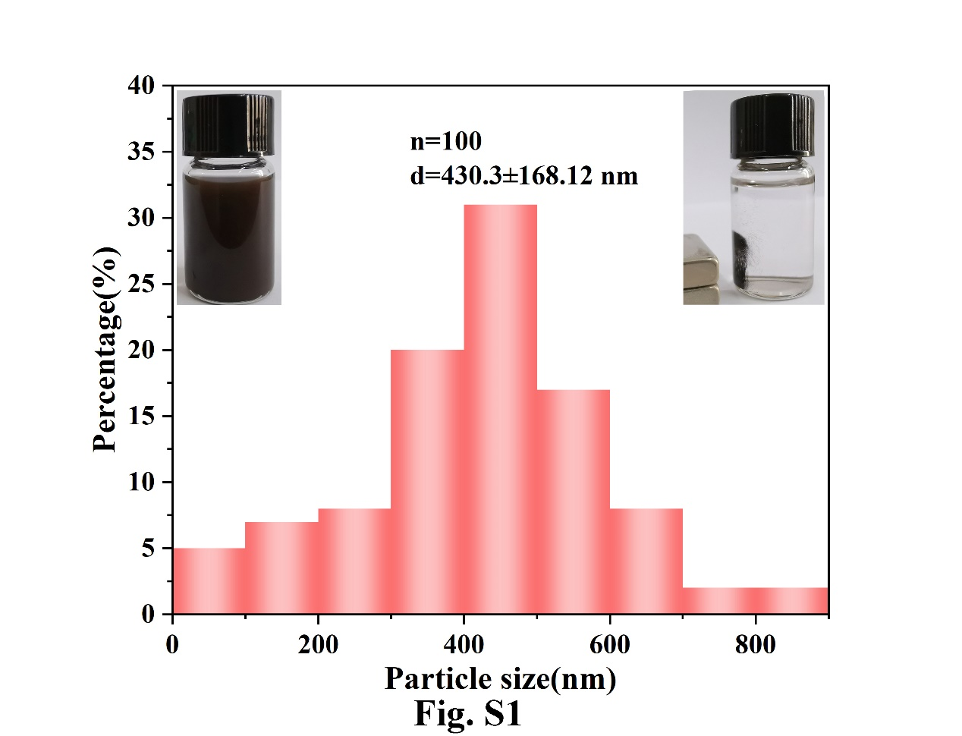
Fig. S1 Size distribution histogram of Au-AgNCs from SEM. MB particles showed well dispersity (the left inset image) and magnetic aggregation (the right inset image).

Table S1 Results of the animal experiments
 | Mice weight (g) |  |  |  | Tumor width (mm) |  |  |  | Tumor length (mm)
Group | 6 d | 12 d | 18 d | 24 d | 6 d | 12 d | 18 d | 24 d | 6 d | 12 d | 18 d | 24 d
1 | 16.7 | 17.7 | 18.5 | 19 | 3.595 | 3.265 | 4.023 | 5.4 | 4.5 | 3.608 | 5.137 | 8.195
2 | 17.8 | 19.3 | - | - | 4.093 | 3.298 | - | - | 4.435 | 3.673 | - | -
3 | 17.5 | - | - | - | 3.752 | - | - | - | 4.782 | - | - | -
4 | 16.5 | 18.3 | 18.5 | - | 3.683 | 3.1 | 3.985 | - | 4.83 | 4.326 | 5.793 | -

Table S2 Results of the proposed SERS analysis platform and qRT-PCR for mice serum samples
Period (d) | SERS (fM) |  | qRT-PCR (fM) |  | Relative error (%)
Period (d) | IDH1 R132H | BRAF V600E | IDH1 R132H | BRAF V600E | IDH1 R132H | BRAF V600E
0 | 0.010 | 0.013 | 0.009 | 0.012 | 10 | 7.7
7 | 0.012 | 0.049 | 0.011 | 0.045 | 8.3 | 8.2
14 | 0.076 | 0.371 | 0.071 | 0.402 | 6.6 | -8.4
21 | 0.164 | 1.114 | 0.171 | 1.036 | -4.3 | 7
28 | 0.473 | 1.968 | 0.493 | 2.123 | -4.2 | -7.9

Table S3 Results of the proposed SERS analysis platform and qRT-PCR for mice serum samples (0 d)
 | SERS (fM) |  | qRT-PCR (fM) |  | Relative error (%)
No. | IDH1 R132H | BRAF V600E | IDH1 R132H | BRAF V600E | IDH1 R132H | BRAF V600E
1 | 0.0113 | 0.0124 | 0.0103 | 0.0127 | 7.2 | 2.4
2 | 0.0089 | 0.0131 | 0.0083 | 0.0119 | 6.7 | 9.2
3 | 0.0092 | 0.0129 | 0.0095 | 0.0135 | -3.2 | -4.7
4 | 0.0110 | 0.0127 | 0.0097 | 0.0119 | 11.8 | 6.3

Table S4 Results of the proposed SERS analysis platform and qRT-PCR for mice serum samples (7 d)
NO. | SERS (fM) |  | qRT-PCR (fM) |  | Relative error (%)
NO. | IDH1 R132H | BRAF V600E | IDH1 R132H | BRAF V600E | IDH1 R132H | BRAF V600E
1 | 0.0114 | 0.0482 | 0.0111 | 0.0441 | 8.5 | 8.5
2 | 0.0098 | 0.0465 | 0.0107 | 0.0427 | -9.2 | 8.2
3 | 0.0112 | 0.0505 | 0.0119 | 0.0458 | -6.3 | 9.3
4 | 0.0106 | 0.0518 | 0.0097 | 0.0496 | 8.5 | 4.2

Table S5 Results of the proposed SERS analysis platform and qRT-PCR for mice serum samples (14 d)
NO. | SERS (fM) |  | qRT-PCR (fM) |  | Relative error (%)
NO. | IDH1 R132H | BRAF V600E2 | IDH1 R132H | BRAF V600E | IDH1 R132H | BRAF V600E
1 | 0.0725 | 0.324 | 0.0689 | 0.349 | 4.96 | -7.7
2 | 0.0831 | 0.412 | 0.0792 | 0.445 | 4.7 | 7.5
3 | 0.0717 | 0.335 | 0.0656 | 0.367 | 8.5 | 9.5
4 | 0.0762 | 0.411 | 0.0716 | 0.447 | 6.04 | 8.8

Table S6 Results of the proposed SERS analysis platform and qRT-PCR for mice serum samples (21 d)
NO. | SERS (fM) |  | qRT-PCR (fM) |  | Relative error (%)
NO. | IDH1 R132H | BRAF V600E | IDH1 R132H | BRAF V600E | IDH1 R132H | BRAF V600E
1 | 0.172 | 1.072 | 0.178 | 1.017 | -3.48 | 5.13
2 | 0.164 | 1.162 | 0.163 | 1.064 | 0.69 | 8.43
3 | 0.165 | 1.140 | 0.176 | 1.037 | -6.66 | 9.04
4 | 0.155 | 1.081 | 0.167 | 1.026 | -7.74 | 5.09

Table S7 Results of the proposed SERS analysis platform and qRT-PCR for mice serum samples (28 d)
NO. | SERS (fM) |  | qRT-PCR (fM) |  | Relative error (%)
NO. | IDH1 R132H | BRAF V600E | IDH1 R132H | BRAF V600E | IDH1 R132H | BRAF V600E
1 | 0.451 | 1.838 | 0.471 | 1.982 | -4.43 | -7.8
2 | 0.467 | 1.937 | 0.483 | 2.114 | -3.4 | -9.1
3 | 0.491 | 2.061 | 0.512 | 2.210 | -4.3 | -7.2
4 | 0.484 | 2.038 | 0.506 | 2.186 | -4.5 | -7.3

