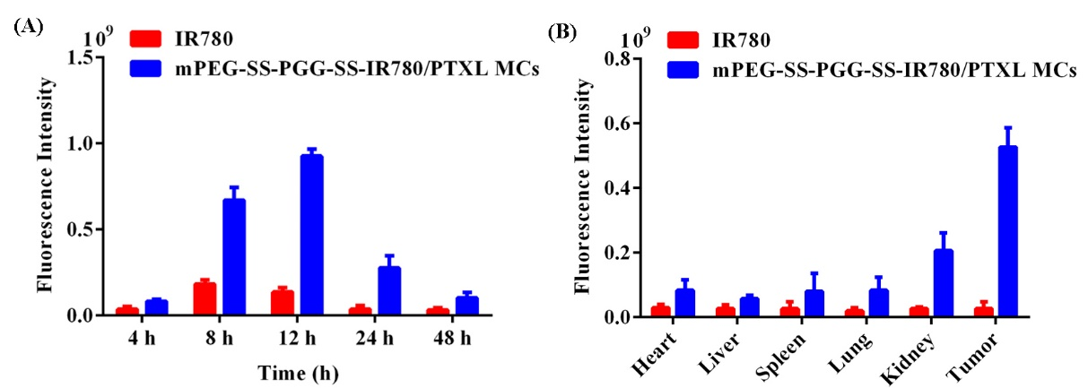

Figure S1 (A) The fluorescence intensity quantification at tumor sites (n =3). (B) Quantification of fluorescence intensity in major organs and tumor tissues (n =3).

