Supplementary Table 1. Week-by-week schedule for cognitive behavior therapy for insomnia(CBT-I) and acceptance and commitment therapy (ACT) for insomnia
 | Cognitive behavior therapy for insomnia | Acceptance and commitment therapy for insomnia
1 week | ·Orientation of sleep program of CBT-I  ·Education for sleep hygiene and sleep diary | ·Orientation of sleep program  ·Education for sleep hygiene  ·Acceptance and Defusion about unwanted thoughts in insomnia
online  reminder | Sending brief instructions of CBT-I and sleep hygiene | Sending brief instructions of ACT and sleep hygiene
2 week | · Check sleep diary and review brief CBT-I  ·Sleep Restriction &Stimulus control therapy  .Relaxation training | ·Check sleep diary and review brief ACT  ·List of sleep problem that can be controlled or cannot be controlled  ·Paradox of control  ·Mindfulness training
online  reminder | Sending brief instructions of stimulus control & sleep restriction | Sending brief instructions of paradox of controlling sleep
3 week | ·Check sleep diary and review brief CBT-I  ·Review Sleep Hygiene & Sleep Restriction & Stimulus control  ·Cognitive modification of dysfunctional thoughts in insomnia  ·Learn how to deal with beliefs about sleep | ·Check sleep diary and review brief ACT  ·Review Sleep Hygiene & Acceptance and Defusion in sleep  ·Mindfulness body meditation in bed time  ·Learn how to apply mindfulness in daily life and daily sleep
online  reminder | Sending brief instructions of Self Cognitive Therapy for sleep | Sending brief instructions of Self Mindfulness meditation
4 week | ·Check sleep diary and the procedures of CBT-I  ·Sleep Education & Sleep Hygiene & Sleep Restriction  ·Modification of dysfunctional cognition and behavior in sleep  ·Relapse prevention lesson in insomnia | ·Check sleep diary and the procedures of ACT  ·Sleep Education & Sleep Hygiene & mindfulness  ·Increase psychological flexibility and a non-judgmental attitude for sleep  ·Values in life and plan a committed action consistent with values
online  reminder | Sending final procedures of CBT-I and self sleep diary | Sending final procedures of ACT and self sleep diary

Supplementary Table 2. Sleep diary
Group |  | Week  I | Week  J | I-J | p |  |  | Week  I | Week  J | I-J | p
CBT-I | TST (min),  Mean  (SD) | 1: Post 1stsession | 2 | -6.919 | 0.788 | ACT | TST (min)  Mean  (SD) | 1: Post 1stsession | 2 | -21.657 | 0.323
CBT-I | TST (min),  Mean  (SD) | 294.775  (48.82) | 3 | 1.367 | 0.970 | ACT | TST (min)  Mean  (SD) | 284.800  (137.92) | 3 | -34.171 | 0.276
CBT-I | TST (min),  Mean  (SD) | 294.775  (48.82) | 4 | -3.714 | 0.920 | ACT | TST (min)  Mean  (SD) | 284.800  (137.92) | 4 | -31.343 | 0.317
CBT-I | TST (min),  Mean  (SD) | 2:Post  2stsession | 1 | 6.919 | 0.788 | ACT | TST (min)  Mean  (SD) | 2:Post  2stsession | 1 | 21.657 | 0.323
CBT-I | TST (min),  Mean  (SD) | 301.694  (79.22) | 3 | 8.286 | 0.756 | ACT | TST (min)  Mean  (SD) | 306.457  (112.38) | 3 | -12.514 | 0.577
CBT-I | TST (min),  Mean  (SD) | 301.694  (79.22) | 4 | 3.204 | 0.905 | ACT | TST (min)  Mean  (SD) | 306.457  (112.38) | 4 | -9.686 | 0.667
CBT-I | TST (min),  Mean  (SD) | 3:Post  3stsession | 1 | -1.367 | 0.970 | ACT | TST (min)  Mean  (SD) | 3:Post  3stsession | 1 | 34.171 | 0.276
CBT-I | TST (min),  Mean  (SD) | 293.408  (71.28) | 2 | -8.286 | 0.756 | ACT | TST (min)  Mean  (SD) | 318.97  (117.39) | 2 | 12.514 | 0.577
CBT-I | TST (min),  Mean  (SD) | 293.408  (71.28) | 4 | -5.081 | 0.804 | ACT | TST (min)  Mean  (SD) | 318.97  (117.39) | 4 | 2.828 | 0.869
CBT-I | TST (min),  Mean  (SD) | 4:Post  4stsession | 1 | 3.714 | 0.920 | ACT | TST (min)  Mean  (SD) | 4:Post  4stsession | 1 | 31.343 | 0.317
CBT-I | TST (min),  Mean  (SD) | 298.490  (66.03) | 2 | -3.204 | 0.905 | ACT | TST (min)  Mean  (SD) | 316.143  (88.22) | 2 | 9.686 | 0.667
CBT-I | TST (min),  Mean  (SD) | 298.490  (66.03) | 3 | 5.081 | 0.804 | ACT | TST (min)  Mean  (SD) | 316.143  (88.22) | 3 | -2.828 | 0.869
CBT-I | SE (%) | 1: Post 1stsession | 2 | -2.000 | 0.723 | ACT | SE (%) | 1: Post 1stsession | 2 | -8.691 | 0.080
CBT-I | SE (%) | 61.357  (9.39) | 3 | -6.716 | 0.251 | ACT | SE (%) | 56.750  (24.76) | 3 | -12.140* | 0.021
CBT-I | SE (%) | 61.357  (9.39) | 4 | -5.561 | 0.370 | ACT | SE (%) | 56.750  (24.76) | 4 | -15.250* | 0.008
CBT-I | SE (%) | 2:Post  2stsession | 1 | 2.000 | 0.723 | ACT | SE (%) | 2:Post  2stsession | 1 | 8.691 | 0.080
CBT-I | SE (%) | 63.357  (15.12) | 3 | -4.716 | 0.311 | ACT | SE (%) | 65.441  (24.03) | 3 | -3.449 | 0.374
CBT-I | SE (%) | 63.357  (15.12) | 4 | -3.561 | 0.549 | ACT | SE (%) | 65.441  (24.03) | 4 | -6.559 | 0.198
CBT-I | SE (%) | 3:Post  3stsession | 1 | 6.716 | 0.723 | ACT | SE (%) | 3:Post  3stsession | 1 | 12.140* | 0.021
CBT-I | SE (%) | 68.072  (14.99) | 2 | 4.716 | 0.311 | ACT | SE (%) | 68.890  (23.54) | 2 | 3.449 | 0.347
CBT-I | SE (%) | 68.072  (14.99) | 4 | 1.154 | 0.821 | ACT | SE (%) | 68.890  (23.54) | 4 | -3.110 | 0.470
CBT-I | SE (%) | 4:Post  4stsession | 1 | 5.561 | 0.370 | ACT | SE (%) | 4:Post  4stsession | 1 | 15.250 | 0.008
CBT-I | SE (%) | 66.918  (15.75) | 2 | 3.561 | 0.549 | ACT | SE (%) | 72.000  (20.31) | 2 | 6.559 | 0.198
CBT-I | SE (%) | 66.918  (15.75) | 3 | -1.154 | 0.821 | ACT | SE (%) | 72.000  (20.31) | 3 | 3.110 | 0.470
CBT-I | WASO  (min) | 1: Post 1stsession | 2 | -26.593 | 0.169 | ACT | WASO  (min) | 1: Post 1stsession | 2 | 8.471 | 0.590
CBT-I | WASO  (min) | 102.938  (84.19) | 3 | 16.326 | 0.501 | ACT | WASO  (min) | 108.900  (81.49) | 3 | 20.000 | 0.329
CBT-I | WASO  (min) | 102.938  (84.19) | 4 | -4.083 | 0.887 | ACT | WASO  (min) | 108.900  (81.49) | 4 | 21.400 | 0.379
CBT-I | WASO  (min) | 2:Post  2stsession | 1 | 26.593 | 0.169 | ACT | WASO  (min) | 2:Post  2stsession | 1 | -8.471 | 0.590
CBT-I | WASO  (min) | 129.531  (89.23) | 3 | 42.919 | 0.058 | ACT | WASO  (min) | 100.429  (82.39) | 3 | 11.529 | 0.520
CBT-I | WASO  (min) | 129.531  (89.23) | 4 | 22.510 | 0.379 | ACT | WASO  (min) | 100.429  (82.39) | 4 | 12.929 | 0.543
CBT-I | WASO  (min) | 3:Post  3stsession | 1 | -16.326 | 0.501 | ACT | WASO  (min) | 3:Post  3stsession | 1 | -20.000 | 0.329
CBT-I | WASO  (min) | 86.612  (39.51) | 2 | -42.919 | 0.058 | ACT | WASO  (min) | 88.900  (72.33) | 2 | -11.529 | 0.520
CBT-I | WASO  (min) | 86.612  (39.51) | 4 | -20.409 | 0.389 | ACT | WASO  (min) | 88.900  (72.33) | 4 | 1.400 | 0.943
CBT-I | WASO  (min) | 4:Post  4stsession | 1 | 4.083 | 0.887 | ACT | WASO  (min) | 4:Post  4stsession | 1 | -21.400 | 0.379
CBT-I | WASO  (min) | 107.021  (96.23) | 2 | -22.510 | 0.379 | ACT | WASO  (min) | 87.500  (83.41) | 2 | -12.929 | 0.543
CBT-I | WASO  (min) | 107.021  (96.23) | 3 | 20.409 | 0.389 | ACT | WASO  (min) | 87.500  (83.41) | 3 | -1.400 | 0.943
CBT-I | SOL (min) | 1: Post 1stsession | 2 | 33.367* | 0.049 | ACT | SOL (min) | 1: Post 1stsession | 2 | 48.071* | 0.002
CBT-I | SOL (min) | 83.470  (45.50) | 3 | 48.857* | 0.022 | ACT | SOL (min) | 76.000  (59.67) | 3 | 44.171* | 0.011
CBT-I | SOL (min) | 83.470  (45.50) | 4 | 35.123 | 0.051 | ACT | SOL (min) | 76.000  (59.67) | 4 | 45.200* | 0.005
CBT-I | SOL (min) | 2:Post  2stsession | 1 | -33.367* | 0.049 | ACT | SOL (min) | 2:Post  2stsession | 1 | -48.071* | 0.002
CBT-I | SOL (min) | 50.102  (42.96) | 3 | 13.490 | 0.306 | ACT | SOL (min) | 27.929  (20.78) | 3 | -3.900 | 0.719
CBT-I | SOL (min) | 50.102  (42.96) | 4 | 1.756 | 0.903 | ACT | SOL (min) | 27.929  (20.78) | 4 | -2.871 | 0.812
CBT-I | SOL (min) | 3:Post  3stsession | 1 | -46.857* | 0.022 | ACT | SOL (min) | 3:Post  3stsession | 1 | -44.171* | 0.011
CBT-I | SOL (min) | 36.612  (26.71) | 2 | -13.490 | 0.306 | ACT | SOL (min) | 31.829  (30.29) | 2 | 3.900 | 0.719
CBT-I | SOL (min) | 36.612  (26.71) | 4 | -11.734 | 0.128 | ACT | SOL (min) | 31.829  (30.29) | 4 | 1.029 | 0.868
CBT-I | SOL (min) | 4:Post  4stsession | 1 | -35.123 | 0.051 | ACT | SOL (min) | 4:Post  4stsession | 1 | -45.200* | 0.005
CBT-I | SOL (min) | 48.347  (32.40) | 2 | -1.756 | 0.903 | ACT | SOL (min) | 30.800  (26.86) | 2 | 2.871 | 0.812
CBT-I | SOL (min) | 48.347  (32.40) | 3 | 11.734 | 0.128 | ACT | SOL (min) | 30.800  (26.86) | 3 | -1.029 | 0.868
CBT-I, Cognitive behavior therapy; ACT, Acceptance and commitment therapy; SE, sleep efficacy; SOL, sleep onset latency; WASO, wake time after sleep onset; level of statistical significance, *p < 0.05, **p < 0.005

Supplementary Figure 1. Online chat consultation (Kakao channel, Seoul, Korea). A patient who was treated by CBT-I and psychologist send videos, which showed relaxation training including breathing exercises and progressive muscle relaxation (A). A patient was treated by ACT for insomnia and psychologist send guides including not struggling with suffering caused by insomnia (B) after session 2 and observing dysfunctional thoughts to live present life (C) and session 3 (C). The psychologist's statements are displayed in yellow boxes, while the patients' responses are shown in white boxes in the chat.
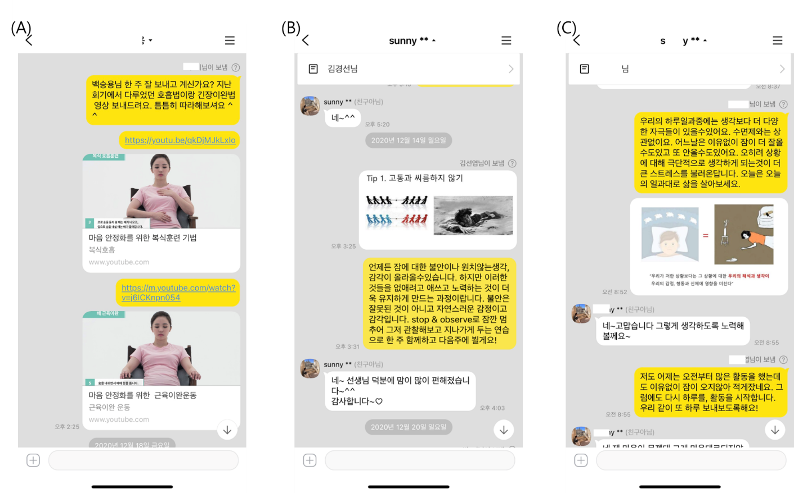

Supplementary Figure 2. Mean values for weekly sleep diary outcome variables for the CBT-I and ACT groups during intervention periods for total sleep time (panel A), sleep efficacy (panel B), wake time after sleep onset (panel C), sleep onset latency (panel D) Data presented here includes all available at each time point (N = 10 in CBT-I group, N = 11 in ACT group, also see raw data in Supplementary Table 2.) Wk, week; *p < 0.05, **p < 0.005
