Supplementary materials
Patient | Age | Gender | VA with correction (logMAR) | Visual field defect | Diagnosis | Medication
s1 | 65 | Male | -0.1 | RHH | Stroke left occipital cortex | Clopidogrel, ezetimibe, nifedipine, pantoprazole, simvastatine, tamsulosine
s2 | 56 | Male | 0 | ILQ | Stroke right occipital cortex | Acenocoumarol, acetylsalicylic acid, amlodipine, citalopram, metoprolol, perindopril, rosuvastatin
s3 | 28 | Male | -0.1 | RHH | Stroke left occipital cortex after tumor resection left frontal cortex | Levetiracetam
s4 | 58 | Male | 0 | RHH | Stroke left occipital cortex | Clopidogrel
s5 | 71 | Male | 0 | ILQ | Stroke right occipital cortex | Simvastatin, apixaban, levetiracetam, hydrochlorothiazide, digoxin, losartan, tramadol
s6 | 57 | Male | -0.1 | LHH | Stroke right occipital cortex | Metoprolol, pantoprazole, rosuvastatin, lisinopril, desloratadine
s7 | 68 | Male | 0 | RHH | Stroke left occipital cortex | Acetylsalicylic acid, simvastatin
s8 | 73 | Male | 0 | LHH | Stroke right occipital cortex | Clopidogrel, losartan, simvastatin
s9 | 74 | Male | 0 | LHH | Stroke right occipital cortex | Perindopril, rosuvastatin, clopidogrel, hydrochlorothiazide, amitriptyline, pantoprazole
s10 | 51 | Female | 0 | LHH | Stroke right occipital cortex | Amlodipine, lisinopril
s11 | 64 | Male | 0 | LHH | Stroke right occipital cortex | Bisoprolol, eplerenone, perindopril, atorvastatin, acetylsalicylic acid
s12 | 79 | Male | 0 | LHH | Stroke right occipital cortex | Atorvastatin, acetylsalicylic acid
s13 | 49 | Female | 0 | LHH | Stroke right occipital cortex | Amlodipine, candesartan, spironolactone
s14 | 46 | Male | 0.05 | RHH | Stroke left occipital cortex | Acenocoumarol, formoterol, levocetirizine
s15 | 49 | Female | -0.1 | SRQ | Stroke left occipital cortex | Clopidogrel, simvastatin
s16 | 63 | Male | 0 | LHH | Stroke right occipital cortex | Atorvastatin, clopidogrel, amlodipine, lisinopril
s17 | 57 | Male | 0 | RHH | Stroke left occipital cortex | Simvastatin, clopidogrel, pantoprazole
s18 | 67 | Male | 0 | ILQ | Stroke right occipital cortex | Clopidogrel, pantoprazole, pravastatin
s19 | 55 | Female | 0 | SRQ | Stroke left occipital cortex | Valsartan
s20 | 28 | Male | -0.2 | LHH | Stroke right occipital cortex after resection arteriovenous malformation | Mebeverine, fexofenadine
Table S1. Patient demographics. VA = visual acuity (in logMAR); LHH = (partial) left homonymous hemianopia; RHH = (partial) right homonymous hemianopia; ILQ = inferior left homonymous quadrantanopia; SRQ = superior right homonymous quadrantanopia.

 | Equiluminant yellow | Cyan | White
Yellow | t₁₈ = 2.91, p = 0.009 | t₁₈ = 0.54, p = 0.60 | t₁₈ = -0.51, p = 0.62
Equiluminant yellow | - | t₁₈ = -1.62, p = 0.12 | t₁₈ = -3.11, p = 0.006
Cyan | - | - | t₁₈ = -0.69, p = 0.50
Table S2. Paired student’s t-test comparing pupil response amplitudes across color conditions of Experiment 1. Significant results highlighted in bold font.

 | Dark yellow | Bright multicolor | Dark multicolor
Bright yellow | t₁₅ = 4.60, p < 0.001 | t₁₅ = 0.78, p = 0.45 | t₁₅ = 4.56, p < 0.001
Dark yellow | - | t₁₅ = -3.62, p = 0.002 | t₁₅ = -0.97, p = 0.35
Bright multicolor | - | - | t₁₅ = 3.65, p = 0.002
Table S3. Paired student’s t-test comparing pupil response amplitudes across conditions of Experiment 2. Significant results highlighted in bold font.

 | Dark yellow | Bright multicolor | Dark multicolor
Bright yellow | t₁₅ = 2.07, p = 0.57 | t₁₅ = 2.80, p = 0.014 | t₁₅ = 2.02, p = 0.61
Dark yellow | - | t₁₅ = -0.24, p = 0.82 | t₁₅ = -1.12, p = 0.28
Bright multicolor | - | - | t₁₅ = -0.59, p = 0.57
Table S4. Paired student’s t-test comparing discriminative power (AUC) across conditions of Experiment 2. Significant results highlighted in bold font.

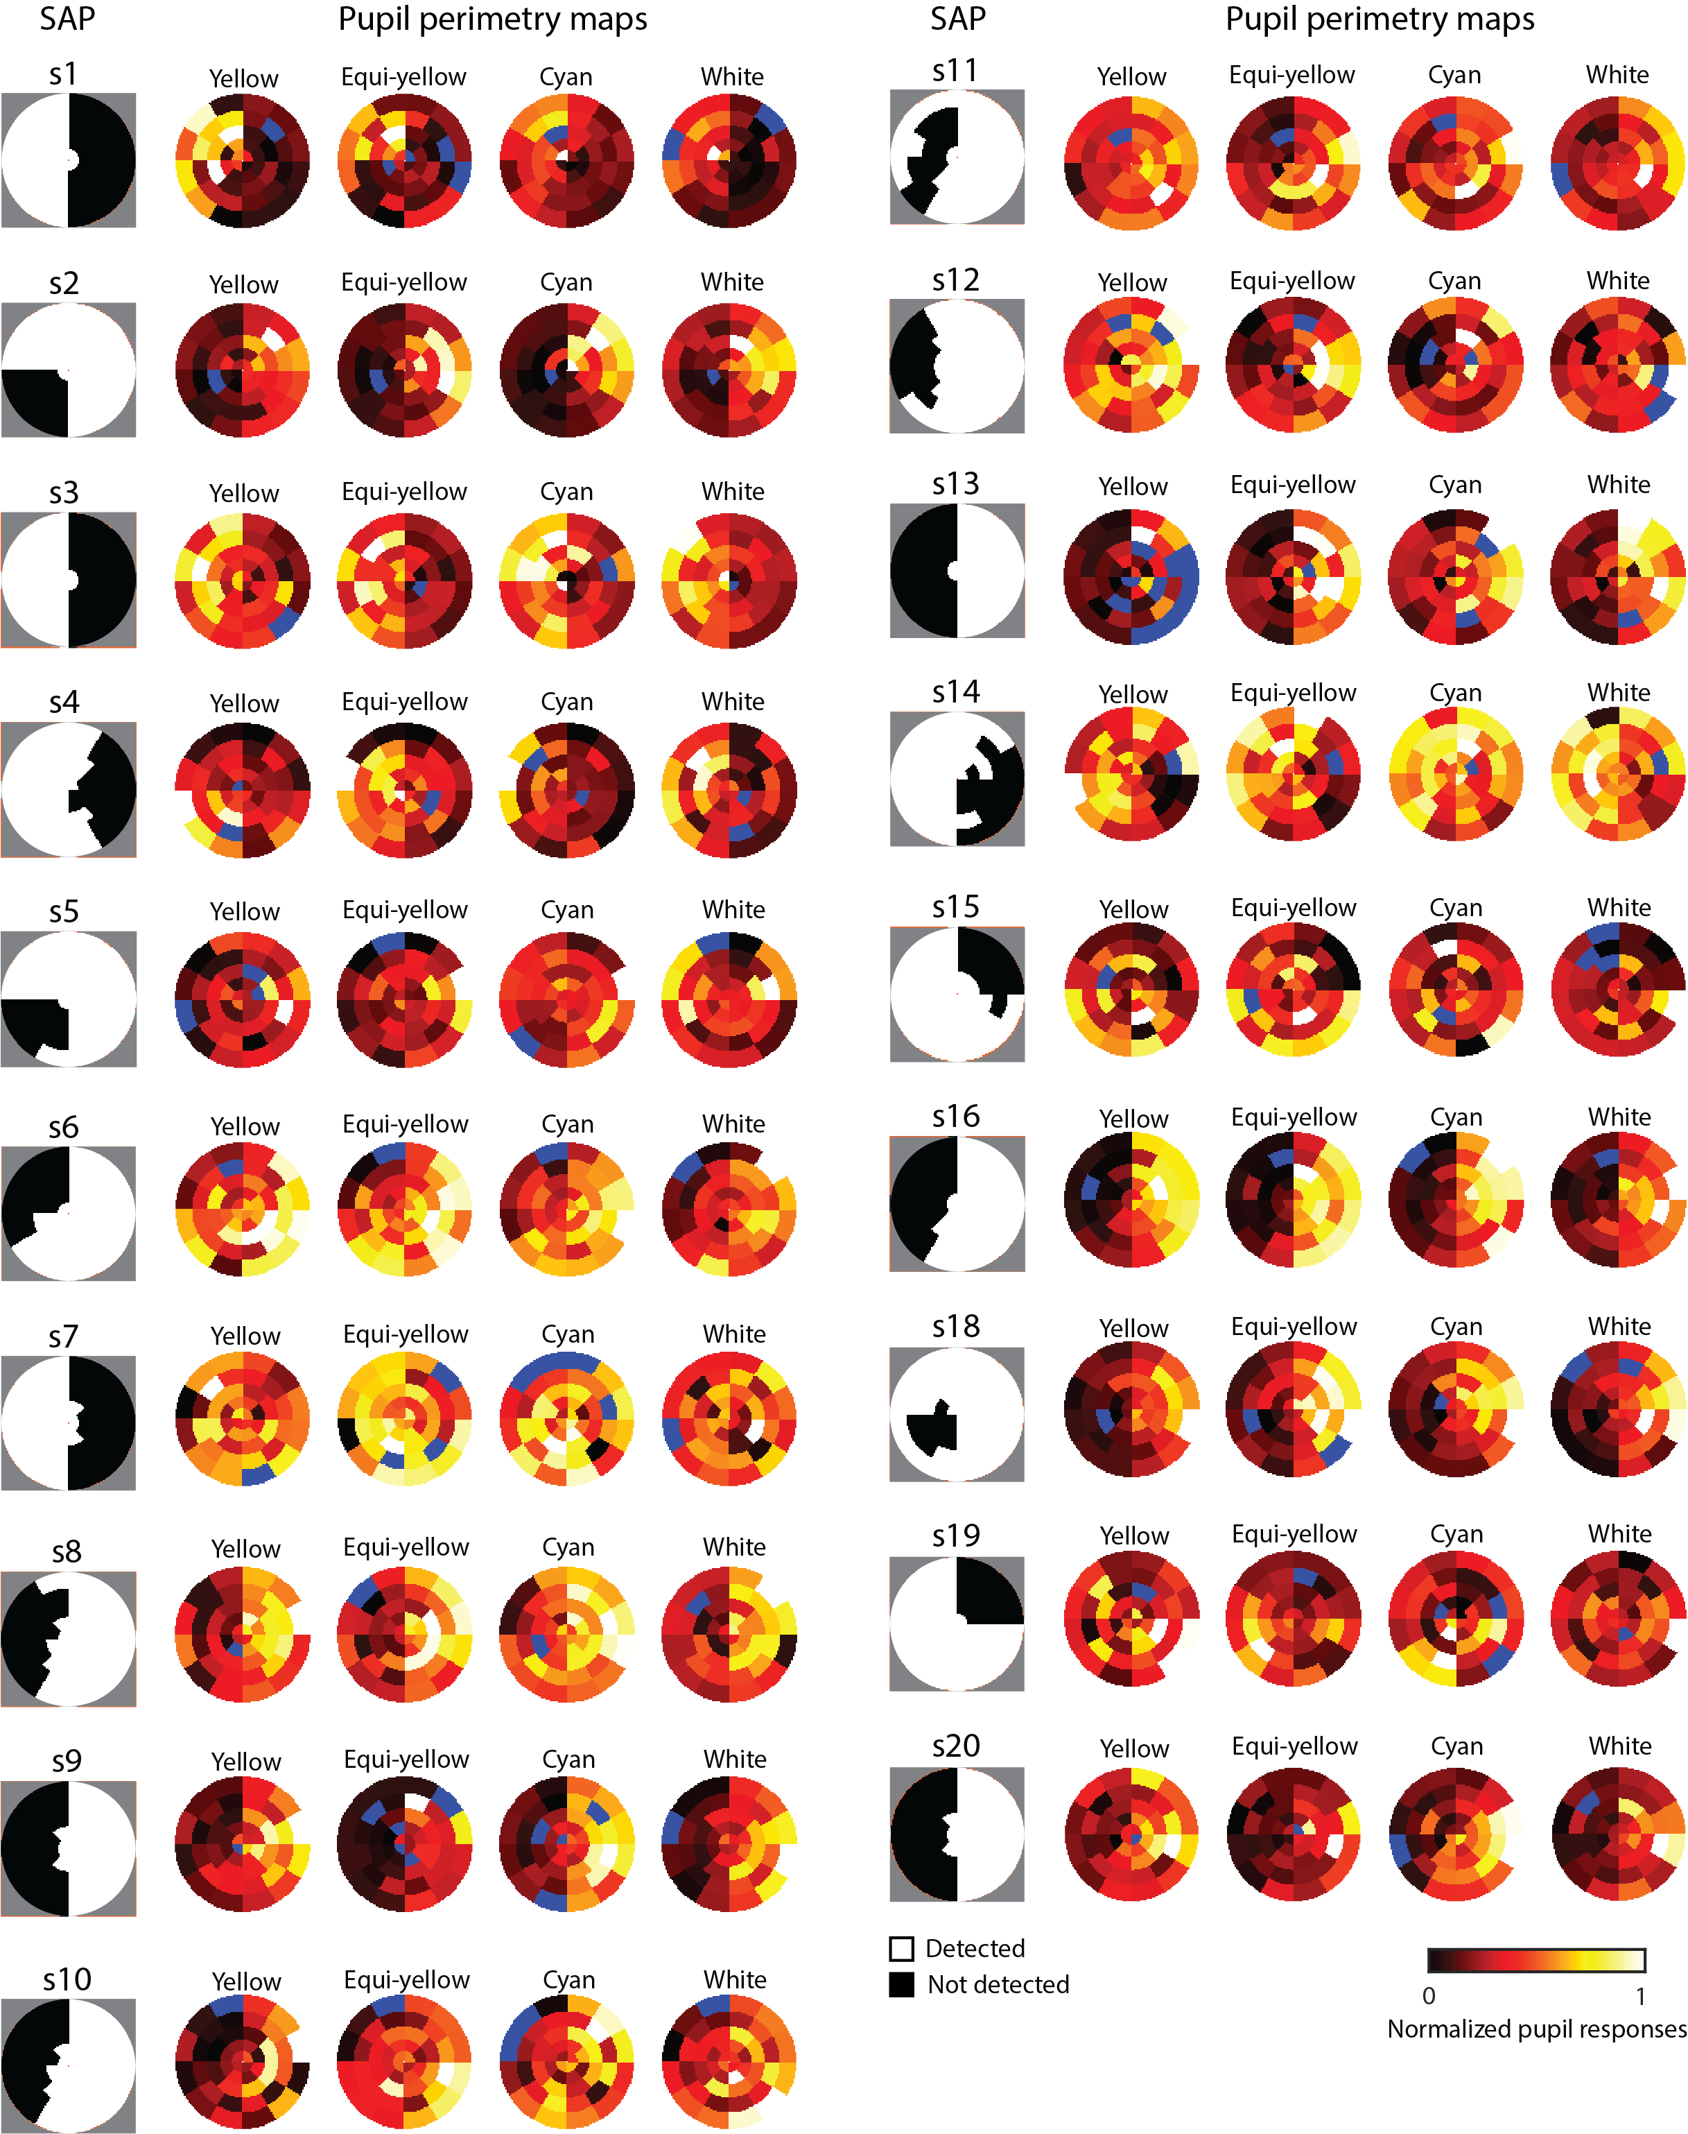
Figure S1. Converted standard automated perimetry (SAP) and normalized pupil perimetry visual field heatmaps (across color conditions) per subject for Experiment 1. The blue wedges in the pupil perimetry maps represent missing trials.

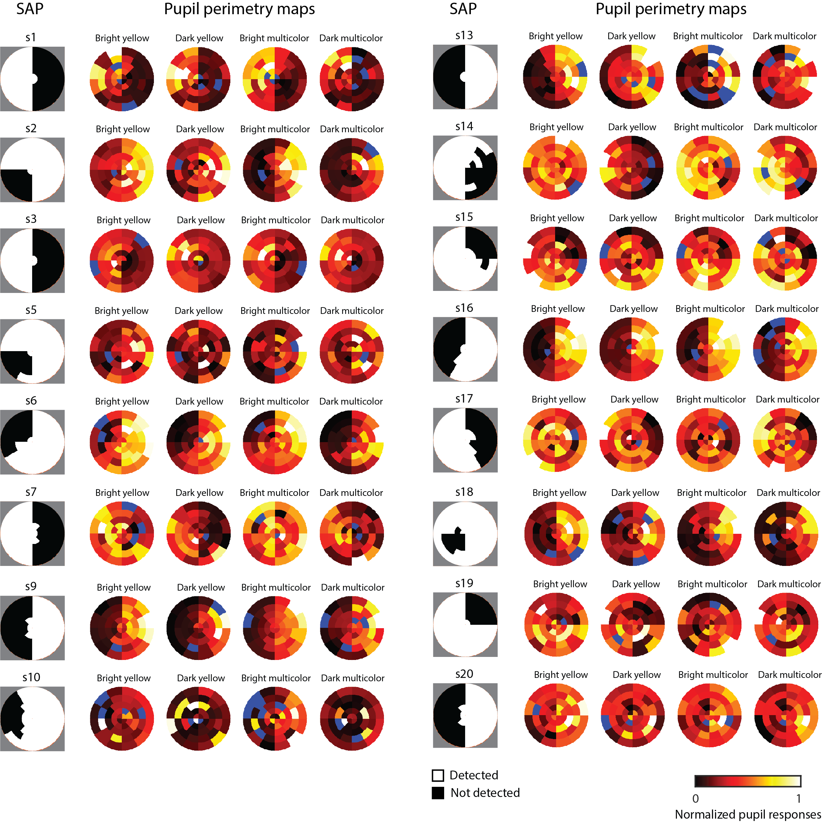
Figure S2. Converted standard automated perimetry (SAP) and normalized pupil perimetry visual field heatmaps (across color conditions) per subject for Experiment 2. The blue wedges in the pupil perimetry maps represent missing trials.

