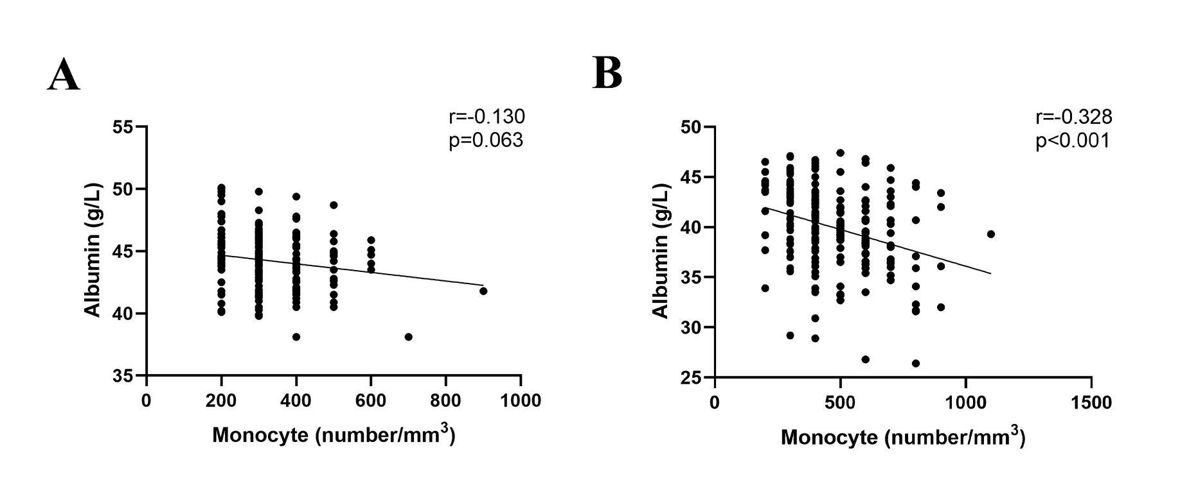
Figure S1: Correlation analysis between monocytes and albumin. (A) healthy controls and (B) NSCLC patients.
Note: P value was calculated by the Spearman correlation analysis. The r value indicates the degree of correlation between the two related indicators.

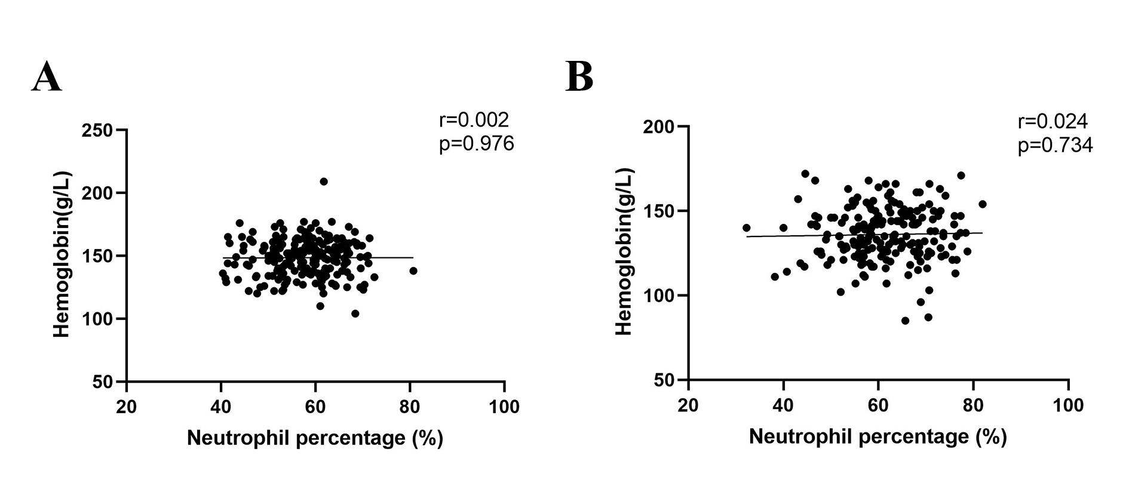

Figure S2: Correlation analysis between neutrophil percentage and hemoglobin. (A) healthy controls and (B) NSCLC patients.
Note: P value was calculated by the Pearson correlation analysis. The r value indicates the degree of correlation between the two related indicators.

