eTable 1. ICD codes used to define dementia in MIMIC-IV database

Codes | version | Long title
2912 | 9 | Alcohol-induced persisting dementia
29410 | 9 | Dementia in conditions classified elsewhere without behavioral disturbance
29411 | 9 | Dementia in conditions classified elsewhere with behavioral disturbance
29420 | 9 | Dementia, unspecified, without behavioral disturbance
29421 | 9 | Dementia, unspecified, with behavioral disturbance
3310 | 9 | Alzheimer's disease
33111 | 9 | Pick's disease
33119 | 9 | Other frontotemporal dementia
3312 | 9 | Senile degeneration of brain
33182 | 9 | Dementia with lewy bodies
33183 | 9 | Mild cognitive impairment, so stated
78093 | 9 | Memory loss
2948 | 9 | Other persistent mental disorders due to conditions classified elsewhere
2900 | 9 | Senile dementia, uncomplicated
29010 | 9 | Presenile dementia, uncomplicated
29011 | 9 | Presenile dementia with delirium
29012 | 9 | Presenile dementia with delusional features
29013 | 9 | Presenile dementia with depressive features
29020 | 9 | Senile dementia with delusional features
29021 | 9 | Senile dementia with depressive features
2903 | 9 | Senile dementia with delirium
29040 | 9 | Vascular dementia, uncomplicated
29041 | 9 | Vascular dementia, with delirium
29042 | 9 | Vascular dementia, with delusions
29043 | 9 | Vascular dementia, with depressed mood
2908 | 9 | Other specified senile psychotic conditions
2909 | 9 | Unspecified senile psychotic condition
2900 | 9 | Senile dementia, uncomplicated
29010 | 9 | Presenile dementia, uncomplicated
29011 | 9 | Presenile dementia with delirium
29012 | 9 | Presenile dementia with delusional features
29013 | 9 | Presenile dementia with depressive features
29020 | 9 | Senile dementia with delusional features
29021 | 9 | Senile dementia with depressive features
2903 | 9 | Senile dementia with delirium
29040 | 9 | Vascular dementia, uncomplicated
29041 | 9 | Vascular dementia, with delirium
29042 | 9 | Vascular dementia, with delusions
29043 | 9 | Vascular dementia, with depressed mood
2908 | 9 | Other specified senile psychotic conditions
2909 | 9 | Unspecified senile psychotic condition
2940 | 9 | Amnestic disorder in conditions classified elsewhere
29410 | 9 | Dementia in conditions classified elsewhere without behavioral disturbance
29411 | 9 | Dementia in conditions classified elsewhere with behavioral disturbance
29420 | 9 | Dementia, unspecified, without behavioral disturbance
29421 | 9 | Dementia, unspecified, with behavioral disturbance
2949 | 9 | Unspecified persistent mental disorders due to conditions classified elsewhere
3310 | 9 | Alzheimer's disease
33111 | 9 | Pick's disease
3312 | 9 | Senile degeneration of brain
3317 | 9 | Cerebral degeneration in diseases classified elsewhere
33182 | 9 | Dementia with lewy bodies
33189 | 9 | Other cerebral degeneration
3319 | 9 | Cerebral degeneration, unspecified
F01 | 10 | Vascular dementia
F015 | 10 | Vascular dementia
F0150 | 10 | Vascular dementia without behavioral disturbance
F0151 | 10 | Vascular dementia with behavioral disturbance
F02 | 10 | Dementia in other diseases classified elsewhere
F028 | 10 | Dementia in other diseases classified elsewhere
F0280 | 10 | Dementia in other diseases classified elsewhere without behavioral disturbance
F0281 | 10 | Dementia in other diseases classified elsewhere with behavioral disturbance
F03 | 10 | Unspecified dementia
F039 | 10 | Unspecified dementia
F0390 | 10 | Unspecified dementia without behavioral disturbance
F0391 | 10 | Unspecified dementia with behavioral disturbance
G310 | 10 | Frontotemporal dementia
G3101 | 10 | Pick's disease
G3109 | 10 | Other frontotemporal dementia
G3183 | 10 | Dementia with Lewy bodies
G3184 | 10 | Mild cognitive impairment, so stated
G311 | 10 | Senile degeneration of brain, not elsewhere classified
G30 | 10 | Alzheimer's disease
G300 | 10 | Alzheimer's disease with early onset
G301 | 10 | Alzheimer's disease with late onset
G308 | 10 | Other Alzheimer's disease
G309 | 10 | Alzheimer's disease, unspecified

Note: There is no decimal point in the “d_icd_diagnoses” table (one table of the MIMIC-IV database).

eTable 2 A Univariate Comparison of Age and GCS (as categorical variables) With and Without Dysphagia in Older Adults With Dementia in Intensive Care Units.

Variable | Overall(n=1009) | No-dysphagia(n=727) | Dysphagia(n=282) | P-value
Age (%) |  |  |  | 0.014*
65 ≤Age < 75 | 146(14.5) | 118(16.2) | 28(9.9)
75 ≤Age < 99 | 863(85.5) | 609(83.8) | 254(90.1)
GCS (%) |  |  |  | <0.001*
13 ≤GCS≤15 | 648 (64.2) | 525 (72.2) | 123 (43.6)
9 ≤GCS ≤ 12 | 195 (19.3) | 116 (16.0) | 79 (28.0)
3 ≤GCS≤ 8 | 166 (16.5) | 86 (11.8) | 80 (28.4)

Note:
⁎Significant differences exist between patients with dementia with dysphagia and without dysphagia (p < 0.05).

eFigure 1 Forest plot for subgroup analysis (based on a univariate Cox proportional-hazards regression model )
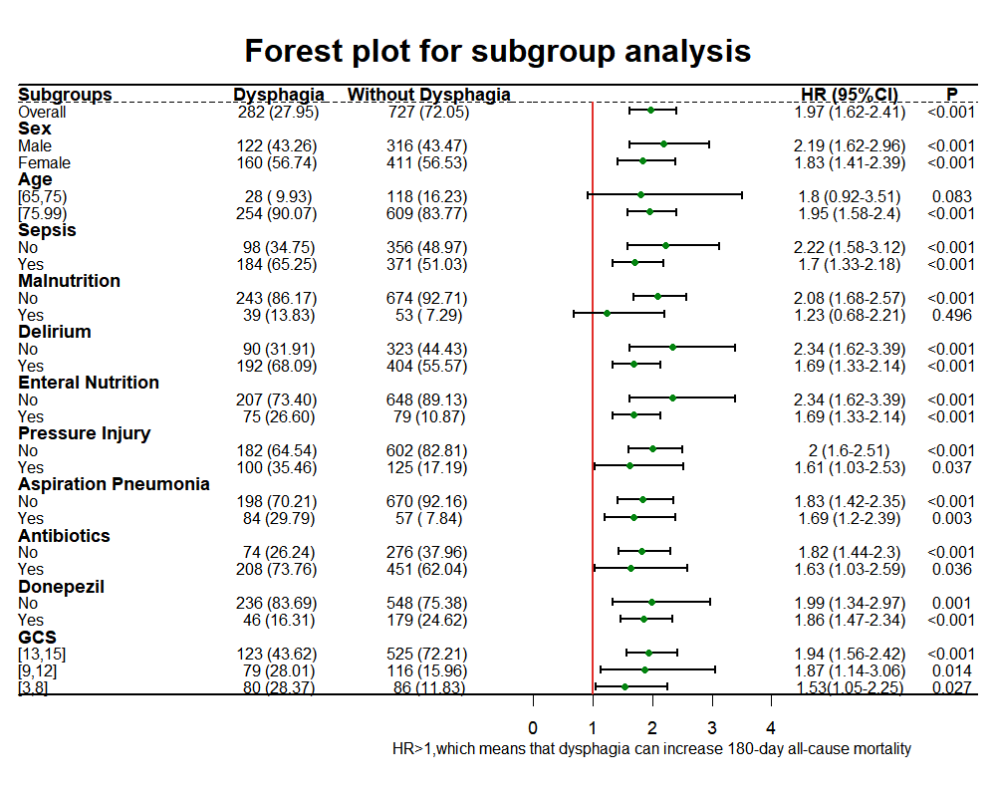
Abbreviations: GCS: Glasgow Coma Score

Note: Subgroup analysis was conducted to explore the association between dysphagia and 180-day all-cause mortality among different subpopulations of older adults with dementia. A p-value of less than 0.05 was considered statistically significant.

