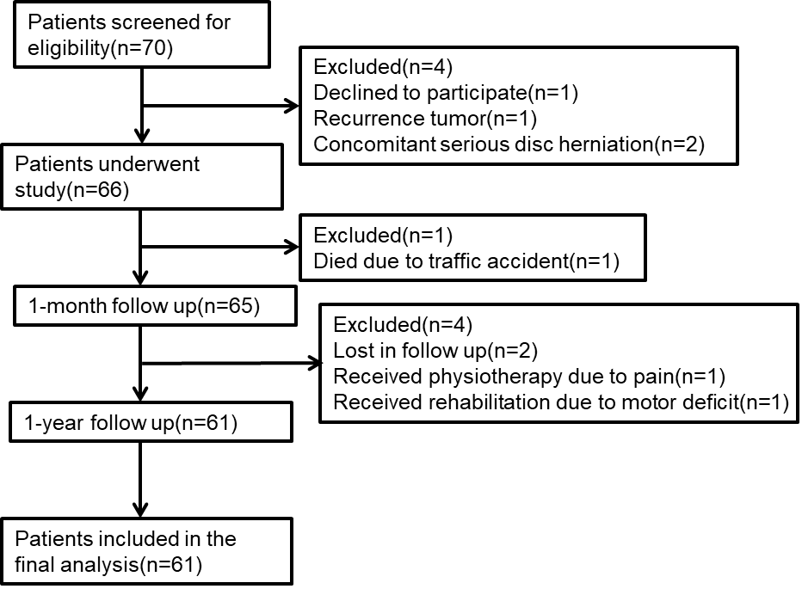

Supplement1. Study flow chart.

