Supplementary Materials
Table S1: List of potential attributes
Adverse event: diarrhea | Need for titration period
Adverse event: nausea | Ease of taking the pill (pill size)
Adverse event: vomiting | Number of pills taken per day
Adverse event: risk of MI | Tested and approved in three indications v one
Adverse event: bleeding | Efficacy (slowdown of disease)
Adverse event: cough | Efficacy (number of exacerbations)
Adverse event: fatigue | Clarity of mechanism of action
Adverse event: photosensitivity reaction | Interaction profile with tobacco products
Adverse event: hepatic enzyme changes | Interaction profile with other drugs or food
Ease of prescription

Table S2: Example patient and caregiver DCE choice set.
Attribute | Drug A | Drug B
Slowdown of disease: How well the treatment slows down the progression of IPF | Disease progression reversed | Disease progression unchanged
Survival: Whether the treatment has an impact on life expectancy | No survival benefit | No survival benefit
Number of exacerbations: Whether the treatment has an impact on the number of IPF exacerbations experienced | Reduction in number of exacerbations | Reduction in number of exacerbations
Adverse event – diarrhea: Whether the treatment causes diarrhea, and, if so, the impact of diarrhea on daily life | Severe diarrhea, or hard to manage in daily life | Severe diarrhea, or hard to manage in daily life
Adverse event – sun sensitivity: Whether the treatment causes sun sensitivity, and, if so, the impact of sun sensitivity on daily life | Sun sensitivity that restricts outside activities by time-of-day despite sun cream and clothing | Sun sensitivity that restricts outside activities by time-of-day despite sun cream and clothing
Adverse event – nausea: whether the treatment causes nausea, and, if so, the impact of nausea reaction on daily life | Severe nausea, or hard to manage in daily life | Mild or moderate nausea, but manageable in daily life

Table S3: Example pulmonologist DCE choice set.
Attribute | Drug A | Drug B
Slowdown of disease: How well the treatment slows down the progression of IPF | Improvement of lung function | Stabilization of lung function
Number of exacerbations: Whether the treatment has an impact on the number of IPF exacerbations experienced | Exacerbation despite treatment | No exacerbation
Adverse event – gastro-intestinal effects: Whether the treatment causes diarrhea and nausea, and, if so, the impact of diarrhea on daily life | GI effects causing a large impact on quality of life but patient feels better with reduced dose | GI effects causing a large impact on quality of life and discontinuation of medication
Adverse event – photosensitivity reaction: Whether the treatment causes photosensitivity reaction, and, if so, the impact of photosensitivity reaction on daily life | Photosensitivity reaction, but low impact on daily life and continuation of medication | Photosensitivity reaction, causing a large impact on quality of daily life and patient feels better with a reduced dose
Initial prescription and titration period: How simple the initial prescription period is for a treatment, and whether it requires a titration period | Straight-forward titration period and only one dosage | No titration period and only one dosage

Figure S1: Univariate analysis: Patient DCE coefficients by sex.
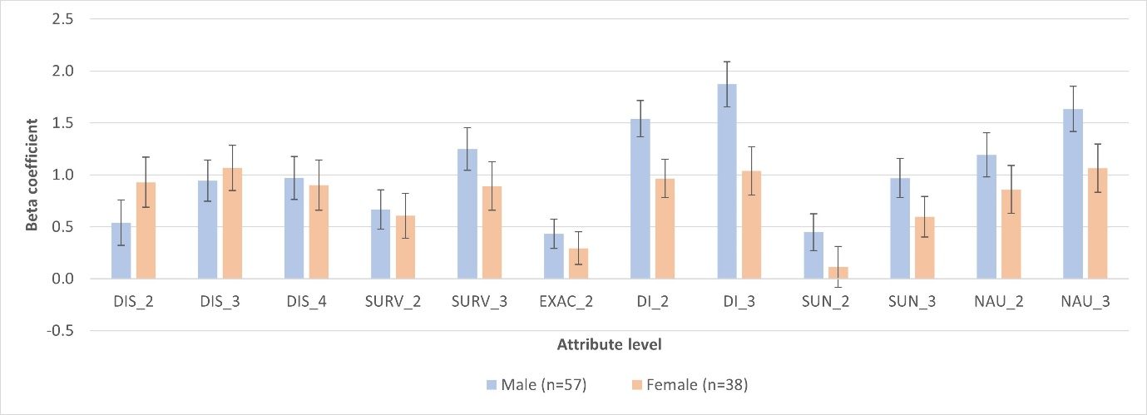
Figure S1: DI_2 mild or moderate diarrhea, manageable daily life; DI_3 no diarrhea; DIS_2 disease progression slower; DIS_3 disease progression stopped; DIS-4 disease progression reversed; EXAC_2, reduction in exacerbations; F, female M, male; NAU_2, mild or moderate nausea but manageable daily life; NAU_3, no nausea; SUN_2, sun sensitivity manageable with sun cream/clothing; SUN_3, no sun sensitivity; SURV_2, Up to one year longer life; SURV_3 more than one year longer life.

Figure S2: Univariate analysis: Patient DCE coefficients by age category.
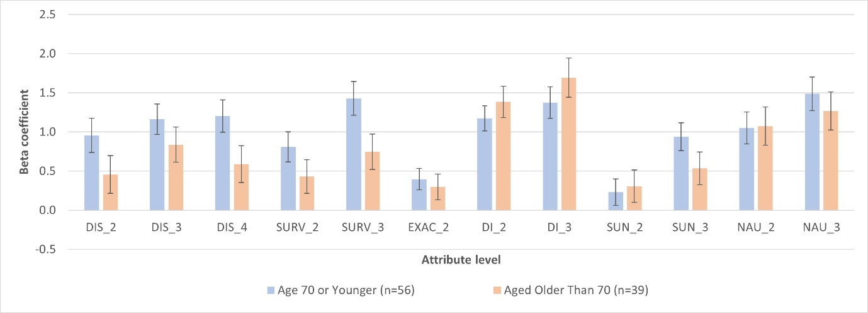
Figure S2: DI_2 mild or moderate diarrhea, manageable daily life; DI_3 no diarrhea; DIS_2 disease progression slower; DIS_3 disease progression stopped; DIS-4 disease progression reversed; EXAC_2, reduction in exacerbations; NAU_2, mild or moderate nausea but manageable daily life; NAU_3, no nausea; SUN_2, sun sensitivity manageable with sun cream/clothing; SUN_3, no sun sensitivity; SURV_2, Up to one year longer life; SURV_3 more than one year longer life.

Figure S3: Univariate analysis: Patient DCE coefficients by current antifibrotic medication.
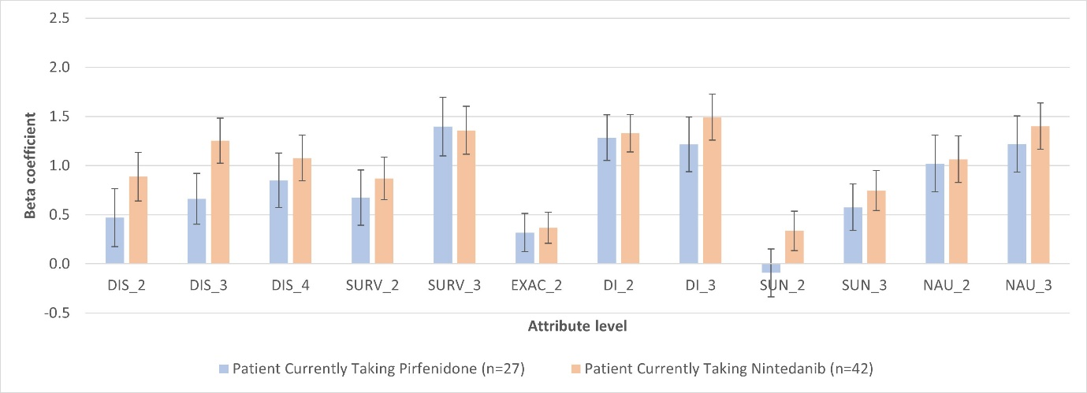
Figure S3: DI_2 mild or moderate diarrhea, manageable daily life; DI_3 no diarrhea; DIS_2 disease progression slower; DIS_3 disease progression stopped; DIS-4 disease progression reversed; EXAC_2, reduction in exacerbations; NAU_2, mild or moderate nausea but manageable daily life; NAU_3, no nausea; SUN_2, sun sensitivity manageable with sun cream/clothing; SUN_3, no sun sensitivity; SURV_2, Up to one year longer life; SURV_3 more than one year longer life.
Figure S4: Univariate analysis: Patient DCE coefficients by disease severity.
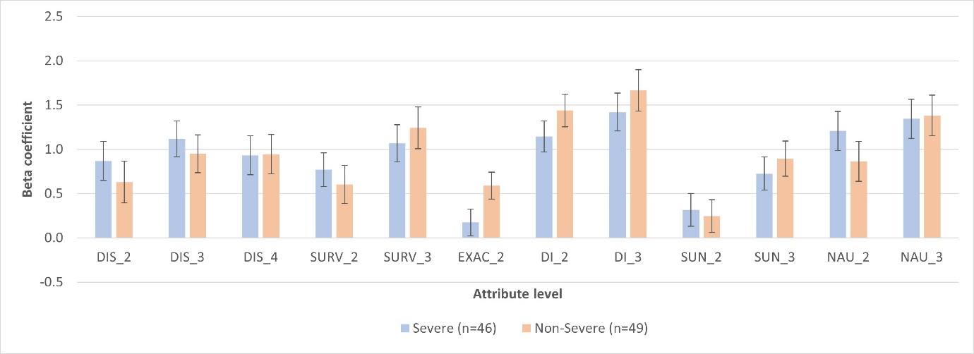
Figure S4: DI_2 mild or moderate diarrhea, manageable daily life; DI_3 no diarrhea; DIS_2 disease progression slower; DIS_3 disease progression stopped; DIS-4 disease progression reversed; EXAC_2, reduction in exacerbations; NAU_2, mild or moderate nausea but manageable daily life; NAU_3, no nausea; NS, not severe; S, severe; SUN_2, sun sensitivity manageable with sun cream/clothing; SUN_3, no sun sensitivity; SURV_2, Up to one year longer life; SURV_3 more than one year longer life.

