S1. Cytotoxicity evaluated by a CCK-8 method
The cytotoxicity of the CM-ICG-hybrid hydrogel on B16F10 cells with or without an 808nm near infrared laser irradiation was detected via a CCK-8 method according to the manufacture’s instruction. Briefly, B16F10 cells were seeded into a 48-well plate at a density of 3×10⁴ cells/well. 24 hours later, 100 μL of PBS, free ICG aqueous solution, free CM solution, blank hybrid hydrogel, ICG-hybrid hydrogel, CM-hybrid hydrogel and CM-ICG-hybrid hydrogel were added to each well respectively. Next, the cells were divided into laser treatment groups and the non-laser treatment groups. For the laser treatment groups, the cells were irradiated with an 808 nm (2.3 W·cm⁻²) near infrared laser for 5 minutes. While for the non-laser treatment groups, no procedures were undertaken. 24 hours later, the supernatant was discarded and the cells were washed with PBS gently before 100 μL of DMEM medium and 10 μL of CCK-8 reagent were added. After incubation at 37 °C for 2 hours, the OD value of each well at 450 nm was measured via an MK3 microplate reader (Thermo, USA). Finally, the cell viability was calculated according to the following formula:
$$Cell viability=({OD}_{experimental group}-{OD}_{blank control})/({OD}_{DMEM group}-{OD}_{blank control})×100\%$$

S2. Cytotoxicity evaluated by a Calcein-AM/PI kit
The cytotoxicity of the CM-ICG-hybrid hydrogel on B16F10 cells with or without an 808nm near infrared laser irradiation was detected via a Calcein-AM/PI kit according to the manufacture’s instruction Briefly, B16F10 cells were seeded into a 96-well plate at a density of 1×10⁴ cells/well. 24 hours later, 100 μL of PBS, free ICG aqueous solution, free CM solution, blank hybrid hydrogel, ICG-hybrid hydrogel, CM-hybrid hydrogel and CM-ICG-hybrid hydrogel were added to each well respectively. Next, the cells were divided into laser treatment groups and the non-laser treatment groups. For the laser treatment groups, the cells were irradiated with a 808 nm (2.3 W·cm⁻²) near infrared laser for 5 minutes. While for the non-laser treatment groups, on procedures were undertaken. 24 hours later, the supernatant was discarded and Calcein-AM/PI mixed staining solution was added. After being incubated at 37°C for 15 minutes in the dark, the cells were gently rinsed with PBS. The images of the cells were observed and captured with an Eclipse Ci upright optical microscope (Nikon, Japan) and the viability of cells were calculated based on the staining result.
S3. Preparation of carbomer hydrogel
The hybrid hydrogel was prepared via swelling method. The carbomer powder was weighed and mixed with deionized water with a ratio of 1:100, which was fully swollen overnight. Adjusted the pH to 6 ~ 8. 50 μL of indocyanine green (ICG) aqueous solution (50 mg/mL) and 100 μL of CM suspension (protein concentration was 166.7 μg/mL) were mixed before being added into 1 mL of the carbomer hydrogel, which was subsequently shaken (4°C, 200 rpm) in dark for 8 h until a uniformly colored CM-ICG-carbomer hydrogel was obtained.
S4. Melanoma cell proliferation analysis
The effect of CM-ICG-hybrid hydrogel on melanoma cell proliferation was analyzed by a ki-67 immunohistochemistry detection kit according to the manufacture’s instruction. Briefly, 3 days after the hydrogel injection, tumors were surgically collected and immersed in a 4% paraformaldehyde solution for 24 hours. After dehydration and being embedded in the paraffin, the organs were sectioned with an RM2016 pathological microtome (Shanghai Leica Instrument Co., Ltd., China). The antigen in the specimens were retrieved in a citrate buffer (pH=6) and washed with PBS for three times before being placed in a 3% hydrogen peroxide solution to block the endogenous peroxidase. 25 minutes later, the specimens were washed with PBS for three times before 3% BSA was added to cover the tissue evenly. 30 minutes later, the BSA solution was replaced with primary antibody and incubated overnight at 4°C in a humidified box. The secondary antibody was mounted on the specimen before they were washed with PBS for three times. Next, the specimens were stained with freshly prepared DAB solution and hematoxylin before being sealed with neutral gum. The image of the specimens was captured by an Axio Vert A1 inverted fluorescence microscope (Zeiss, Germany).
S5. Melanoma cell apoptosis analysis
The effect of CM-ICG-hybrid hydrogel on melanoma cell apoptosis was analyzed by a TUNEL immunohistochemistry detection kit based on the manufacture’s instruction. Briefly, 3 days after the hydrogel injection, tumors were surgically collected and immersed in a 4% paraformaldehyde solution for 24 hours. After dehydration and being embedded in the paraffin, the tumors were sectioned with an RM2016 pathological microtome (Shanghai Leica Instrument Co., Ltd., China). The antigen in the specimen were retrieved in a citrate buffer (pH=6) and washed with PBS for three times. The specimens were mounted with proteinase K solution for 20 minutes and then rinsed with Tween 20 in PBS for 5 minutes. Subsequently, the specimens were quenched with 3% of hydrogen peroxide solution for 20 minutes and allowed to equilibrate with Terminal deoxynucleotidyl transferase (TdT) buffer for 1 hour before being washed with PBS for 3 times. Next, streptavidin-HRP and TBST mixed solution (1:200) was mounted on the specimens and incubated in 37 °C for 30 min before being washed with PBS for three times. Finally, the specimens were stained with freshly prepared DAB solution and hematoxylin before being sealed with neutral gum. The labeling was visualized by an Axio Vert A1 inverted fluorescence microscope (Zeiss, Germany).
S6. IFN-γ and TNF-α
The peripheral blood was collected into a sterile anticoagulant tube 7 days after the hydrogel injection. An ELISA kit was used to detect IFN-γ and TNF-α in the blood based on the manufacturer’s instructions. Briefly, the blood was centrifuged at 1000 g for 20 min to obtain the serum in the supernatant. 100 μL of the serum was added to the sample well and incubated for 90 min in a 37°C incubator. Next, the solution in each well was replaced with 100 μL of bioplasticized antibody working solution and incubated in a 37°C incubator. 60 minutes later, the liquid in the plate was discarded and the wells were washed with 350 μL of washing solution for three times. 100 μL of HRP enzyme conjugate working solution was subsequently added to each well and incubated in a 37°C incubator. 30 minutes later, the liquid in the plate was discarded and the plate was washed with washing solution for five times before 90 μL of substrate solution was added and incubated in 37℃ for 15 minutes. Finally, 50 μL of stop solution was added and the OD value of each well at a wavelength of 450 nm was examined via a MK3 microplate reader (Thermo, USA) and the IFN-γ and TNF-α level was calculated based on the standard curve.
S7. T cells in the spleen
The immune activation effect of CM-ICG-hybrid hydrogel was evaluated by analyzing the T cells in spleen. Briefly, the mice were sacrificed by cervical dislocation on the third day and the spleens were collected and washed with PBS containing 2% FBS. After being triturated, the spleen debris was filtered through a 70 μm cell strainer to prepare a single cell suspension. After centrifugation, 1 mL of erythrocyte lysate was added and incubated at 4°C for 2 minutes in the dark. The sample was subsequently centrifuged at 400 g for 5 minutes before 9 mL of PBS buffer was added to stop the lysis of the red blood cells. The erythrocyte lysate was removed by centrifugation before the spleen cells were filtered through a 70 μm cell mesh. After adjusting the cell concentration to 2×10⁶ cells/mL, anti-CD3-APC, anti-CD4-FITC, and anti-CD8-PE mixed dye solution were added into 100 μL of the cell suspensions and incubated at 4°C for 30 minutes in the dark. After washed with PBS and resuspended with 500 μL flow buffer. The proportion of effector T cells in the spleen was analyzed with a flow cytometer (BD FACSAria III, USA).
S8. T-cell infiltration in distal tumors
The mice were sacrificed by cervical dislocation 21 days after the second tumor inoculation and the tumors were collected and divided into two parts. One part was for flow cytometry analysis, another was for immunofluorescence staining. The specific procedures were described in the supplementary materials.
The flow cytometry analysis part was washed with PBS containing 2% FBS before being triturated. Next, it was digested Enzyme D, Enzyme R and Enzyme A and filtered through a 70 μm cell mesh to obtain a tumor single cell suspension. After adjusting the cell concentration to 2×10⁶ cells/mL with RPMI 1640 medium, anti-CD3-APC, anti-CD4-FITC, and anti-CD8-PE mixed dye solution were added into 100 μL of the cell suspensions and incubated at 4°C for 30 minutes in the dark. After washed with PBS and resuspended with 500 μL flow buffer. The proportion of effector T cells and helper T cells in the spleen was analyzed with a flow cytometer (BD FACSAria III, USA).
The immunofluorescence staining part was immersed in a 4% paraformaldehyde solution for 24 hours. After dehydration and being embedded in the paraffin, the tumors were sectioned with an RM2016 pathological microtome (Shanghai Leica Instrument Co., Ltd., China). Next, the sections were dewaxed and subject to antigen retrieval in an EDTA buffer (pH 8.0). After incubation in a blocking buffer (3% BSA) for 1 hour, the specimens were incubated in primary antibody overnight at 4 °C. Next, the specimens were rinsed with PBS for three times before CY3-TSA was added. After washing the slides 3 times with PBS, the mounting medium with DAPI was applied on the top of the specimens for 5 minutes and a cover slip was carefully applied to each slide. The labeling was visualized by a Nikon Eclipse Ti microscope (Nikon Corporation, Japan). The relative fluorescence intensity of each channel and the proportion of cells were analyzed by Image J.
S9. Memory T cell analysis
The mice were sacrificed by cervical dislocation 21 days after the second tumor inoculation and the spleens were collected and washed with PBS containing 2% FBS. After being triturated, the spleen debris was filtered through a 70 μm cell strainer to prepare a single cell suspension. After centrifugation, 1 mL of erythrocyte lysate was added and incubated at 4°C for 2 minutes in the dark. The sample was subsequently centrifuged at 400 g for 5 minutes before 9 mL of PBS buffer was added to stop the lysis of the red blood cells. The erythrocyte lysate was removed by centrifugation before the spleen cells were filtered through a 70 μm cell mesh. After adjusting the cell concentration to 2×10⁶ cells/mL, anti-CD8-percp/cy5.5, anti-CD44-FITC, anti-CD62L-PE mixed dye solution were added into 100 μL of the cell suspensions and incubated at 4°C for 30 minutes in the dark. After washed with PBS and resuspended with 500 μL flow buffer. The proportion of memory T cells in the spleen was analyzed with a flow cytometer (BD FACSAria III, USA).

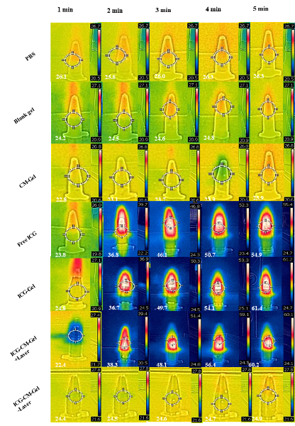

Figure S1. The in vitro photothermal conversion property of different groups.

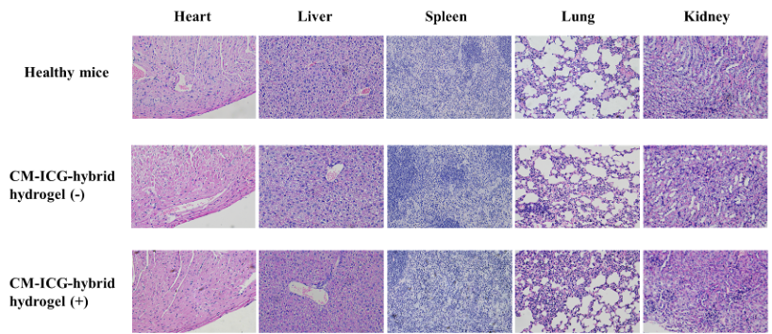

Figure S2. The in vivo safety of the CM-ICG-hybrid hydrogel.

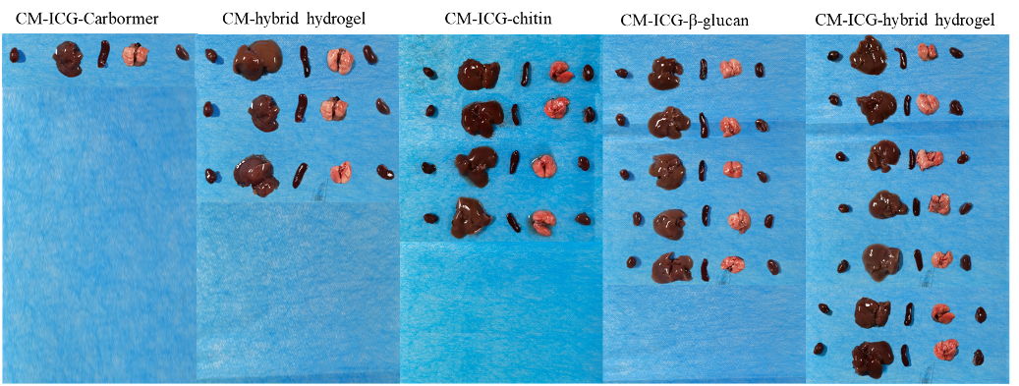

Figure S3. The observation of the metastasis of the melanoma in major organs in different groups after the 60-day survival test.

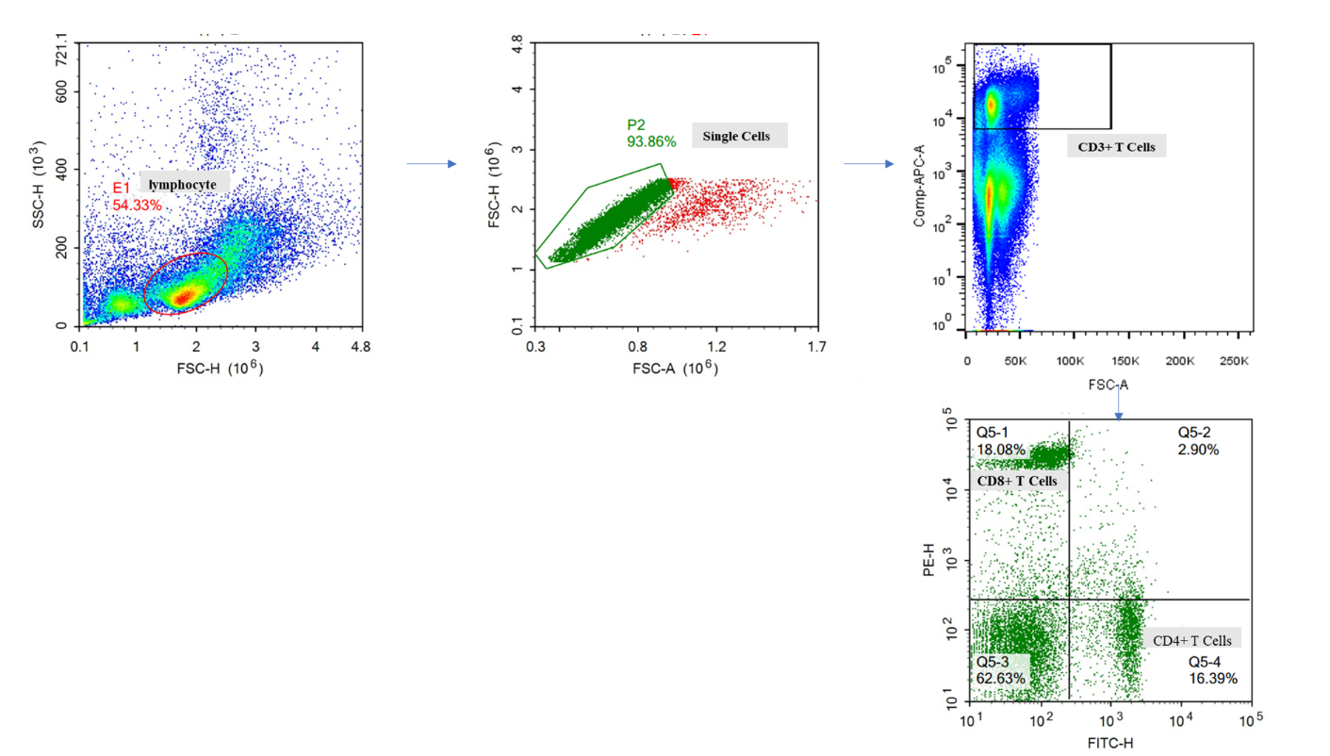
Figure S4. The gating strategy for tumor analysis.

