Table S1. Serum concentrations of Osteopontin, KL-6, Syndecan-4, and Gremlin-1.
Biomarkers | HCs (N=100) | DEWs (N=100) | CWPs (N=200) | CWPs
Biomarkers | HCs (N=100) | DEWs (N=100) |  | Stage I (N=111) | Stage II (N=35) | Stage III (N=54)
Osteopontin, ng/ml | 6.39±2.75 | 10.33±2.69* | 13.48±2.81*# | 13.75±2.88 | 12.48±2.34 | 13.58±2.84
KL-6, U/ml | 433.40±154.71 | 571.57±170.01* | 785.22±185.93*# | 777.21±188.02 | 818.41±126.53 | 780.18±212.78
Syndecan-4, ng/ml | 4.03±1.24 | 5.84±1.72* | 6.73±1.45*# | 6.66±1.44 | 6.82±1.02 | 6.81±1.72
Gremlin-1, ng/ml | 703.60±197.05 | 1003.33±235.81* | 1054.03±232.66* | 1057.04±224.59 | 1027.94±250.50 | 1064.76±240.24
p value was computed by Kruskal–Wallis test among HCs, DEWs, and CWPs. *Compared with HCs, p < 0.05; #Compared with DEWs, p < 0.05.
p value was computed by Kruskal–Wallis test among different stage of CWPs in Osteopontin, KL-6, Syndecan-4 and Gremlin-1. All p > 0.05.

Table S2. Correlations between biomarkers and clinical-/biological features in DEW patients.
Variables | Osteopontin | KL-6 | Syndecan-4 | Gremlin-1 | FVC | FEV1 | FEV1/FVC
Osteopontin | 1.00 | 0.10 | 0.21* | 0.02 | 0.07 | 0.05 | -0.05
KL-6 | 0.10 | 1.00 | 0.75** | 0.48** | -0.05 | -0.08 | -0.03
Syndecan-4 | 0.21* | 0.75* | 1.00 | 0.56* | -0.03 | -0.06 | -0.10
Gremlin-1 | 0.02 | 0.48** | 0.56* | 1.00 | -0.01 | -0.06 | -0.14
** p<0.01, * p<0.05.

Table S3. Correlations between biomarkers and clinical-/biological features in CWP patients.
Variables | Osteopontin | KL-6 | Syndecan-4 | Gremlin-1 | FVC | FEV1 | FEV1/FVC
Osteopontin | 1.00 | 0.07 | 0.03 | 0.12 | -0.03 | -0.04 | -0.04
KL-6 | 0.07 | 1.00 | 0.53** | 0.27** | -0.02 | 0.01 | 0.03
Syndecan-4 | 0.03 | 0.53** | 1.00 | 0.32** | -0.07 | -0.03 | 0.04
Gremlin-1 | 0.12 | 0.27** | 0.32** | 1.00 | -0.05 | -0.01 | 0.04
** p<0.01

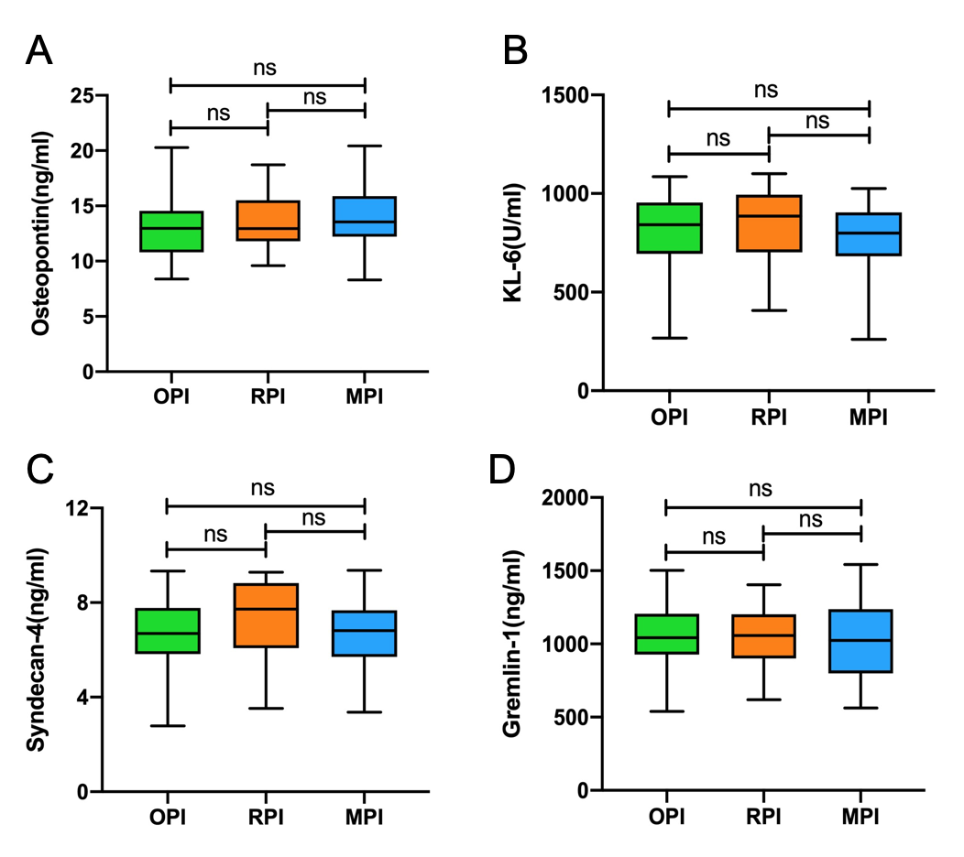
Figure S1. Comparison of serum concentrations of biomarkers among the OPI, RPI and MPI groups in CWP patients. A. Osteopontin; B. KL-6; C. Syndecan-4; D. Gremlin-1. Bars represent median with interquartile 25-75, min-maximum. OPI: obstructive pattern of impairment; RPI: restrictive pattern of impairment; MPI: mixed pattern of impairment; ns: no significant.

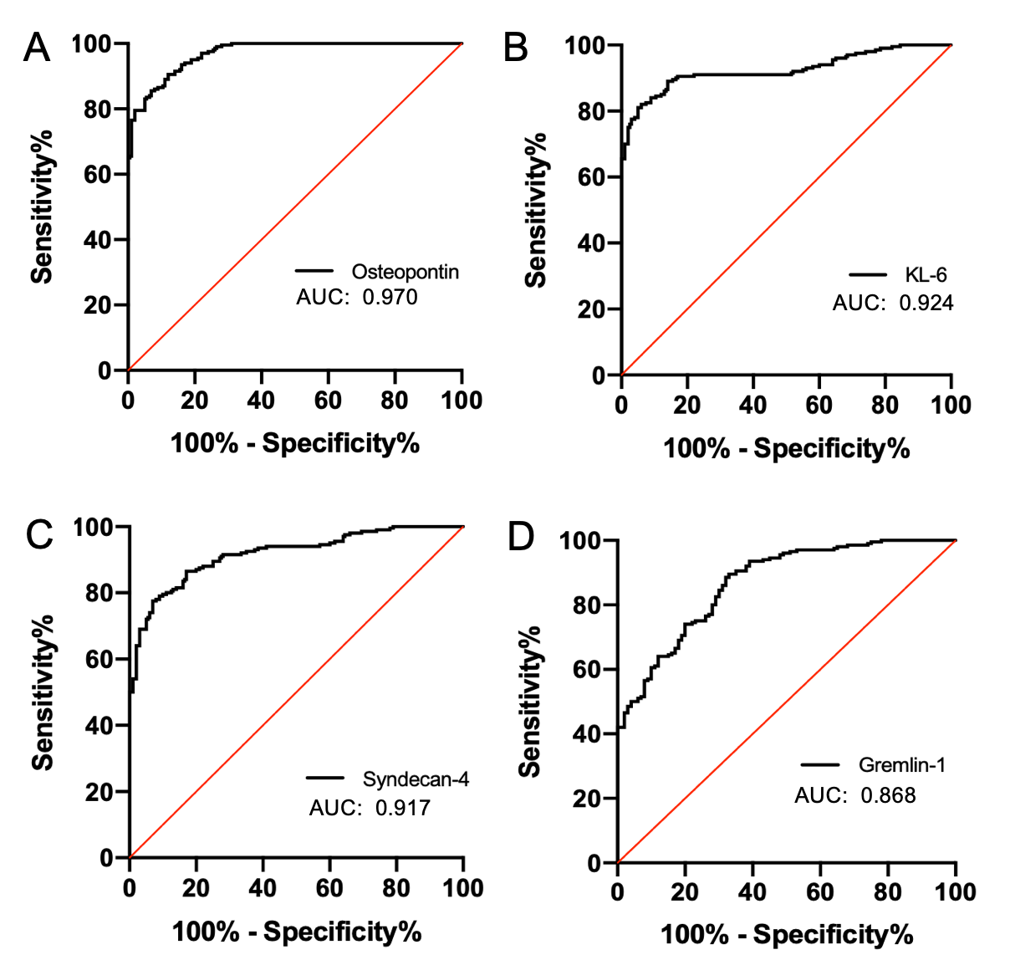
Figure S2. ROC curve analysis for biomarkers to differentiate patients with CWP from healthy controls. A. Osteopontin; B. KL-6; C. Syndecan-4; D. Gremlin-1.

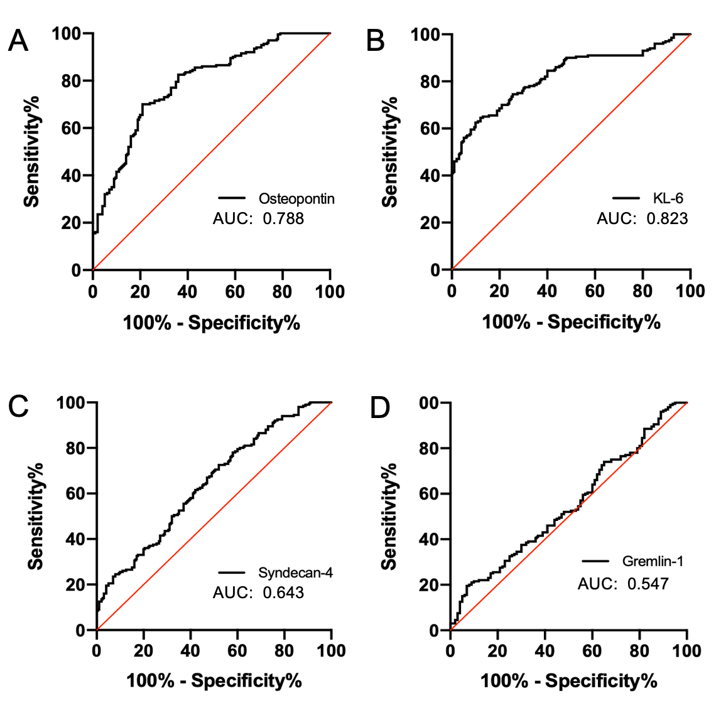
Figure S3. ROC curve analysis for biomarkers to differentiate patients with CWP from DEWs. A. Osteopontin; B. KL-6; C. Syndecan-4; D. Gremlin-1.

