Supplementary Material
Supplementary Table 1. The correlation matrix of ADHD-Cognition network based on parent ratings
 | VCI | PRI | WMI | PSI | IS | HIS | ODD | CD | MD | AI | RI
VCI |  | 0.38 | 0.13 | 0.06 | 0.00 | 0.00 | 0.00 | 0.00 | -0.02 | -0.08 | 0.00
PRI | 0.38 |  | 0.26 | 0.07 | 0.00 | 0.00 | 0.00 | 0.00 | 0.00 | -0.12 | 0.00
WMI | 0.13 | 0.26 |  | 0.11 | 0.00 | 0.00 | 0.00 | 0.00 | 0.00 | -0.16 | 0.00
PSI | 0.06 | 0.07 | 0.11 |  | -0.10 | 0.00 | 0.00 | 0.00 | 0.00 | -0.07 | 0.00
IS | 0.00 | 0.00 | 0.00 | -0.10 |  | 0.32 | 0.03 | 0.00 | 0.01 | 0.05 | 0.09
HIS | 0.00 | 0.00 | 0.00 | 0.00 | 0.32 |  | 0.11 | 0.10 | 0.00 | 0.00 | 0.00
ODD | 0.00 | 0.00 | 0.00 | 0.00 | 0.03 | 0.11 |  | 0.35 | 0.09 | 0.00 | 0.27
CD | 0.00 | 0.00 | 0.00 | 0.00 | 0.00 | 0.10 | 0.35 |  | 0.03 | 0.00 | 0.10
MD | -0.02 | 0.00 | 0.00 | 0.00 | 0.01 | 0.00 | 0.09 | 0.03 |  | 0.07 | 0.19
AI | -0.08 | -0.12 | -0.16 | -0.07 | 0.05 | 0.00 | 0.00 | 0.00 | 0.07 |  | 0.04
RI | 0.00 | 0.00 | 0.00 | 0.00 | 0.09 | 0.00 | 0.27 | 0.10 | 0.19 | 0.04
Abbreviations: VCI, Verbal comprehension index; PRI, Perceptual reasoning index; WMI, Working memory index; PSI, Processing speed index; IS, Inattention symptoms; HIS, Hyperactivity/impulsivity symptoms; ODD, Oppositional defiant disorder; CD, Conduct disorder; MD, Mood disorder; AI, Academic impairment; RI, Relationship impairment.
Supplementary Table 2. The correlation matrix of ADHD-Cognition network based on teacher ratings
 | VCI | PRI | WMI | PSI | IS | HIS | ODD/CD | MD | AI | CBI
VCI |  | 0.38 | 0.16 | 0.08 | -0.03 | 0.00 | 0.00 | -0.16 | -0.13 | -0.03
PRI | 0.38 |  | 0.28 | 0.06 | 0.00 | 0.06 | 0.00 | -0.04 | -0.06 | 0.00
WMI | 0.16 | 0.28 |  | 0.12 | 0.00 | 0.00 | 0.00 | 0.00 | -0.08 | 0.00
PSI | 0.08 | 0.06 | 0.12 |  | -0.02 | 0.00 | 0.00 | 0.00 | -0.12 | 0.00
IS | -0.03 | 0.00 | 0.00 | -0.02 |  | 0.12 | 0.11 | 0.08 | 0.06 | 0.47
HIS | 0.00 | 0.06 | 0.00 | 0.00 | 0.11 |  | 0.44 | -0.03 | 0.00 | 0.18
ODD/CD | 0.00 | 0.00 | 0.00 | 0.00 | 0.11 | 0.44 |  | 0.15 | 0.00 | 0.11
MD | -0.16 | -0.04 | 0.00 | 0.00 | 0.08 | -0.03 | 0.15 |  | 0.00 | 0.00
AI | -0.13 | -0.06 | -0.08 | -0.12 | 0.06 | 0.00 | 0.00 | 0.00 |  | 0.15
CBI | -0.03 | 0.00 | 0.00 | 0.00 | 0.47 | 0.18 | 0.11 | 0.00 | 0.15
Abbreviations: VCI, Verbal comprehension index; PRI, Perceptual reasoning index; WMI, Working memory index; PSI, Processing speed index; IS, Inattention symptoms; HIS, Hyperactivity/impulsivity symptoms; ODD, Oppositional defiant disorder; CD, Conduct disorder; MD, Mood disorder; AI, Academic impairment; CBI, Class behavior impairment.

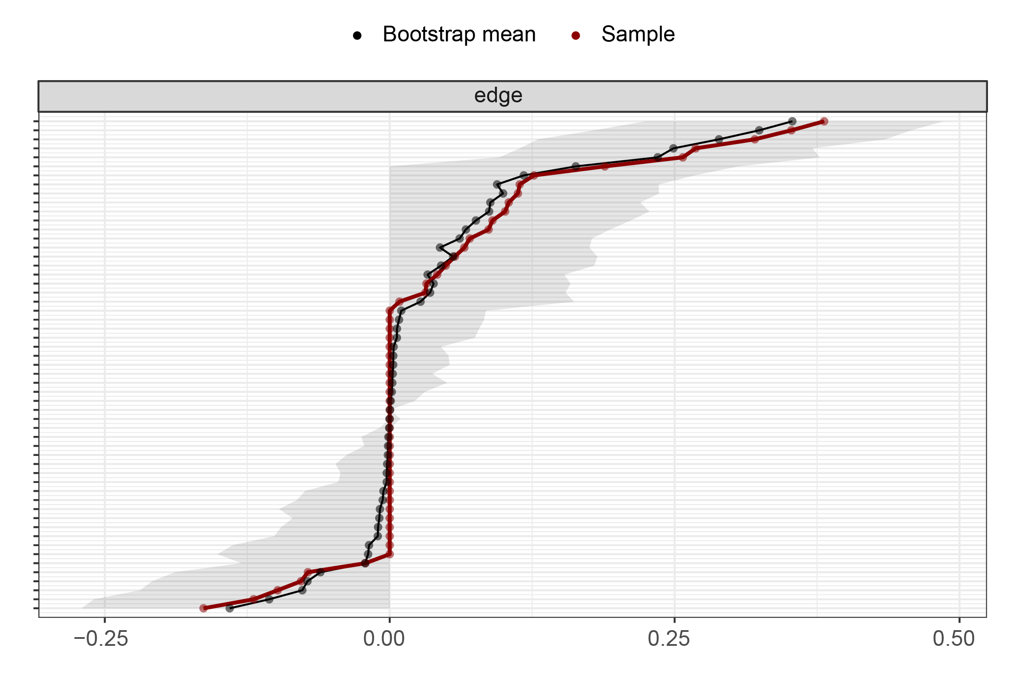
Supplementary Figure 1: Edge weights stability in the ADHD-Cognition network based on the parent ratings.
Bootstrapped confidence intervals of estimated edge-weights for the estimated ADHD-Cognition network based on parent ratings. The red line indicates the sample values and the gray area represents the bootstrapped CIs. Each horizontal line represents one edge of the network, ordered from the edge with the highest edge-weight to the edge with the lowest edge-weight. Y-axis labels have been removed to avoid cluttering.
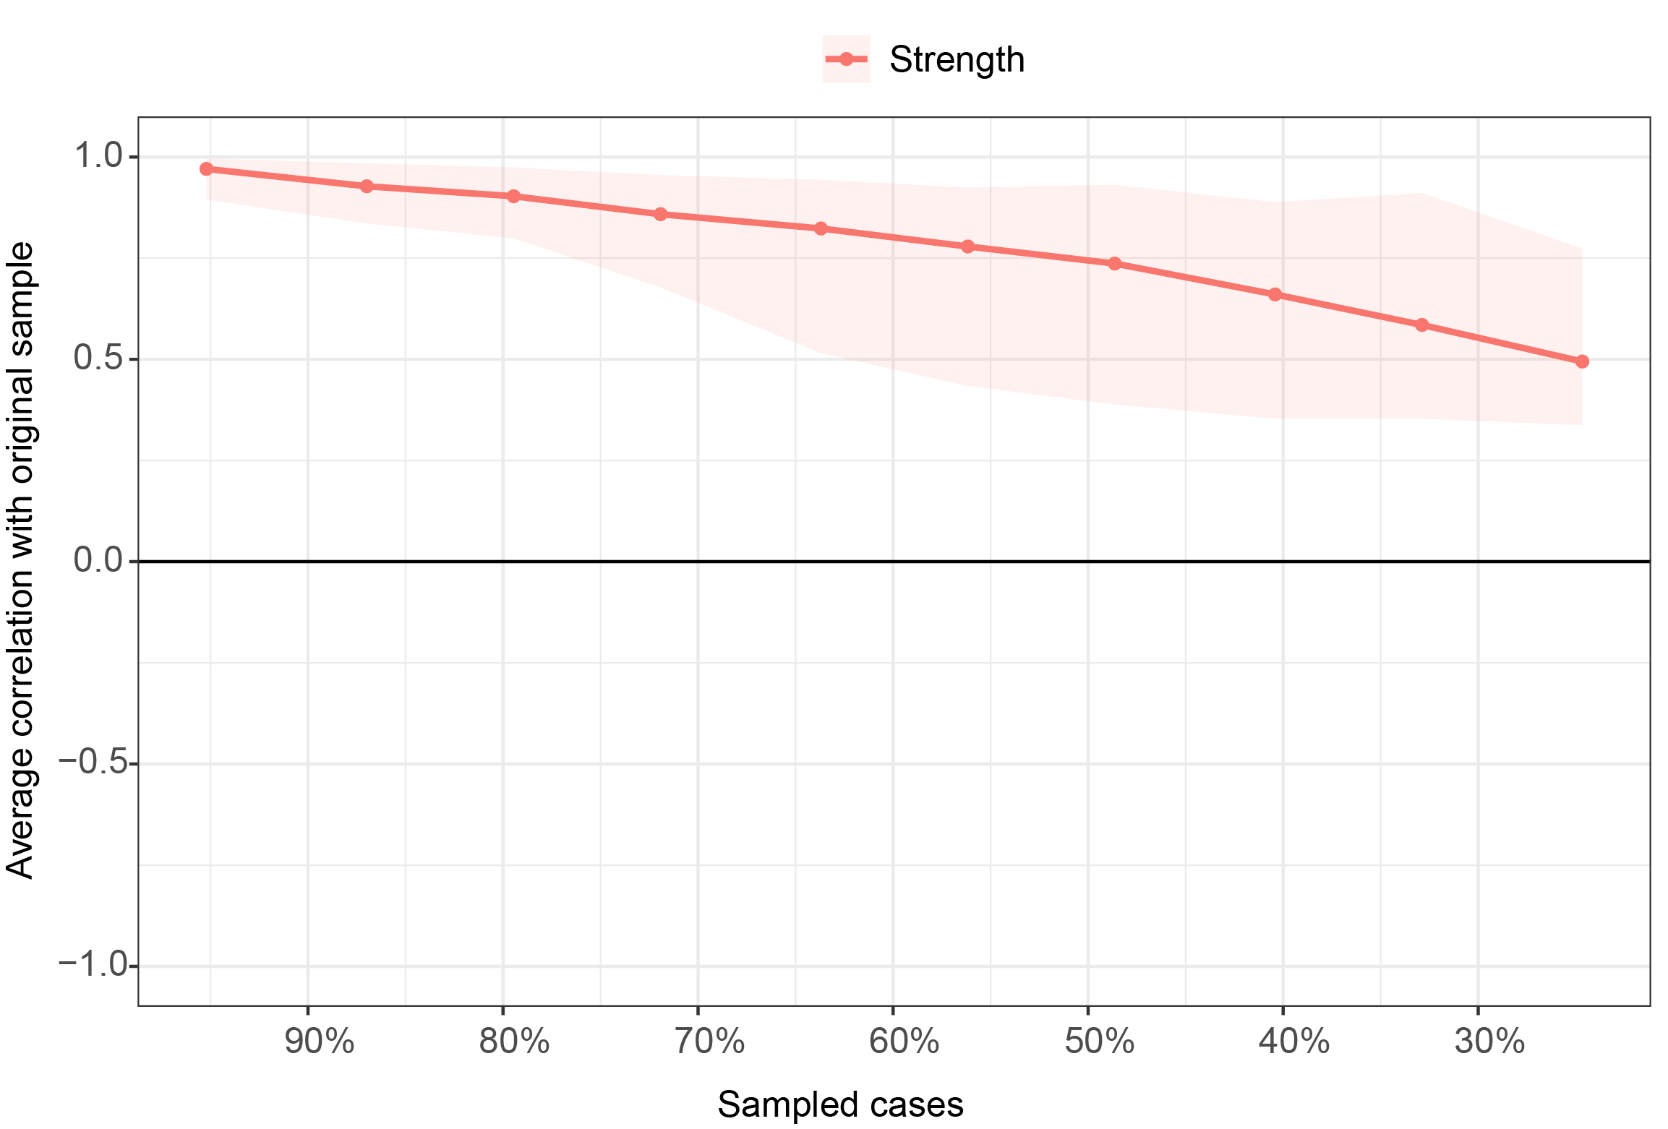
Supplementary Figure 2: Centrality stability in the ADHD-Cognition network based on the parent ratings.
Average correlations between centrality indices of networks sampled with persons dropped and the original sample. Lines indicate the means and areas indicate the range from the 2.5th quantile to the 97.5th quantile. The x-axis indicates the included portion of cases, and the y-axis indicates the average correlations with the original samples.
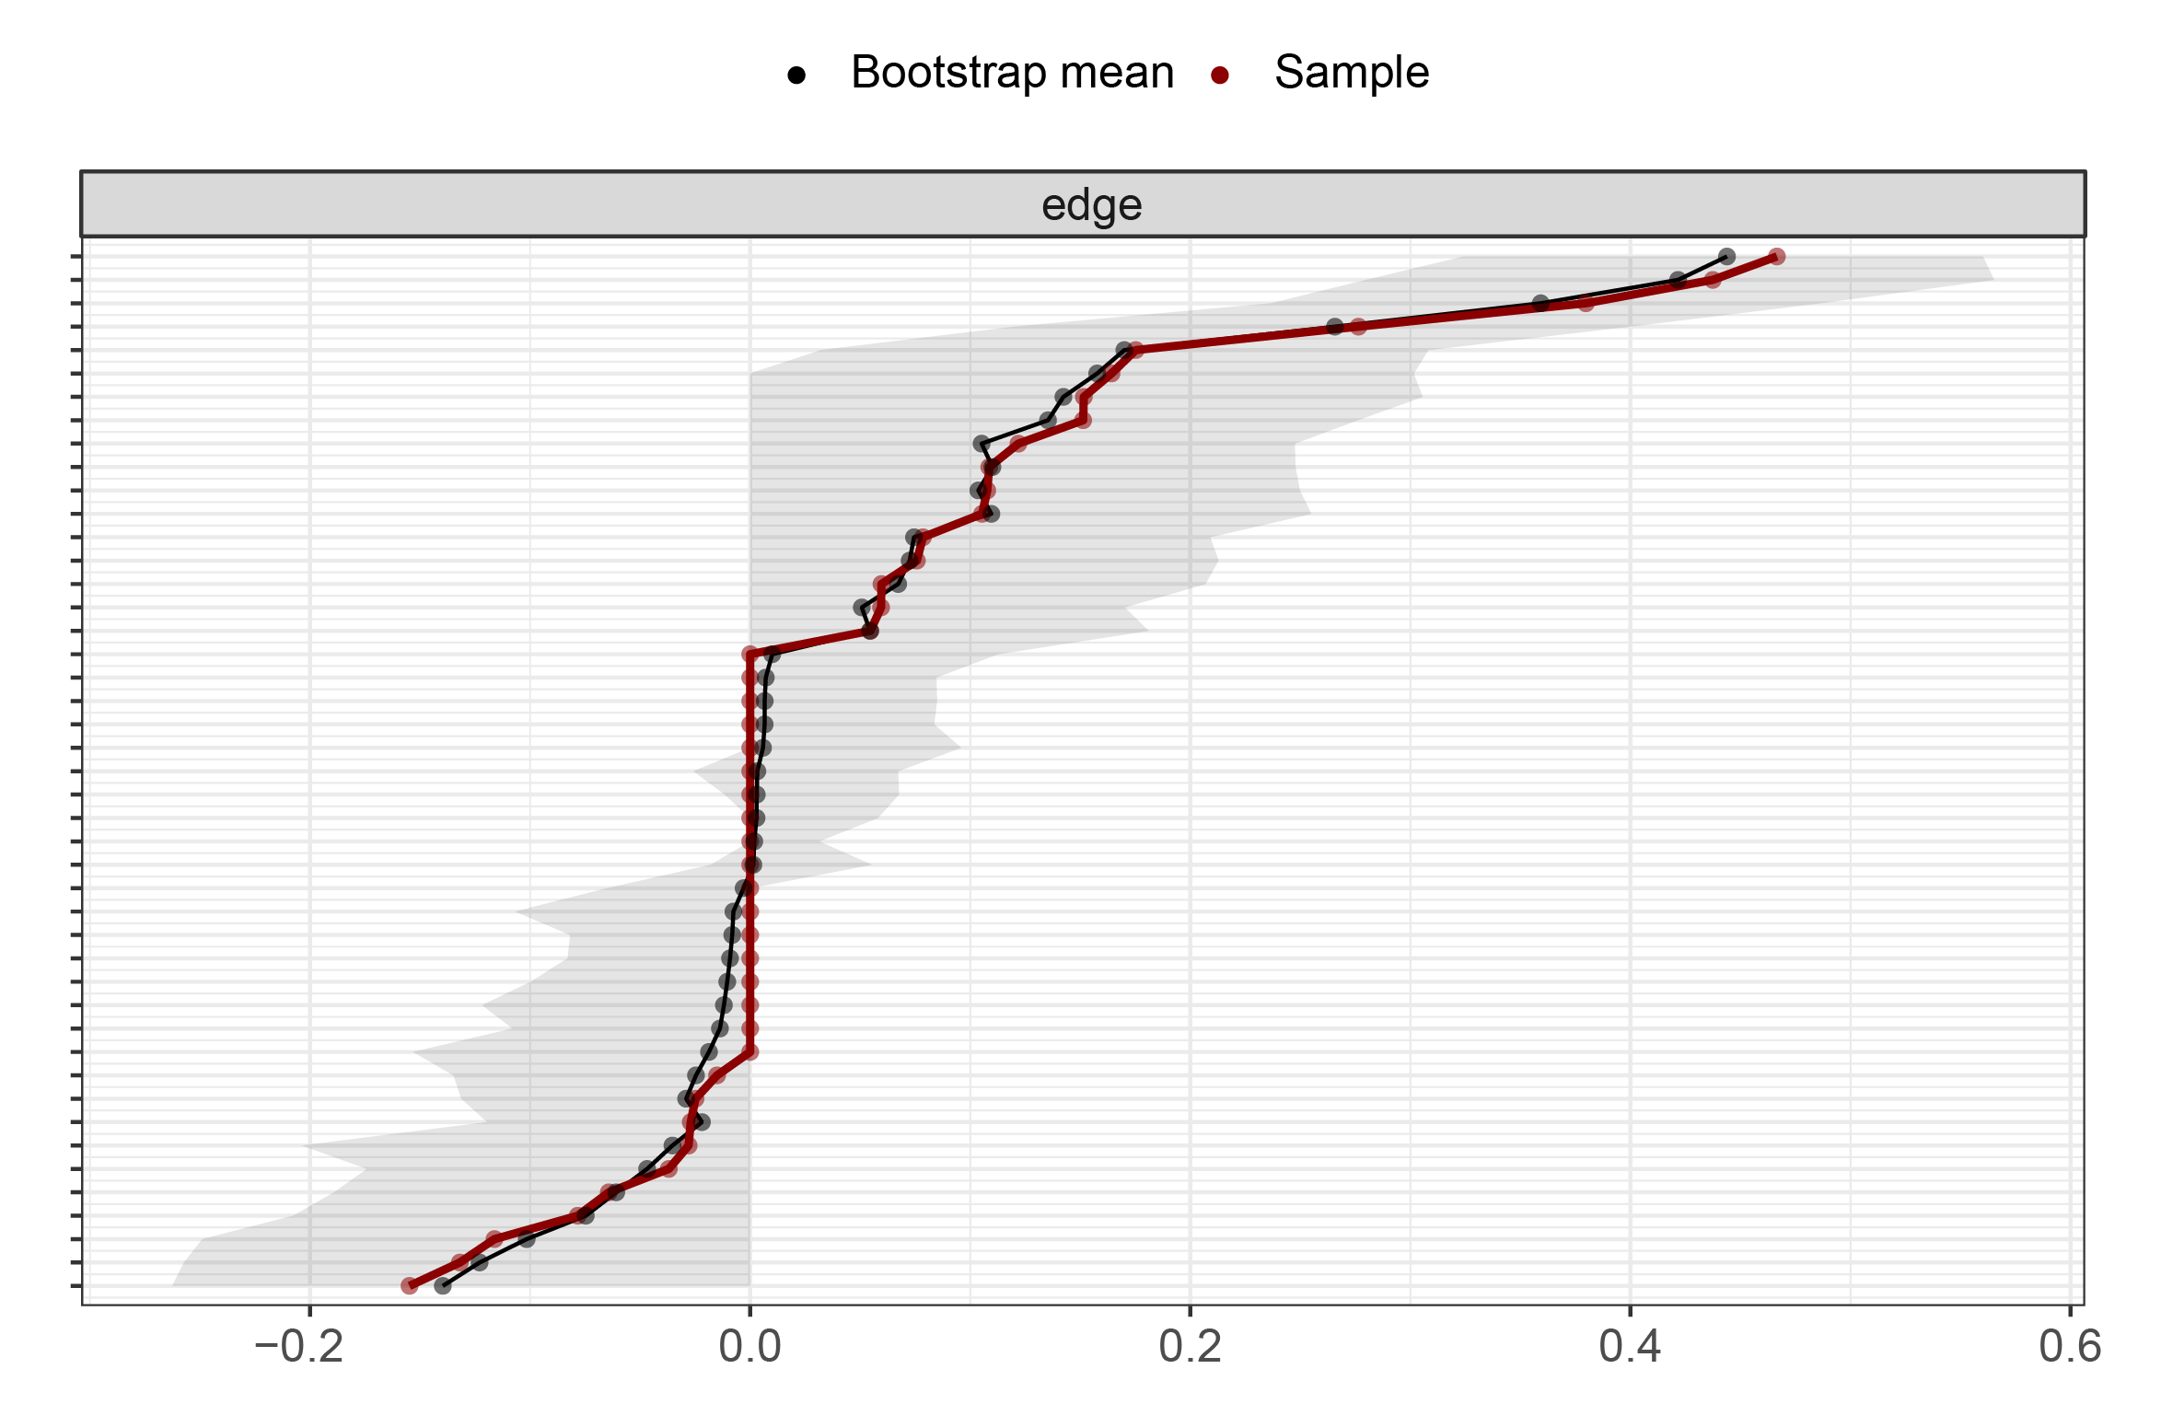
Supplementary Figure 3: Edge weights stability in the ADHD-Cognition network based on the teacher ratings.
Bootstrapped confidence intervals of estimated edge-weights for the estimated ADHD-Cognition network based on teacher ratings. The red line indicates the sample values and the gray area the bootstrapped CIs. Each horizontal line represents one edge of the network, ordered from the edge with the highest edge-weight to the edge with the lowest edge-weight. Y-axis labels have been removed to avoid cluttering.
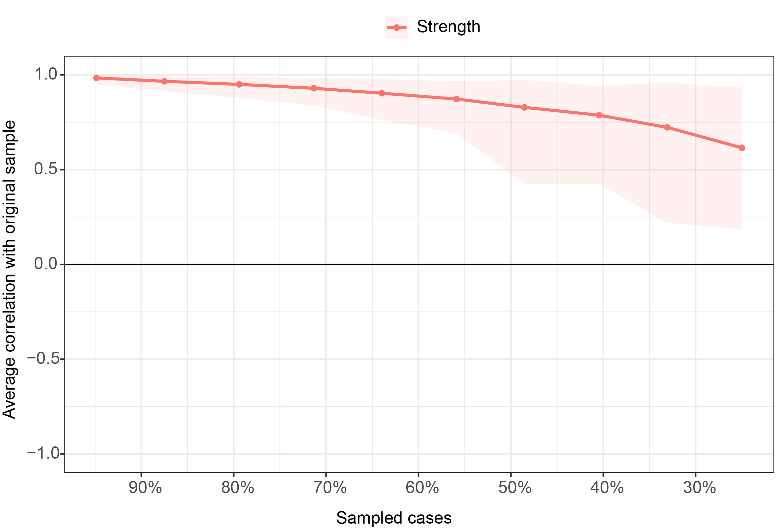
Supplementary Figure 4: Centrality stability in the ADHD-Cognition network based on the teacher’s rating scale.
Average correlations between centrality indices of networks sampled with persons dropped and the original sample. Lines indicate the means and areas indicate the range from the 2.5th quantile to the 97.5th quantile. The x-axis indicates the included portion of cases, and the y-axis indicates the average correlations with the original samples.

