Supplementary material

Supplementary methods

Intervention
The patient application is a progressive, responsive web-application, accessible through smart phone, tablet or computer. Participants are sent a daily text message and email reminder to complete standard patient-reported outcome (PRO) questionnaires to aid structured reflection on COPD symptoms. The application provides access to standardized self-management advice, individualized rescue-pack advice (when activated by clinician) and patient-clinician asynchronous messaging for non-urgent advice regarding COPD self-management. The messaging service was reviewed by the COPD clinical team from Monday to Friday during regular office hours, and participant queries were handled in line with usual care practices. Further self-management material is available via the ‘Managing my COPD’ support website, as an additional component to the intervention. This can be accessed at: https://support.nhscopd.scot/managing-my-copd.

Registration to the service prompts clinician review and completion of structured clinical summary data in the web-browser based clinical dashboard. The structured content supports remote monitoring and optimization of COPD management. The NHS Greater Glasgow and Clyde (NHS GG&C) COPD clinical team additionally use the messaging facility and the rich dataset aggregated in the dashboard to facilitate out of hospital care and to maximize information available during scheduled care. The patient application has a banner noting that clinical team review and respond to messages Monday - Friday 8am-4pm, with signposting to alternative channels for emergency care.

Data processing and storage
All data was stored within NHS GG&C Azure cloud tenancy with standard NHS data control, processing and security governance arrangements. Participant permission for data sharing was additionally captured within the patient application. Identity for each participant was linked by unique participant identifiers. Analysis of data generated was undertaken by named researchers using a deidentified data feed from the Lenus COPD database. Identification of the control cohort and analysis of control cohort data was undertaken by named researchers via the NHS GG&C Safe Haven trusted research environment.

Definition of a COPD or respiratory-related admission
For the RECEIVER cohort, COPD or respiratory-related emergency department (ED) attendances and hospital admissions data were collated by the research team from review of electronic health records, looking at the window from one year preceding the date each participant onboarded onto the support service to the follow-up censor date (31st August 2021). Elective admissions were included if they related to optimization of COPD management. Where there were uncertainties relating to the nature of an admission, consensus was achieved by discussion within the investigator team. COPD or respiratory-related ICD-10 diagnosis codes were applied to the ED attendance/admission data for the control cohort to acquire COPD or respiratory related-admission and occupied bed day counts.

The date of hospital admission was used to determine inclusion in the year before index date and the year after index date counts. Occupied bed days were counted in whole days from date of attendance to discharge; ED attendances of <24 hours were therefore counted as one day.

Definition of community-managed exacerbations
Exacerbations were identified from a once weekly PRO question in the patient application which asked the participants “have you taken antibiotics/steroids in the last week?” A ‘yes’ response was designed to be a surrogate marker of a community-managed exacerbation in the previous week. To account for sustained symptoms and the requirement for extended courses of therapy amongst some individuals, criteria for refining which ‘yes’ responses to the weekly PRO were classed as new community-managed exacerbation events were developed and referred to as the PRO LOGIC criteria. The PRO LOGIC criteria for defining a new exacerbation event from a ‘yes’ response from the weekly PRO question were as follows:
- More than 5 weeks since previous ‘yes’ response: always considered a new community-managed exacerbation event.
- More than 2 weeks but less than 5 weeks since last ‘yes’ response: only a new community-managed exacerbation event if there were two consecutive ‘no’ responses between the previous ‘yes’ response and the ‘yes’ response in question

Patient-clinician interactions via the Lenus COPD messaging facility and emergency clinical summary prescribing data were reviewed to allow clinician verification of a selection of these events. Good correlation between ‘PRO LOGIC’ and clinician-verifiable events was noted (Spearman's rank correlation coefficient = 0.8423).

Supplementary tables
Supplementary Table 1 Table showing the objectives of the RECEIVER trial, the relevant outcomes to each objective reported in this paper, and data that was collected during the trial related to each objective that is not reported here
Objective | Relevant outcomes reported | Data measured but not reported here
To determine utilization of the patient application by a population with severe COPD over an extended period | Percentage of participants completing at least one COPD assessment test (CAT) entry each week  Percentage of participants resident in SIMD quintile 1 postcodes completing at least one CAT entry per week  Mean number of CAT entries completed per week  Completion of medical research council (MRC) Dyspnoea Scale and EQ-5D entries | Utilization of self-management information (page views)  Utilization of the patient-clinician messaging facility  Completion of daily symptom diary questions
To explore potential determinants of patient application utilization | Reporting on the demographics, disease severity, current therapies , comorbidity prevalence, and clinical event count over follow-up of participants with different application utilization levels
To determine the impact of the service on the clinical outcomes of a population with severe COPD compared to a matched control cohort | Comparison of survival to event metrics between the RECEIVER and control cohorts  Comparison of post-index date changes in annual COPD or respiratory-related admissions and occupied bed days between the RECEIVER and control cohorts
To determine the impact of the service on disease impact metrics amongst a population with severe COPD | Longitudinal analysis of CAT scores and EQ-5D visual analogue scale (VAS) scores | Longitudinal data collected through PROs: MRC Dyspnoea scale, symptom diary, and EQ-5D descriptive system
To provide a platform for the implementation and evaluation of additional innovations | Future work | Wearable physiology monitor and home non-invasive ventilation (NIV) machine data
To determine the cost-effectiveness of the intervention | Future work | Projected direct and indirect cost savings, development and implementation costs

Supplementary Table 2 Table showing the Scottish Index of Multiple Deprivation (SIMD) breakdown of the RECEIVER and control cohorts compared to the SIMD breakdown of COPD burden within NHS Greater Glasgow and Clyde overall (NHS GG&C)
 | SIMD quintile 1 | SIMD quintile 2 | SIMD quintile 3 | SIMD quintile 4 | SIMD quintile 5
RECEIVER cohort, % | 57.8 | 21.7 | 10.8 | 4.8 | 4.8
Control cohort*, % | 62.5 | 16.2 | 9.2 | 7.7 | 4.4
COPD admissions in NHS GG&C in 2018/19, % | 60.9 | 18.3 | 9.2 | 6.2 | 5.5
Notes: COPD burden within NHS GG&C is determined by the number of individuals having 1-3 emergency COPD admissions over the 2018/19 period (Public Health Scotland Scottish Atlas of Variation data, available at: https://www.isdscotland.org/products-and-services/scottish-atlas-of-variation/view-the-atlas/respiratory.asp). *SIMD data available for 413/ 415 of individuals in the control cohort.

Supplementary Table 3 Table showing the baseline characteristics for RECEIVER participants in each of the four utilization quartiles
 | Very regular users (Quartile 4), n = 21 | Regular users (Quartile 3), n = 20 | Intermittent users (Quartile 2), n = 21 | Infrequent or non-users (Quartile 1), n = 21 | p-value
Age at baseline, mean | 63.1 | 67.3 | 64.0 | 63.3 | 0.3318
Sex, % female | 52.4 | 60.0 | 71.4 | 71.4 | 0.4992
Smoking Status, % current | 23.8 | 25.0 | 38.1 | 33.3 | 0.7093
COPD or respiratory-related admissions in previous year, mean | 2.7 | 2.5 | 2.4 | 2.3 | 0.9572
SIMD Quintile, mean | 1.7 | 1.8 | 2.0 | 1.5 | 0.305
FEV1% predicted, mean | 44.7 | 50.0 | 48.0 | 49.00 | 0.8428
FEV1 /FVC predicted, mean | 0.45 | 0.47 | 0.47 | 0.45 | 0.9837
Previous pulmonary rehabilitation, % had | 28.6 | 35.0 | 19.0 | 14.3 | 0.4029
NIV therapy, % users | 33.3 | 20.0 | 19.0 | 42.9 | 0.2665
Home Oxygen User, % users | 33.3 | 35.0 | 33.3 | 47.6 | 0.7331
Baseline CAT, mean | 21.2 | 23.4 | 24.6 | 23.8 | 0.4737
Baseline MRC, mean | 3.6 | 3.8 | 4.0 | 3.3 | 0.2728
Highest eosinophil count, mean | 0.55 | 0.51 | 0.56 | 0.93 | 0.6877
Comorbidities, % with
Osteoporosis | 28.6 | 5.0 | 9.5 | 9.5 | 0.1126
Ischaemic Heart Disease | 4.8 | 5.0 | 9.5 | 14.3 | 0.6514
Obstructive Sleep Apnoea | 9.5 | 5.0 | 9.5 | 23.8 | 0.2690
Diabetes Mellitus | 9.5 | 5.0 | 4.8 | 23.8 | 0.1578
Asthma Overlap | 9.5 | 10.0 | 4.8 | 14.3 | 0.7777
Bronchiectasis | 0.0 | 5.0 | 0.0 | 4.8 | 0.5515
Atrial Fibrillation | 14.3 | 15.0 | 4.8 | 4.8 | 0.5072
Heart Failure | 14.3 | 10.0 | 14.3 | 4.8 | 0.7213
Cerebrovascular Disease | 0.0 | 0.0 | 0.0 | 0.0 | NA
Pulmonary Fibrosis | 0.0 | 0.0 | 0.0 | 0.0 | NA
Pulmonary Hypertension | 4.8 | 0.0 | 0.0 | 0.0 | 0.3934
Previous Pneumothorax | 4.8 | 0.0 | 4.8 | 0.0 | 0.5723
Deep Vein Thrombosis or pulmonary Thromboembolism | 9.5 | 5.0 | 0.0 | 0.0 | 0.285
Lung Cancer | 4.8 | 0.0 | 0.0 | 0.0 | 0.3934
Notes: Utilization is defined as the mean number of entries completed in the previous seven-days at each possible point over the first year of follow-up. The p-value from statistical analysis to determine the significance of the difference in each characteristic between quartiles is also shown (Kruskal-Wallis test or Chi-square test as appropriate). NA is shown when no incidences of a binary feature were observed.

Supplementary Table 4 Table showing the COPD or respiratory-related admission and occupied bed day count over the first year of follow-up for RECEIVER participants in each of the four utilization quartiles
 | Very regular users (Quartile 4), n = 20 | Regular users (Quartile 3), n = 16 | Intermittent users (Quartile 2), n = 16 | Infrequent or non-users (Quartile 1), n = 17 | p-value
COPD or respiratory-related admission events over first year of follow-up, mean | 0.85 | 0.625 | 1.31 | 1.18 | 0.5665
COPD or respiratory-related occupied bed days over first year of follow-up, mean | 5.45 | 3.06 | 7.62 | 12.2 | 0.3262
Notes: Utilization is defined as the mean number of entries completed in the previous seven-days at each possible point over the first year of follow-up. The p-value from statistical analysis to determine the significance of the differences between quartiles is also shown (Kruskal-Wallis test). Data shown is for individuals alive 12-months post-index date.

Supplementary Table 5 Table compiling admissions data for all individuals in the RECEIVER and control cohorts, including individuals who died within the first year of follow-up
 |  |  | Mean |  |  | Wilcoxon signed-rank test effect size
 |  |  | Year before | Year after | change | Wilcoxon signed-rank test effect size
Admissions | Control | n=415 | 2.47 | 1.58 | 0.89 | 0.4979 ***
Admissions | RECEIVER | n=83 | 2.46 | 1.17 | 1.29 | 0.5941 ***
Occupied bed days | Control | n=415 | 19.18 | 12.20 | 6.98 | 0.3684 ***
Occupied bed days | RECEIVER | n=83 | 19.18 | 9.95 | 9.23 | 0.4913 ***
Notes: Mean admission and occupied bed day counts in the year before and year after study index date are shown. The mean changes for each cohort and the effect sizes of these changes (Wilcoxon signed-rank tests) are also displayed. *** p < 0.001, Wilcoxon signed-rank test

Supplementary Figures

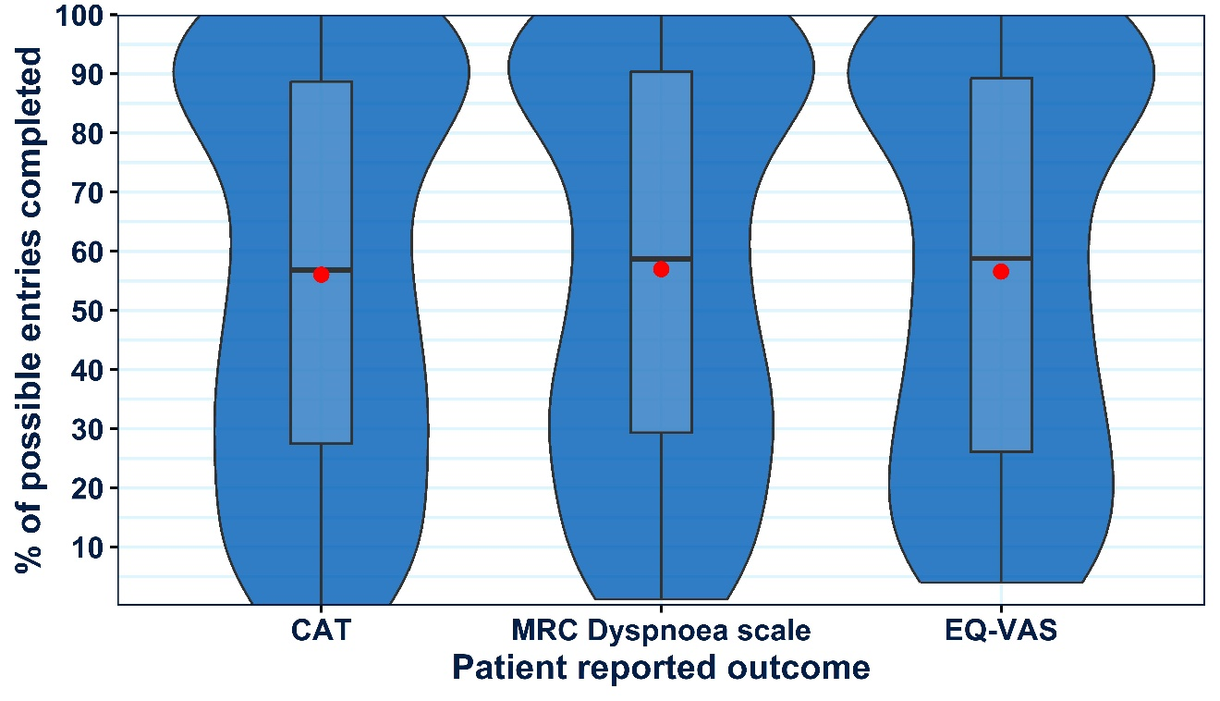Supplementary Figure 1 Violin boxplots showing the distribution of CAT entry, MRC Dyspnoea Scale, and EQ-5D entry completions amongst the RECEIVER cohort across the length of follow-up. Violin-box plots are selected to ensure complete data provision. For their interpretation: standard boxplots illustrate the variation of values (median and IQR), the relative frequency of individual data points is illustrated by the width of the violin plot at each point on the y-axis, and mean values are shown by red dots.

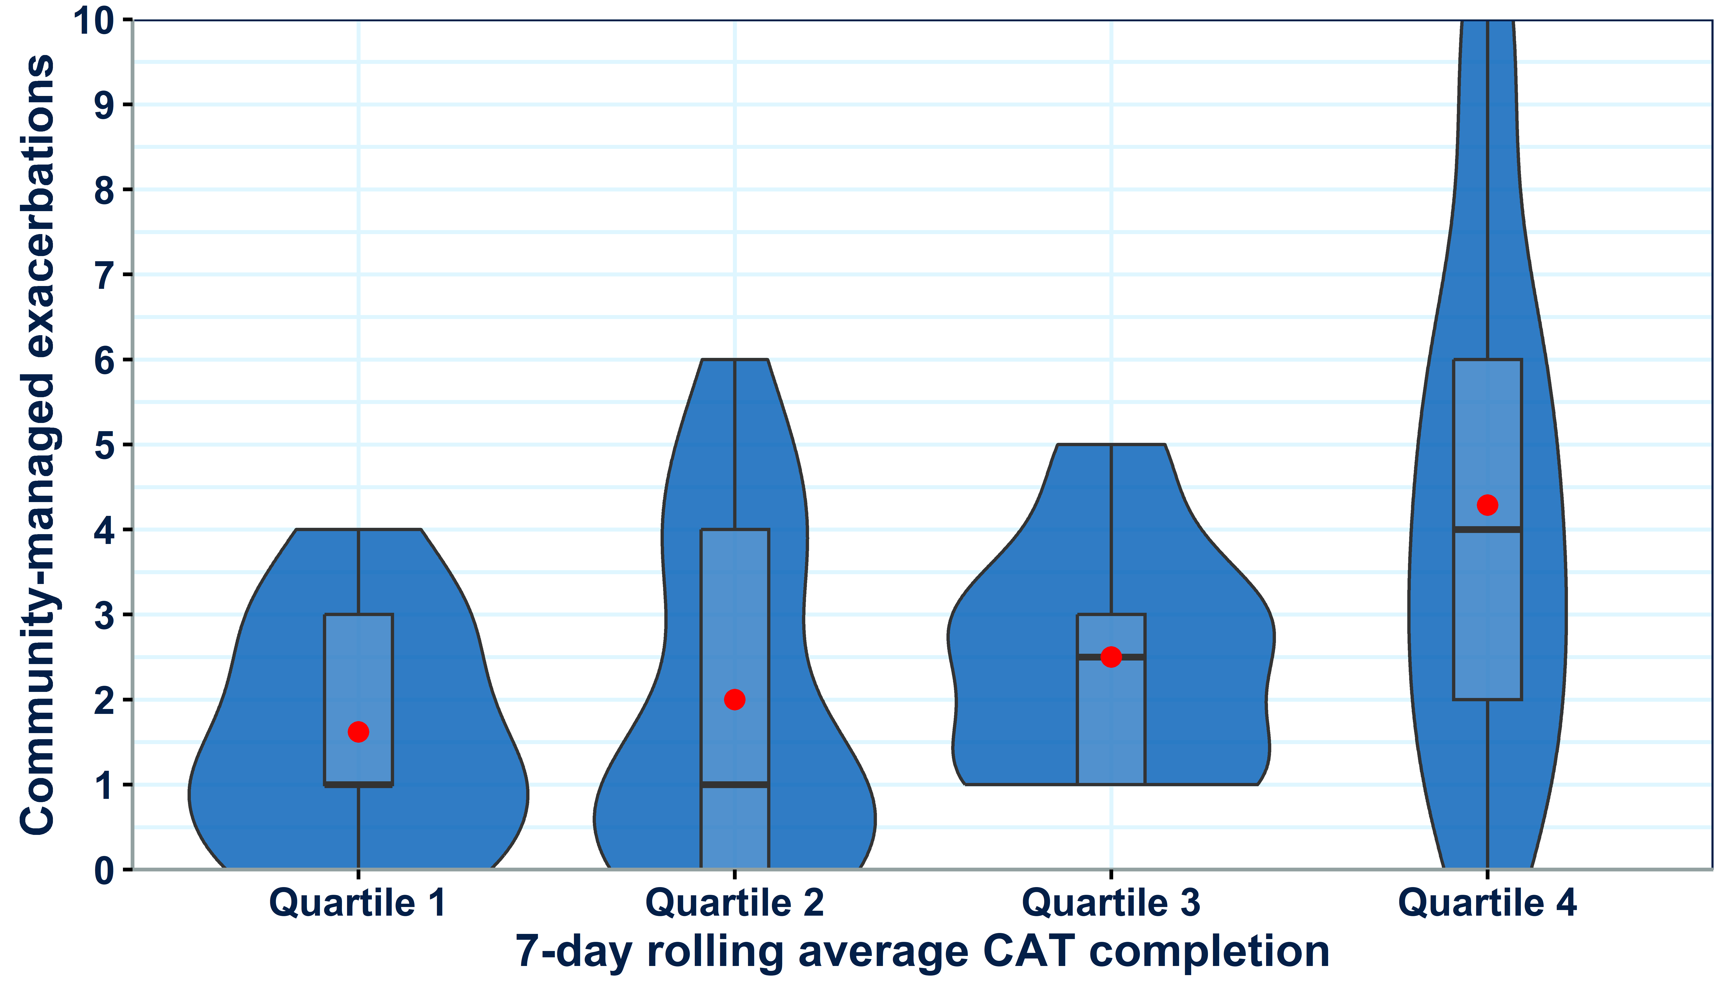
Supplementary Figure 2 Violin boxplots showing the distribution of community-managed exacerbation counts within the RECEIVER cohort during the first year of follow-up. The cohort is stratified into four utilization quartiles based on mean CAT entry count in the previous 7-days at each point over the first year of follow-up. Violin-box plots are selected to ensure complete data provision. For their interpretation: standard boxplots illustrate the variation of values (median and IQR), the relative frequency of individual data points is illustrated by the width of the violin plot at each point on the y-axis, and mean values are shown by red dots.


Supplementary Figure 3 Additional plain language resources summarizing the trial results

