Supplementary Figure 1
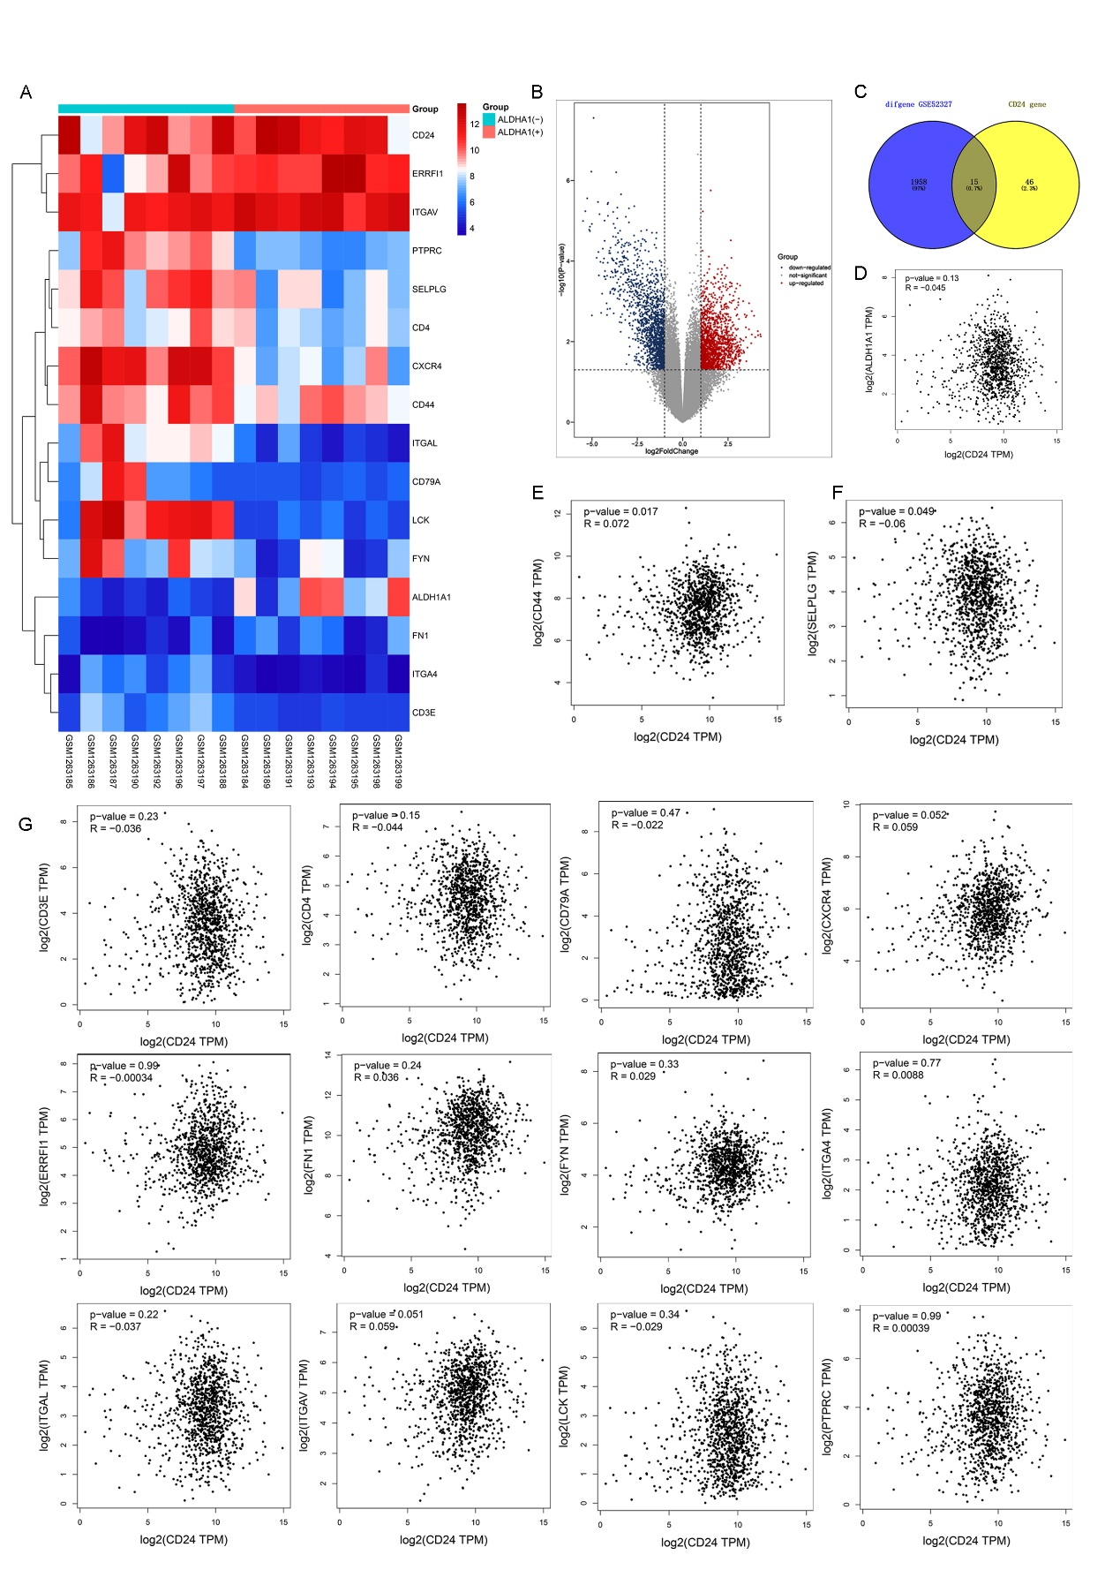
Supplementary figure 1: The regulatory mechanism underlying CD24 and its co-expressed proteins
A: Heatmap of significantly differently expressed CD24 co-expressed genes and CD24 in the GEO dataset GSE52327 (Log FC>1 or <-1, P<0.05).
B: Volcano plot of all differently expressed genes in the GSE52327 database (Log FC>1 or <-1, P<0.05)
C: Venn diagram of differently expressed genes in the GSE52327 database and CD24 co-expressed genes.
D: The relationship between CD24 and ALDH1A1 expression gain was determined using the GEPIA database.
E: The relationship between CD24 and CD44 expression gain was determined using the GEPIA database.
F: The relationships between CD24 and SELPLG expression gain determined using the GEPIA database.
G: The correlation between CD24 expression and CD3E expression, CD4 expression, CD79A expression, CXCR4 expression, ERRFI1 expression, FN1 expression, FYN expression, ITGA4 expression, ITGAL expression, ITGAV expression, LCK expression, and PTPRC expression.

Supplementary Figure 2
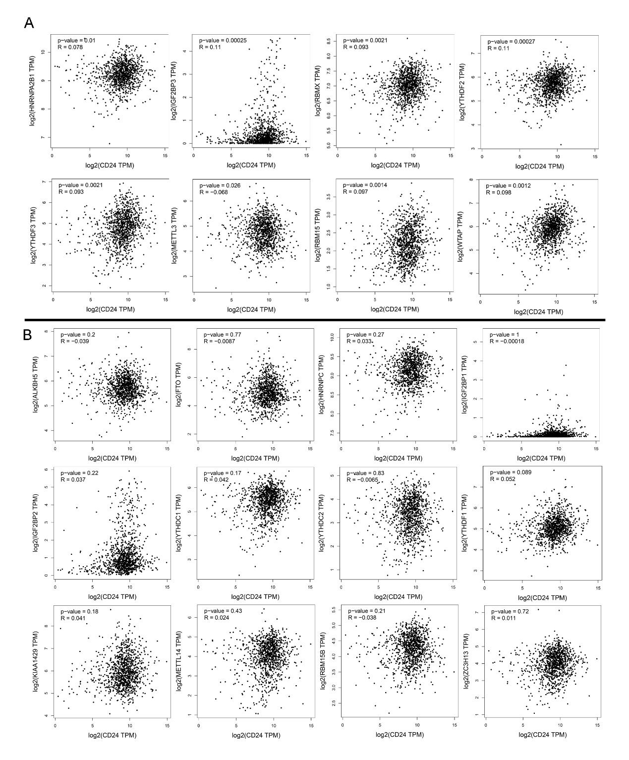
Supplementary Figure 2: The correlation between CD24 expression and the expression of m6A RNA methylation regulators determined by the GEPIA database
A: The correlation between CD24 expression and HNRNPA2B1 expression, IGF2BP3 expression, RBMX expression, YTHDF2 expression, YTHDF3 expression, METTL3 expression, RBM15 expression, and WTAP expression.
B: The correlation between CD24 expression and ALKBH5 expression, FTO expression, HNRNPC expression, IGF2BP1 expression, IGF2BP2 expression, YTHDC1 expression, YTHDC2 expression, YTHDF1 expression, KIAA1429 expression, METTL14 expression, RBM15B expression, and ZC3H13 expression.

