Table S1. Anoikis-related genes list
Gene Symbol
ABHD2
ABHD4
ABL1
ADCY10
AFAP1L1
AFP
AKT1
AKT3
ANGPTL2
ANGPTL4
ANKRD13C
ANXA5
APOBEC3G
AR
ARHGEF7
ATF4
BAD
BAG1
BAK1
BAX
BCAR1
BCL2
BCL2L1
BCL2L11
BCL2L15
BDNF
BID
BIRC3
BIRC5
BMF
BMP6
BNIP3
BNIP3L
BRAF
BRCA2
BRMS1
BSG
BST2
CALR
CASP10
CASP2
CASP3
CASP6
CASP8
CASP9
CAV1
CBL
CCND1
CCR7
CD151
CD24
CD36
CD44
CD63
CDCP1
CDH1
CDH2
CDH3
CDKN1A
CDKN1B
CDKN2A
CDKN3
CEACAM1
CEACAM3
CEACAM5
CEACAM6
CEBPB
CFLAR
CHEK2
CHUK
CLDN1
COL13A1
COL4A2
COPS5
CPEB2
CPT1A
CRYAB
CSNK2A1
CSPG4
CTNNB1
CTNND1
CTTN
CXCL12
CXCR4
CYCS
DAP3
DAPK1
DAPK2
DLG1
DOCK1
E2F1
EDIL3
EEF1A1
EEF2K
EGF
EGFR
EIF2AK3
ELANE
ELK1
EPHA2
EPHB6
ERBB2
ETV4
EZH2
FADD
FAS
FASLG
FASN
FER
FGF2
FN1
GLI2
GLO1
GLUD1
GRHL2
HAVCR2
HGF
HIF1A
HK2
HMCN1
HMGA1
HMOX1
HOXA10
HRAS
HTRA1
IFI27
IGF1
IGF1R
IKBKG
IKZF3
IL6
ILK
INHBB
IQGAP1
ITGA2
ITGA3
ITGA4
ITGA5
ITGA6
ITGA8
ITGAV
ITGB1
ITGB3
ITGB4
ITPRIP
KDR
KL
KLF12
KRAS
LAMA3
LAMB3
LAMC2
LATS1
LGALS1
LGALS3
LMO3
LPAR1
LRP1
LTB4R2
LTF
MAP2K1
MAP3K7
MAPK1
MAPK11
MAPK3
MAPK8
MCL1
MDM2
MET
MIR200A
MIR204
MIR21
MIR30B
MMP11
MMP13
MMP2
MMP9
MNX1
MSLN
MTA1
MTDH
MUC1
MYBBP1A
MYC
MYH9
MYO5A
NAT1
NFE2L2
NOTCH1
NOTCH3
NOX4
NQO1
NRAS
NRP1
NTF3
NTRK2
PAK1
PAK2
PAK3
PAK4
PARP1
PBK
PDCD4
PDGFRB
PDK4
PECAM1
PHLDA2
PIK3CA
PIK3CB
PIK3CG
PIK3R1
PIK3R2
PIK3R3
PIN1
PLAT
PLAU
PLAUR
PLK1
PPARG
PPP1R13B
PPP2CA
PPP2R1A
PPP2R2D
PPP2R5A
PRDX4
PRKACA
PRKCA
PRKCI
PRKCQ
PRKD1
PRPF4B
PTEN
PTGS2
PTHLH
PTK2
PTK2B
PTK6
PTPN1
PTPN11
PTRH2
PYCARD
RAC1
RAD9A
RAF1
RANBP9
RB1
RBL2
RELA
RHOA
RHOB
RHOC
RHOG
RIPK1
ROCK1
RPS6KB1
S100A4
SATB1
SCRIB
SDCBP
SERPINA1
SESN1
SESN2
SESN3
SFN
SH3GLB1
SHC1
SIK1
SIK2
SIRPA
SIRT1
SIRT3
SKP2
SLC2A1
SLCO1B3
SMAD4
SNAI2
SOD2
SP1
SPIB
SPINK1
SRC
STAT3
STK11
TAGLN
TFDP1
THBS1
TIMP1
TLE1
TLN1
TLR3
TNFRSF10B
TNFRSF12A
TNFRSF1A
TNFSF10
TP53
TPM1
TRAF2
TRIM31
TSC2
TSG101
TUBB3
TWIST1
UBE2C
UCHL1
USP9X
VEGFA
VPS37A
WNT2
XIAP
YAP1
YWHAZ
ZBTB7A
ZEB1
ZEB2
ZNF304
ZNF32

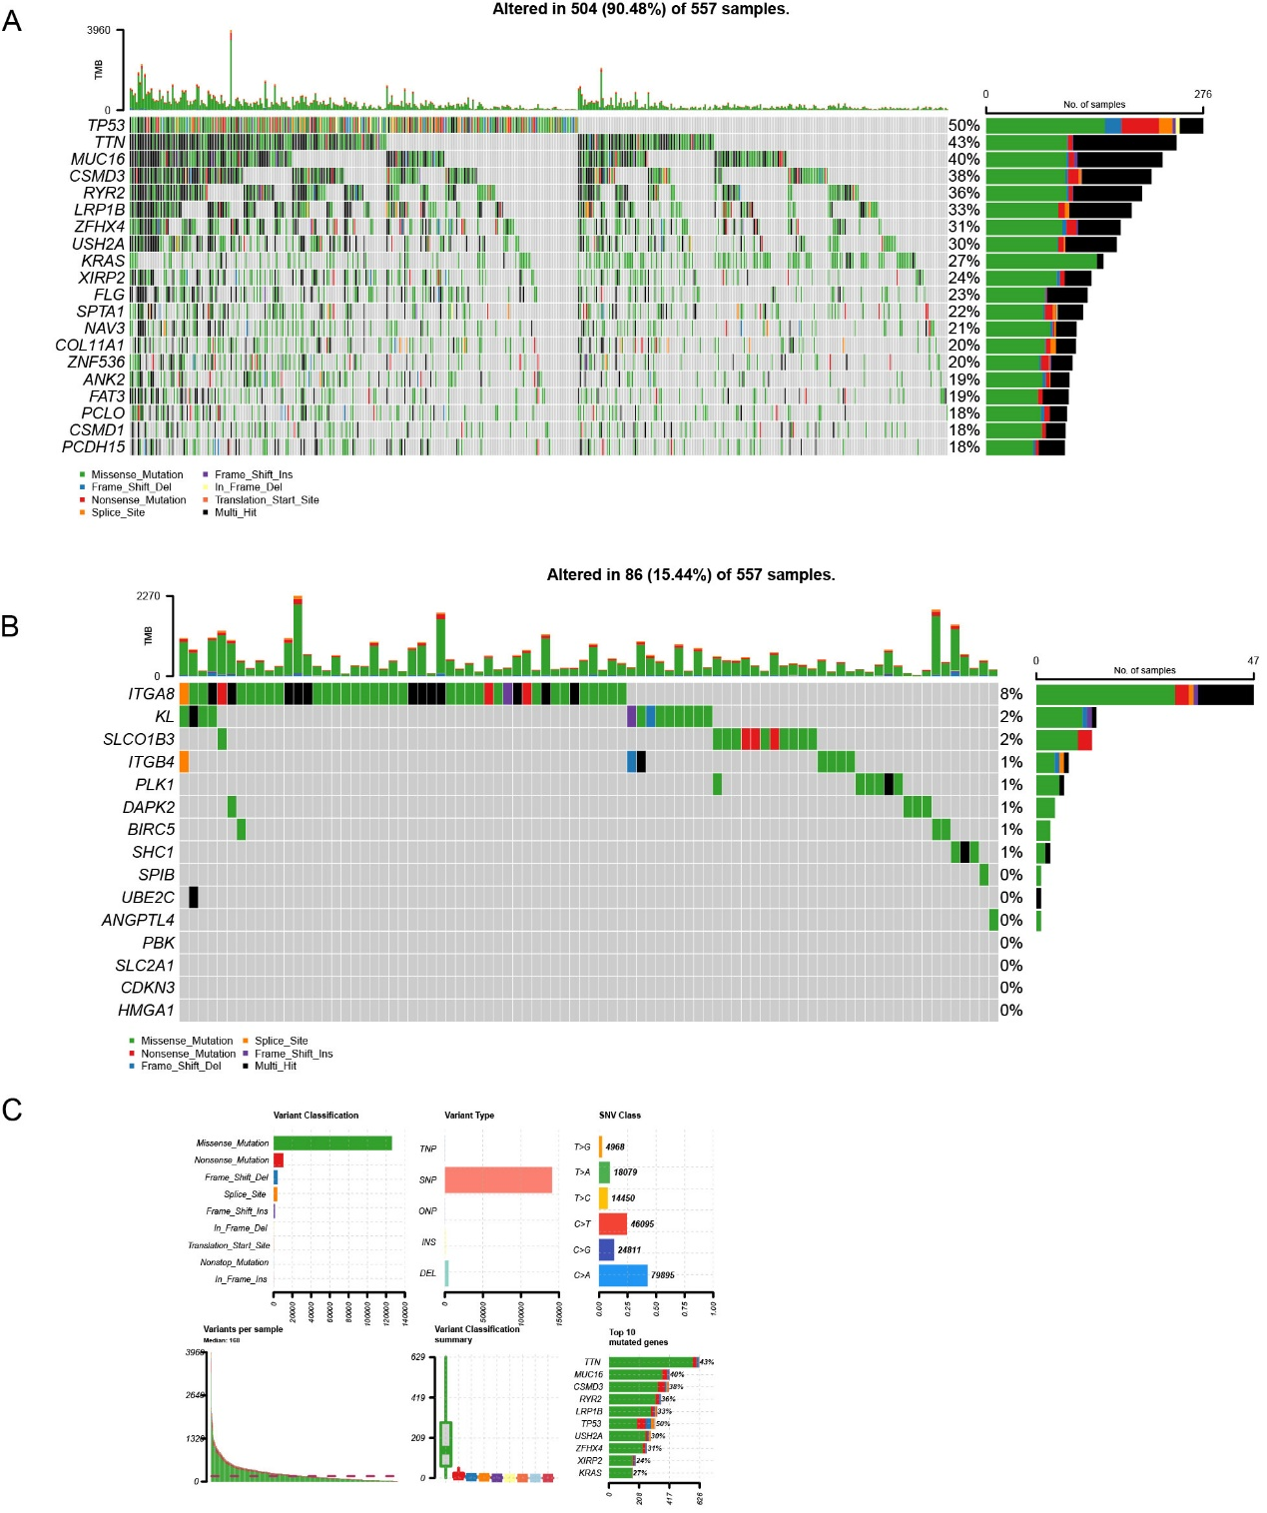

Figure S1
Variations of LUAD in the TCGA dataset.
A: Mutation loads of LUAD.
B: Alteration loads of LUAD in anoikis-related genes.
C: Variant classification and variant types of LUAD.

