Supplementary Materials
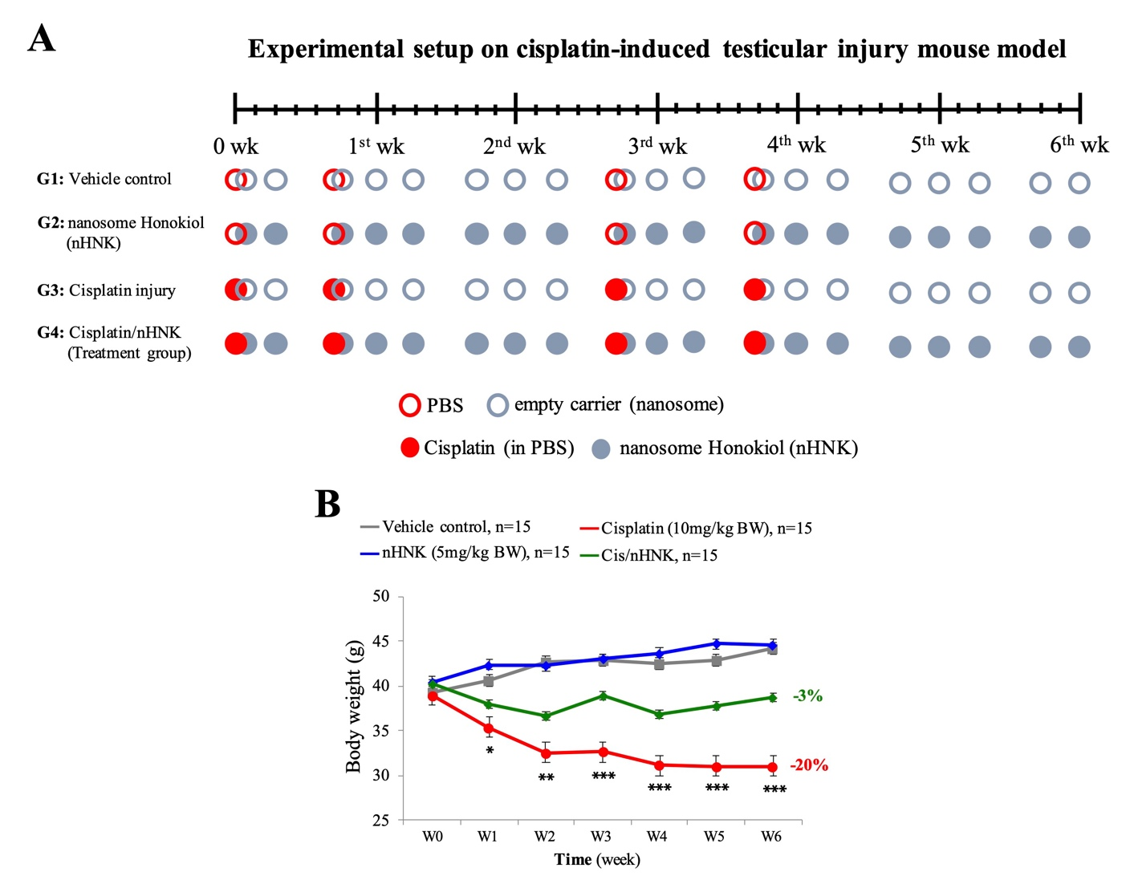
Supplementary figure 1

Supplementary figure legend 1 Establishment of a cisplatin-induced testicular damage mouse model. (A) Graphic illustration of the experimental setup for cisplatin-induced testicular damage mouse model. Animals were randomly allocated into 4 experimental groups (n = 15 for each group) and described as follow. G1 (vehicle control): mice in this group were given four intraperinatal injections of 100 μL sterilized phosphate-buffered saline (PBS, red open circle), additional 100 μL of nanosized liposomes (vehicle control for HNK, grey open circle) was given at a three times/week interval for consecutive 6 weeks via tail vein injection (IV). G2 (nHNK, nanosome HNK group): besides sterilized PBS (as in G1), animals in this group received 5 mg/kg B.W. nHNK (grey closed circle, 100 μL volume) at a three times/week interval for 6 weeks. G3 (cisplatin injury group): the testicular injury was created by intraperinatal injections of 10 mg/kg B.W. cisplatin at weeks 0, 1, 3, and 4 (red closed circle); moreover, mice in this group also received an additional 100 μL of nHNK at the same intervals as mice in G2. G4 (cisplatin/nHNK, treatment group): mice in the treatment group were first injured by cisplatin as in G3, counteracting treatment was performed by injection of 5 mg/kg B.W. nHNK (grey closed circle, 100 μL volume) as indicated in the G2. (B) Mouse body weight was measured every week for six consecutive weeks to monitor the physical condition of the mice. Bars represent standard deviation (S.D.), and results were presented as mean ± standard deviation (S.D.). *=p<0.05, **=p<0.01, ***=p<0.001, and illustrated statistical differences between the experimental group and control values (grey line).
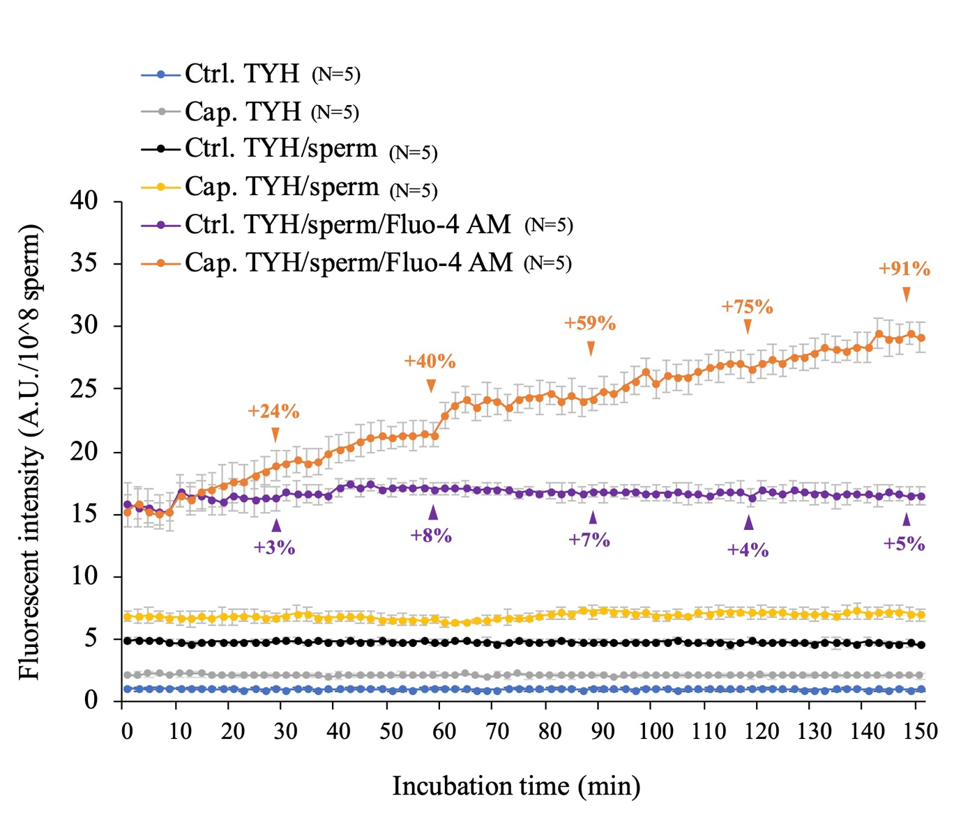
Supplementary figure 2

Supplementary figure legend 2 Establishment of baseline values for the dynamic intracellular calcium influx measurements. To establish baseline and background values for the dynamic intracellular calcium influx measurements, several sperm incubation conditions were set up and measured. Background signals were measured when sperm cells were incubated in either control (Ctrl. TYH) or capacitation (Cap. TYH) Hepes-based tyrodes medium (TYH). Sperm cells without Flu-4 AM dye-loading process (Ctrl./Cap. TYH/sperm) were used as background noise due to autofluorescent, and signals were measured and used for subtraction. Fluorescent signals from dye-loaded sperm cells were measured, and kinetic changes were monitored every 2 minutes for 150 minutes. Compared with relatively flat signal patterns in the above-mentioned control or baseline values, a time-dependent increase in signals can be measured when sperm cells are incubated in the capacitation medium (orange line). Bars represent standard deviation (S.D.). For each experimental condition, five independent repeats were performed, and results were presented as mean ± standard deviation (S.D.).

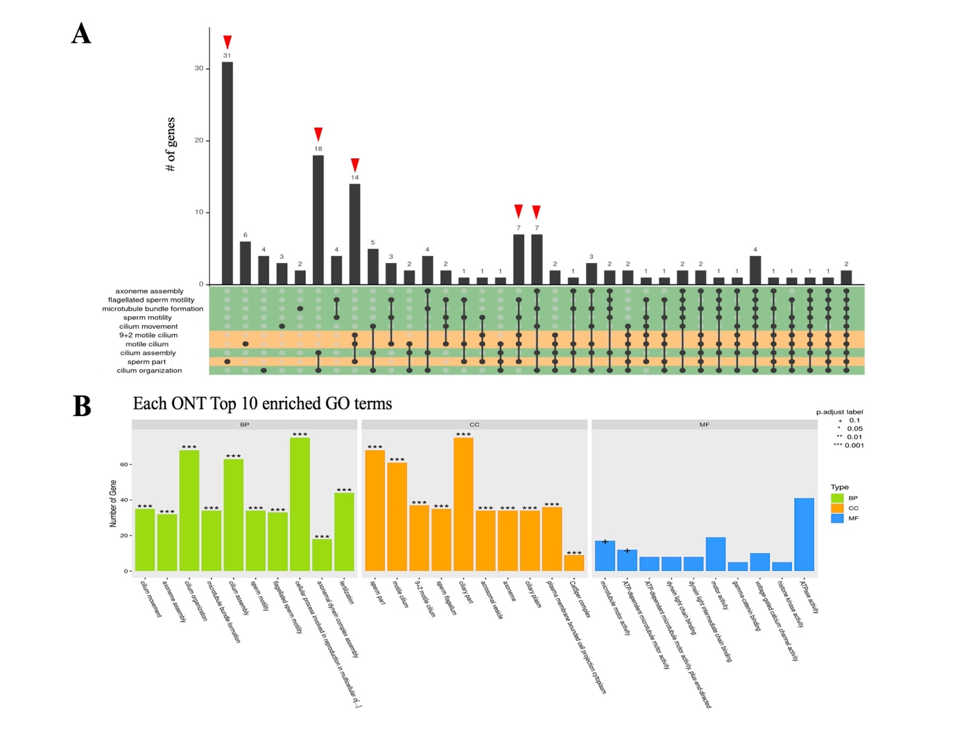
Supplementary figure 3

Supplementary figure legends 3 (A) Next-generation sequence analysis showed that affected genes were related to the maintenance of sperm tail structure and sperm motility. Red arrowheads indicated the major gene clusters that were identified. (B) When affected genes were classified based on their biological process (BP), cellular component (CC), and molecular function (MF), the top 10 categories were presented.

Supplementary figure 4
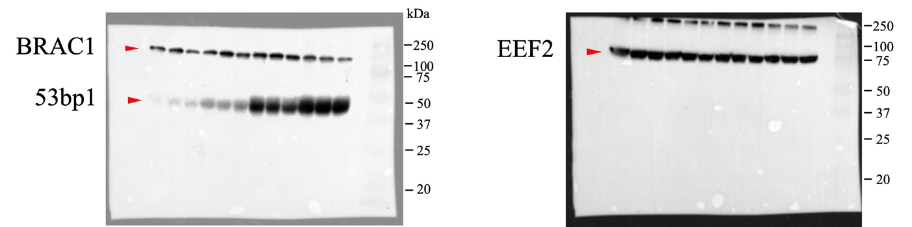
Supplementary figure legends 4 Original whole blots for western blotting analysis

Supplementary table 1. KEGG pathways analysis on the top 10 significantly affected pathways
GO_accession | Description | p-value | Affected gene counts
GO:0098857 | membrane microdomain | 8.3E-22 | 119
GO:0009611 | response to wounding | 1.9E-18 | 136
GO:0048871 | multicellular organismal homeostasis | 2.3E-16 | 130
GO:1901615 | organic hydroxy compound metabolic process | 5.2E-15 | 126
GO:0031012 | extracellular matrix | 1.3E-14 | 124
GO:0006979 | response to oxidative stress | 4.2E-13 | 106
GO:0048608 | reproductive structure development | 4.9E-12 | 113
GO:0050673 | epithelial cell proliferation | 2.1E-10 | 104
GO:0015629 | actin cytoskeleton | 2.4E-10 | 115
GO:0005911 | cell-cell junction | 2.2E-08 | 107

Supplementary table 2. RNAseq analysis of genes involved in the regulation of sperm functions
Ensembl_gene_id | Symbol | Description | Ctrl vs C | C vs CH
ENSMUSG00000002190 | Clgn | calmegin [Source:MGI Symbol;Acc:MGI:107472] | -8.915 | 8.408
ENSMUSG00000010592 | Dazl | deleted in azoospermia-like [Source:MGI Symbol;Acc:MGI:1342328] | -5.172 | 5.632
ENSMUSG00000017195 | Zpbp2 | zona pellucida binding protein 2 [Source:MGI Symbol;Acc:MGI:1916626] | -8.510 | 8.049
ENSMUSG00000020193 | Zpbp | zona pellucida binding protein [Source:MGI Symbol;Acc:MGI:1855701] | -6.861 | 6.324
ENSMUSG00000020882 | Cacnb1 | calcium channel, voltage-dependent, beta 1 subunit [Source:MGI Symbol;Acc:MGI:102522] | -3.117 | 3.359
ENSMUSG00000021499 | Catsper3 | cation channel, sperm associated 3 [Source:MGI Symbol;Acc:MGI:1924106] | -6.846 | 6.134
ENSMUSG00000021590 | Spata9 | spermatogenesis associated 9 [Source:MGI Symbol;Acc:MGI:1922821] | -7.087 | 6.394
ENSMUSG00000023930 | Crisp2 | cysteine-rich secretory protein 2 [Source:MGI Symbol;Acc:MGI:98815] | -6.281 | 3.871
ENSMUSG00000024112 | Cacna1h | calcium channel, voltage-dependent, T type, alpha 1H subunit [Source:MGI Symbol;Acc:MGI:1928842] | -5.665 | 5.015
ENSMUSG00000025482 | Odf3 | outer dense fiber of sperm tails 3 [Source:MGI Symbol;Acc:MGI:1916537] | -6.676 | 6.443
ENSMUSG00000027329 | Spef1 | sperm flagellar 1 [Source:MGI Symbol;Acc:MGI:3513546] | -4.201 | 3.879
ENSMUSG00000029682 | Spam1 | sperm adhesion molecule 1 [Source:MGI Symbol;Acc:MGI:109335] | -6.880 | 5.895
ENSMUSG00000029703 | Lrwd1 | leucine-rich repeats and WD repeat domain containing 1 [Source:MGI Symbol;Acc:MGI:1918985] | -6.040 | 5.597
ENSMUSG00000029867 | Llcfc1 | LLLL and CFNLAS motif containing 1 [Source:MGI Symbol;Acc:MGI:1923856] | -6.899 | 6.277
ENSMUSG00000030376 | Slc8a2 | solute carrier family 8 (sodium/calcium exchanger), member 2 [Source:MGI Symbol;Acc:MGI:107996] | -4.082 | 3.579
ENSMUSG00000030851 | Ldhc | lactate dehydrogenase C [Source:MGI Symbol;Acc:MGI:96764] | -11.680 | 11.476
ENSMUSG00000031552 | Adam18 | a disintegrin and metallopeptidase domain 18 [Source:MGI Symbol;Acc:MGI:105986] | -6.873 | 6.467
ENSMUSG00000032921 | Odf4 | outer dense fiber of sperm tails 4 [Source:MGI Symbol;Acc:MGI:2182079] | -6.704 | 6.130
ENSMUSG00000033486 | Catsper2 | cation channel, sperm associated 2 [Source:MGI Symbol;Acc:MGI:2387404] | -7.513 | 7.055
ENSMUSG00000038128 | Camk4 | calcium/calmodulin-dependent protein kinase IV [Source:MGI Symbol;Acc:MGI:88258] | -3.428 | 2.890
ENSMUSG00000038498 | Catsper1 | cation channel, sperm associated 1 [Source:MGI Symbol;Acc:MGI:2179947] | -7.296 | 6.657
ENSMUSG00000038709 | Txndc8 | thioredoxin domain containing 8 [Source:MGI Symbol;Acc:MGI:1914652] | -6.384 | 6.282
ENSMUSG00000040828 | Catsperd | cation channel sperm associated auxiliary subunit delta [Source:MGI Symbol;Acc:MGI:2147030] | -6.224 | 5.667
ENSMUSG00000042554 | Zp3r | zona pellucida 3 receptor [Source:MGI Symbol;Acc:MGI:104965] | -7.479 | 6.903
ENSMUSG00000047014 | Catsperb | cation channel sperm associated auxiliary subunit beta [Source:MGI Symbol;Acc:MGI:2443988] | -5.671 | 5.060
ENSMUSG00000048003 | Catsper4 | cation channel, sperm associated 4 [Source:MGI Symbol;Acc:MGI:3043288] | -6.207 | 5.727
ENSMUSG00000050623 | Catsperz | cation channel sperm associated auxiliary subunit zeta [Source:MGI Symbol;Acc:MGI:1914327] | -7.150 | 6.898
ENSMUSG00000051146 | Camk2n2 | calcium/calmodulin-dependent protein kinase II inhibitor 2 [Source:MGI Symbol;Acc:MGI:1920297] | -3.065 | 2.981
ENSMUSG00000052488 | Cherp | calcium homeostasis endoplasmic reticulum protein [Source:MGI Symbol;Acc:MGI:106417] | -4.021 | 3.497
ENSMUSG00000053395 | Cacng8 | calcium channel, voltage-dependent, gamma subunit 8 [Source:MGI Symbol;Acc:MGI:1932376] | -2.712 | 2.502
ENSMUSG00000056999 | Ide | insulin degrading enzyme [Source:MGI Symbol;Acc:MGI:96412] | -6.486 | 5.755
ENSMUSG00000064158 | Izumo1 | izumo sperm-egg fusion 1 [Source:MGI Symbol;Acc:MGI:1920706] | -6.009 | 5.264
ENSMUSG00000072663 | Spef2 | sperm flagellar 2 [Source:MGI Symbol;Acc:MGI:2443727] | -4.441 | 3.903
ENSMUSG00000091476 | Catspere2 | catsper channel auxiliary subunit epsilon 2 [Source:MGI Symbol;Acc:MGI:5589632] | -3.921 | 2.256
ENSMUSG00000080316 | Spaca6 | sperm acrosome associated 6 [Source:MGI Symbol;Acc:MGI:1922452] | -7.979 | 2.781
ENSMUSG00000094845 | Tmem95 | transmembrane protein 95 [Source:MGI Symbol;Acc:MGI:3779488] | -5.683 | 4.978
ENSMUSG00000102483 | Catspere1 | cation channel sperm associated auxiliary subunit epsilon 1 [Source:MGI Symbol;Acc:MGI:3647531] | -5.088 | 3.932

