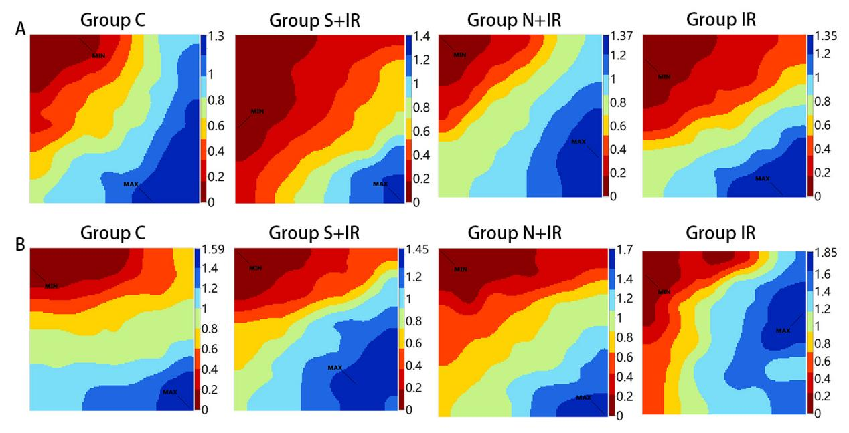Supplementary Figure 1 Classic activation maps were obtained in the four groups at T₁ (A) and T₃ (B).

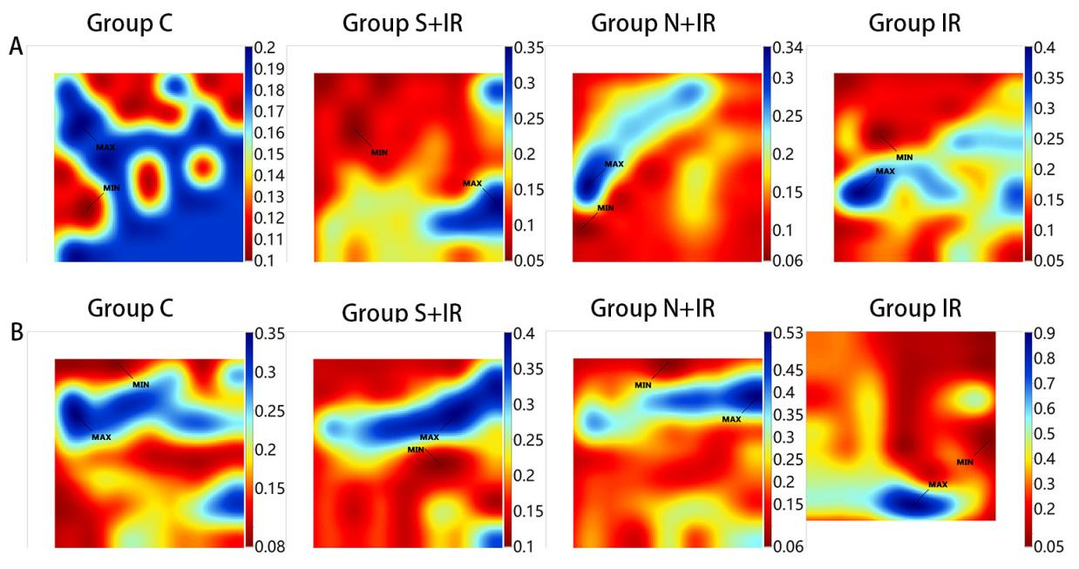
Supplementary Figure 2 Representative inhomogeneity maps were acquired in the four groups at T₁ (A) and T₃ (B).

