Is age the most important risk factor in COVID-19 patients? The relevance of comorbidity: A retrospective analysis of 10,551 hospitalizations

  - Supplementary file

Contents
Supplementary Figures: methods 3
Figure S1. Prevalence of SARS-CoV-2 variants of concern throughout the investigated period. A: Pango lineages. B: WHO nomenclature. Source: http://covidtag.paseq.org/ 3
Supplementary Figures: individual distribution across the Queralt DxS groups through the successive waves 4
Figure S2. Individual distribution across the Queralt DxS groups, according to age and sex. First wave. 4
Figure S3. Individual distribution across the Queralt DxS groups, according to age and sex. Second wave. 4
Figure S4. Individual distribution across the Queralt DxS groups, according to age and sex. Third wave. 5
Figure S5. Individual distribution across the Queralt DxS groups, according to age and sex. Fourth wave. 5
Figure S6. Individual distribution across the Queralt DxS groups, according to age and sex. Fifth wave. 5
Figure S7. Individual distribution across the Queralt DxS groups, according to age and sex. Sixth wave. 6
Figure S8. Individual distribution across the Queralt DxS groups, according to age and sex. Seventh wave. 6
Supplementary Tables: Main characteristics of individuals admitted in the successive waves 7
Table S1. Main demographic, clinical, and epidemiological characteristics of individuals admitted during the first wave 7
Table S2. Main demographic, clinical, and epidemiological characteristics of individuals admitted during the second wave 8
Table S3. Main demographic, clinical, and epidemiological characteristics of individuals admitted during the third wave. 9
Table S4. Main demographic, clinical, and epidemiological characteristics of individuals admitted during the fourth wave. 10
Table S5. Main demographic, clinical, and epidemiological characteristics of individuals admitted during the fifth wave. 11
Table S6. Main demographic, clinical, and epidemiological characteristics of individuals admitted during the sixth wave. 12
Table S7. Main demographic, clinical, and epidemiological characteristics of individuals admitted during the seventh wave. 13
Supplementary Tables: Adjusted models of age and sex 14
Table S8. Effect of age (coefficients and odds ratios for age groups) and sex on critical illness using multiple logistic regressions. First wave. 14
Table S9. Effect of age (coefficients and odds ratios for age groups) and sex on critical illness using multiple logistic regressions. Second wave. 15
Table S10. Effect of age (coefficients and odds ratios for age groups) and sex on critical illness using multiple logistic regressions. Third wave. 16
Table S11. Effect of age (coefficients and odds ratios for age groups) and sex on critical illness using multiple logistic regressions. Fourth wave. 17
Table S12. Effect of age (coefficients and odds ratios for age groups) and sex on critical illness using multiple logistic regressions. Fifth wave. 18
Table S13. Effect of age (coefficients and odds ratios for age groups) and sex on critical illness using multiple logistic regressions. Sixth wave. 19
Table S14. Effect of age (coefficients and odds ratios for age groups) and sex on critical illness using multiple logistic regressions. Seventh wave. 20
Supplementary Tables: Performance of the models 21
Table S15. Performance of the models for explaining critical illness. First wave. 21
Table S16. Performance of the models for explaining critical illness. Second wave. 22
Table S17. Performance of the models for explaining critical illness. Third wave. 23
Table S18. Performance of the models for explaining critical illness. Fourth wave. 24
Table S19. Performance of the models for explaining critical illness. Fifth wave. 25
Table S20. Performance of the models for explaining critical illness. Sixth wave. 26
Table S21. Performance of the models for explaining critical illness. Seventh wave. 27
Supplementary Tables: Causal mediation analysis by wave 28
Table S22. Causal mediation effect, direct effect, and proportion of mediation effect by comorbidity measures. First wave. 28
Table S23. Causal mediation effect, direct effect, and proportion of mediation effect by comorbidity measures. Second wave. 29
Table S24. Causal mediation effect, direct effect, and proportion of mediation effect by comorbidity measures. Third wave. 30
Table S25. Causal mediation effect, direct effect, and proportion of mediation effect by comorbidity measures. Fourth wave. 31
Table S27. Causal mediation effect, direct effect, and proportion of mediation effect by comorbidity measures. Sixth wave. 33
Table S28. Causal mediation effect, direct effect, and proportion of mediation effect by comorbidity measures. Seventh wave. 34

Supplementary Figures: methods

Figure S1. Prevalence of SARS-CoV-2 variants of concern throughout the investigated period. A: Pango lineages. B: WHO nomenclature. Source: http://covidtag.paseq.org/

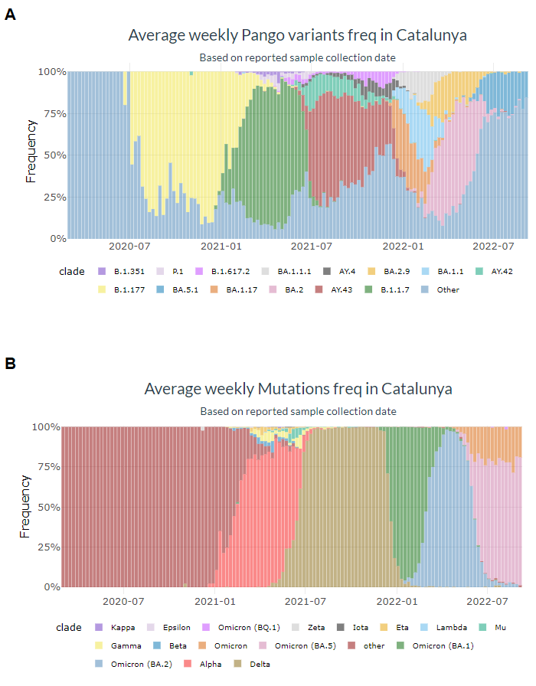

Supplementary Figures: individual distribution across the Queralt DxS groups through the successive waves

Figure S2. Individual distribution across the Queralt DxS groups, according to age and sex. First wave.
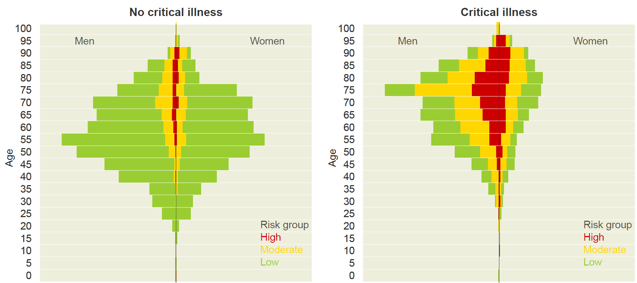

Figure S3. Individual distribution across the Queralt DxS groups, according to age and sex. Second wave.
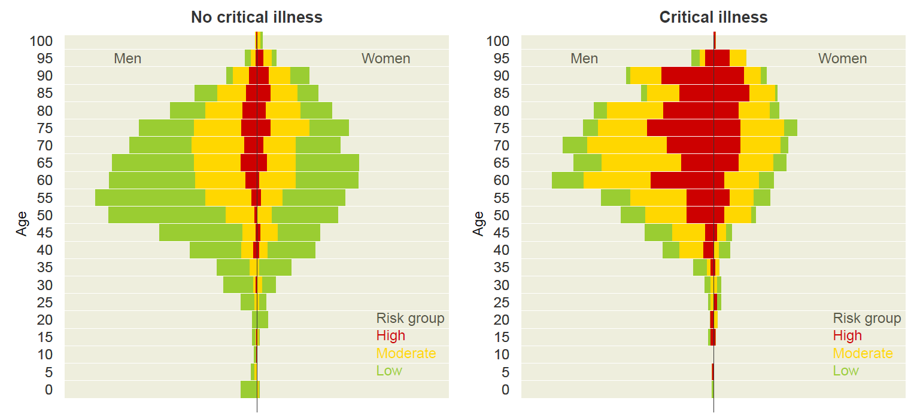

Figure S4. Individual distribution across the Queralt DxS groups, according to age and sex. Third wave.
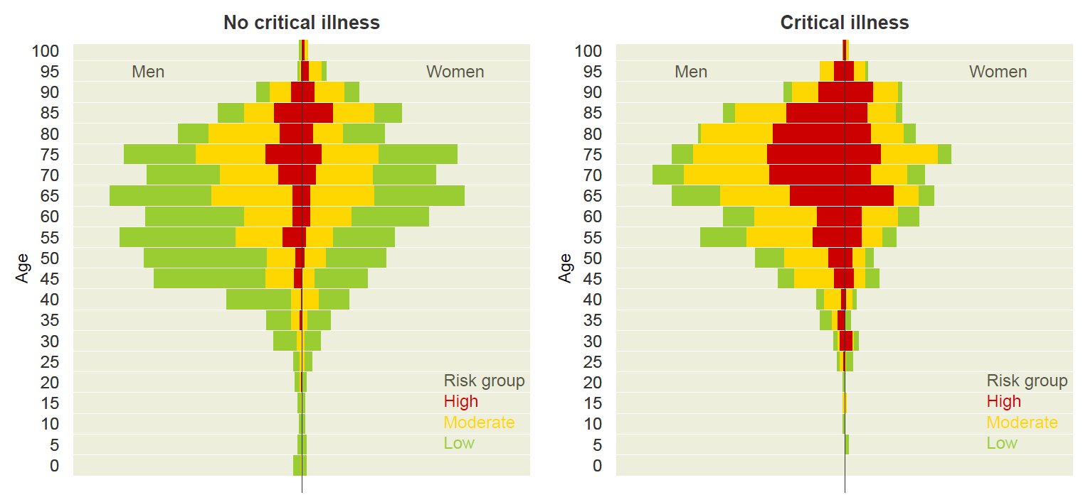

Figure S5. Individual distribution across the Queralt DxS groups, according to age and sex. Fourth wave.
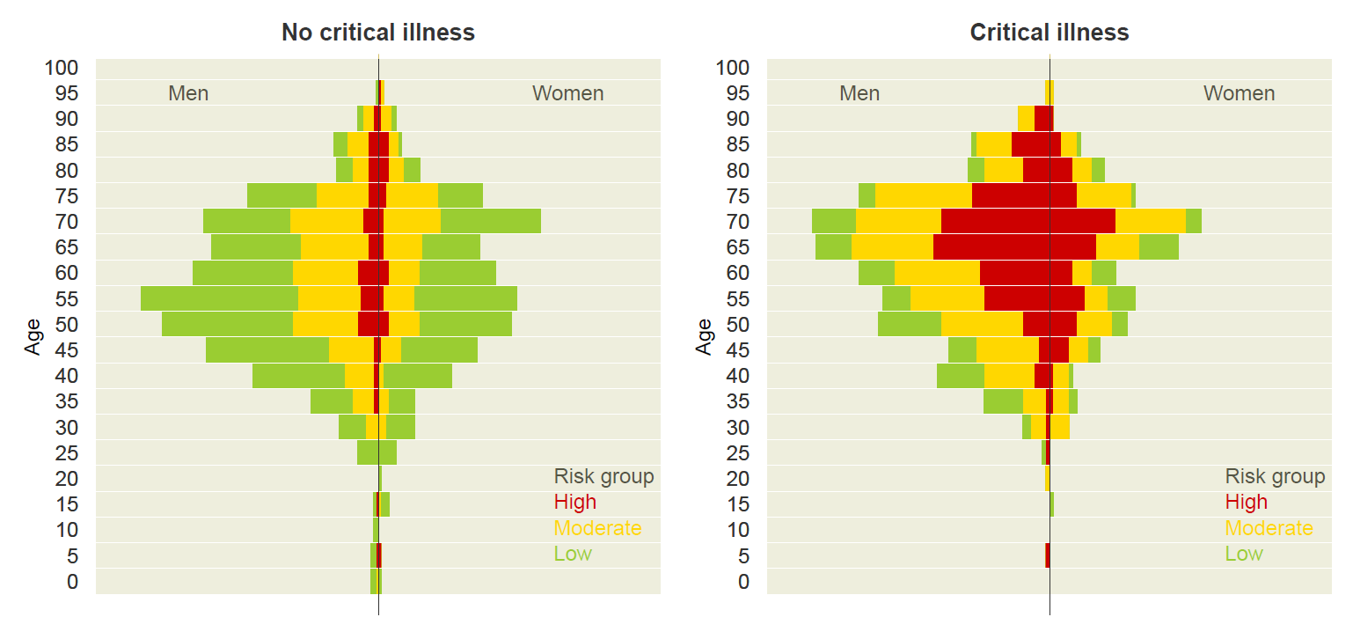

Figure S6. Individual distribution across the Queralt DxS groups, according to age and sex. Fifth wave.
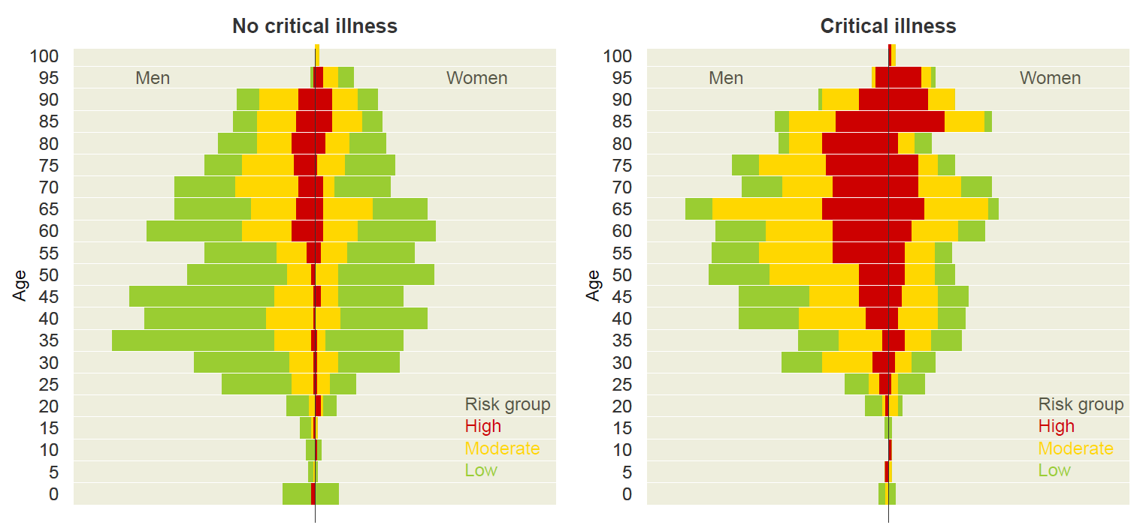

Figure S7. Individual distribution across the Queralt DxS groups, according to age and sex. Sixth wave.
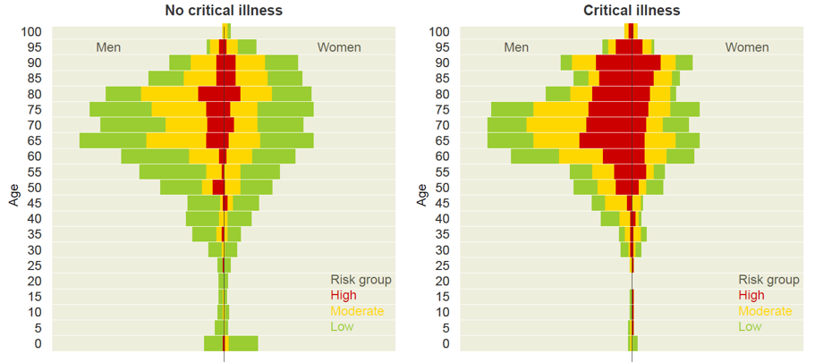

Figure S8. Individual distribution across the Queralt DxS groups, according to age and sex. Seventh wave.
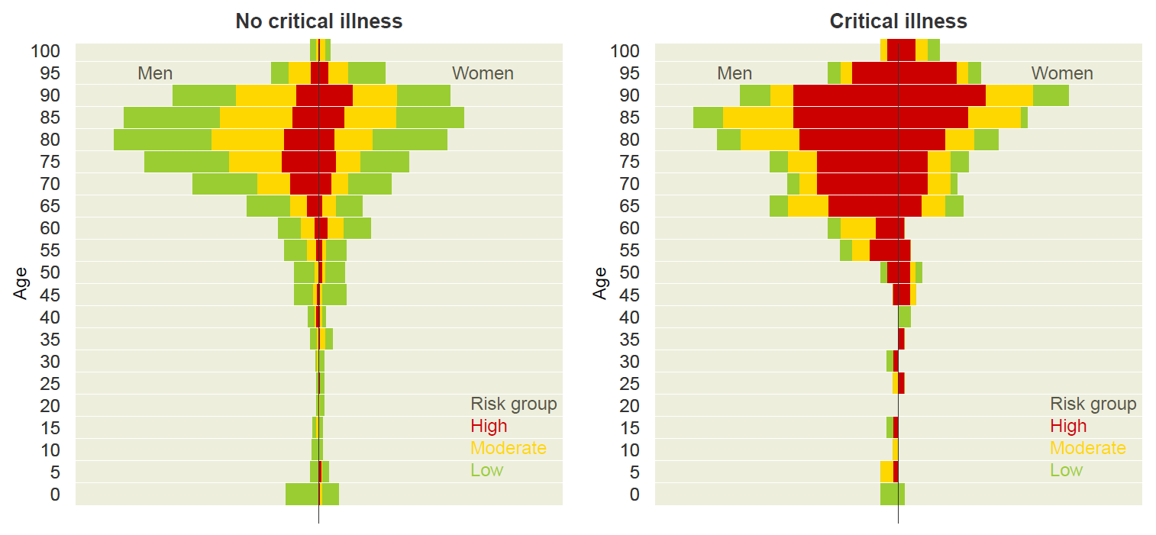

Supplementary Tables: Main characteristics of individuals admitted in the successive waves

Table S1. Main demographic, clinical, and epidemiological characteristics of individuals admitted during the first wave

 | No critical illness | Critical illness | Total | P
Age |  |  |  | < 0.001
Mean (SD) | 57.9 (15.2) | 68.3 (14.9) | 61.5 (15.9)
Age group |  |  |  | < 0.001
0 - 39 | 289 (84.8%) | 52 (15.2%) | 341 (100.0%)
40 - 49 | 436 (81.5%) | 99 (18.5%) | 535 (100.0%)
50 - 59 | 631 (75.2%) | 208 (24.8%) | 839 (100.0%)
60 - 69 | 524 (64.7%) | 286 (35.3%) | 810 (100.0%)
70 - 79 | 441 (54.7%) | 365 (45.3%) | 806 (100.0%)
80 -> | 183 (36.4%) | 320 (63.6%) | 503 (100.0%)
Sex |  |  |  | < 0.001
Men | 1367 (60.3%) | 901 (39.7%) | 2268 (100.0%)
Women | 1137 (72.6%) | 429 (27.4%) | 1566 (100.0%)
Hospital |  |  |  | < 0.001
Arnau de Vilanova | 143 (54.2%) | 121 (45.8%) | 264 (100.0%)
Joan XXIII | 64 (52.9%) | 57 (47.1%) | 121 (100.0%)
Verge de la Cinta | 29 (64.4%) | 16 (35.6%) | 45 (100.0%)
Dr Trueta | 176 (59.1%) | 122 (40.9%) | 298 (100.0%)
Bellvitge | 778 (68.5%) | 358 (31.5%) | 1136 (100.0%)
Germans Trias | 281 (49.4%) | 288 (50.6%) | 569 (100.0%)
Vall Hebron | 1033 (73.7%) | 368 (26.3%) | 1401 (100.0%)
Vaccine
No vaccine | 2504 (65.3%) | 1330 (34.7%) | 3834 (100.0%)
1st dose | 0 (NaN%) | 0 (NaN%) | 0 (NaN%)
2nd dose | 0 (NaN%) | 0 (NaN%) | 0 (NaN%)
3rd dose | 0 (NaN%) | 0 (NaN%) | 0 (NaN%)
Wave |  |  |  | < 0.001
1st wave | 2504 (65.3%) | 1330 (34.7%) | 3834 (100.0%)
Charlson index |  |  |  | < 0.001
Mean (SD) | 0.7 (1.3) | 1.3 (1.7) | 0.9 (1.5)
Charlson risk |  |  |  | < 0.001
Low | 1631 (73.7%) | 583 (26.3%) | 2214 (100.0%)
Moderate | 699 (59.4%) | 477 (40.6%) | 1176 (100.0%)
High | 174 (39.2%) | 270 (60.8%) | 444 (100.0%)
Elixhauser index |  |  |  | < 0.001
Mean (SD) | 1.2 (5.5) | 5.0 (8.2) | 2.5 (6.8)
Elixhauser risk |  |  |  | < 0.001
Low | 1831 (75.8%) | 586 (24.2%) | 2417 (100.0%)
Moderate | 422 (53.2%) | 371 (46.8%) | 793 (100.0%)
High | 251 (40.2%) | 373 (59.8%) | 624 (100.0%)
Elixhauser measure |  |  |  | < 0.001
Mean (SD) | 1.4 (1.5) | 2.5 (1.7) | 1.8 (1.7)
Elix. measure risk |  |  |  | < 0.001
Low | 1565 (78.2%) | 435 (21.8%) | 2000 (100.0%)
Moderate | 699 (55.6%) | 559 (44.4%) | 1258 (100.0%)
High | 240 (41.7%) | 336 (58.3%) | 576 (100.0%)
Queralt DxS index |  |  |  | < 0.001
Mean (SD) | 10.9 (9.5) | 25.8 (15.5) | 16.0 (13.9)
Queralt DxS risk |  |  |  | < 0.001
Low | 2136 (80.2%) | 528 (19.8%) | 2664 (100.0%)
Moderate | 271 (37.7%) | 448 (62.3%) | 719 (100.0%)
High | 97 (21.5%) | 354 (78.5%) | 451 (100.0%)

Table S2. Main demographic, clinical, and epidemiological characteristics of individuals admitted during the second wave

 | No critical illness | Critical illness | Total | P
Age |  |  |  | < 0.001
Mean (SD) | 60.6 (17.5) | 66.5 (16.0) | 62.4 (17.3)
Age group |  |  |  | < 0.001
0 - 39 | 268 (83.0%) | 55 (17.0%) | 323 (100.0%)
40 - 49 | 358 (78.9%) | 96 (21.1%) | 454 (100.0%)
50 - 59 | 515 (72.8%) | 192 (27.2%) | 707 (100.0%)
60 - 69 | 529 (69.4%) | 233 (30.6%) | 762 (100.0%)
70 - 79 | 438 (65.3%) | 233 (34.7%) | 671 (100.0%)
80 -> | 352 (58.9%) | 246 (41.1%) | 598 (100.0%)
Sex |  |  |  | < 0.001
Men | 1426 (67.4%) | 691 (32.6%) | 2117 (100.0%)
Women | 1034 (74.0%) | 364 (26.0%) | 1398 (100.0%)
Hospital |  |  |  | < 0.001
Arnau de Vilanova | 515 (74.7%) | 174 (25.3%) | 689 (100.0%)
Joan XXIII | 293 (81.6%) | 66 (18.4%) | 359 (100.0%)
Verge de la Cinta | 116 (73.4%) | 42 (26.6%) | 158 (100.0%)
Dr Trueta | 216 (60.8%) | 139 (39.2%) | 355 (100.0%)
Bellvitge | 316 (68.0%) | 149 (32.0%) | 465 (100.0%)
Germans Trias | 402 (62.8%) | 238 (37.2%) | 640 (100.0%)
Vall Hebron | 602 (70.9%) | 247 (29.1%) | 849 (100.0%)
Vaccine
No vaccine | 2460 (70.0%) | 1055 (30.0%) | 3515 (100.0%)
1st dose | 0 (NaN%) | 0 (NaN%) | 0 (NaN%)
2nd dose | 0 (NaN%) | 0 (NaN%) | 0 (NaN%)
3rd dose | 0 (NaN%) | 0 (NaN%) | 0 (NaN%)
Wave |  |  |  | < 0.001
1st wave | 2460 (70.0%) | 1055 (30.0%) | 3515 (100.0%)
Charlson index |  |  |  | < 0.001
Mean (SD) | 1.0 (1.5) | 1.4 (1.9) | 1.1 (1.6)
Charlson risk |  |  |  | < 0.001
Low | 1318 (75.6%) | 425 (24.4%) | 1743 (100.0%)
Moderate | 832 (66.6%) | 417 (33.4%) | 1249 (100.0%)
High | 310 (59.3%) | 213 (40.7%) | 523 (100.0%)
Elixhauser index |  |  |  | < 0.001
Mean (SD) | 1.5 (6.4) | 4.7 (8.9) | 2.5 (7.4)
Elixhauser risk |  |  |  | < 0.001
Low | 1630 (77.6%) | 471 (22.4%) | 2101 (100.0%)
Moderate | 530 (63.1%) | 310 (36.9%) | 840 (100.0%)
High | 300 (52.3%) | 274 (47.7%) | 574 (100.0%)
Elixhauser measure |  |  |  | < 0.001
Mean (SD) | 1.8 (1.7) | 2.6 (1.7) | 2.1 (1.7)
Elix. measure risk |  |  |  | < 0.001
Low | 1232 (80.3%) | 303 (19.7%) | 1535 (100.0%)
Moderate | 848 (64.8%) | 461 (35.2%) | 1309 (100.0%)
High | 380 (56.6%) | 291 (43.4%) | 671 (100.0%)
Queralt DxS index |  |  |  | < 0.001
Mean (SD) | 18.8 (11.0) | 32.8 (17.1) | 23.0 (14.6)
Queralt DxS risk |  |  |  | < 0.001
Low | 1483 (88.4%) | 194 (11.6%) | 1677 (100.0%)
Moderate | 656 (62.2%) | 399 (37.8%) | 1055 (100.0%)
High | 321 (41.0%) | 462 (59.0%) | 783 (100.0%)

Table S3. Main demographic, clinical, and epidemiological characteristics of individuals admitted during the third wave.

 | No critical illness | Critical illness | Total | P
Age |  |  |  | < 0.001
Mean (SD) | 62.7 (16.7) | 67.2 (15.3) | 64.3 (16.3)
Age group |  |  |  | < 0.001
0 - 39 | 156 (75.0%) | 52 (25.0%) | 208 (100.0%)
40 - 49 | 255 (75.7%) | 82 (24.3%) | 337 (100.0%)
50 - 59 | 388 (68.0%) | 183 (32.0%) | 571 (100.0%)
60 - 69 | 456 (63.5%) | 262 (36.5%) | 718 (100.0%)
70 - 79 | 415 (59.6%) | 281 (40.4%) | 696 (100.0%)
80 -> | 314 (55.6%) | 251 (44.4%) | 565 (100.0%)
Sex |  |  |  | < 0.001
Men | 1128 (60.6%) | 732 (39.4%) | 1860 (100.0%)
Women | 856 (69.3%) | 379 (30.7%) | 1235 (100.0%)
Hospital |  |  |  | < 0.001
Arnau de Vilanova | 347 (71.1%) | 141 (28.9%) | 488 (100.0%)
Joan XXIII | 188 (70.1%) | 80 (29.9%) | 268 (100.0%)
Verge de la Cinta | 117 (77.5%) | 34 (22.5%) | 151 (100.0%)
Dr Trueta | 162 (54.9%) | 133 (45.1%) | 295 (100.0%)
Bellvitge | 295 (60.5%) | 193 (39.5%) | 488 (100.0%)
Germans Trias | 363 (53.9%) | 310 (46.1%) | 673 (100.0%)
Vall Hebron | 512 (69.9%) | 220 (30.1%) | 732 (100.0%)
Vaccine
No vaccine | 1945 (64.0%) | 1095 (36.0%) | 3040 (100.0%)
1st dose | 38 (71.7%) | 15 (28.3%) | 53 (100.0%)
2nd dose | 1 (50.0%) | 1 (50.0%) | 2 (100.0%)
3rd dose | 0 (NaN%) | 0 (NaN%) | 0 (NaN%)
Wave |  |  |  | < 0.001
1st wave | 1984 (64.1%) | 1111 (35.9%) | 3095 (100.0%)
Charlson index |  |  |  | < 0.001
Mean (SD) | 1.1 (1.6) | 1.4 (1.9) | 1.2 (1.7)
Charlson risk |  |  |  | < 0.001
Low | 1015 (69.2%) | 452 (30.8%) | 1467 (100.0%)
Moderate | 700 (61.5%) | 439 (38.5%) | 1139 (100.0%)
High | 269 (55.0%) | 220 (45.0%) | 489 (100.0%)
Elixhauser index |  |  |  | < 0.001
Mean (SD) | 1.6 (6.5) | 4.7 (8.9) | 2.7 (7.6)
Elixhauser risk |  |  |  | < 0.001
Low | 1292 (71.5%) | 516 (28.5%) | 1808 (100.0%)
Moderate | 436 (60.6%) | 283 (39.4%) | 719 (100.0%)
High | 256 (45.1%) | 312 (54.9%) | 568 (100.0%)
Elixhauser measure |  |  |  | < 0.001
Mean (SD) | 1.9 (1.7) | 2.6 (1.8) | 2.2 (1.7)
Elix. measure risk |  |  |  | < 0.001
Low | 925 (73.5%) | 333 (26.5%) | 1258 (100.0%)
Moderate | 721 (61.7%) | 447 (38.3%) | 1168 (100.0%)
High | 338 (50.5%) | 331 (49.5%) | 669 (100.0%)
Queralt DxS index |  |  |  | < 0.001
Mean (SD) | 19.9 (11.1) | 32.3 (15.9) | 24.4 (14.3)
Queralt DxS risk |  |  |  | < 0.001
Low | 1101 (83.5%) | 218 (16.5%) | 1319 (100.0%)
Moderate | 585 (58.4%) | 417 (41.6%) | 1002 (100.0%)
High | 298 (38.5%) | 476 (61.5%) | 774 (100.0%)

Table S4. Main demographic, clinical, and epidemiological characteristics of individuals admitted during the fourth wave.

 | No critical illness | Critical illness | Total | P
Age |  |  |  | < 0.001
Mean (SD) | 56.9 (15.4) | 61.3 (14.4) | 58.5 (15.2)
Age group |  |  |  | < 0.001
0 - 39 | 126 (71.6%) | 50 (28.4%) | 176 (100.0%)
40 - 49 | 206 (71.3%) | 83 (28.7%) | 289 (100.0%)
50 - 59 | 258 (64.5%) | 142 (35.5%) | 400 (100.0%)
60 - 69 | 238 (57.3%) | 177 (42.7%) | 415 (100.0%)
70 - 79 | 185 (57.1%) | 139 (42.9%) | 324 (100.0%)
80 -> | 54 (48.6%) | 57 (51.4%) | 111 (100.0%)
Sex |  |  |  | < 0.001
Men | 638 (59.2%) | 439 (40.8%) | 1077 (100.0%)
Women | 429 (67.2%) | 209 (32.8%) | 638 (100.0%)
Hospital |  |  |  | < 0.001
Arnau de Vilanova | 289 (72.4%) | 110 (27.6%) | 399 (100.0%)
Joan XXIII | 67 (61.5%) | 42 (38.5%) | 109 (100.0%)
Verge de la Cinta | 53 (61.6%) | 33 (38.4%) | 86 (100.0%)
Dr Trueta | 83 (45.9%) | 98 (54.1%) | 181 (100.0%)
Bellvitge | 134 (61.2%) | 85 (38.8%) | 219 (100.0%)
Germans Trias | 147 (53.5%) | 128 (46.5%) | 275 (100.0%)
Vall Hebron | 294 (65.9%) | 152 (34.1%) | 446 (100.0%)
Vaccine
No vaccine | 886 (62.0%) | 543 (38.0%) | 1429 (100.0%)
1st dose | 151 (61.9%) | 93 (38.1%) | 244 (100.0%)
2nd dose | 30 (71.4%) | 12 (28.6%) | 42 (100.0%)
3rd dose | 0 (NaN%) | 0 (NaN%) | 0 (NaN%)
Wave |  |  |  | < 0.001
1st wave | 1067 (62.2%) | 648 (37.8%) | 1715 (100.0%)
Charlson index |  |  |  | < 0.001
Mean (SD) | 0.6 (1.1) | 1.1 (1.6) | 0.8 (1.4)
Charlson risk |  |  |  | < 0.001
Low | 684 (67.5%) | 330 (32.5%) | 1014 (100.0%)
Moderate | 314 (57.5%) | 232 (42.5%) | 546 (100.0%)
High | 69 (44.5%) | 86 (55.5%) | 155 (100.0%)
Elixhauser index |  |  |  | < 0.001
Mean (SD) | 0.9 (5.8) | 2.8 (8.4) | 1.6 (6.9)
Elixhauser risk |  |  |  | < 0.001
Low | 767 (67.0%) | 378 (33.0%) | 1145 (100.0%)
Moderate | 176 (55.3%) | 142 (44.7%) | 318 (100.0%)
High | 124 (49.2%) | 128 (50.8%) | 252 (100.0%)
Elixhauser measure |  |  |  | < 0.001
Mean (SD) | 1.5 (1.5) | 2.3 (1.7) | 1.8 (1.6)
Elix. measure risk |  |  |  | < 0.001
Low | 611 (72.1%) | 236 (27.9%) | 847 (100.0%)
Moderate | 342 (55.1%) | 279 (44.9%) | 621 (100.0%)
High | 114 (46.2%) | 133 (53.8%) | 247 (100.0%)
Queralt DxS index |  |  |  | < 0.001
Mean (SD) | 18.8 (10.6) | 31.5 (15.7) | 23.6 (14.2)
Queralt DxS risk |  |  |  | < 0.001
Low | 649 (82.7%) | 136 (17.3%) | 785 (100.0%)
Moderate | 289 (56.4%) | 223 (43.6%) | 512 (100.0%)
High | 129 (30.9%) | 289 (69.1%) | 418 (100.0%)

Table S5. Main demographic, clinical, and epidemiological characteristics of individuals admitted during the fifth wave.

 | No critical illness | Critical illness | Total | P
Age |  |  |  | < 0.001
Mean (SD) | 54.2 (21.0) | 58.8 (19.5) | 55.9 (20.5)
Age group |  |  |  | < 0.001
0 - 39 | 404 (71.5%) | 161 (28.5%) | 565 (100.0%)
40 - 49 | 271 (65.1%) | 145 (34.9%) | 416 (100.0%)
50 - 59 | 192 (58.0%) | 139 (42.0%) | 331 (100.0%)
60 - 69 | 259 (57.8%) | 189 (42.2%) | 448 (100.0%)
70 - 79 | 168 (56.9%) | 127 (43.1%) | 295 (100.0%)
80 -> | 211 (58.1%) | 152 (41.9%) | 363 (100.0%)
Sex |  |  |  | 0.036
Men | 888 (60.6%) | 578 (39.4%) | 1466 (100.0%)
Women | 617 (64.8%) | 335 (35.2%) | 952 (100.0%)
Hospital |  |  |  | < 0.001
Arnau de Vilanova | 156 (66.4%) | 79 (33.6%) | 235 (100.0%)
Joan XXIII | 147 (72.4%) | 56 (27.6%) | 203 (100.0%)
Verge de la Cinta | 61 (64.2%) | 34 (35.8%) | 95 (100.0%)
Dr Trueta | 98 (46.2%) | 114 (53.8%) | 212 (100.0%)
Bellvitge | 342 (62.8%) | 203 (37.2%) | 545 (100.0%)
Germans Trias | 231 (51.9%) | 214 (48.1%) | 445 (100.0%)
Vall Hebron | 470 (68.8%) | 213 (31.2%) | 683 (100.0%)
Vaccine
No vaccine | 826 (62.2%) | 503 (37.8%) | 1329 (100.0%)
1st dose | 277 (66.1%) | 142 (33.9%) | 419 (100.0%)
2nd dose | 402 (60.0%) | 268 (40.0%) | 670 (100.0%)
3rd dose | 0 (NaN%) | 0 (NaN%) | 0 (NaN%)
Wave |  |  |  | < 0.001
1st wave | 1505 (62.2%) | 913 (37.8%) | 2418 (100.0%)
Charlson index |  |  |  | 0.012
Mean (SD) | 0.9 (1.5) | 1.1 (1.6) | 1.0 (1.5)
Charlson risk |  |  |  | < 0.001
Low | 877 (65.5%) | 462 (34.5%) | 1339 (100.0%)
Moderate | 440 (59.4%) | 301 (40.6%) | 741 (100.0%)
High | 188 (55.6%) | 150 (44.4%) | 338 (100.0%)
Elixhauser index |  |  |  | < 0.001
Mean (SD) | 1.8 (6.3) | 2.9 (7.6) | 2.2 (6.8)
Elixhauser risk |  |  |  | < 0.001
Low | 993 (66.2%) | 507 (33.8%) | 1500 (100.0%)
Moderate | 319 (59.6%) | 216 (40.4%) | 535 (100.0%)
High | 193 (50.4%) | 190 (49.6%) | 383 (100.0%)
Elixhauser measure |  |  |  | < 0.001
Mean (SD) | 1.6 (1.7) | 2.2 (1.7) | 1.8 (1.7)
Elix. measure risk |  |  |  | < 0.001
Low | 844 (69.0%) | 379 (31.0%) | 1223 (100.0%)
Moderate | 452 (57.7%) | 332 (42.3%) | 784 (100.0%)
High | 209 (50.9%) | 202 (49.1%) | 411 (100.0%)
Queralt DxS index |  |  |  | < 0.001
Mean (SD) | 18.0 (10.9) | 29.2 (14.8) | 22.2 (13.6)
Queralt DxS risk |  |  |  | < 0.001
Low | 944 (79.0%) | 251 (21.0%) | 1195 (100.0%)
Moderate | 379 (54.5%) | 317 (45.5%) | 696 (100.0%)
High | 182 (34.5%) | 345 (65.5%) | 527 (100.0%)

Table S6. Main demographic, clinical, and epidemiological characteristics of individuals admitted during the sixth wave.

 | No critical illness | Critical illness | Total | P
Age |  |  |  | < 0.001
Mean (SD) | 65.1 (20.8) | 68.2 (17.5) | 66.2 (19.8)
Age group |  |  |  | 0.002
0 - 39 | 203 (77.2%) | 60 (22.8%) | 263 (100.0%)
40 - 49 | 155 (66.8%) | 77 (33.2%) | 232 (100.0%)
50 - 59 | 248 (65.3%) | 132 (34.7%) | 380 (100.0%)
60 - 69 | 438 (63.5%) | 252 (36.5%) | 690 (100.0%)
70 - 79 | 445 (63.4%) | 257 (36.6%) | 702 (100.0%)
80 -> | 505 (64.7%) | 275 (35.3%) | 780 (100.0%)
Sex |  |  |  | < 0.001
Men | 1106 (62.5%) | 665 (37.5%) | 1771 (100.0%)
Women | 888 (69.6%) | 388 (30.4%) | 1276 (100.0%)
Hospital |  |  |  | < 0.001
Arnau de Vilanova | 356 (66.5%) | 179 (33.5%) | 535 (100.0%)
Joan XXIII | 179 (71.0%) | 73 (29.0%) | 252 (100.0%)
Verge de la Cinta | 147 (73.9%) | 52 (26.1%) | 199 (100.0%)
Dr Trueta | 155 (54.4%) | 130 (45.6%) | 285 (100.0%)
Bellvitge | 303 (61.2%) | 192 (38.8%) | 495 (100.0%)
Germans Trias | 282 (55.4%) | 227 (44.6%) | 509 (100.0%)
Vall Hebron | 572 (74.1%) | 200 (25.9%) | 772 (100.0%)
Vaccine |  |  |  | < 0.001
No vaccine | 567 (59.7%) | 382 (40.3%) | 949 (100.0%)
1st dose | 91 (61.9%) | 56 (38.1%) | 147 (100.0%)
2nd dose | 617 (67.0%) | 304 (33.0%) | 921 (100.0%)
3rd dose | 719 (69.8%) | 311 (30.2%) | 1030 (100.0%)
Wave |  |  |  | < 0.001
1st wave | 1994 (65.4%) | 1053 (34.6%) | 3047 (100.0%)
Charlson index |  |  |  | 0.589
Mean (SD) | 1.7 (2.0) | 1.8 (1.9) | 1.7 (2.0)
Charlson risk |  |  |  | 0.183
Low | 663 (65.1%) | 355 (34.9%) | 1018 (100.0%)
Moderate | 824 (67.2%) | 403 (32.8%) | 1227 (100.0%)
High | 507 (63.2%) | 295 (36.8%) | 802 (100.0%)
Elixhauser index |  |  |  | < 0.001
Mean (SD) | 4.3 (8.1) | 5.8 (9.2) | 4.8 (8.5)
Elixhauser risk |  |  |  | < 0.001
Low | 928 (68.4%) | 428 (31.6%) | 1356 (100.0%)
Moderate | 628 (68.3%) | 292 (31.7%) | 920 (100.0%)
High | 438 (56.8%) | 333 (43.2%) | 771 (100.0%)
Elixhauser measure |  |  |  | < 0.001
Mean (SD) | 2.6 (1.9) | 2.9 (1.9) | 2.7 (1.9)
Elix. measure risk |  |  |  | < 0.001
Low | 645 (70.3%) | 273 (29.7%) | 918 (100.0%)
Moderate | 780 (65.9%) | 404 (34.1%) | 1184 (100.0%)
High | 569 (60.2%) | 376 (39.8%) | 945 (100.0%)
Queralt DxS index |  |  |  | < 0.001
Mean (SD) | 19.2 (12.4) | 30.8 (18.8) | 23.2 (15.9)
Queralt DxS risk |  |  |  | < 0.001
Low | 1135 (77.6%) | 328 (22.4%) | 1463 (100.0%)
Moderate | 569 (66.1%) | 292 (33.9%) | 861 (100.0%)
High | 290 (40.1%) | 433 (59.9%) | 723 (100.0%)

Table S7. Main demographic, clinical, and epidemiological characteristics of individuals admitted during the seventh wave.

 | No critical illness | Critical illness | Total | P
Age |  |  |  | 0.012
Mean (SD) | 72.8 (20.5) | 75.8 (18.4) | 73.3 (20.2)
Age group |  |  |  | 0.244
0 - 39 | 116 (87.9%) | 16 (12.1%) | 132 (100.0%)
40 - 49 | 68 (89.5%) | 8 (10.5%) | 76 (100.0%)
50 - 59 | 107 (84.3%) | 20 (15.7%) | 127 (100.0%)
60 - 69 | 189 (80.1%) | 47 (19.9%) | 236 (100.0%)
70 - 79 | 430 (83.3%) | 86 (16.7%) | 516 (100.0%)
80 -> | 780 (82.0%) | 171 (18.0%) | 951 (100.0%)
Sex |  |  |  | 0.265
Men | 965 (82.1%) | 210 (17.9%) | 1175 (100.0%)
Women | 725 (84.0%) | 138 (16.0%) | 863 (100.0%)
Hospital |  |  |  | < 0.001
Arnau de Vilanova | 309 (81.3%) | 71 (18.7%) | 380 (100.0%)
Joan XXIII | 167 (87.0%) | 25 (13.0%) | 192 (100.0%)
Verge de la Cinta | 89 (89.0%) | 11 (11.0%) | 100 (100.0%)
Dr Trueta | 99 (74.4%) | 34 (25.6%) | 133 (100.0%)
Bellvitge | 261 (81.6%) | 59 (18.4%) | 320 (100.0%)
Germans Trias | 275 (76.8%) | 83 (23.2%) | 358 (100.0%)
Vall Hebron | 490 (88.3%) | 65 (11.7%) | 555 (100.0%)
Vaccine |  |  |  | 0.859
No vaccine | 235 (81.3%) | 54 (18.7%) | 289 (100.0%)
1st dose | 25 (80.6%) | 6 (19.4%) | 31 (100.0%)
2nd dose | 148 (83.1%) | 30 (16.9%) | 178 (100.0%)
3rd dose | 1282 (83.2%) | 258 (16.8%) | 1540 (100.0%)
Wave |  |  |  | < 0.001
1st wave | 1690 (82.9%) | 348 (17.1%) | 2038 (100.0%)
Charlson index |  |  |  | 0.012
Mean (SD) | 2.2 (2.1) | 2.5 (2.3) | 2.3 (2.1)
Charlson risk |  |  |  | 0.060
Low | 354 (86.3%) | 56 (13.7%) | 410 (100.0%)
Moderate | 745 (83.1%) | 152 (16.9%) | 897 (100.0%)
High | 591 (80.8%) | 140 (19.2%) | 731 (100.0%)
Elixhauser index |  |  |  | < 0.001
Mean (SD) | 6.2 (8.1) | 10.5 (10.4) | 6.9 (8.7)
Elixhauser risk |  |  |  | < 0.001
Low | 536 (87.6%) | 76 (12.4%) | 612 (100.0%)
Moderate | 655 (87.9%) | 90 (12.1%) | 745 (100.0%)
High | 499 (73.3%) | 182 (26.7%) | 681 (100.0%)
Elixhauser measure |  |  |  | < 0.001
Mean (SD) | 3.0 (1.8) | 3.7 (1.9) | 3.1 (1.8)
Elix. measure risk |  |  |  | < 0.001
Low | 368 (88.9%) | 46 (11.1%) | 414 (100.0%)
Moderate | 717 (85.7%) | 120 (14.3%) | 837 (100.0%)
High | 605 (76.9%) | 182 (23.1%) | 787 (100.0%)
Queralt DxS index |  |  |  | < 0.001
Mean (SD) | 20.4 (12.5) | 37.7 (21.1) | 23.3 (15.8)
Queralt DxS risk |  |  |  | < 0.001
Low | 904 (93.8%) | 60 (6.2%) | 964 (100.0%)
Moderate | 509 (84.0%) | 97 (16.0%) | 606 (100.0%)
High | 277 (59.2%) | 191 (40.8%) | 468 (100.0%)

Supplementary Tables: Adjusted models of age and sex

Table S8. Effect of age (coefficients and odds ratios for age groups) and sex on critical illness using multiple logistic regressions. First wave.
The base model included only age, sex, and hospital, whereas the other models were built by adjusting the base model for each of the multimorbidity measures: the Charlson index, the Elixhauser index, the unweighted count of Elixhauser diagnoses (Elixhauser measure), and the Queralt DxS.
 |  | Coefficients |  |  | OR
 |  | Estimate | St. dev. | p-value | Estimate | 95% CI
Base model
Age 40 - 49 |  | 0.219 | 0.190 | 0.251 | 1.244 | 0.857 - 1.807
Age 50 - 59 |  | 0.594 | 0.174 | < 0.001 | 1.811 | 1.289 - 2.545
Age 60 - 69 |  | 1.099 | 0.171 | < 0.001 | 3.000 | 2.147 - 4.192
Age 70 - 79 |  | 1.513 | 0.170 | < 0.001 | 4.540 | 3.252 - 6.338
Age >=80 |  | 2.250 | 0.182 | < 0.001 | 9.487 | 6.644 - 13.544
Women |  | -0.629 | 0.077 | < 0.001 | 0.533 | 0.459 - 0.619
Charlson index
Age 40 - 49 |  | 0.195 | 0.190 | 0.305 | 1.216 | 0.837 - 1.766
Age 50 - 59 |  | 0.543 | 0.174 | 0.002 | 1.722 | 1.224 - 2.421
Age 60 - 69 |  | 1.002 | 0.172 | < 0.001 | 2.723 | 1.944 - 3.814
Age 70 - 79 |  | 1.354 | 0.173 | < 0.001 | 3.872 | 2.759 - 5.436
Age >=80 |  | 2.009 | 0.187 | < 0.001 | 7.457 | 5.167 - 10.764
Women |  | -0.595 | 0.077 | < 0.001 | 0.552 | 0.474 - 0.641
Elixhauser index
Age 40 - 49 |  | 0.227 | 0.192 | 0.236 | 1.255 | 0.862 - 1.827
Age 50 - 59 |  | 0.555 | 0.175 | 0.002 | 1.743 | 1.237 - 2.455
Age 60 - 69 |  | 0.969 | 0.173 | < 0.001 | 2.634 | 1.878 - 3.695
Age 70 - 79 |  | 1.308 | 0.173 | < 0.001 | 3.699 | 2.637 - 5.19
Age >=80 |  | 1.965 | 0.185 | < 0.001 | 7.136 | 4.968 - 10.25
Women |  | -0.532 | 0.078 | < 0.001 | 0.588 | 0.504 - 0.685
Elixhauser measure
Age 40 - 49 |  | 0.121 | 0.192 | 0.527 | 1.129 | 0.775 - 1.644
Age 50 - 59 |  | 0.407 | 0.176 | 0.020 | 1.502 | 1.065 - 2.12
Age 60 - 69 |  | 0.779 | 0.174 | < 0.001 | 2.180 | 1.548 - 3.068
Age 70 - 79 |  | 1.015 | 0.177 | < 0.001 | 2.760 | 1.951 - 3.905
Age >=80 |  | 1.629 | 0.190 | < 0.001 | 5.100 | 3.512 - 7.406
Women |  | -0.617 | 0.078 | < 0.001 | 0.540 | 0.463 - 0.629
Queralt DxS index
Age 40 - 49 |  | 0.201 | 0.209 | 0.336 | 1.222 | 0.812 - 1.84
Age 50 - 59 |  | 0.298 | 0.193 | 0.122 | 1.347 | 0.924 - 1.964
Age 60 - 69 |  | 0.508 | 0.191 | 0.008 | 1.663 | 1.143 - 2.419
Age 70 - 79 |  | 0.688 | 0.192 | < 0.001 | 1.991 | 1.368 - 2.898
Age >=80 |  | 1.024 | 0.205 | < 0.001 | 2.785 | 1.862 - 4.166
Women |  | -0.552 | 0.086 | < 0.001 | 0.576 | 0.486 - 0.682

Table S9. Effect of age (coefficients and odds ratios for age groups) and sex on critical illness using multiple logistic regressions. Second wave.
The base model included only age, sex, and hospital, whereas the other models were built by adjusting the base model for each of the multimorbidity measures: the Charlson index, the Elixhauser index, the unweighted count of Elixhauser diagnoses (Elixhauser measure), and the Queralt DxS.
 |  | Coefficients |  |  | OR
 |  | Estimate | St. dev. | p-value | Estimate | 95% CI
Base model
Age 40 - 49 |  | 0.238 | 0.189 | 0.208 | 1.269 | 0.876 - 1.839
Age 50 - 59 |  | 0.595 | 0.173 | < 0.001 | 1.813 | 1.293 - 2.542
Age 60 - 69 |  | 0.786 | 0.170 | < 0.001 | 2.195 | 1.573 - 3.063
Age 70 - 79 |  | 0.998 | 0.171 | < 0.001 | 2.713 | 1.939 - 3.796
Age >=80 |  | 1.287 | 0.173 | < 0.001 | 3.620 | 2.577 - 5.086
Women |  | -0.400 | 0.079 | < 0.001 | 0.671 | 0.574 - 0.783
Charlson index
Age 40 - 49 |  | 0.230 | 0.189 | 0.225 | 1.258 | 0.868 - 1.824
Age 50 - 59 |  | 0.569 | 0.173 | < 0.001 | 1.767 | 1.26 - 2.479
Age 60 - 69 |  | 0.705 | 0.171 | < 0.001 | 2.025 | 1.448 - 2.832
Age 70 - 79 |  | 0.860 | 0.175 | < 0.001 | 2.364 | 1.679 - 3.328
Age >=80 |  | 1.115 | 0.178 | < 0.001 | 3.049 | 2.151 - 4.322
Women |  | -0.387 | 0.079 | < 0.001 | 0.679 | 0.581 - 0.793
Elixhauser index
Age 40 - 49 |  | 0.271 | 0.191 | 0.154 | 1.312 | 0.903 - 1.906
Age 50 - 59 |  | 0.615 | 0.174 | < 0.001 | 1.850 | 1.316 - 2.601
Age 60 - 69 |  | 0.755 | 0.171 | < 0.001 | 2.127 | 1.52 - 2.976
Age 70 - 79 |  | 0.857 | 0.174 | < 0.001 | 2.356 | 1.676 - 3.311
Age >=80 |  | 1.079 | 0.177 | < 0.001 | 2.942 | 2.081 - 4.159
Women |  | -0.342 | 0.080 | < 0.001 | 0.711 | 0.607 - 0.831
Elixhauser measure
Age 40 - 49 |  | 0.178 | 0.190 | 0.349 | 1.195 | 0.823 - 1.736
Age 50 - 59 |  | 0.471 | 0.174 | 0.007 | 1.601 | 1.139 - 2.252
Age 60 - 69 |  | 0.538 | 0.173 | 0.002 | 1.713 | 1.219 - 2.407
Age 70 - 79 |  | 0.613 | 0.178 | < 0.001 | 1.847 | 1.302 - 2.62
Age >=80 |  | 0.800 | 0.184 | < 0.001 | 2.225 | 1.552 - 3.19
Women |  | -0.427 | 0.080 | < 0.001 | 0.652 | 0.558 - 0.763
Queralt DxS index
Age 40 - 49 |  | 0.141 | 0.209 | 0.500 | 1.151 | 0.765 - 1.733
Age 50 - 59 |  | 0.321 | 0.192 | 0.094 | 1.378 | 0.947 - 2.007
Age 60 - 69 |  | 0.294 | 0.190 | 0.123 | 1.341 | 0.924 - 1.948
Age 70 - 79 |  | 0.221 | 0.194 | 0.255 | 1.248 | 0.852 - 1.826
Age >=80 |  | 0.244 | 0.199 | 0.220 | 1.277 | 0.864 - 1.886
Women |  | -0.351 | 0.087 | < 0.001 | 0.704 | 0.594 - 0.835

Table S10. Effect of age (coefficients and odds ratios for age groups) and sex on critical illness using multiple logistic regressions. Third wave.
The base model included only age, sex, and hospital, whereas the other models were built by adjusting the base model for each of the multimorbidity measures: the Charlson index, the Elixhauser index, the unweighted count of Elixhauser diagnoses (Elixhauser measure), and the Queralt DxS.
 |  | Coefficients |  |  | OR
 |  | Estimate | St. dev. | p-value | Estimate | 95% CI
Base model
Age 40 - 49 |  | -0.056 | 0.208 | 0.786 | 0.945 | 0.629 - 1.42
Age 50 - 59 |  | 0.382 | 0.187 | 0.041 | 1.466 | 1.016 - 2.115
Age 60 - 69 |  | 0.591 | 0.181 | 0.001 | 1.805 | 1.266 - 2.574
Age 70 - 79 |  | 0.782 | 0.181 | < 0.001 | 2.187 | 1.533 - 3.12
Age >=80 |  | 0.922 | 0.185 | < 0.001 | 2.515 | 1.75 - 3.615
Women |  | -0.482 | 0.081 | < 0.001 | 0.618 | 0.527 - 0.724
Charlson index
Age 40 - 49 |  | -0.060 | 0.208 | 0.771 | 0.941 | 0.627 - 1.414
Age 50 - 59 |  | 0.364 | 0.187 | 0.052 | 1.440 | 0.998 - 2.077
Age 60 - 69 |  | 0.552 | 0.182 | 0.002 | 1.737 | 1.216 - 2.481
Age 70 - 79 |  | 0.714 | 0.184 | < 0.001 | 2.043 | 1.424 - 2.93
Age >=80 |  | 0.837 | 0.189 | < 0.001 | 2.310 | 1.594 - 3.346
Women |  | -0.463 | 0.081 | < 0.001 | 0.629 | 0.537 - 0.738
Elixhauser index
Age 40 - 49 |  | -0.048 | 0.208 | 0.817 | 0.953 | 0.634 - 1.433
Age 50 - 59 |  | 0.344 | 0.188 | 0.067 | 1.410 | 0.976 - 2.037
Age 60 - 69 |  | 0.513 | 0.182 | 0.005 | 1.670 | 1.169 - 2.386
Age 70 - 79 |  | 0.619 | 0.183 | < 0.001 | 1.857 | 1.297 - 2.66
Age >=80 |  | 0.691 | 0.188 | < 0.001 | 1.997 | 1.381 - 2.886
Women |  | -0.433 | 0.082 | < 0.001 | 0.648 | 0.552 - 0.761
Elixhauser measure
Age 40 - 49 |  | -0.086 | 0.208 | 0.678 | 0.917 | 0.61 - 1.38
Age 50 - 59 |  | 0.287 | 0.188 | 0.127 | 1.332 | 0.921 - 1.927
Age 60 - 69 |  | 0.387 | 0.184 | 0.036 | 1.472 | 1.026 - 2.112
Age 70 - 79 |  | 0.454 | 0.188 | 0.016 | 1.574 | 1.089 - 2.274
Age >=80 |  | 0.520 | 0.194 | 0.007 | 1.683 | 1.15 - 2.462
Women |  | -0.467 | 0.081 | < 0.001 | 0.627 | 0.534 - 0.735
Queralt DxS index
Age 40 - 49 |  | -0.190 | 0.225 | 0.399 | 0.827 | 0.532 - 1.286
Age 50 - 59 |  | 0.087 | 0.204 | 0.671 | 1.090 | 0.731 - 1.626
Age 60 - 69 |  | 0.066 | 0.199 | 0.739 | 1.068 | 0.724 - 1.577
Age 70 - 79 |  | 0.003 | 0.201 | 0.988 | 1.003 | 0.676 - 1.488
Age >=80 |  | -0.091 | 0.208 | 0.662 | 0.913 | 0.608 - 1.372
Women |  | -0.404 | 0.088 | < 0.001 | 0.667 | 0.561 - 0.793

Table S11. Effect of age (coefficients and odds ratios for age groups) and sex on critical illness using multiple logistic regressions. Fourth wave.
The base model included only age, sex, and hospital, whereas the other models were built by adjusting the base model for vaccination status and each of the multimorbidity measures: the Charlson index, the Elixhauser index, the unweighted count of Elixhauser diagnoses (Elixhauser measure), and the Queralt DxS.
 |  | Coefficients |  |  | OR
 |  | Estimate | St. dev. | p-value | Estimate | 95% CI
Base model
Age 40 - 49 |  | 0.099 | 0.216 | 0.645 | 1.104 | 0.724 - 1.686
Age 50 - 59 |  | 0.365 | 0.201 | 0.070 | 1.440 | 0.971 - 2.137
Age 60 - 69 |  | 0.830 | 0.202 | < 0.001 | 2.294 | 1.543 - 3.411
Age 70 - 79 |  | 0.836 | 0.208 | < 0.001 | 2.308 | 1.534 - 3.472
Age >=80 |  | 1.275 | 0.272 | < 0.001 | 3.578 | 2.101 - 6.094
Women |  | -0.372 | 0.108 | < 0.001 | 0.689 | 0.557 - 0.852
Charlson index
Age 40 - 49 |  | 0.040 | 0.216 | 0.852 | 1.041 | 0.681 - 1.591
Age 50 - 59 |  | 0.286 | 0.202 | 0.158 | 1.331 | 0.895 - 1.977
Age 60 - 69 |  | 0.701 | 0.205 | < 0.001 | 2.015 | 1.35 - 3.009
Age 70 - 79 |  | 0.606 | 0.214 | 0.005 | 1.834 | 1.206 - 2.788
Age >=80 |  | 1.011 | 0.278 | < 0.001 | 2.749 | 1.595 - 4.738
Women |  | -0.349 | 0.109 | 0.001 | 0.705 | 0.569 - 0.874
Elixhauser index
Age 40 - 49 |  | 0.098 | 0.216 | 0.652 | 1.103 | 0.722 - 1.685
Age 50 - 59 |  | 0.357 | 0.202 | 0.077 | 1.429 | 0.962 - 2.123
Age 60 - 69 |  | 0.786 | 0.203 | < 0.001 | 2.194 | 1.473 - 3.267
Age 70 - 79 |  | 0.755 | 0.210 | < 0.001 | 2.127 | 1.409 - 3.21
Age >=80 |  | 1.120 | 0.275 | < 0.001 | 3.065 | 1.788 - 5.251
Women |  | -0.335 | 0.109 | 0.002 | 0.715 | 0.577 - 0.886
Elixhauser measure
Age 40 - 49 |  | 0.041 | 0.217 | 0.850 | 1.042 | 0.681 - 1.595
Age 50 - 59 |  | 0.172 | 0.205 | 0.400 | 1.188 | 0.795 - 1.775
Age 60 - 69 |  | 0.572 | 0.207 | 0.006 | 1.772 | 1.18 - 2.66
Age 70 - 79 |  | 0.395 | 0.219 | 0.072 | 1.484 | 0.966 - 2.279
Age >=80 |  | 0.736 | 0.284 | 0.010 | 2.088 | 1.196 - 3.644
Women |  | -0.373 | 0.110 | < 0.001 | 0.689 | 0.555 - 0.855
Queralt DxS index
Age 40 - 49 |  | -0.058 | 0.235 | 0.805 | 0.944 | 0.595 - 1.496
Age 50 - 59 |  | -0.095 | 0.223 | 0.668 | 0.909 | 0.588 - 1.406
Age 60 - 69 |  | 0.215 | 0.225 | 0.339 | 1.240 | 0.798 - 1.926
Age 70 - 79 |  | 0.015 | 0.234 | 0.949 | 1.015 | 0.642 - 1.605
Age >=80 |  | 0.131 | 0.310 | 0.672 | 1.140 | 0.621 - 2.092
Women |  | -0.346 | 0.123 | 0.005 | 0.708 | 0.556 - 0.9

Table S12. Effect of age (coefficients and odds ratios for age groups) and sex on critical illness using multiple logistic regressions. Fifth wave.
The base model included only age, sex, and hospital, whereas the other models were built by adjusting the base model for vaccination status and each of the multimorbidity measures: the Charlson index, the Elixhauser index, the unweighted count of Elixhauser diagnoses (Elixhauser measure), and the Queralt DxS.
 |  | Coefficients |  |  | OR
 |  | Estimate | St. dev. | p-value | Estimate | 95% CI
Base model
Age 40 - 49 |  | 0.367 | 0.142 | 0.010 | 1.444 | 1.092 - 1.909
Age 50 - 59 |  | 0.601 | 0.150 | < 0.001 | 1.825 | 1.359 - 2.449
Age 60 - 69 |  | 0.762 | 0.145 | < 0.001 | 2.142 | 1.614 - 2.844
Age 70 - 79 |  | 0.866 | 0.168 | < 0.001 | 2.378 | 1.712 - 3.303
Age >=80 |  | 0.785 | 0.176 | < 0.001 | 2.192 | 1.554 - 3.091
Women |  | -0.224 | 0.089 | 0.012 | 0.799 | 0.671 - 0.952
Charlson index
Age 40 - 49 |  | 0.367 | 0.142 | 0.010 | 1.443 | 1.092 - 1.907
Age 50 - 59 |  | 0.597 | 0.151 | < 0.001 | 1.816 | 1.352 - 2.441
Age 60 - 69 |  | 0.754 | 0.146 | < 0.001 | 2.126 | 1.596 - 2.832
Age 70 - 79 |  | 0.854 | 0.172 | < 0.001 | 2.348 | 1.677 - 3.289
Age >=80 |  | 0.773 | 0.179 | < 0.001 | 2.167 | 1.527 - 3.076
Women |  | -0.223 | 0.089 | 0.013 | 0.800 | 0.672 - 0.953
Elixhauser index
Age 40 - 49 |  | 0.364 | 0.142 | 0.011 | 1.439 | 1.089 - 1.902
Age 50 - 59 |  | 0.587 | 0.150 | < 0.001 | 1.799 | 1.339 - 2.416
Age 60 - 69 |  | 0.733 | 0.145 | < 0.001 | 2.081 | 1.565 - 2.767
Age 70 - 79 |  | 0.820 | 0.170 | < 0.001 | 2.270 | 1.629 - 3.165
Age >=80 |  | 0.731 | 0.178 | < 0.001 | 2.078 | 1.467 - 2.944
Women |  | -0.209 | 0.090 | 0.019 | 0.811 | 0.681 - 0.967
Elixhauser measure
Age 40 - 49 |  | 0.305 | 0.143 | 0.033 | 1.357 | 1.025 - 1.797
Age 50 - 59 |  | 0.433 | 0.154 | 0.005 | 1.542 | 1.141 - 2.084
Age 60 - 69 |  | 0.515 | 0.151 | < 0.001 | 1.674 | 1.245 - 2.25
Age 70 - 79 |  | 0.520 | 0.178 | 0.003 | 1.682 | 1.187 - 2.383
Age >=80 |  | 0.393 | 0.188 | 0.036 | 1.481 | 1.025 - 2.141
Women |  | -0.227 | 0.090 | 0.012 | 0.797 | 0.669 - 0.951
Queralt DxS index
Age 40 - 49 |  | 0.208 | 0.152 | 0.171 | 1.231 | 0.914 - 1.657
Age 50 - 59 |  | 0.345 | 0.162 | 0.033 | 1.412 | 1.028 - 1.938
Age 60 - 69 |  | 0.205 | 0.158 | 0.194 | 1.228 | 0.901 - 1.674
Age 70 - 79 |  | 0.179 | 0.185 | 0.334 | 1.196 | 0.832 - 1.72
Age >=80 |  | -0.097 | 0.197 | 0.623 | 0.908 | 0.616 - 1.336
Women |  | -0.140 | 0.097 | 0.149 | 0.870 | 0.72 - 1.051

Table S13. Effect of age (coefficients and odds ratios for age groups) and sex on critical illness using multiple logistic regressions. Sixth wave.
The base model included only age, sex, and hospital, whereas the other models were built by adjusting the base model for vaccination status and each of the multimorbidity measures: the Charlson index, the Elixhauser index, the unweighted count of Elixhauser diagnoses (Elixhauser measure), and the Queralt DxS.
 |  | Coefficients |  |  | OR
 |  | Estimate | St. dev. | p-value | Estimate | 95% CI
Base model
Age 40 - 49 |  | 0.647 | 0.208 | 0.002 | 1.910 | 1.27 - 2.871
Age 50 - 59 |  | 0.729 | 0.188 | < 0.001 | 2.074 | 1.434 - 3
Age 60 - 69 |  | 0.923 | 0.175 | < 0.001 | 2.516 | 1.786 - 3.545
Age 70 - 79 |  | 0.968 | 0.177 | < 0.001 | 2.633 | 1.862 - 3.725
Age >=80 |  | 1.015 | 0.179 | < 0.001 | 2.758 | 1.942 - 3.918
Women |  | -0.327 | 0.081 | < 0.001 | 0.721 | 0.616 - 0.845
Charlson index
Age 40 - 49 |  | 0.643 | 0.208 | 0.002 | 1.902 | 1.265 - 2.86
Age 50 - 59 |  | 0.719 | 0.189 | < 0.001 | 2.052 | 1.417 - 2.969
Age 60 - 69 |  | 0.909 | 0.176 | < 0.001 | 2.481 | 1.759 - 3.5
Age 70 - 79 |  | 0.945 | 0.179 | < 0.001 | 2.572 | 1.812 - 3.651
Age >=80 |  | 0.990 | 0.181 | < 0.001 | 2.691 | 1.887 - 3.838
Women |  | -0.324 | 0.081 | < 0.001 | 0.723 | 0.618 - 0.847
Elixhauser index
Age 40 - 49 |  | 0.680 | 0.208 | 0.001 | 1.973 | 1.311 - 2.97
Age 50 - 59 |  | 0.728 | 0.189 | < 0.001 | 2.071 | 1.431 - 2.997
Age 60 - 69 |  | 0.907 | 0.175 | < 0.001 | 2.476 | 1.756 - 3.491
Age 70 - 79 |  | 0.907 | 0.178 | < 0.001 | 2.476 | 1.748 - 3.508
Age >=80 |  | 0.931 | 0.180 | < 0.001 | 2.537 | 1.782 - 3.612
Women |  | -0.303 | 0.081 | < 0.001 | 0.739 | 0.63 - 0.866
Elixhauser measure
Age 40 - 49 |  | 0.601 | 0.209 | 0.004 | 1.825 | 1.212 - 2.746
Age 50 - 59 |  | 0.621 | 0.190 | 0.001 | 1.861 | 1.282 - 2.701
Age 60 - 69 |  | 0.791 | 0.177 | < 0.001 | 2.205 | 1.557 - 3.121
Age 70 - 79 |  | 0.779 | 0.182 | < 0.001 | 2.178 | 1.525 - 3.111
Age >=80 |  | 0.805 | 0.185 | < 0.001 | 2.237 | 1.557 - 3.214
Women |  | -0.336 | 0.081 | < 0.001 | 0.715 | 0.61 - 0.838
Queralt DxS index
Age 40 - 49 |  | 0.549 | 0.220 | 0.013 | 1.731 | 1.124 - 2.667
Age 50 - 59 |  | 0.447 | 0.200 | 0.026 | 1.563 | 1.056 - 2.313
Age 60 - 69 |  | 0.566 | 0.186 | 0.002 | 1.762 | 1.224 - 2.535
Age 70 - 79 |  | 0.497 | 0.189 | 0.008 | 1.644 | 1.136 - 2.379
Age >=80 |  | 0.323 | 0.193 | 0.094 | 1.381 | 0.946 - 2.017
Women |  | -0.273 | 0.086 | 0.002 | 0.761 | 0.643 - 0.902

Table S14. Effect of age (coefficients and odds ratios for age groups) and sex on critical illness using multiple logistic regressions. Seventh wave.
The base model included only age, sex, and hospital, whereas the other models were built by adjusting the base model for vaccination status and each of the multimorbidity measures: the Charlson index, the Elixhauser index, the unweighted count of Elixhauser diagnoses (Elixhauser measure), and the Queralt DxS.
 |  | Coefficients |  |  | OR
 |  | Estimate | St. dev. | p-value | Estimate | 95% CI
Base model
Age 40 - 49 |  | -0.098 | 0.472 | 0.836 | 0.907 | 0.36 - 2.286
Age 50 - 59 |  | 0.435 | 0.379 | 0.250 | 1.545 | 0.736 - 3.246
Age 60 - 69 |  | 0.751 | 0.331 | 0.023 | 2.119 | 1.107 - 4.055
Age 70 - 79 |  | 0.453 | 0.316 | 0.152 | 1.574 | 0.847 - 2.925
Age >=80 |  | 0.560 | 0.305 | 0.067 | 1.750 | 0.962 - 3.184
Women |  | -0.123 | 0.123 | 0.317 | 0.885 | 0.696 - 1.125
Charlson index
Age 40 - 49 |  | -0.123 | 0.472 | 0.794 | 0.884 | 0.351 - 2.229
Age 50 - 59 |  | 0.391 | 0.380 | 0.304 | 1.478 | 0.702 - 3.114
Age 60 - 69 |  | 0.664 | 0.336 | 0.048 | 1.943 | 1.005 - 3.758
Age 70 - 79 |  | 0.365 | 0.322 | 0.256 | 1.441 | 0.767 - 2.709
Age >=80 |  | 0.492 | 0.309 | 0.111 | 1.635 | 0.893 - 2.996
Women |  | -0.109 | 0.123 | 0.377 | 0.897 | 0.705 - 1.142
Elixhauser index
Age 40 - 49 |  | -0.145 | 0.477 | 0.761 | 0.865 | 0.34 - 2.201
Age 50 - 59 |  | 0.350 | 0.383 | 0.361 | 1.419 | 0.669 - 3.01
Age 60 - 69 |  | 0.487 | 0.337 | 0.149 | 1.627 | 0.84 - 3.15
Age 70 - 79 |  | 0.214 | 0.321 | 0.505 | 1.238 | 0.661 - 2.321
Age >=80 |  | 0.317 | 0.309 | 0.305 | 1.373 | 0.749 - 2.517
Women |  | -0.061 | 0.125 | 0.624 | 0.941 | 0.736 - 1.202
Elixhauser measure
Age 40 - 49 |  | -0.270 | 0.475 | 0.569 | 0.763 | 0.301 - 1.936
Age 50 - 59 |  | 0.173 | 0.384 | 0.653 | 1.189 | 0.559 - 2.526
Age 60 - 69 |  | 0.366 | 0.341 | 0.283 | 1.441 | 0.739 - 2.811
Age 70 - 79 |  | -0.008 | 0.330 | 0.981 | 0.992 | 0.519 - 1.895
Age >=80 |  | 0.094 | 0.319 | 0.768 | 1.099 | 0.588 - 2.055
Women |  | -0.110 | 0.124 | 0.375 | 0.896 | 0.703 - 1.142
Queralt DxS index
Age 40 - 49 |  | -0.546 | 0.520 | 0.294 | 0.579 | 0.209 - 1.606
Age 50 - 59 |  | -0.087 | 0.413 | 0.833 | 0.917 | 0.408 - 2.061
Age 60 - 69 |  | 0.127 | 0.365 | 0.727 | 1.136 | 0.555 - 2.323
Age 70 - 79 |  | -0.392 | 0.354 | 0.268 | 0.676 | 0.338 - 1.351
Age >=80 |  | -0.337 | 0.342 | 0.324 | 0.714 | 0.365 - 1.395
Women |  | -0.138 | 0.137 | 0.313 | 0.871 | 0.666 - 1.139

Supplementary Tables: Performance of the models

Table S15. Performance of the models for explaining critical illness. First wave.
AUPRC: area under the precision-recall curve. AUROC: area under the receiving operating characteristics curve. BIC: bayesian criteria. Int.: models accounting for interactions between age and the comorbidity measure. The point estimate cells are colored based on a gradient that ranges from red (poorer performance, corresponding to lower values for the AUROCC and AUPRC, and higher values for the BIC) to green (better performance, corresponding to higher values for the AUROCC and AUPRC, and lower values for the BIC). All models have been adjusted for the hospital in which admission occurred.

 | BIC |  | AUROCC |  | AUPRC
 | BIC |  | Estimate | 95% CI | Estimate | 95% CI
Age | 4572 |  | 0.710 | 0.694 - 0.726 | 0.546 | 0.523 - 0.57
Sex | 4818 |  | 0.636 | 0.617 - 0.654 | 0.464 | 0.438 - 0.491
Charlson | 4726 |  | 0.670 | 0.653 - 0.687 | 0.505 | 0.478 - 0.533
Elixhauser (index) | 4612 |  | 0.688 | 0.669 - 0.705 | 0.551 | 0.515 - 0.579
Elixhauser (count) | 4539 |  | 0.715 | 0.697 - 0.731 | 0.549 | 0.513 - 0.581
Queralt DxS | 3787 |  | 0.839 | 0.827 - 0.851 | 0.706 | 0.685 - 0.742
BL model (age and sex) | 4510 |  | 0.726 | 0.709 - 0.743 | 0.561 | 0.538 - 0.584
BL + Charlson | 4491 |  | 0.732 | 0.716 - 0.749 | 0.564 | 0.538 - 0.595
BL + Elixhauser (index) | 4394 |  | 0.751 | 0.735 - 0.766 | 0.595 | 0.566 - 0.621
BL + Elixhauser (count) | 4386 |  | 0.753 | 0.737 - 0.769 | 0.588 | 0.561 - 0.615
BL + Queralt DxS | 3755 |  | 0.847 | 0.834 - 0.858 | 0.715 | 0.694 - 0.742
BL + Charlson + int. | 4523 |  | 0.734 | 0.717 - 0.75 | 0.565 | 0.54 - 0.596
BL + Elixhauser (index) + int. | 4409 |  | 0.751 | 0.734 - 0.767 | 0.606 | 0.578 - 0.633
BL + Elixhauser (count) + int. | 4396 |  | 0.755 | 0.739 - 0.771 | 0.591 | 0.569 - 0.618
BL + Queralt DxS + int. | 3730 |  | 0.847 | 0.835 - 0.859 | 0.715 | 0.692 - 0.737

Table S16. Performance of the models for explaining critical illness. Second wave.
AUPRC: area under the precision-recall curve. AUROC: area under the receiving operating characteristics curve. BIC: bayesian criteria. Int.: models accounting for interactions between age and the comorbidity measure. The point estimate cells are colored based on a gradient that ranges from red (poorer performance, corresponding to lower values for the AUROCC and AUPRC, and higher values for the BIC) to green (better performance, corresponding to higher values for the AUROCC and AUPRC, and lower values for the BIC). All models have been adjusted for the hospital in which admission occurred.

 | BIC |  | AUROCC |  | AUPRC
 | BIC |  | Estimate | 95% CI | Estimate | 95% CI
Age | 4239 |  | 0.630 | 0.611 - 0.649 | 0.394 | 0.367 - 0.422
Sex | 4278 |  | 0.593 | 0.574 - 0.613 | 0.369 | 0.346 - 0.392
Charlson | 4242 |  | 0.617 | 0.597 - 0.636 | 0.398 | 0.371 - 0.425
Elixhauser (index) | 4184 |  | 0.637 | 0.616 - 0.659 | 0.434 | 0.406 - 0.467
Elixhauser (count) | 4165 |  | 0.654 | 0.634 - 0.676 | 0.411 | 0.388 - 0.44
Queralt DxS | 3590 |  | 0.786 | 0.77 - 0.802 | 0.612 | 0.583 - 0.646
BL model (age and sex) | 4221 |  | 0.639 | 0.62 - 0.658 | 0.41 | 0.382 - 0.435
BL + Charlson | 4211 |  | 0.647 | 0.626 - 0.666 | 0.419 | 0.393 - 0.443
BL + Elixhauser (index) | 4161 |  | 0.664 | 0.644 - 0.683 | 0.449 | 0.422 - 0.482
BL + Elixhauser (count) | 4160 |  | 0.666 | 0.648 - 0.685 | 0.430 | 0.404 - 0.451
BL + Queralt DxS | 3619 |  | 0.789 | 0.774 - 0.805 | 0.616 | 0.582 - 0.648
BL + Charlson + int. | 4240 |  | 0.647 | 0.628 - 0.667 | 0.429 | 0.395 - 0.458
BL + Elixhauser (index) + int. | 4194 |  | 0.666 | 0.646 - 0.687 | 0.454 | 0.427 - 0.49
BL + Elixhauser (count) + int. | 4182 |  | 0.670 | 0.652 - 0.689 | 0.434 | 0.408 - 0.465
BL + Queralt DxS + int. | 3639 |  | 0.790 | 0.774 - 0.806 | 0.617 | 0.583 - 0.646

Table S17. Performance of the models for explaining critical illness. Third wave.
AUPRC: area under the precision-recall curve. AUROC: area under the receiving operating characteristics curve. BIC: bayesian criteria. Int.: models accounting for interactions between age and the comorbidity measure. The point estimate cells are colored based on a gradient that ranges from red (poorer performance, corresponding to lower values for the AUROCC and AUPRC, and higher values for the BIC) to green (better performance, corresponding to higher values for the AUROCC and AUPRC, and lower values for the BIC). All models have been adjusted for the hospital in which admission occurred.

 | BIC |  | AUROCC |  | AUPRC
 | BIC |  | Estimate | 95% CI | Estimate | 95% CI
Age | 3999 |  | 0.627 | 0.607 - 0.647 | 0.453 | 0.426 - 0.482
Sex | 3996 |  | 0.610 | 0.589 - 0.629 | 0.451 | 0.424 - 0.482
Charlson | 4000 |  | 0.614 | 0.593 - 0.636 | 0.446 | 0.414 - 0.474
Elixhauser (index) | 3924 |  | 0.640 | 0.62 - 0.662 | 0.503 | 0.467 - 0.536
Elixhauser (count) | 3927 |  | 0.650 | 0.63 - 0.671 | 0.474 | 0.443 - 0.502
Queralt DxS | 3431 |  | 0.775 | 0.759 - 0.791 | 0.647 | 0.62 - 0.68
BL model (age and sex) | 3971 |  | 0.645 | 0.625 - 0.664 | 0.480 | 0.452 - 0.503
BL + Charlson | 3974 |  | 0.647 | 0.627 - 0.666 | 0.481 | 0.456 - 0.509
BL + Elixhauser (index) | 3914 |  | 0.667 | 0.647 - 0.688 | 0.525 | 0.488 - 0.552
BL + Elixhauser (count) | 3927 |  | 0.665 | 0.643 - 0.684 | 0.499 | 0.477 - 0.531
BL + Queralt DxS | 3453 |  | 0.780 | 0.763 - 0.797 | 0.654 | 0.633 - 0.682
BL + Charlson + int. | 4011 |  | 0.648 | 0.629 - 0.668 | 0.480 | 0.455 - 0.508
BL + Elixhauser (index) + int. | 3935 |  | 0.672 | 0.653 - 0.694 | 0.533 | 0.499 - 0.562
BL + Elixhauser (count) + int. | 3947 |  | 0.670 | 0.65 - 0.689 | 0.509 | 0.475 - 0.537
BL + Queralt DxS + int. | 3469 |  | 0.783 | 0.766 - 0.801 | 0.655 | 0.62 - 0.68

Table S18. Performance of the models for explaining critical illness. Fourth wave.
AUPRC: area under the precision-recall curve. AUROC: area under the receiving operating characteristics curve. BIC: bayesian criteria. Int.: models accounting for interactions between age and the comorbidity measure. The point estimate cells are colored based on a gradient that ranges from red (poorer performance, corresponding to lower values for the AUROCC and AUPRC, and higher values for the BIC) to green (better performance, corresponding to higher values for the AUROCC and AUPRC, and lower values for the BIC). All models have been adjusted for the hospital in which admission occurred.

 | BIC |  | AUROCC |  | AUPRC
 | BIC |  | Estimate | 95% CI | Estimate | 95% CI
Age | 2282 |  | 0.638 | 0.614 - 0.663 | 0.503 | 0.459 - 0.552
Sex | 2287 |  | 0.607 | 0.582 - 0.634 | 0.475 | 0.437 - 0.519
Charlson | 2248 |  | 0.634 | 0.607 - 0.661 | 0.522 | 0.482 - 0.556
Elixhauser (index) | 2266 |  | 0.622 | 0.596 - 0.648 | 0.512 | 0.475 - 0.556
Elixhauser (count) | 2212 |  | 0.659 | 0.635 - 0.686 | 0.544 | 0.506 - 0.587
Queralt DxS | 1863 |  | 0.805 | 0.783 - 0.828 | 0.711 | 0.674 - 0.745
BL model (age and sex) | 2277 |  | 0.646 | 0.618 - 0.672 | 0.512 | 0.463 - 0.555
BL + Charlson | 2255 |  | 0.662 | 0.635 - 0.69 | 0.545 | 0.506 - 0.584
BL + Elixhauser (index) | 2266 |  | 0.655 | 0.626 - 0.678 | 0.537 | 0.505 - 0.573
BL + Elixhauser (count) | 2230 |  | 0.678 | 0.653 - 0.704 | 0.557 | 0.517 - 0.597
BL + Queralt DxS | 1897 |  | 0.808 | 0.785 - 0.827 | 0.714 | 0.672 - 0.746
BL + Charlson + int. | 2282 |  | 0.667 | 0.642 - 0.692 | 0.551 | 0.512 - 0.588
BL + Elixhauser (index) + int. | 2288 |  | 0.662 | 0.636 - 0.688 | 0.548 | 0.514 - 0.586
BL + Elixhauser (count) + int. | 2260 |  | 0.682 | 0.655 - 0.707 | 0.557 | 0.524 - 0.603
BL + Queralt DxS + int. | 1921 |  | 0.808 | 0.787 - 0.829 | 0.719 | 0.683 - 0.746

Table S19. Performance of the models for explaining critical illness. Fifth wave.
AUPRC: area under the precision-recall curve. AUROC: area under the receiving operating characteristics curve. BIC: bayesian criteria. Int.: models accounting for interactions between age and the comorbidity measure. The point estimate cells are colored based on a gradient that ranges from red (poorer performance, corresponding to lower values for the AUROCC and AUPRC, and higher values for the BIC) to green (better performance, corresponding to higher values for the AUROCC and AUPRC, and lower values for the BIC). All models have been adjusted for the hospital in which admission occurred.

 | BIC |  | AUROCC |  | AUPRC
 | BIC |  | Estimate | 95% CI | Estimate | 95% CI
Age | 3206 |  | 0.625 | 0.602 - 0.647 | 0.487 | 0.453 - 0.517
Sex | 3209 |  | 0.600 | 0.576 - 0.623 | 0.473 | 0.445 - 0.511
Charlson | 3210 |  | 0.602 | 0.577 - 0.623 | 0.462 | 0.428 - 0.495
Elixhauser (index) | 3204 |  | 0.608 | 0.586 - 0.631 | 0.471 | 0.439 - 0.505
Elixhauser (count) | 3151 |  | 0.638 | 0.614 - 0.662 | 0.500 | 0.469 - 0.525
Queralt DxS | 2804 |  | 0.763 | 0.743 - 0.782 | 0.649 | 0.611 - 0.682
BL model (age and sex) | 3208 |  | 0.630 | 0.607 - 0.651 | 0.495 | 0.461 - 0.527
BL + Charlson | 3215 |  | 0.630 | 0.608 - 0.654 | 0.495 | 0.464 - 0.524
BL + Elixhauser (index) | 3212 |  | 0.631 | 0.609 - 0.653 | 0.498 | 0.47 - 0.533
BL + Elixhauser (count) | 3177 |  | 0.649 | 0.628 - 0.672 | 0.512 | 0.484 - 0.542
BL + Queralt DxS | 2840 |  | 0.765 | 0.746 - 0.785 | 0.652 | 0.618 - 0.688
BL + Charlson + int. | 3251 |  | 0.631 | 0.61 - 0.655 | 0.494 | 0.456 - 0.523
BL + Elixhauser (index) + int. | 3232 |  | 0.644 | 0.62 - 0.665 | 0.509 | 0.48 - 0.545
BL + Elixhauser (count) + int. | 3200 |  | 0.653 | 0.63 - 0.676 | 0.526 | 0.488 - 0.552
BL + Queralt DxS + int. | 2869 |  | 0.765 | 0.746 - 0.785 | 0.654 | 0.626 - 0.695

Table S20. Performance of the models for explaining critical illness. Sixth wave.
AUPRC: area under the precision-recall curve. AUROC: area under the receiving operating characteristics curve. BIC: bayesian criteria. Int.: models accounting for interactions between age and the comorbidity measure. The point estimate cells are colored based on a gradient that ranges from red (poorer performance, corresponding to lower values for the AUROCC and AUPRC, and higher values for the BIC) to green (better performance, corresponding to higher values for the AUROCC and AUPRC, and lower values for the BIC). All models have been adjusted for the hospital in which admission occurred.

 | BIC |  | AUROCC |  | AUPRC
 | BIC |  | Estimate | 95% CI | Estimate | 95% CI
Age | 3906 |  | 0.628 | 0.607 - 0.648 | 0.458 | 0.432 - 0.488
Sex | 3898 |  | 0.619 | 0.599 - 0.64 | 0.454 | 0.425 - 0.479
Charlson | 3909 |  | 0.614 | 0.595 - 0.635 | 0.437 | 0.41 - 0.465
Elixhauser (index) | 3881 |  | 0.628 | 0.608 - 0.65 | 0.454 | 0.432 - 0.485
Elixhauser (count) | 3877 |  | 0.634 | 0.612 - 0.655 | 0.454 | 0.427 - 0.477
Queralt DxS | 3479 |  | 0.746 | 0.729 - 0.766 | 0.621 | 0.597 - 0.65
BL model (age and sex) | 3897 |  | 0.639 | 0.617 - 0.659 | 0.471 | 0.443 - 0.499
BL + Charlson | 3904 |  | 0.640 | 0.618 - 0.662 | 0.467 | 0.439 - 0.496
BL + Elixhauser (index) | 3881 |  | 0.650 | 0.631 - 0.672 | 0.476 | 0.448 - 0.507
BL + Elixhauser (count) | 3883 |  | 0.651 | 0.63 - 0.671 | 0.471 | 0.441 - 0.498
BL + Queralt DxS | 3503 |  | 0.751 | 0.733 - 0.77 | 0.624 | 0.59 - 0.656
BL + Charlson + int. | 3932 |  | 0.643 | 0.623 - 0.664 | 0.471 | 0.442 - 0.497
BL + Elixhauser (index) + int. | 3909 |  | 0.655 | 0.634 - 0.676 | 0.481 | 0.451 - 0.517
BL + Elixhauser (count) + int. | 3911 |  | 0.653 | 0.633 - 0.672 | 0.475 | 0.441 - 0.502
BL + Queralt DxS + int. | 3531 |  | 0.752 | 0.734 - 0.77 | 0.629 | 0.604 - 0.655

Table S21. Performance of the models for explaining critical illness. Seventh wave.
AUPRC: area under the precision-recall curve. AUROC: area under the receiving operating characteristics curve. BIC: bayesian criteria. Int.: models accounting for interactions between age and the comorbidity measure. The point estimate cells are colored based on a gradient that ranges from red (poorer performance, corresponding to lower values for the AUROCC and AUPRC, and higher values for the BIC) to green (better performance, corresponding to higher values for the AUROCC and AUPRC, and lower values for the BIC). All models have been adjusted for the hospital in which admission occurred.

 | BIC |  | AUROCC |  | AUPRC
 | BIC |  | Estimate | 95% CI | Estimate | 95% CI
Age | 1934 |  | 0.610 | 0.576 - 0.64 | 0.241 | 0.215 - 0.28
Sex | 1911 |  | 0.600 | 0.566 - 0.633 | 0.220 | 0.192 - 0.251
Charlson | 1908 |  | 0.605 | 0.574 - 0.638 | 0.232 | 0.206 - 0.267
Elixhauser (index) | 1848 |  | 0.657 | 0.625 - 0.688 | 0.302 | 0.264 - 0.347
Elixhauser (count) | 1880 |  | 0.637 | 0.605 - 0.669 | 0.256 | 0.221 - 0.3
Queralt DxS | 1614 |  | 0.782 | 0.753 - 0.81 | 0.490 | 0.435 - 0.532
BL model (age and sex) | 1940 |  | 0.611 | 0.579 - 0.643 | 0.243 | 0.213 - 0.288
BL + Charlson | 1946 |  | 0.613 | 0.58 - 0.643 | 0.246 | 0.217 - 0.291
BL + Elixhauser (index) | 1889 |  | 0.664 | 0.634 - 0.695 | 0.303 | 0.259 - 0.352
BL + Elixhauser (count) | 1920 |  | 0.641 | 0.609 - 0.672 | 0.262 | 0.223 - 0.299
BL + Queralt DxS | 1652 |  | 0.785 | 0.757 - 0.812 | 0.495 | 0.458 - 0.545
BL + Charlson + int. | 1981 |  | 0.617 | 0.587 - 0.647 | 0.244 | 0.213 - 0.287
BL + Elixhauser (index) + int. | 1924 |  | 0.667 | 0.636 - 0.697 | 0.312 | 0.275 - 0.363
BL + Elixhauser (count) + int. | 1949 |  | 0.652 | 0.621 - 0.684 | 0.268 | 0.228 - 0.31
BL + Queralt DxS + int. | 1688 |  | 0.785 | 0.759 - 0.813 | 0.496 | 0.449 - 0.54

Supplementary Tables: Causal mediation analysis by wave

Table S22. Causal mediation effect, direct effect, and proportion of mediation effect by comorbidity measures. First wave.
The proportion mediated shows the contribution of the comorbidity-mediating pathway to critical illness, estimated as the proportion between the ACME and the total effect. ACME: average causal mediation effect of comorbidity (mediator). ADE: average direct effect of age.

Measure | Effect | Estimate | IC | 95%
Charlson index | ACME | 0.02752 | 0.01674 | 0.03917
 | ADE | 0.21176 | 0.17976 | 0.24267
 | Total effect | 0.23928 | 0.21217 | 0.26554
 | prop. Mediation | 0.11500 | 0.06800 | 0.16700
Elixhauser index | ACME | 0.03926 | 0.03145 | 0.04775
 | ADE | 0.19690 | 0.16954 | 0.22703
 | Total effect | 0.23616 | 0.20885 | 0.26515
 | prop. Mediation | 0.16600 | 0.12900 | 0.20900
Elixhauser measure | ACME | 0.07308 | 0.06004 | 0.08588
 | ADE | 0.16234 | 0.13149 | 0.19461
 | Total effect | 0.23542 | 0.20723 | 0.26306
 | prop. Mediation | 0.31000 | 0.24500 | 0.38300
Queralt DxS index | ACME | 0.14664 | 0.13110 | 0.16413
 | ADE | 0.06922 | 0.04064 | 0.09791
 | Total effect | 0.21585 | 0.18925 | 0.24334
 | prop. Mediation | 0.67900 | 0.58600 | 0.79200

Table S23. Causal mediation effect, direct effect, and proportion of mediation effect by comorbidity measures. Second wave.
The proportion mediated shows the contribution of the comorbidity-mediating pathway to critical illness, estimated as the proportion between the ACME and the total effect. ACME: average causal mediation effect of comorbidity (mediator). ADE: average direct effect of age.

Measure | Effect | Estimate | IC | 95%
Charlson index | ACME | 0.01983 | 0.01139 | 0.02826
 | ADE | 0.09269 | 0.06828 | 0.11916
 | Total effect | 0.11253 | 0.08933 | 0.13555
 | prop. Mediation | 0.17600 | 0.09800 | 0.27100
Elixhauser index | ACME | 0.02249 | 0.01637 | 0.02896
 | ADE | 0.08950 | 0.06638 | 0.11397
 | Total effect | 0.11198 | 0.08951 | 0.13596
 | prop. Mediation | 0.20100 | 0.13900 | 0.27700
Elixhauser measure | ACME | 0.05265 | 0.04131 | 0.06510
 | ADE | 0.05854 | 0.03037 | 0.08544
 | Total effect | 0.11119 | 0.08493 | 0.13464
 | prop. Mediation | 0.47300 | 0.34100 | 0.66400
Queralt DxS index | ACME | 0.09961 | 0.08529 | 0.11285
 | ADE | -0.00037 | -0.02530 | 0.02670
 | Total effect | 0.09924 | 0.07471 | 0.12393
 | prop. Mediation | 1.00400 | 0.78100 | 1.33100

Table S24. Causal mediation effect, direct effect, and proportion of mediation effect by comorbidity measures. Third wave.
The proportion mediated shows the contribution of the comorbidity-mediating pathway to critical illness, estimated as the proportion between the ACME and the total effect. ACME: average causal mediation effect of comorbidity (mediator). ADE: average direct effect of age.

Measure | Effect | Estimate | IC | 95%
Charlson index | ACME | 0.01176 | 0.00163 | 0.02262
 | ADE | 0.09221 | 0.06361 | 0.12210
 | Total effect | 0.10397 | 0.07797 | 0.13065
 | prop. Mediation | 0.11300 | 0.01600 | 0.23200
Elixhauser index | ACME | 0.02547 | 0.01781 | 0.03376
 | ADE | 0.07588 | 0.04781 | 0.10158
 | Total effect | 0.10135 | 0.07426 | 0.12664
 | prop. Mediation | 0.25100 | 0.16800 | 0.37300
Elixhauser measure | ACME | 0.05544 | 0.04126 | 0.06973
 | ADE | 0.04622 | 0.01439 | 0.07923
 | Total effect | 0.10165 | 0.07412 | 0.12987
 | prop. Mediation | 0.54500 | 0.36900 | 0.81000
Queralt DxS index | ACME | 0.11021 | 0.09657 | 0.12354
 | ADE | -0.01751 | -0.04601 | 0.01042
 | Total effect | 0.09270 | 0.06338 | 0.12031
 | prop. Mediation | 1.18900 | 0.91100 | 1.70900

Table S25. Causal mediation effect, direct effect, and proportion of mediation effect by comorbidity measures. Fourth wave.
The proportion mediated shows the contribution of the comorbidity-mediating pathway to critical illness, estimated as the proportion between the ACME and the total effect. ACME: average causal mediation effect of comorbidity (mediator). ADE: average direct effect of age.

Measure | Effect | Estimate | IC | 95%
Charlson index | ACME | 0.02848 | 0.01776 | 0.04012
 | ADE | 0.11256 | 0.06994 | 0.15621
 | Total effect | 0.14103 | 0.10073 | 0.18252
 | prop. Mediation | 0.20200 | 0.11900 | 0.32000
Elixhauser index | ACME | 0.01405 | 0.00665 | 0.02224
 | ADE | 0.12562 | 0.08556 | 0.16812
 | Total effect | 0.13967 | 0.10067 | 0.18067
 | prop. Mediation | 0.10100 | 0.04400 | 0.17400
Elixhauser measure | ACME | 0.05802 | 0.04194 | 0.07636
 | ADE | 0.07761 | 0.03479 | 0.12267
 | Total effect | 0.13563 | 0.09591 | 0.17758
 | prop. Mediation | 0.42800 | 0.28100 | 0.65200
Queralt DxS index | ACME | 0.11042 | 0.08675 | 0.13376
 | ADE | 0.01868 | -0.02670 | 0.06285
 | Total effect | 0.12910 | 0.08543 | 0.16972
 | prop. Mediation | 0.85500 | 0.61800 | 1.29800

Table S26. Causal mediation effect, direct effect, and proportion of mediation effect by comorbidity measures. Fifth wave.
The proportion mediated shows the contribution of the comorbidity-mediating pathway to critical illness, estimated as the proportion between the ACME and the total effect. ACME: average causal mediation effect of comorbidity (mediator). ADE: average direct effect of age

Measure | Effect | Estimate | IC | 95%
Charlson index | ACME | 0.00173 | -0.00555 | 0.00934
 | ADE | 0.08552 | 0.05432 | 0.11702
 | Total effect | 0.08726 | 0.05704 | 0.11778
 | prop. Mediation | 0.02000 | -0.06700 | 0.11900
Elixhauser index | ACME | 0.00460 | -0.00077 | 0.01015
 | ADE | 0.08571 | 0.05432 | 0.11718
 | Total effect | 0.09031 | 0.05917 | 0.12166
 | prop. Mediation | 0.05100 | -0.00900 | 0.12200
Elixhauser measure | ACME | 0.04303 | 0.03010 | 0.05683
 | ADE | 0.02227 | -0.01430 | 0.05862
 | Total effect | 0.06530 | 0.03129 | 0.09901
 | prop. Mediation | 0.65900 | 0.38200 | 141800
Queralt DxS index | ACME | 0.08316 | 0.06796 | 0.09734
 | ADE | -0.00660 | -0.03728 | 0.02694
 | Total effect | 0.07656 | 0.04469 | 0.10985
 | prop. Mediation | 1.08600 | 0.74600 | 1.78500

Table S27. Causal mediation effect, direct effect, and proportion of mediation effect by comorbidity measures. Sixth wave.
The proportion mediated shows the contribution of the comorbidity-mediating pathway to critical illness, estimated as the proportion between the ACME and the total effect. ACME: average causal mediation effect of comorbidity (mediator). ADE: average direct effect of age.

Measure | Effect | Estimate | IC | 95%
Charlson index | ACME | -0.00126 | -0.00652 | 0.00373
 | ADE | 0.08557 | 0.06211 | 0.10938
 | Total effect | 0.08432 | 0.06127 | 0.10752
 | prop. Mediation | -0.01500 | -0.08200 | 0.04800
Elixhauser index | ACME | 0.00582 | 0.00237 | 0.00980
 | ADE | 0.07212 | 0.04941 | 0.09444
 | Total effect | 0.07794 | 0.05527 | 0.10017
 | prop. Mediation | 0.07500 | 0.02900 | 0.13600
Elixhauser measure | ACME | 0.01747 | 0.01000 | 0.02592
 | ADE | 0.05737 | 0.02816 | 0.08332
 | Total effect | 0.07484 | 0.04834 | 0.09835
 | prop. Mediation | 0.23300 | 0.12200 | 0.44100
Queralt DxS index | ACME | 0.05808 | 0.04805 | 0.06878
 | ADE | 0.01749 | -0.00618 | 0.04128
 | Total effect | 0.07556 | 0.05210 | 0.09755
 | prop. Mediation | 0.76900 | 0.56600 | 1.11000

Table S28. Causal mediation effect, direct effect, and proportion of mediation effect by comorbidity measures. Seventh wave.
The proportion mediated shows the contribution of the comorbidity-mediating pathway to critical illness, estimated as the proportion between the ACME and the total effect. ACME: average causal mediation effect of comorbidity (mediator). ADE: average direct effect of age.

Measure | Effect | Estimate | IC | 95%
Charlson index | ACME | 0.00232 | -0.00215 | 0.00645
 | ADE | 0.02828 | 0.00258 | 0.05124
 | Total effect | 0.03059 | 0.00646 | 0.05229
 | prop. Mediation | 0.07600 | -0.08600 | 0.46600
Elixhauser index | ACME | 0.00875 | 0.00489 | 0.01348
 | ADE | 0.02131 | -0.00215 | 0.04357
 | Total effect | 0.03006 | 0.00773 | 0.05155
 | prop. Mediation | 0.29100 | 0.12200 | 109800
Elixhauser measure | ACME | 0.01940 | 0.01077 | 0.02981
 | ADE | 0.00684 | -0.02535 | 0.03399
 | Total effect | 0.02624 | 0.00033 | 0.04969
 | prop. Mediation | 0.73900 | 0.03800 | 6.38600
Queralt DxS index | ACME | 0.03555 | 0.02734 | 0.04471
 | ADE | -0.00809 | -0.03321 | 0.01473
 | Total effect | 0.02746 | 0.00491 | 0.04864
 | prop. Mediation | 1.29500 | 0.63500 | 5.29100

