Supporting Information
Formulation and evaluation on synergetic anti-hepatoma effect of a chemically stable and release-controlled nanoself-assembly with natural monomers
Lanlan Zong^{1,&}, Yanling Wang^{1,&}, Shiyu Song¹, Huiqi Zhang¹, Shengcai Mu¹, Wenshang Liu¹, Yu Feng¹, Shumin Wang¹, Ziwei Tu¹, Qi Yuan^{1,*},Luhui Li², Xiaohui Pu^{1,*}
¹School of Pharmacy and Henan Province Engineering Research Center of High Value Utilization to Natural Medical Resource in Yellow River Basin, Henan University, Kaifeng, Henan, 475004, People’s Republic of China
²Medical school, Henan Technical Institute, Kaifeng, Henan, 475004, People’s Republic of China
& These authors contributed equally to this work and should be considered co-first authors
∗ Correspondence:
Qi Yuan, kaifengYQ2017@163.com;
Xiaohui Pu, Tel/Fax +86-371-23880680, pgh425@163.com

Model fitting – Eq S1 – S9
Multivariate linear, quadratic and cubic polynomial fitting was performed on R₁, R₂, R₃, and the fitting results were as follows:
Multiple linear equations:
R₁=185.42+1.60 A+0.28 B-2.00 C (r²=0.0609，P=0.0154<0.05) (Eq. S1)
R₂=5.58-0.10 A+1.02 B-0.42 C (r²=0.4791，P=0.0324<0.05) (Eq. S2)
R₃=4.02+0.74 A-0.59 B+0.36 C (r²=0.4618，P=0.0395<0.05) (Eq. S3)
Quadratic polynomial equation：
R₁=182.06+1.60 A+0.27 B-2.00 C-0.57 AB-2.98 AC+2.03 B C+8.8 A²-1.07 B²-0.67 C² (r²=0.5052，P=0.0090<0.05) (Eq. S4)
R₂=5.84-0.10 A+1.02 B-0.42 C+0.76 AB+0.7 AC+0.037 BC+0.42 A²-0.76 B²-0.23 C² (r²=0.8497，P=0.0319<0.05) (Eq. S5)
R₃=3.47+0.74 A-0.59 B+0.3 C-0.39 AB+0.45 AC-0.84 BC+0.20 A²+0.33 B²+0.62 C² (r²=0.8358，P=0.0396<0.05) (Eq. S6)
Cubic polynomial equation:
R₁=182.06-3.18 A+2.03 B+2.92 C-0.57 AB-2.98 AC+2.03 BC+8.8 A²-1.07 B²-0.67 C²-3.50 A²B-9.85 A²C+9.55 AB² (r²=0.9653，P=0.0224<0.05) (Eq. S7)
R₂=5.84+0.38 A+1.15 B-0.36 C+0.76 AB+0.71 AC+0.037 BC+0.42 A²-0.76 B²-0.2 C²-0.25 A²B-0.12 A²C-0.97 AB² (r²=0.9486，P=0.0466<0.05) (Eq. S8)
R₃=3.47+1.11 A-0.77 B+0.012 C-0.39 AB+0.45 AC-0.84 BC+0.20 A²+0.33 B²+0.62 C²+0.36 A²B+0.70 A²C-0.74 AB² (r²=0.9705，P=0.0166<0.0001) (Eq. S9)
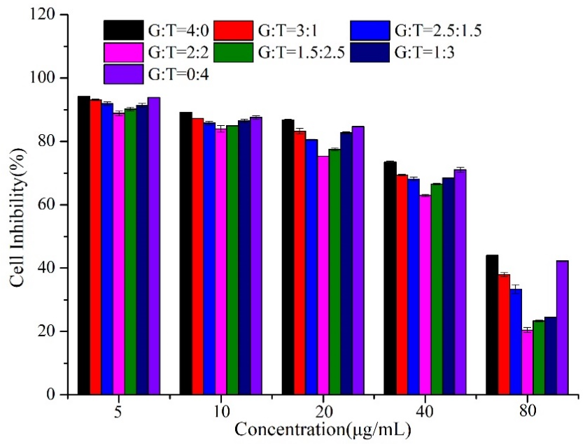
Fig. S1 Cytotoxicity of free drugs with different mass ratios on HepG2 cell after 24 h.

Fig. S2 Three-dimensional effect surface map of star design.
Fig. S3 Schematic diagram of docking between TAN and DCA (A), GA and DCA (B), and GA and TAN (C).
Fig. S4 The results of protein adsorption test. *P<0.05, **P<0.01.

Fig. S5 The results of hemolysis test. A: The appearance of hemolytic samples (a. Original samples; b. 50 μg/mL; c. 100 μg/mL; d. 250 μg/mL; e. 500 μg/mL); B: The results of hemolysis rate.
Fig. S6 The results of cell uptake assay. *P<0.05, **P<0.01.
Fig. S7 The inhibition ratio of tumor weight in each treatment groups. *P<0.05, **P<0.01.

Table S1 The factors and levels of star design
Factors | Level
Factors | -1 | 0 | 1
Drug:Carrier | 1:15 | 1:10 | 1:5
GA:TAN | 1:2 | 1:1 | 2:1
Organic solvent:Water | 1:15 | 1:10 | 2:15

Table S2 Experimental results of star design
Number | Factors |  |  | Experimental Results
Number | A | B | C | Y₁/Size (nm) | Y₂/GA-LC% | Y₃/TAN-LC%
1 | 0 | 0 | 0 | 181.1 | 5.44 | 3.41
2 | 0 | 1 | -1 | 177.4 | 6.33 | 4.48
3 | -1 | 1 | 0 | 182.6 | 6.23 | 3.62
4 | 0 | 0 | 0 | 185.5 | 5.25 | 3.32
5 | 1 | 0 | -1 | 197.0 | 6.19 | 4.25
6 | -1 | 0 | 1 | 189.5 | 4.47 | 3.45
7 | 1 | 0 | 1 | 177.2 | 6.65 | 6.56
8 | 0 | -1 | 1 | 179.2 | 3.31 | 6.05
9 | 1 | -1 | 0 | 198.3 | 3.25 | 5.17
10 | -1 | -1 | 0 | 184.4 | 5.96 | 3.66
11 | 0 | -1 | -1 | 177.4 | 4.11 | 4.34
12 | 0 | 0 | 0 | 180.5 | 6.11 | 3.26
13 | 0 | 0 | 0 | 184.3 | 5.89 | 3.26
14 | 1 | 1 | 0 | 194.2 | 6.58 | 3.48
15 | -1 | 0 | -1 | 197.4 | 6.84 | 2.92
16 | 0 | 1 | 1 | 187.3 | 5.68 | 2.82
17 | 0 | 0 | 0 | 178.9 | 6.53 | 4.12

Table S3 The characteristics of three batches of PD@TG-Nanos for process verification (n=3)
Groups | Size(nm) | DLC% of GA | DLC% of TAN | EE% of GA | EE% of TAN
1 | 175.2 | 6.51 | 6.43 | 80.83 | 78.59
2 | 176.4 | 6.41 | 6.49 | 79.75 | 78.74
3 | 180.7 | 6.48 | 6.53 | 80.21 | 79.42

