ONLINE SUPPLEMENT
Supplemental Table 1 List of Anxiety and Depression Diagnostic Read Codes and Treatments
Anxiety Read Code | Description
E200.00 | Anxiety states
E200000 | Anxiety state unspecified
E200100 | Panic disorder
E200111 | Panic attack
E200200 | Generalised anxiety disorder
E200300 | Anxiety with depression
E200400 | Chronic anxiety
E200500 | Recurrent anxiety
E200z00 | Anxiety state NOS
Eu40.00 | Phobic anxiety disorders
Eu40y00 | Other phobic anxiety disorders
Eu40z00 | Phobic anxiety disorder, unspecified
Eu41.00 | Other anxiety disorders
Eu41000 | Panic disorder [episodic paroxysmal anxiety]
Eu41100 | Generalised anxiety disorder
Eu41111 | Anxiety neurosis
Eu41112 | Anxiety reaction
Eu41113 | Anxiety state
Eu41y00 | Other specified anxiety disorders
Eu41y11 | Anxiety hysteria
Eu41z00 | Anxiety disorder, unspecified
Eu41z11 | Anxiety NOS
Eu40012 | Panic disorder with agoraphobia
Eu41000 | Panic disorder [episodic paroxysmal anxiety]
Eu41011 | Panic attack
Eu41012 | Panic state
E280.00 | Acute panic state due to acute stress reaction
1B13.00 | Anxiousness
1B13.11 | Anxiousness – symptom
1B13.12 | Anxious
Anxiolytic Treatments
Anxiety Treatments  Benzodiazepines  Other | Alprazolam, clonazepam, lorazepam, diazepam  Buspirone
Antidepressants also used to treat anxiety  SSRIs  SNRIs: | Fluoxetine, citalopram, paroxetine, sertraline, fluvoxamine, escitalopram oxalate, trazodone hydrochloride, nefazodone hydrochloride, zimelidine  Viloxazine hydrochloride, mirtazapine, bupropion, venlafaxine, duloxetine hydrochloride, agomelatine, desvenlafaxine succinate
Beta-blockers used for panic disorder | Acebutolol hydrochloride, atenolol, betaxolol, bisoprolol fumarate, carteolol hydrochloride tablets, carvedilol, labetalol hydrochloride, metoprolol, nadolol, nebivolol, penbutolol, pindolol, propranolol, timolol maleate
Depression Read Code | Description
E11..11 | Bipolar psychoses
E11..12 | Depressive psychoses
E112.00 | Single major depressive episode
E112.11 | Agitated depression
E112.12 | Endogenous depression first episode
E112.13 | Endogenous depression first episode
E112.14 | Endogenous depression
E112000 | Single major depressive episode, unspecified
E112100 | Single major depressive episode, mild
E112200 | Single major depressive episode, moderate
E112300 | Single major depressive episode, severe, without psychosis
E112400 | Single major depressive episode, severe, with psychosis
E112500 | Single major depressive episode, partial or unspecified remission
E112600 | Single major depressive episode, in full remission
E112z00 | Single major depressive episode NOS
E113.00 | Recurrent major depressive episode
E113.11 | Endogenous depression – recurrent
E113000 | Recurrent major depressive episodes, unspecified
E113100 | Recurrent major depressive episodes, mild
E113200 | Recurrent major depressive episodes, moderate
E113300 | Recurrent major depressive episodes, severe, no psychosis
E113400 | Recurrent major depressive episodes, severe, with psychosis
E113500 | Recurrent major depressive episodes, partial/unspecified remission
E113600 | Recurrent major depressive episodes, in full remission
E113700 | Recurrent depression
E113z00 | Recurrent major depressive episode NOS
E115.11 | Manic-depressive – now depressed
E115000 | Bipolar affective disorder, currently depressed, unspecified
E115100 | Bipolar affective disorder, currently depressed, mild
E115200 | Bipolar affective disorder, currently depressed, moderate
E115300 | Bipolar affect disorder, now depressed, severe, no psychosis
E115400 | Bipolar affect disorder, now depressed, severe with psychosis
E115600 | Bipolar affective disorder, now depressed, in full remission
E115z00 | Bipolar affective disorder, currently depressed, NOS
E116.00 | Mixed bipolar affective disorder
E116000 | Mixed bipolar affective disorder, unspecified
E116100 | Mixed bipolar affective disorder, mild
E116200 | Mixed bipolar affective disorder, moderate
E116300 | Mixed bipolar affective disorder, severe, without psychosis
E116400 | Mixed bipolar affective disorder, severe, with psychosis
E116500 | Mixed bipolar affective disorder, partial/unspecified remission
E116600 | Mixed bipolar affective disorder, in full remission
E116z00 | Mixed bipolar affective disorder, NOS
E117.00 | Unspecified bipolar affective disorder
E117000 | Unspecified bipolar affective disorder, unspecified
E117100 | Unspecified bipolar affective disorder, mild
E117200 | Unspecified bipolar affective disorder, moderate
E117400 | Unspecified bipolar affective disorder, severe with psychosis
E117500 | Unspecified bipolar affective disorder, partial/unspecified remission
E117600 | Unspecified bipolar affective disorder, in full remission
E117z00 | Unspecified bipolar affective disorder, NOS
E11y.00 | Other and unspecified manic-depressive psychoses
E11y000 | Unspecified manic-depressive psychoses
E11y200 | Atypical depressive disorder
E11y300 | Other mixed manic-depressive psychoses
E11yz00 | Other and unspecified manic-depressive psychoses NOS
E11z100 | Rebound mood swings
E11z200 | Masked depression
E130.00 | Reactive depressive psychosis
E130.11 | Psychotic reactive depression
E135.00 | Agitated depression
E204.00 | Neurotic depression reactive type
E2B..00 | Depressive disorder NEC
E2B1.00 | Chronic depression
Eu3..00 | Mood – affective disorders
Eu31.00 | Bipolar affective disorder
Eu31.11 | Manic-depressive illness
Eu31.12 | Manic-depressive psychosis
Eu31.13 | Manic-depressive reaction
Eu31000 | Bipolar affective disorder, current episode hypomanic
Eu31100 | Bipolar affective disorder, current episode manic without psychotic symptoms
Eu31200 | Bipolar affective disorder, current episode manic with psychotic symptoms
Eu31300 | Bipolar affective disorder, current episode mild or moderate depression
Eu31400 | Bipolar affective disorder, current episode severe depression, no psychotic symptoms
Eu31500 | Bipolar affective disorder, current episode severe depression with psychotic symptoms
Eu31600 | Bipolar affective disorder, current episode mixed
Eu31700 | Bipolar affective disorder, currently in remission
Eu31y00 | Other bipolar affective disorders
Eu31z00 | Bipolar affective disorder, unspecified
Eu32.00 | Depressive episode
Eu32.11 | Single episode of depressive reaction
Eu32.12 | Single episode of psychogenic depression
Eu32.13 | Single episode of reactive depression
Eu32000 | Mild depressive episode
Eu32100 | Moderate depressive episode
Eu32200 | Severe depressive episode without psychotic symptoms
Eu32211 | Single episode agitated depression without psychotic symptoms
Eu32212 | Single episode major depression without psychotic symptoms
Eu32213 | Single episode vital depression without psychotic symptoms
Eu32300 | Severe depressive episode with psychotic symptoms
Eu32311 | Single episode of major depression and psychotic symptoms
Eu32312 | Single episode of psychogenic depressive psychosis
Eu32313 | Single episode of psychotic depression
Eu32314 | Single episode of reactive depressive psychosis
Eu32y00 | Other depressive episodes
Eu32y11 | Atypical depression
Eu32z00 | Depressive episode, unspecified
Eu32z11 | Depression NOS
Eu32z12 | Depressive disorder NOS
Eu32z13 | Prolonged single episode of reactive depression
Eu32z14 | Reactive depression NOS
Eu33.00 | Recurrent depressive disorder
Eu33.11 | Recurrent episodes of depressive reaction
Eu33.12 | Recurrent episodes of psychogenic depression
Eu33.13 | Recurrent episodes of reactive depression
Eu33000 | Recurrent depressive disorder, current episode mild
Eu33100 | Recurrent depressive disorder, current episode moderate
Eu33200 | Recurrent depressive disorder, current episode severe without psychotic symptoms
Eu33211 | Endogenous depression without psychotic symptoms
Eu33212 | Major depression, recurrent without psychotic symptoms
Eu33213 | Manic-depressive psychosis, depressed, no psychotic symptoms
Eu33300 | Recurrent depressive disorder, current episode severe with psychotic symptoms
Eu33311 | Endogenous depression with psychotic symptoms
Eu33312 | Manic-depressive psychosis, depressed type + psychotic symptoms
Eu33313 | Recurrent severe episodes/major depression + psychotic symptoms
Eu33314 | Recurrent severe episodes/psychogenic depressive psychosis
Eu33315 | Recurrent severe episodes of psychotic depression
Eu33316 | Recurrent severe episodes/reactive depressive psychosis
Eu33400 | Recurrent depressive disorder, currently in remission
Eu33y00 | Other recurrent depressive disorders
Eu33z00 | Recurrent depressive disorder, unspecified
Eu33z11 | Monopolar depression NOS
Eu34.00 | Persistent mood affective disorders
Eu34111 | Depressive neurosis
Eu34113 | Neurotic depression
Eu34114 | Persistent anxiety depression
Eu34y00 | Other persistent mood affective disorders
Eu34z00 | Persistent mood affective disorder, unspecified
Eu3y.00 | Other mood affective disorders
Eu3y000 | Other single mood affective disorders
Eu3y100 | Other recurrent mood affective disorders
Eu3y111 | Recurrent brief depressive episodes
Eu3yy00 | Other specified mood affective disorders
Eu3z.00 | Unspecified mood affective disorder
ZV11111 | Personal history of manic-depressive psychosis
ZV11112 | Personal history of manic-depressive psychosis
Eu3240 | Mild depression
Eu32500 | Major depression; mild
Eu32600 | Major depression; moderately severe
Eu32700 | Major depression; severe without psychotic symptoms
Eu32800 | Major depression; severe with psychotic symptoms
Eu32900 | Single major depressive episode; severe with psychosis; psychosis in remission
Eu32A00 | Recurrent major depressive episode; severe with psychosis; psychosis in remission
Eu32y12 | Single episode of masked depression NOS
Eu33214 | Vital depression; recurrent without psychotic symptoms
E200300 | Anxiety with depression
Eu41200 | Mixed anxiety and depressive disorder
Eu41211 | Mild anxiety depression
2257.00 | O/E – depressed
1JJ..00 | Suspected depression
E290.00 | Brief depressive reaction
E290z00 | Brief depressive reaction NOS
E291.00 | Prolonged depressive reaction
1B17.00 | Depressed
1B17.11 | C/O – feeling depressed
1BT..00 | Depressed mood
Antidepressants
MAOIs | Phenelzine sulfate, isocarboxazid, tranylcypromine, iproniazid, moclobemide
Tricyclic antidepressants | Desipramine, imipramine hydrochloride, opipramol hydrochloride, trimipramine, lofepramine, dibenzepin hydrochloride, dibenzepin, amitriptyline hydrochloride, amitriptyline and ba-34276, chlordiazepoxide with amitriptyline, nortriptyline, protriptyline hydrochloride, doxepin hydrochloride, doxepin hydrochloride, iprindole, melitracen, butriptyline, dosulepin, amoxapine, noxiptyline
Tetracyclic antidepressants | Maprotiline hydrochloride, mianserin, nomifensine maleate
SSRIs | Fluoxetine, citalopram, paroxetine, sertraline, fluvoxamine, escitalopram oxalate, trazodone hydrochloride, nefazodone hydrochloride, zimelidine
SNRIs | Viloxazine hydrochloride, mirtazapine, bupropion, venlafaxine, duloxetine hydrochloride, agomelatine, desvenlafaxine succinate
NDRIs | Reboxetine
Lithium | Lithium citrate, lithium carbonate
Other antidepressants | Oxitriptan, tryptophan, tofenacin
Abbreviations: C/O, complains of; MAOI, monoamine oxidase inhibitor; NDRI, norepinephrine and dopamine reuptake inhibitor; NEC, not elsewhere classified; NOS, not otherwise specified; O/E, on examination; SNRI, serotonin-norepinephrine reuptake inhibitor; SSRI, selective serotonin reuptake inhibitor.

Supplemental Figure 1 Cumulative incidence of treated anxiety after VWD diagnosis/match date among individuals with versus without VWD, stratified by sex.
Abbreviations: VWD, von Willebrand disease.
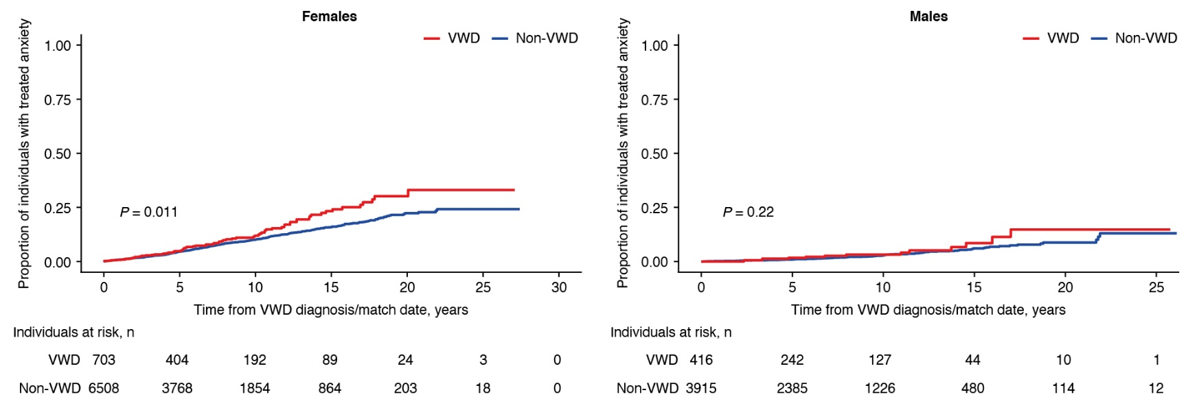

Supplemental Figure 2 Cumulative incidence of treated anxiety after VWD diagnosis/match date among individuals with versus without VWD, stratified by age category.
Abbreviations: VWD, von Willebrand disease.
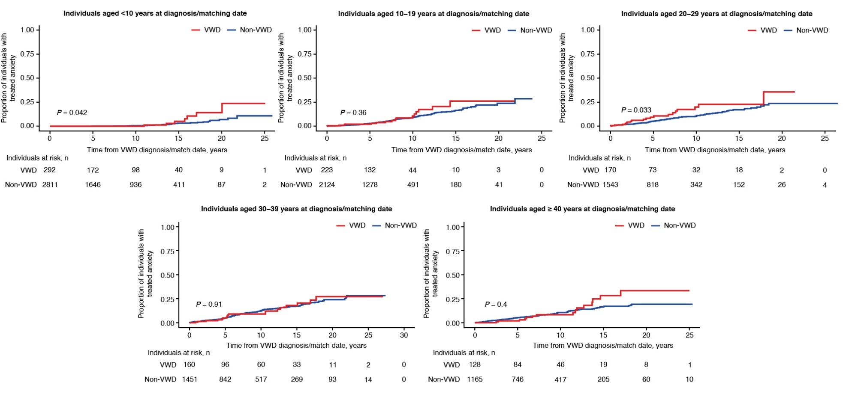

Supplemental Figure 3 Cumulative incidence of treated anxiety after VWD diagnosis/match date among females with versus without VWD, stratified by age at VWD diagnosis/match date.
Abbreviations: VWD, von Willebrand disease.
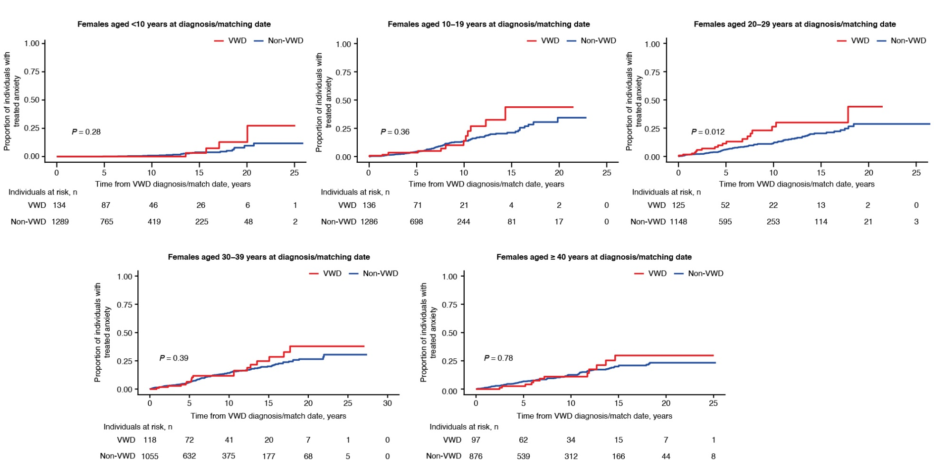
Supplemental Figure 4 Cumulative incidence of treated depression after VWD diagnosis/match date among individuals with versus without VWD, stratified by sex.
Abbreviations: VWD, von Willebrand disease.
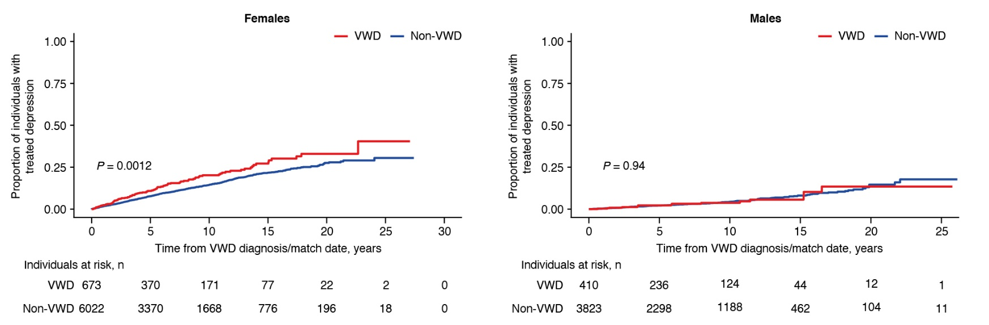

Supplemental Figure 5 Cumulative incidence of treated depression after VWD diagnosis/match date among individuals with versus without VWD, stratified by age category.
Abbreviations: VWD, von Willebrand disease.
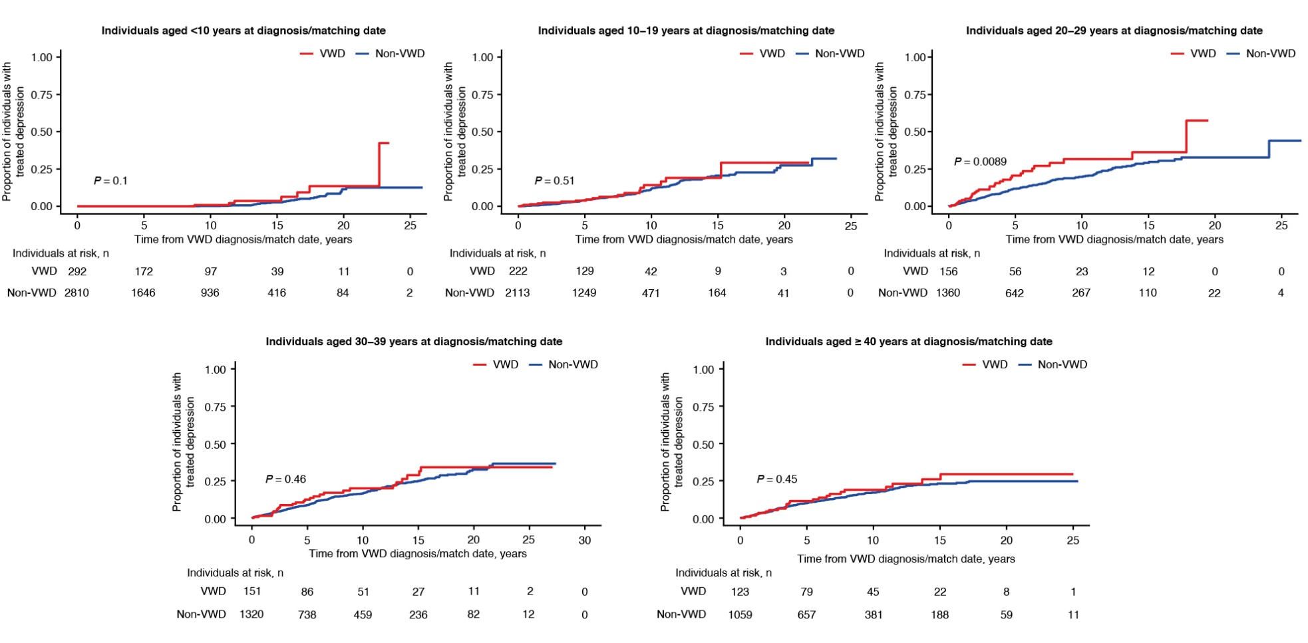
Supplemental Figure 6 Cumulative incidence of treated depression after VWD diagnosis/match date among females with versus without VWD, stratified by age at VWD diagnosis/match date.
Abbreviations: VWD, von Willebrand disease.
