Supplementary Table

Supplementary Table 1: The sizes of investigated study sites and their cooperating medical services

 | Hospital size (n) | Size of affiliated medical services (n)
Class 3 hospitals | 35
Class 2 hospitals | 8 | 31
Class 1 hospitals |  | 6
Community service center |  | 3
Total | 43 | 40

Supplementary Figures

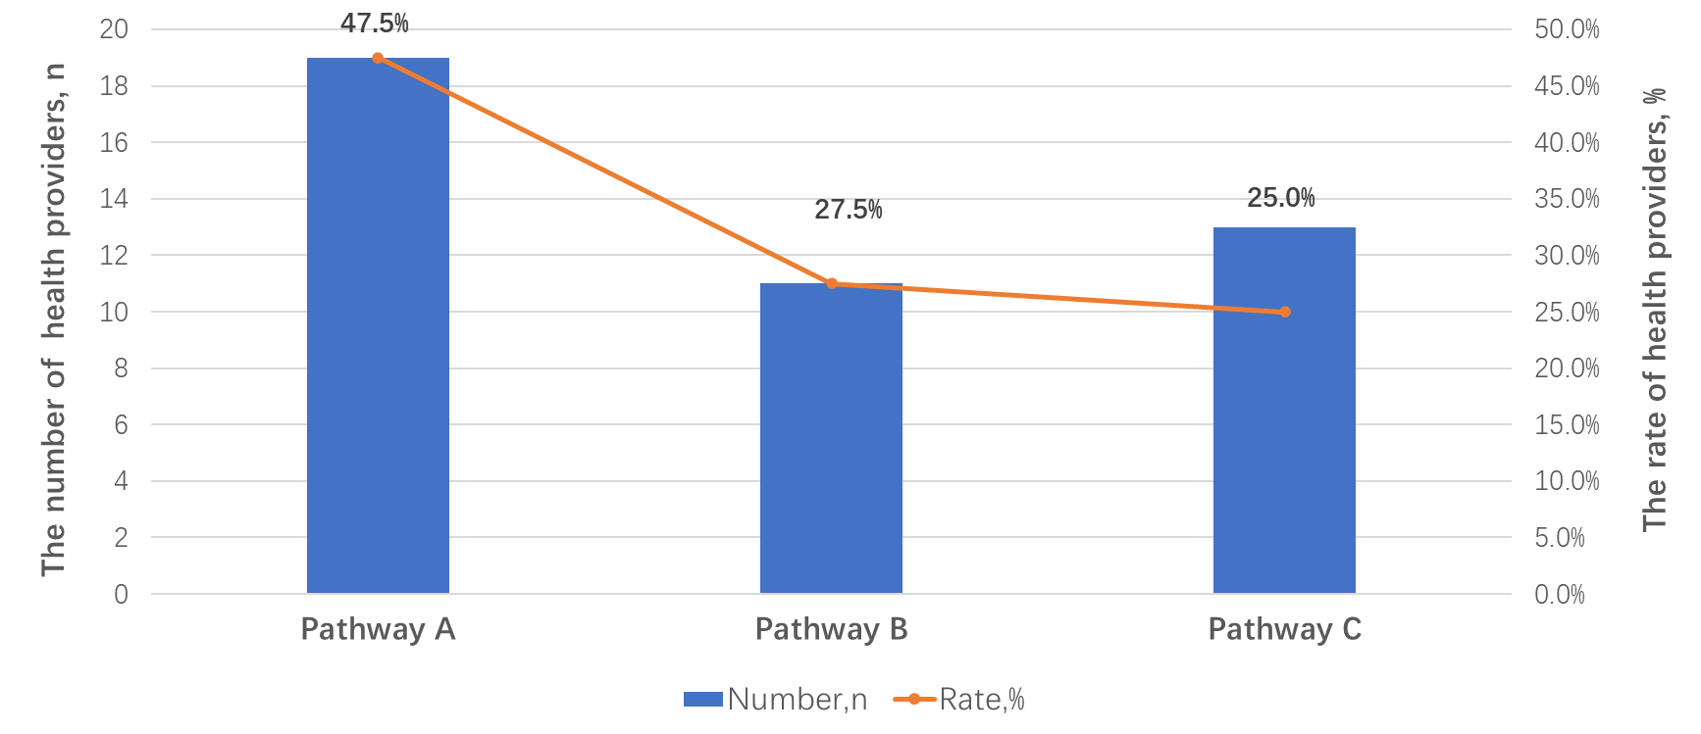
Supplementary Figure 1:The clinical pathway focused by doctors

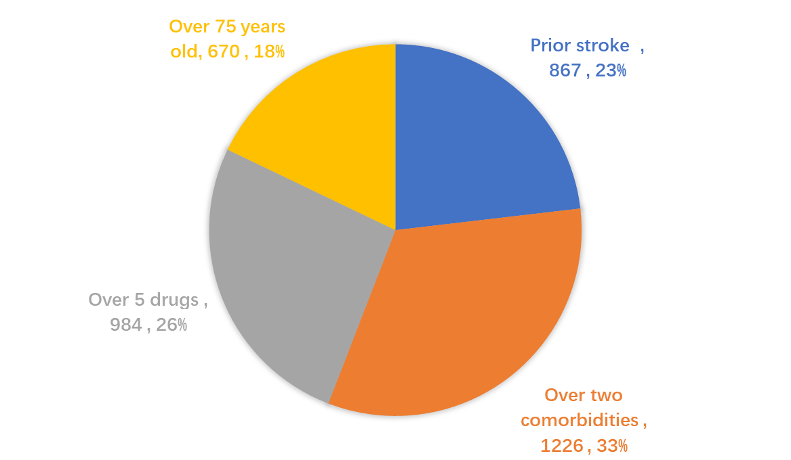

Supplementary Figure 2: The distribution of ‘high-risk’ AF patients among investigated hospitals

Supplementary Material 1

Academic Steering Committee
Gregory Y H Lip, MD, Liverpool Centre for Cardiovascular Science, University of Liverpool and Liverpool Heart & Chest Hospital, Liverpool, United Kingdom (Co-Chair)
Yutao Guo, MD, PhD, Department of Pulmonary vessel and Thrombotic Disease, Chinese PLA General Hospital, Beijing, China (Co-Chair)
Tatjana Potpara, MD, PhD, School of Medicine, Belgrade University; Clinical Centre of Serbia, Belgrade, Serbia
Jun Zhu, MD, PhD, Fuwai Hospital, Beijing, China
Jiefu Yang, MD, PhD, Heart Center, Beijing Hospital, Beijing, China
Yundai Chen, PhD, Department of Cardiology, Chinese PLA General Hospital, Beijing, China
Liming Wang, MD, PhD, The National Center for Chronic and Noncommunicable Disease Control and Prevention, Chinese Center for Disease Control and Prevention, Beijing, China
Yihong Sun, MD, PhD, China-Japan Friendship Hospital, Beijing, China
Kehui Dong, MD, PhD, Center of Neurology, Beijing Tiantan Hospital, Capital Medical University, Beijing, China
Zhenyu Liu, MD, PhD, Peking Union Medical College Hospital, Beijing, China
Jianguo Liu, MD, PhD, Department of Neurology, Chinese PLA General Hospital, Beijing, China
Tong Liu, MD, PhD, Tianjin Key Laboratory of Ionic-Molecular Function of Cardiovascular Disease, Tianjin Institute of Cardiology, Second Hospital of Tianjin Medical University, Tianjin, China

Supplementary Material 2

Data Management Committee
Yuan Yao, MD, PhD, Institution for Management on Hospital, Chinese PLA General Hospital, Beijing, China
Yi Zhang, MD, Institutional Ethics Committee, The Sixth Medical Center of PLA General Hospital, Beijing, China
Miao Liu, MD, PhD, Department of Statistics and Epidemiology, Graduate school of Chinese PLA General Hospital, Beijing, China
Dandi Chen, MD, PhD, Department of Health Management, West China School of Public Health,Sichuan, China

