Supplementary Data

Synthesis, anti-bacterial and molecular docking studies of arylated butyl 2-bromoisonicotinate against clinical isolates of Escherichia coli and methicillin-resistant Staphylococcus aureus.
Shazia Naheed ¹, Irum Umar Din ¹, Muhammad Usman Qamar ², Nasir Rasool ¹*, Matloob Ahmad¹, Muhammad Bilal¹, Aqsa Khalid ³, Gulraiz Ahmad ¹, Sami A Al-Hussain ⁴, Magdi E. A Zaki ⁴ ** ,
1 Department of Chemistry, Government College University Faisalabad, 38000, Pakistan
2 Institute of Microbiology, Faculty of Life Sciences, Government College, University, Faisalabad 38000, Pakistan
3 School of Interdisciplinary Engineering & Science (SINES), National University of Sciences and Technology (NUST), Islamabad 44000, Pakistan
4 Department of Chemistry, Faculty of Science, Imam Mohammad Ibn Saud Islamic University, Riyad, 11623, Saudi Arabia
* Correspondence: nasirrasool@gcuf.edu.pk, mezaki@imamu.edu.sa

Table of Contents
Figure S1: ¹H NMR (500 MHz, DMSO-d₆) spectrum of compound 3. S3
Figure S2: ¹H NMR (500 MHz, DMSO-d₆) spectrum of compound 5a. S3
Figure S3: ¹H NMR (500 MHz, DMSO-d₆) spectrum of compound 5c. S4
Figure S4: ¹H NMR (500 MHz, DMSO-d₆) spectrum of compound 5d. S4
Figure S5: ¹H NMR (500 MHz, DMSO-d₆) spectrum of compound 5e. S5
Figure S6: ¹H NMR (500 MHz, DMSO-d₆) spectrum of compound 5f. S5
Figure S7: ¹H NMR (500 MHz, DMSO-d₆) spectrum of compound 5g. S6
Figure S8: ¹H NMR (500 MHz, DMSO-d₆) spectrum of compound 5h. S6
Figure S9: Interaction pattern of 5c-5g compounds with E. coli (2Y2T) receptor …………………………………..S7

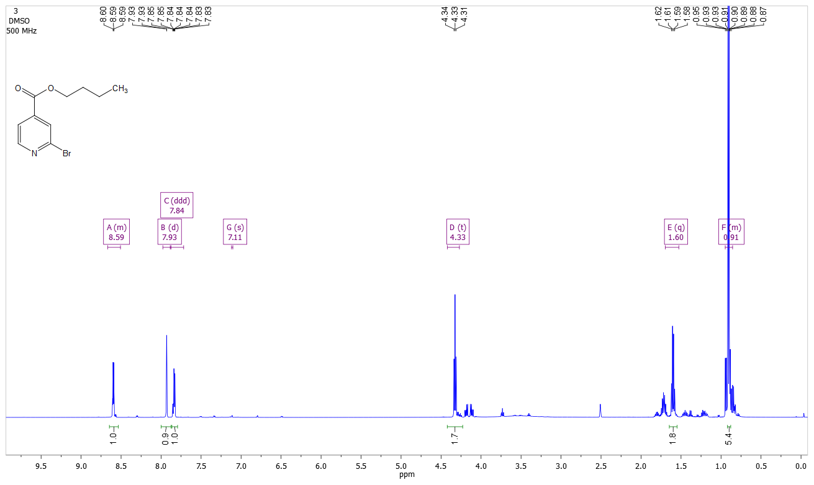
Figure S1: ¹H-NMR (500 MHz, DMSO-d₆) spectrum of compound 3.

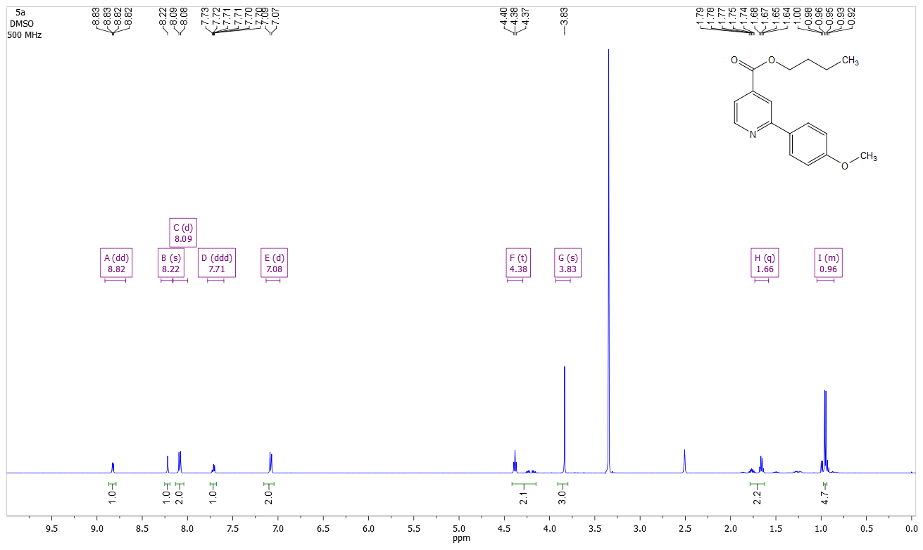
Figure S2: ¹H-NMR (500 MHz, DMSO-d₆) spectrum of compound 5a.
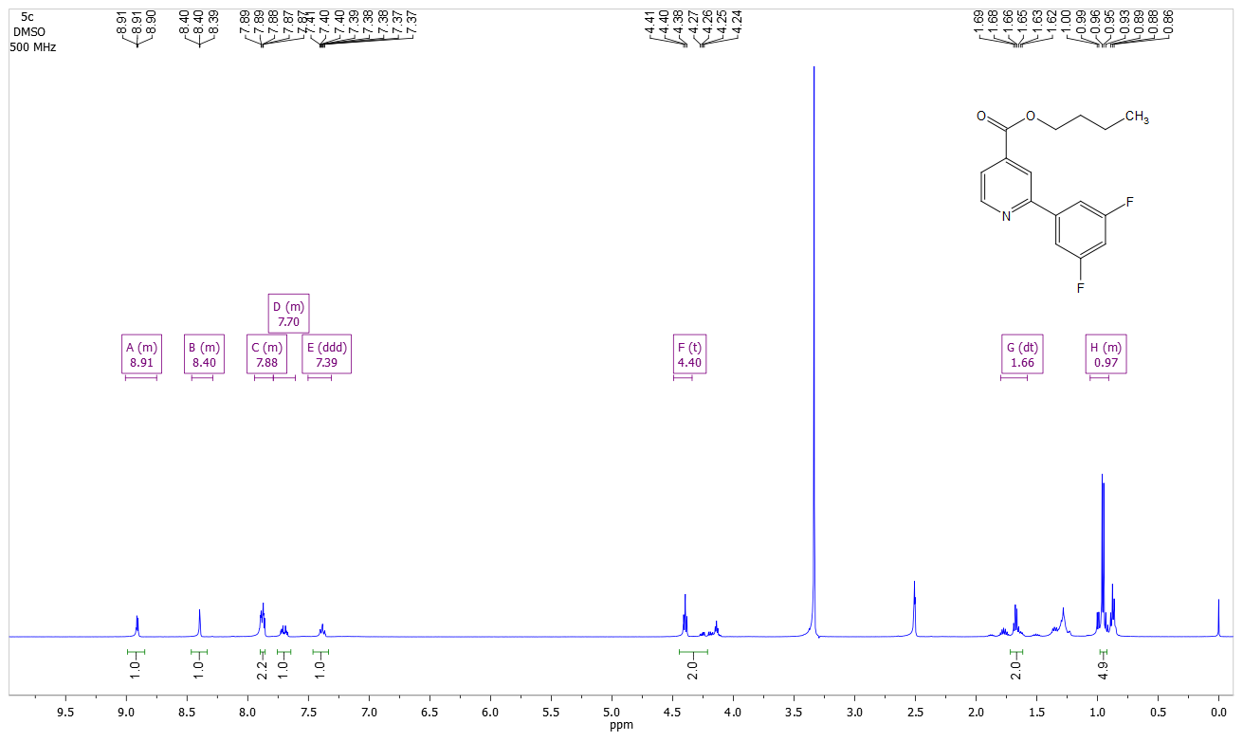
Figure S3: ¹H-NMR (500 MHz, DMSO-d₆) spectrum of compound 5c.

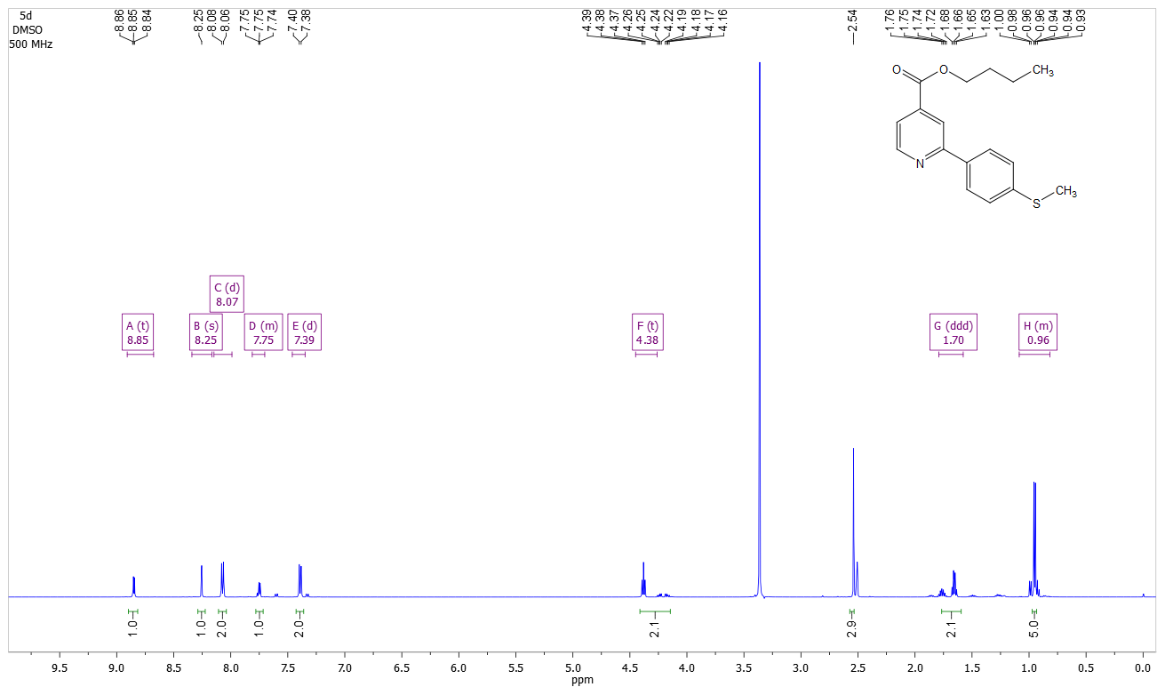
Figure S4: ¹H-NMR (500 MHz, DMSO-d₆) spectrum of compound 5d.
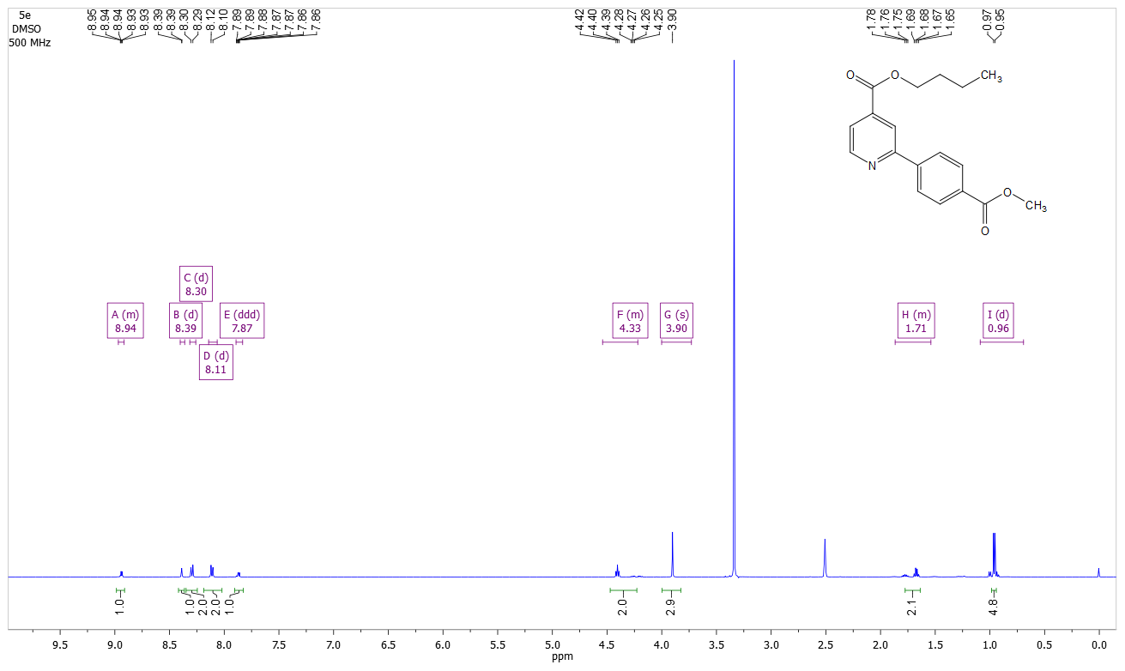
Figure S5: ¹H-NMR (500 MHz, DMSO-d₆) spectrum of compound 5e.

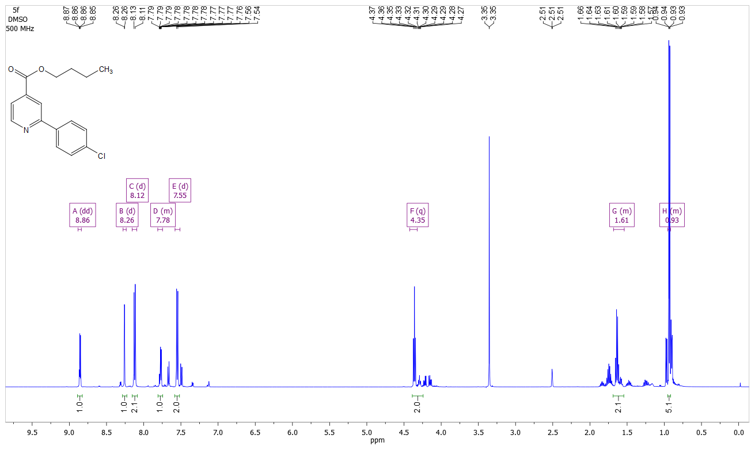
Figure S6: ¹H-NMR (500 MHz, DMSO-d₆) spectrum of compound 5f.
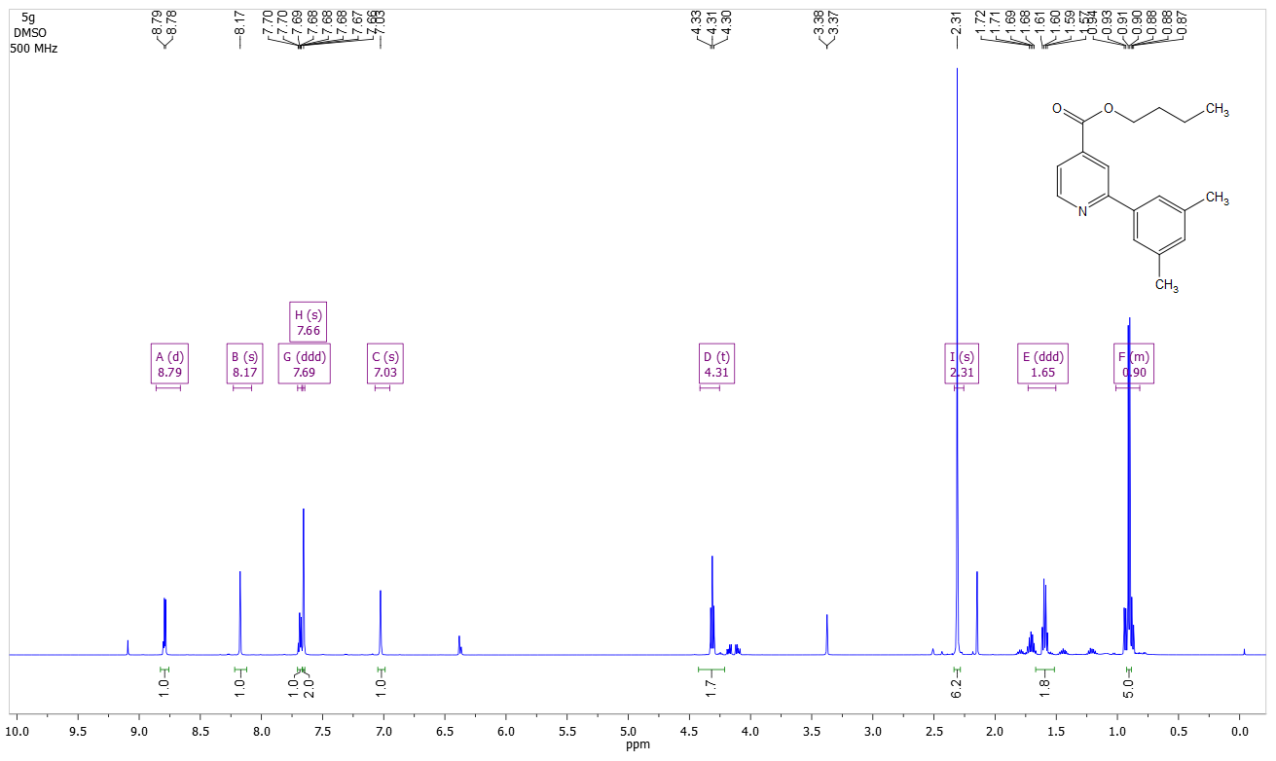
Figure S7: ¹H-NMR (500 MHz, DMSO-d₆) spectrum of compound 5g.

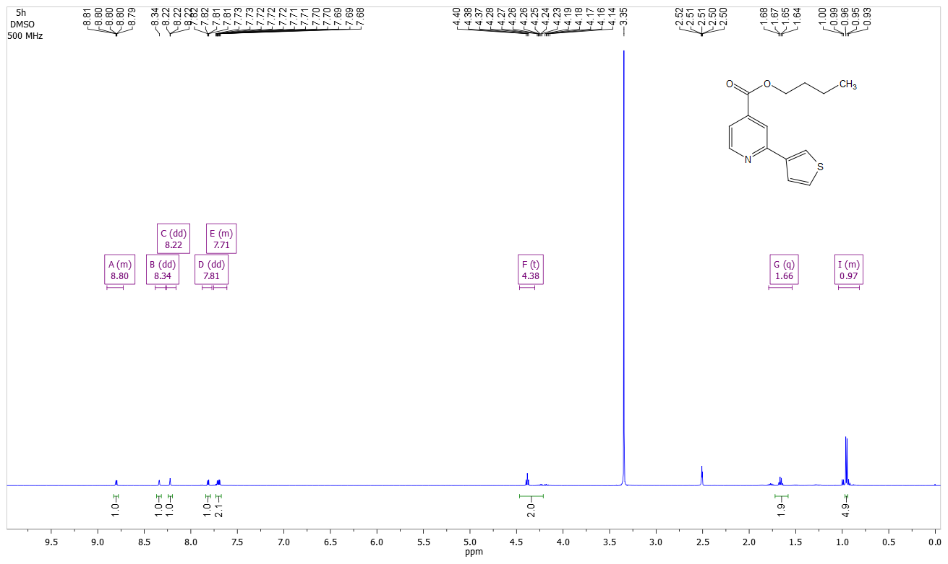
Figure S8: ¹H-NMR (500 MHz, DMSO-d₆) spectrum of compound 5h.
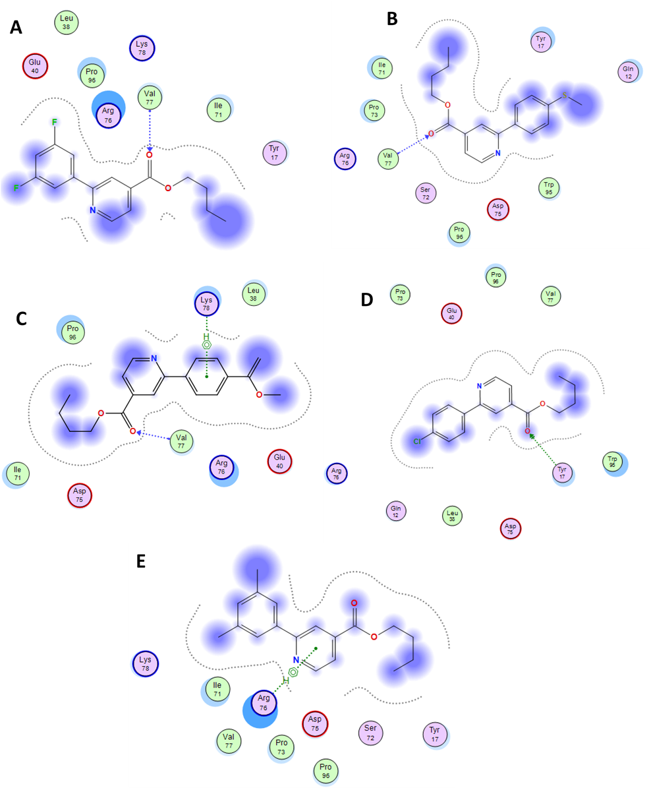
Figure S9: Interaction pattern of 5c-5g compounds with E. coli (2Y2T) receptor. A) 5c forming 1H bond with Val77. B) 5d forming 1H bond with Val77. C) 5e forming 1H bond and 1-pi-H bond with Lys78. D) 5f forming 1H bond with Tyr17. E) 5g forming 1-hydrophboic interaction with Arg76.

