RESULTS
Additional information for MTT Cytotoxicity
Table S1. MTT Cytotoxicity results
Material | Percent Viability [%] | Standard Deviation [%] | System Suitability
4SEAL®
Positive control | 2.18 | 0.36 | Valid
Negative control | 118.72 | 3.30 | Valid
Dilution 1x | 99.55 | 4.05 | no cytotoxic potential
Dilution 2x | 101.94 | 3.31 | no cytotoxic potential
Dilution 3x | 101.25 | 1.86 | no cytotoxic potential
Dilution 4x | 96.13 | 7.42 | no cytotoxic potential
Starsil®
Positive control | 2.42 | 1.58 | Valid
Negative control | 96.03 | 3.22 | Valid
Dilution 1x | 103.05 | 3.13 | no cytotoxic potential
Dilution 2x | 119.48 | 8.35 | no cytotoxic potential
Dilution 3x | 114.17 | 5.10 | no cytotoxic potential
Dilution 4x | 109.67 | 2.63 | no cytotoxic potential
PerClot®
Positive control | 0.81 | 0.06 | Valid
Negative control | 91.69 | 4.80 | Valid
Dilution 1x | 68.47 | 1.76 | cytotoxic potential
Dilution 2x | 82.81 | 1.45 | no cytotoxic potential
Dilution 3x | 86.53 | 2.39 | no cytotoxic potential
Dilution 4x | 88.64 | 2.33 | no cytotoxic potential
ARISTA™
Positive control | 0.81 | 0.06 | Valid
Negative control | 91.69 | 4.80 | Valid
Dilution 1x | 67.29 | 0.78 | cytotoxic potential
Dilution 2x | 89.07 | 2.65 | no cytotoxic potential
Dilution 3x | 98.66 | 2.66 | no cytotoxic potential
Dilution 4x | 101.99 | 4.39 | no cytotoxic potential
SuperClot®
Positive control | 0.81 | 0.06 | Valid
Negative control | 91.69 | 4.80 | Valid
Dilution 1x | 56.06 | 1.36 | cytotoxic potential
Dilution 2x | 84.17 | 2.53 | no cytotoxic potential
Dilution 3x | 85.41 | 2.28 | no cytotoxic potential
Dilution 4x | 87.89 | 2.97 | no cytotoxic potential
4DryField®
Positive control | 2.42 | 1.58 | Valid
Negative control | 96.03 | 3.22 | Valid
Dilution 1x | 72.60 | 6.74 | no cytotoxic potential
Dilution 2x | 95.52 | 0.79 | no cytotoxic potential
Dilution 3x | 95.93 | 0.98 | no cytotoxic potential
Dilution 4x | 94.54 | 1.30 | no cytotoxic potential
Quality check of assay | Result |  | System Suitability
Absolute value of optical density (OD₅₇₀) | 0.34 |  | Valid
Systematic cell seeding errors | 1.36 % |  | Valid

Additional information for Water Absorption Capacity (WAC)
Table S2. Results of water absorption capacity (WAC) for 0.5 g of hemostatic powders
Specimen | Water Absorption Capacity (WAC) [mL]
Specimen | 4SEAL® | Starsil® | PerClot® | ARISTA™ | SuperClot® | 4DryField®
1 | 22.206 | 20.137 | 19.984 | 7.550 | 6.227 | 17.488
2 | 22.342 | 17.535 | 19.846 | 8.789 | 6.381 | 18.517
3 | 22.819 | 17.831 | 19.787 | 9.776 | 6.782 | 18.019
Mean | 22.456 | 18.501 | 19.872 | 8.705 | 6.463 | 18.008
Standard Deviation | 0.322 | 1.425 | 0.101 | 1.115 | 0.287 | 0.515
Table S3. Result of one-way ANOVA with Bonferroni's multiple comparisons test for Water Absorption Capacity (WAC)
Bonferroni's multiple comparisons test | Mean Diff. | Summary | Adjusted P Value
4Seal® vs. Starsil® | 3.955 | ** | 0.0030
4Seal® vs. PerClot® | 2.583 | ns | 0.0591
4Seal® vs. ARISTA™ | 13.75 | **** | <0.0001
4Seal® vs. SuperClot® | 15.99 | **** | <0.0001
4Seal® vs. 4DryField® | 4.448 | ** | 0.0012
Starsil® vs. PerClot® | -1.371 | ns | >0.9999
Starsil® vs. ARISTA™ | 9.796 | **** | <0.0001
Starsil® vs. SuperClot® | 12.04 | **** | <0.0001
Starsil® vs. 4DryField® | 0.4930 | ns | >0.9999
PerClot® vs. ARISTA™ | 11.17 | **** | <0.0001
PerClot® vs. SuperClot® | 13.41 | **** | <0.0001
PerClot® vs. 4DryField® | 1.864 | ns | 0.3412
ARISTA™ vs. SuperClot® | 2.242 | ns | 0.1346
ARISTA™ vs. 4DryField® | -9.303 | **** | <0.0001
SuperClot® vs. 4DryField® | -11.54 | **** | <0.0001

Legend:
Symbol: | p-value:
ns | 0.1234
* | 0.0332
** | 0.0021
*** | 0.0002
**** | <0.0001
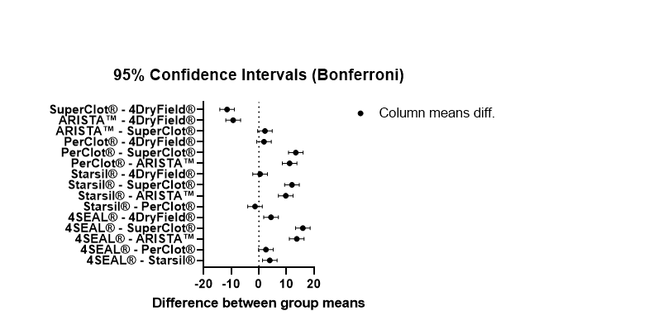
Figure S1. Result of one-way ANOVA with Bonferroni's multiple comparisons test for Water Absorption Capacity (WAC).

Additional information for Water Absorption Rate (WAR)
Table S4. Results of water absorption rate (WAR) for 0.1 g of hemostatic powders
Specimen ▼ | Water absorption rate (WAR) [mL]
Time [s] ► | 20 | 40 | 60
4Seal®
1 | 1.5 | 2.2 | 2.5
2 | 2.2 | 2.5 | 2.6
3 | 2.2 | 2.5 | 2.6
Mean | 1.97 | 2.40 | 2.57
Standard Deviation | 0.40 | 0.17 | 0.06
Starsil®
1 | 1.8 | 2.1 | 2.2
2 | 2.1 | 2.6 | 2.7
3 | 1.9 | 2.3 | 2.4
Mean | 1.93 | 2.33 | 2.43
Standard Deviation | 0.15 | 0.25 | 0.25
PerClot®
1 | 0.5 | 0.8 | 1.0
2 | 0.5 | 0.7 | 0.9
3 | 0.5 | 0.9 | 1.0
Mean | 0.50 | 0.80 | 0.97
Standard Deviation | 0.00 | 0.10 | 0.06
ARISTA™
1 | 0.6 | 0.9 | 1.0
2 | 0.6 | 0.9 | 1.0
3 | 0.5 | 0.7 | 0.8
Mean | 0.57 | 0.83 | 0.93
Standard Deviation | 0.06 | 0.12 | 0.12
SuperClot®
1 | 0.5 | 0.6 | 0.7
2 | 0.3 | 0.5 | 0.5
3 | 0.3 | 0.4 | 0.5
Mean | 0.37 | 0.50 | 0.57
Standard Deviation | 0.12 | 0.10 | 0.12
4DryField®
1 | 1.0 | 1.2 | 1.3
2 | 0.9 | 1.0 | 1.0
3 | 1.0 | 1.1 | 1.2
Mean | 0.97 | 1.10 | 1.17
Standard Deviation | 0.06 | 0.10 | 0.15

Table S5. Result of two-way ANOVA with Bonferroni's multiple comparisons test for Water Absorption Rate (WAR)
Bonferroni's multiple comparisons test | Mean Diff. | Summary | Adjusted P Value
20 s
4Seal® vs. Starsil® | 0.03333 | ns | >0.9999
4Seal® vs. PerClot® | 1.467 | **** | <0.0001
4Seal® vs. ARISTA™ | 1.400 | **** | <0.0001
4Seal® vs. SuperClot® | 1.600 | **** | <0.0001
4Seal® vs. 4DryField® | 1.000 | **** | <0.0001
Starsil® vs. PerClot® | 1.433 | **** | <0.0001
Starsil® vs. ARISTA™ | 1.367 | **** | <0.0001
Starsil® vs. SuperClot® | 1.567 | **** | <0.0001
Starsil® vs. 4DryField® | 0.9667 | **** | <0.0001
PerClot® vs. ARISTA™ | -0.06667 | ns | >0.9999
PerClot® vs. SuperClot® | 0.1333 | ns | >0.9999
PerClot® vs. 4DryField® | -0.4667 | * | 0.0159
ARISTA™ vs. SuperClot® | 0.2000 | ns | >0.9999
ARISTA™ vs. 4DryField® | 0.4000 | ns | 0.0636
SuperClot® vs. 4DryField® | -0.6000 | *** | 0.0008
40 s
4Seal® vs. Starsil® | 0.06667 | ns | >0.9999
4Seal® vs. PerClot® | 1.600 | **** | <0.0001
4Seal® vs. ARISTA™ | 1.567 | **** | <0.0001
4Seal® vs. SuperClot® | 1.900 | **** | <0.0001
4Seal® vs. 4DryField® | 1.300 | **** | <0.0001
Starsil® vs. PerClot® | 1.533 | **** | <0.0001
Starsil® vs. ARISTA™ | 1.500 | **** | <0.0001
Starsil® vs. SuperClot® | 1.833 | **** | <0.0001
Starsil® vs. 4DryField® | 1.233 | **** | <0.0001
PerClot® vs. ARISTA™ | -0.03333 | ns | >0.9999
PerClot® vs. SuperClot® | 0.3000 | ns | 0.4197
PerClot® vs. 4DryField® | -0.3000 | ns | 0.4197
ARISTA™ vs. SuperClot® | 0.3333 | ns | 0.2306
ARISTA™ vs. 4DryField® | -0.2667 | ns | 0.7379
SuperClot® vs. 4DryField® | -0.6000 | *** | 0.0008
60 s
4Seal® vs. Starsil® | 0.1333 | ns | >0.9999
4Seal® vs. PerClot® | 1.600 | **** | <0.0001
4Seal® vs. ARISTA™ | 1.633 | **** | <0.0001
4Seal® vs. SuperClot® | 2.000 | **** | <0.0001
4Seal® vs. 4DryField® | 1.400 | **** | <0.0001
Starsil® vs. PerClot® | 1.467 | **** | <0.0001
Starsil® vs. ARISTA™ | 1.500 | **** | <0.0001
Starsil® vs. SuperClot® | 1.867 | **** | <0.0001
Starsil® vs. 4DryField® | 1.267 | **** | <0.0001
PerClot® vs. ARISTA™ | 0.03333 | ns | >0.9999
PerClot® vs. SuperClot® | 0.4000 | ns | 0.0636
PerClot® vs. 4DryField® | -0.2000 | ns | >0.9999
ARISTA™ vs. SuperClot® | 0..3667 | ns | 0.1228
ARISTA™ vs. 4DryField® | -0.2333 | ns | >0.9999
SuperClot® vs. 4DryField® | -0.6000 | *** | 0.0008

Legend:
symbol: | p-value:
ns | 0.1234
* | 0.0332
** | 0.0021
*** | 0.0002
**** | <0.0001

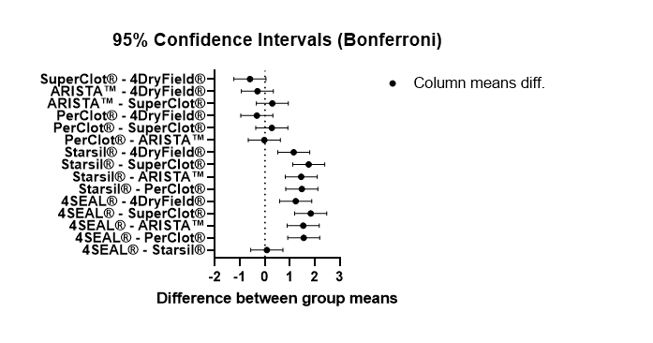
Figure S2. Result of two-way ANOVA with Bonferroni's multiple comparisons test for Water Absorption Rate (WAR).
Additional information for Adhesion potential
Table S6. Results of adhesion of hemostatic powders
Specimen | Force [N]
Specimen | 4SEAL® | Starsil® | PerClot® | ARISTA™ | SuperClot® | 4DryField®
1 | 0.39 | 0.30 | 0.09 | 0.05 | 0.05 | 0.10
2 | 0.35 | 0.29 | 0.11 | 0.05 | 0.05 | 0.09
3 | 0.32 | 0.25 | 0.09 | 0.05 | 0.05 | 0.09
Mean | 0.353 | 0.280 | 0.097 | 0.05 | 0.05 | 0.093
Standard Deviation | 0.035 | 0.027 | 0.012 | 0.000 | 0.000 | 0.006

Table S7. Result of one-way ANOVA with Bonferroni's multiple comparisons test for Adhesion potential
Bonferroni's multiple comparisons test | Mean Diff. | Summary | Adjusted P Value
4Seal® vs. Starsil® | 0.07333 | ** | 0.0065
4Seal® vs. PerClot® | 0.2567 | **** | <0.0001
4Seal® vs. ARISTA™ | 0.3033 | **** | <0.0001
4Seal® vs. SuperClot® | 0.3033 | **** | <0.0001
4Seal® vs. 4DryField® | 0.26 | **** | <0.0001
Starsil® vs. PerClot® | 0.1833 | **** | <0.0001
Starsil® vs. ARISTA™ | 0.23 | **** | <0.0001
Starsil® vs. SuperClot® | 0.23 | **** | <0.0001
Starsil® vs. 4DryField® | 0.1867 | **** | <0.0001
PerClot® vs. ARISTA™ | 0.04667 | ns | 0.1499
PerClot® vs. SuperClot® | 0.04667 | ns | 0.1499
PerClot® vs. 4DryField® | 0.003333 | ns | >0.9999
ARISTA™ vs. SuperClot® | 0 | ns | >0.9999
ARISTA™ vs. 4DryField® | -0.04333 | ns | 0.2248
SuperClot® vs. 4DryField® | -0.04333 | ns | 0.2248

Legend:
symbol | p-value:
ns | 0.1234
* | 0.0332
** | 0.0021
*** | 0.0002
**** | <0.0001

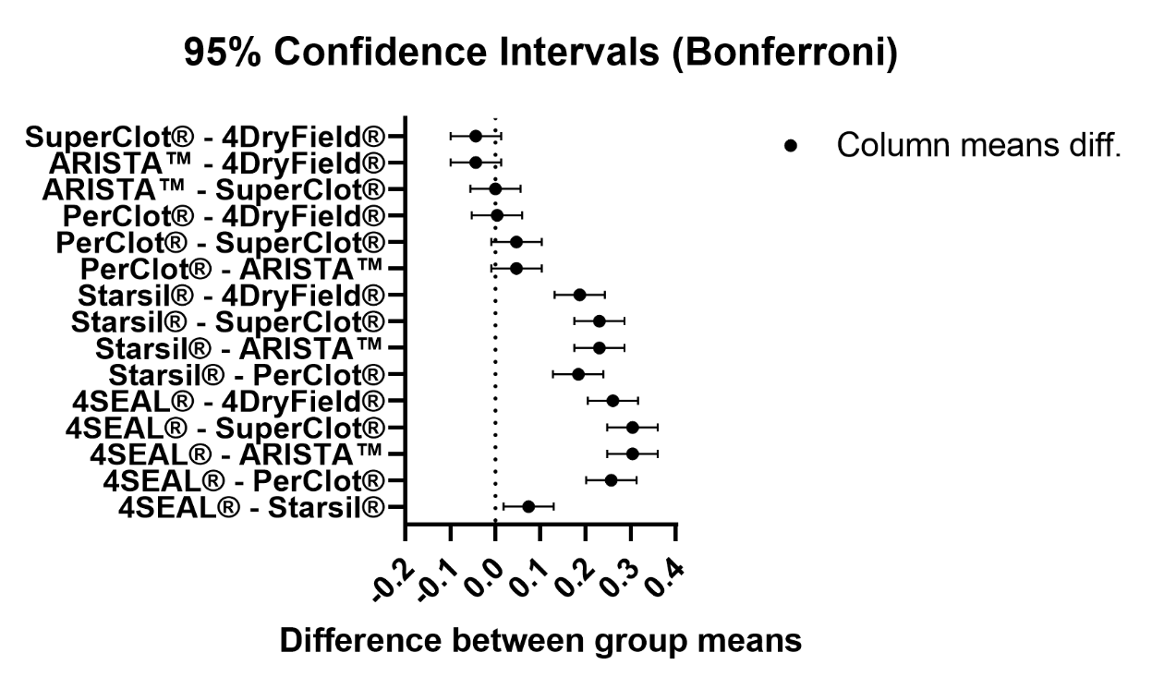
Figure S3. Result of one-way ANOVA with Bonferroni's multiple comparisons test for Adhesion potential

HEMOSTATIC POWDERS
Table S8. Information about hemostatic powders
Name | Manufacturer | REF | LOT
4SEAL® | Grena Biomed Ltd. | 1203-HP005 | Z/210505
Starsil® | Hemostat Manufacturing GmbH | SS005 | H190001
PerClot® | CryoLife, Inc. | STA0001 | 180303
ARISTA™ | BD, Inc. | SM0002-USA | 6111801
SuperClot® | AMP | SC0003 | 200502
4DryField® | PlantTec Medical | SK0005-EU | 200101

Figure S4. Morphology of evaluated hemostats. A - 4DryField, B - 4Seal, C - Arista, D - PerClot, E - SuperClot, F – Starsil. Images were taken using Revolve Microscope (ECHO A BICO COMPANY, USA) and ECHO Pro ver. 6.4.2 software at 100 x magnification.

