Supplementary Materials

Combined amphiphilic silybin meglumine nanosuspension effective against hepatic fibrosis in mice model
Qin Yang^{1, 2, #}
Tiantian Tan^{2, #}
Qin He²
Chenqi Guo²
Dan Chen²
Yulu Tan²
Jiaxing Feng²
Xu Song²
Tao Gong²
Jia Li^{2, 3, *}
¹ School of Pharmacy, North Sichuan Medical College, Nanchong, 637100, China.
² Key Laboratory of Drug-Targeting and Drug Delivery System of the Education Ministry and Sichuan Province, Sichuan Engineering Laboratory for Plant-Sourced Drug and Sichuan Research Center for Drug Precision Industrial Technology, West China School of Pharmacy, Sichuan University, Chengdu, 610041, China.
³ National Clinical Research Center for Oral Diseases, West China Hospital of Stomatology, Sichuan University, Chengdu, 610041, China.

Synthesis of hyaluronic acid-cholesterol (HC) conjugate

Figure S1. Synthesis scheme of HC conjugates.

Amphiphilic cholesterol-modified hyaluronic acid was synthesized as shown in Figure S1.¹⁻³ Firstly, aminated CHO was synthesized^{4,5}. Briefly, 0.6 g CHO-Cl (1.3 mmol) was dissolved in dichloromethane (DCM, 15 mL), with ice water bath and nitrogen protection. Ethanediamine (EDA, 1.76 mL) and triethylamine (TEA, 1.3 mmol) were mixed and dropped into the cool CHO-Cl solution. Kept the reaction at room temperature for 10 h. The filtrate was collected after filtration, being washed and dried with purified water and anhydrous magnesium sulfate. Then, it was dried under vacuum rotary evaporation to obtain the white solid CHO-NH₂.
Next, EDC (70 mg, 0.37 mmol) and HOBT (50 mg, 0.37 mmol) were dissolved in DI water (1 mL) and dropped into the sodium hyaluronate solution with 50 mg sodium hyaluronate (Mw 89 kDa) and DI water (20 mL). The pH value of the mixture solution was adjusted to 5.5 and kept the reaction stirring for 30 min to obtain the HA. Then, CHO-NH₂ solution including CHO-NH₂ (20 mg, 0.04 mmol) and tetrahydrofuran (THF, 1 mL) was added to the above HA solution and stirred for 24 h. Finally, the reaction mixture was dialyzed and lyophilized to get the HC.

Characterization of HC
Fourier transform infrared spectroscopy of HC was acquired on a fourier infrared spectrometer (FT-IR, Spectrum Two, Perkin Elmer, USA). Dry powder of HC and HA were prepared with solid slice, and the spectrometer scanning ranged from 400 to 4000 cm⁻¹.
In order to get modified amphiphilic HC, cholesterol was chosen as the hydrophobic part linked to hydrophilic HA (Figure S1). The chemical structure of the small-molecular intermediate product CHO-NH₂ was confirmed by ¹H NMR spectra {(CDCl₃, 400MHz): δ: 5.38(s, 1H), 5.01(brs, 1H), 4.51-4.49(m, 1H), 3.30-3.22(m, 3H), 2.82(t, J = 6.0Hz, 1H), 2.34-2.72(m, 2H), 2.02-1.84(m, 6H), 1.56-0.86(m, 34H), 0.67(s, 3H)}. The characteristic functional groups of the end product HC were analyzed using FT-IR. Signals at 1610 and 1032 cm⁻¹ were carbonyl asymmetrical stretching vibration and -C-OH stretching vibration of native HA, respectively. Both two absorption peaks were observed at a lower wavelength and with weakened intensity of HC. That could be attributed to effects of the intermolecular hydrogen bonding among HC molecules.

Figure S2. The size stability of dispersed CS (A) and CS-HC (B) at 4°C, n = 3.
Figure S3. The UV-vis absorption spectra of free SLB-M and CS-SLB dissolved in DI water.
Figure S4. The expression of CD44 in LX-2, HepG₂, LO₂ and RAW_{264.7} cells, detected by flow cytometer. Data were shown as mean ± SD, n = 3, ****: p < 0.0001; ***: p < 0.001; *: p < 0.05 vs RAW_{264.7}.

Figure S5. Appearance and histological analysis of CCl₄- and bile duct ligation (BDL-)induced fibrotic livers by H&E and Masson stain. Arrowheads indicate collagen ﬁbrils.

Figure S6. Distribution of SLB, NS-SLB, and NS-SLB-HCS in normal mice (A) and CCl₄-induced hepatic fibrosis mice (B). Data were shown as mean ± SD, n = 5, ****, p < 0.0001; ***, p < 0.001; **, p < 0.01; *, p < 0.05 vs free SLB.

Figure S7. Body weight and TGF-β levels of hepatic fibrosis mice induced by CCl₄ (A, B) and BDL (C, D) and treated with saline, SLB solution, NS-SLB, and NS-SLB-HC. Normal mice were used as controls. Data were shown as mean ± SD (n ≥ 5). ***, p < 0.001; **, p < 0.01; *, p < 0.05; ns, non-significant difference vs control.

Figure S8. Efficacy of nanosuspensions against CCl₄-induced hepatic fibrosis in mice. (A) Appearance and histological analysis of liver tissues after 10 weeks of treatment with different formulations. Scale bar, 100 μm. (B, C) Levels of alanine aminotransferase (ALT) and aspartate aminotransferase (AST) after 10 weeks of treatment. Normal mice were used as controls. (D) Immunofluorescence staining of liver sections against α-smooth muscle actin (α-SMA) or collagen I with Alexa Fluor® 488-labeled IgG (green) after 10 weeks of treatment. Cell nuclei were stained with DAPI (blue). Scale bar, 50 μm. (E) Semi-quantitative analysis of immunofluorescence images. Data are shown as mean ± SD (n = 5). ****P < 0.0001; ***P < 0.001; **P < 0.01; *P < 0.05; ns, non-significant difference vs control.

Figure S9. Efficacy of nanosuspensions against BDL-induced hepatic fibrosis in mice. (A) Appearance and histological analysis of liver tissues after 2 weeks of treatment with different formulations. Scale bar, 100 μm. (B, C) Levels of alanine aminotransferase (ALT) and aspartate aminotransferase (AST) after 2 weeks of treatment. (D) Immunofluorescence staining of liver sections against α-smooth muscle actin (α-SMA) or collagen I with Alexa Fluor® 488-labeled IgG (green) after 3 weeks of treatment. Cell nuclei were stained with DAPI (blue). Scale bar, 50 μm. (E) Semi-quantitative analysis of immunofluorescence images. Normal mice were used as controls. Data are shown as mean ± SD (n = 5). ****P < 0.0001; ***P < 0.001; *P < 0.05; ns, non-significant difference vs control.

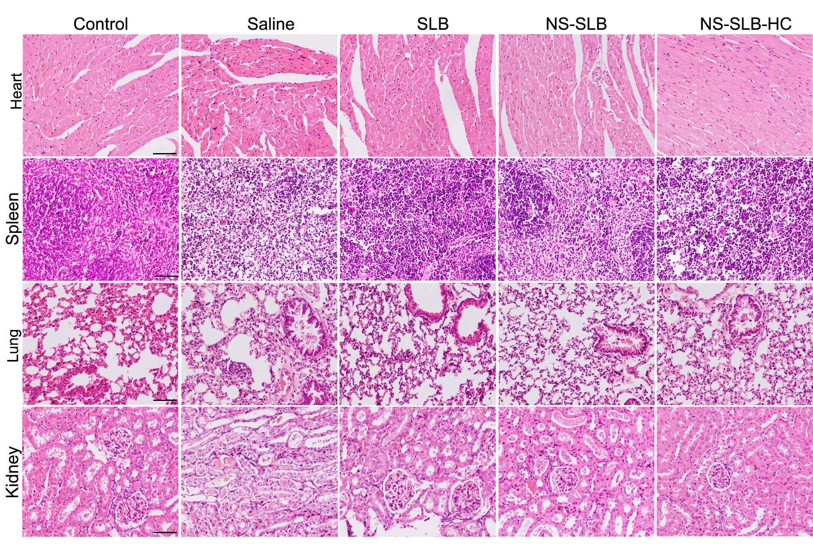
Figure S10. Systemic toxicity evaluation of nanosuspensions against BDL-induced hepatic fibrosis in mice after 2 weeks of treatment with different formulations. Scale bar, 30 μm.

References
1. Liu X, Li W, Chen T, et al. Hyaluronic Acid-Modified Micelles Encapsulating Gem-C12 and HNK for Glioblastoma Multiforme Chemotherapy. Mol Pharm. 2018;15(3):1203-1214.
2. Li W, Zhou C, Fu Y, et al. Targeted delivery of hyaluronic acid nanomicelles to hepatic stellate cells in hepatic fibrosis rats. Acta Pharm Sin B. 2020;10(4):693-710.
3. Huerta-Angeles G, Brandejsova M, Novotny J, et al. Grafting of steroids to hyaluronan towards the design of delivery systems for antioxidants: The role of hydrophobic core. Carbohydr Polym. 2018;193:383-392.
4. Avadisian M, Fletcher S, Liu BX, et al. Artificially Induced Protein-Membrane Anchorage with Cholesterol-Based Recognition Agents as a New Therapeutic Concept. Angewandte Chemie. 2011;50(28):6248-6253.
5. He T, Li K, Wu MY, et al. Water promoted enantioselective aldol Reaction by proline-cholesterol and -diosgenin based amphiphilic organocatalysts. Tetrahedron. 2013;69(25):5136-5143.

