Supplementary Materials：

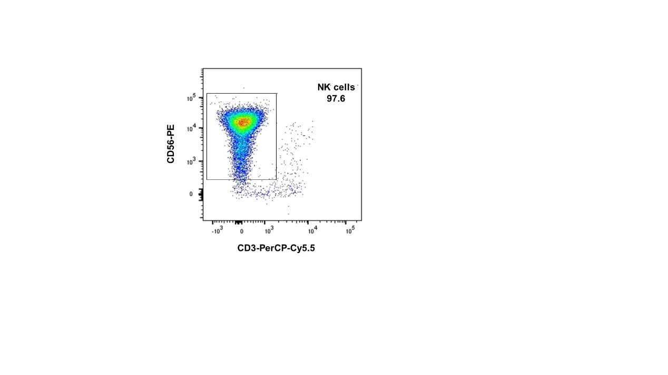
Figure S1. The purity of NK cells after magnetic activated cell sorting.

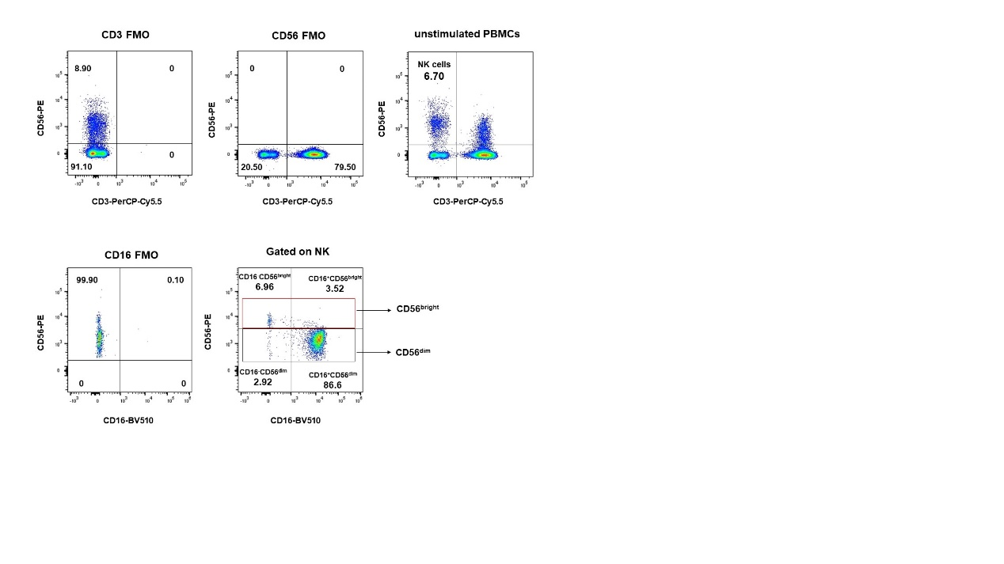
Figure S2. The flow cytometry gating strategy were set with FMO for NK cells.

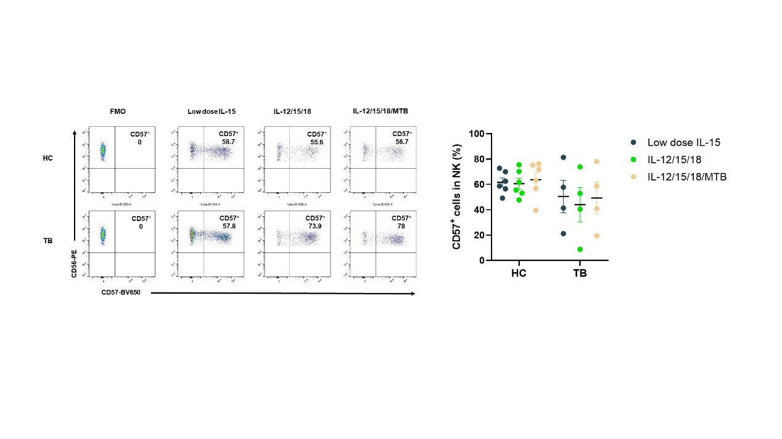
Figure S3. CD57⁺NK cells were analyzed using flow cytometry.

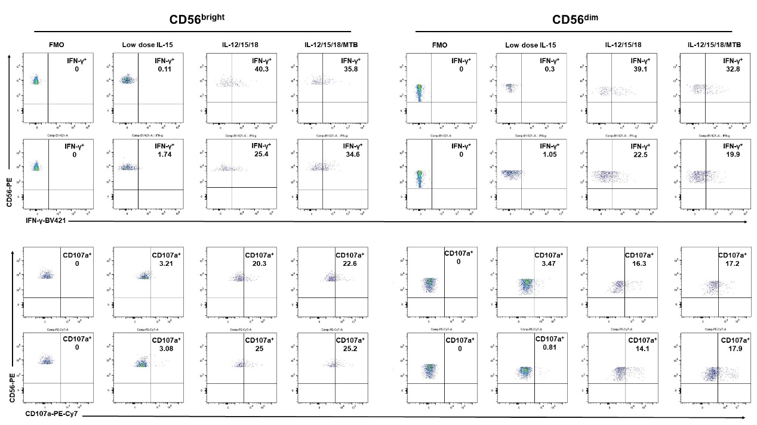
Figure S4. Representative flow cytometry gating strategy for IFN-γ and CD107 in CD56^{bright} and CD56^{dim} NK cells.

Figure legends：
Figure S1. The purity of NK cells after magnetic activated cell sorting. CD3⁻CD56⁺ NK cells were purified to >95% purity using negative magnetic bead separation. This gating is shown from 1 representative individual. Labeled numbers are the percentages of CD3⁻CD56⁺ NK cells in all live cells.

Figure S2. The flow cytometry gating strategy were set with FMO for NK cells. This gating is shown from 1 representative individuals. The numbers in the panels indicate percentage in the gated areas of sorted cells.

Figure S3. CD57⁺NK cells were analyzed using flow cytometry. (A) Representative flow cytometry gating strategy. NK cells were gated on CD57. This gating is shown from 2 representative individuals. labeled numbers are the percentage of CD57 positive in NK cells. (B) Summary of data shown as Means ± SEM percentage of CD57⁺ NK cells. There was no significant differences of percentages of CD57⁺ NK cells among groups.

Figure S4. Representative flow cytometry gating strategy for IFN-γ and CD107 in CD56bright and CD56dim NK cells. This gating is shown from 2 representative individuals. Inset numbers are the percentages of IFN-γ or CD107a positive NK cells.

