Supplementary data
PET data acquisition
Subjects were placed in the PET scanner gantry with two intravenous (antecubital) lines placed. Head movement was minimized using a light forehead restraint. For each subject, 15±1 mCi of [¹¹C]CFN were administered intravenously with a maximum mass injected of 0.03 μg/kg to ensure that the compound was administered in true tracer quantities, eliminating significant receptor occupancy. Fifty percent of the dose was administered as a bolus and the remainder as a continuous infusion using a computer-controlled automated pump to achieve steady-state tracer levels.¹ A total of 21 frames over 90 minutes with increasing duration were acquired with a Siemens HR+ scanner in 3-D mode (reconstructed full width at half-maximum (FWHM) resolution ~5.5 mm in-plane and 5.0 mm axially) with septa retracted and scatter correction.

Sustained Thermal Pain Threshold Stress Challenge
We used the sustained thermal pain threshold stress (STPTS) challenge paradigm, designed and developed in-house.² We previously observed activation of μOR in response to the STPTS challenge during both interictal and ictal phases in migraine individuals.^{2–4} Specifically, heat pain stimulus was applied to the trigeminal mandibular region (V3) ipsilateral to the worst headache side by using a 16 mm² thermal probe system (MEDOC Pathway Model, Ramat Yishai, Israel). After setting the baseline of 32°C as a starting point, the temperature was automatically increased or decreased by a 1°C/sec rate based on participants' responses. The maximum temperature was set to 50°C. The participants tapped the mouse button as soon as they perceived the stimulus as painful, and the system returned to baseline temperature. The STPTS challenge lasted for 20 minutes with a 10-second cycle which is sufficiently long in duration to collect enough data points that permits quantification of thermal pain threshold. The thermal pain threshold for pre-and post-treatment measured during STPTS challenge in PET scanner was 47.8 ± 1.3 and 47.7 ± 2.0 for the active group (n=13); 47.1 ± 2.2 and 47.7 ± 1.5 for the sham group (n=12), respectively. The repeated measures ANOVA showed that there were not any significant effects of treatment (F (1,23) = 0.25, P = 0.62), time (F (1,23) = 0.43, P = 0.52), or interaction effect between treatment and time (F (1,23) = 1.26, P = 0.27) on thermal pain threshold.

MRI acquisition
We separately acquired high-resolution T1-weighted scans for anatomical standardization with the following parameters: a 3T GE scanner (Milwaukee, WI) with FAST spoiled gradient recalled echo (SPGR) sequence; TE=5.2, TR=12.28, TI=500, flip angle=15º, field of view (FOV)=25.6 cm, 1.0 mm thick slices, number of excitations (NEX)=1, and acquisition matrix=256x256.

PET preprocessing
The interactive algorithm was implemented with attenuation and scatter corrections to reconstruct PET images into a 128 × 128 pixel-matrix in a 24 × 24 cm FOV. Dynamic image data was transformed on a voxel-by-voxel basis into two sets of parametric maps, which included a tracer transport measure (k1 ratio) and receptor-related measures (distribution volume ratio, DVR), which then are co-registered to each other. These data were analyzed using a modified Logan graphical analysis⁵ with the occipital cortex (a region devoid of µORs) as the reference region. The Logan plot becomes linear well within 10 min after radiotracer administrations with a slope proportional to the (Bmax/Kd) + 1 for this receptor site, where Bmax represents the receptor concentration and Kd the receptor affinity for the radiotracer. Bmax/Kd is the receptor availability or non-displaceable binding potential (BP_{ND}). If noise-related underestimations in BP_{ND} measures are observed, these can be further corrected utilizing published methods.⁵ For late phase periods (45-90 mins after [¹¹C]CFN injection), the ratio of specific to non-specific binding at full equilibrium [(specific minus non-specific)/non-specific] was used to ensure that biases are not introduced by using Logan plots.⁶
Individual T1-weighted anatomical and PET images were then co-registered with each other using a mutual information algorithm. For this purpose, K₁ ratio images were first aligned to the T1-weighted MR, and the anatomical scans were then non-linearly warped to the standardized Montreal Neurological Institute (MNI) space. The resulting transformation matrix was then applied to both K₁ ratio and BP_{ND} image sets, followed by smoothing with 3-3-2 mm Gaussian Kernel. After non-linear warping to standard space, we flipped PET data for five patients stimulated on the right M1 (contralateral to worst pain; two active vs. three sham) to align the side of HD-tDCS stimulation for all subjects. Quality control/check was conducted for non-linearly warped images.

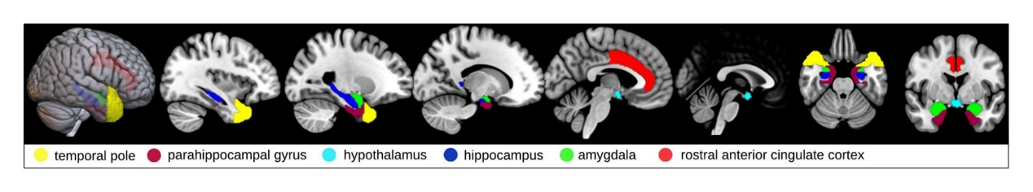 Figure S1 Brain masks used in small-volume correction in the voxel-wise analysis. All regions except the hypothalamus were derived from the Harvard-Oxford probabilistic atlas. For the hypothalamus, we used Neurosynth meta-analytic maps (http://neurosynth.org) with the term ‘hypothalamus’.
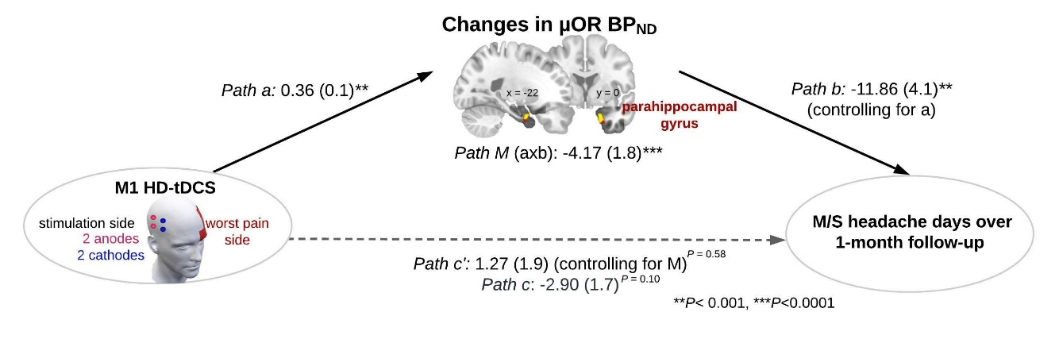
Figure S2. Potential mediator of M1 HD-tDCS efficacy. Path diagram showed that active HD-tDCS increased µOR BP_{ND} compared to sham in the left parahippocampal region during the STPTS challenge, which predicted M/S headache days over 1-month follow-up among higher-frequency patients. Numbers indicate path coefficients with standard errors in parentheses. A significant interaction effect between the treatment group and time in the parahippocampal gyrus is shown in yellow (Fig. 3A), and voxels mediating HD-tDCS and outcome are shown in red (q < 0.05, FDR-corrected). *** P < 0.0001, **P < 0.001.

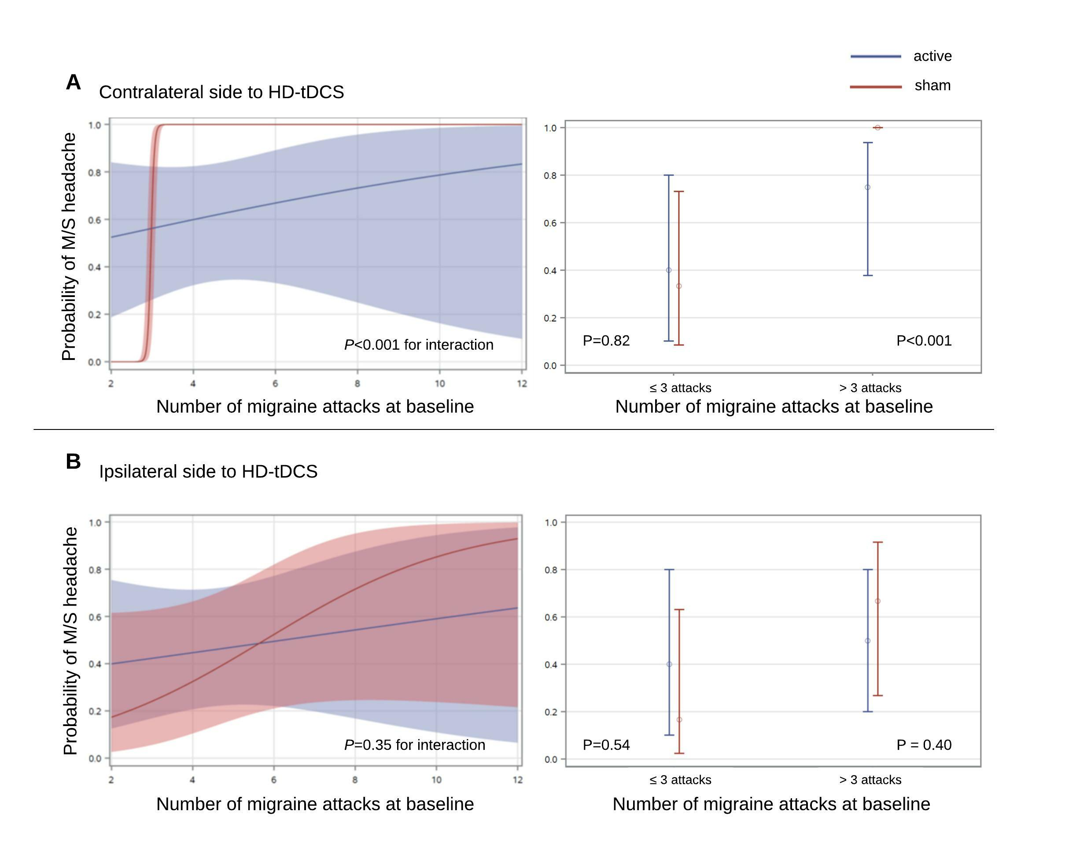
Figure S3 Changes in maximum pain intensity in the contralateral or ipsilateral side to the M1 HD-tDCS over 1-month follow-up. A. The number of pre-treatment migraine attacks was related to maximum pain intensity measured by 3D-mobile pain tracking technology. Results are presented predicted probability of having M/S (moderate-to-severe) intensity headache pain contralateral to the HD-tDCS with a 95% confidence interval (CI) by monthly attack frequency at baseline. B. The ipsilateral side of the HD-tDCS appeared no clinical benefit from the treatment.
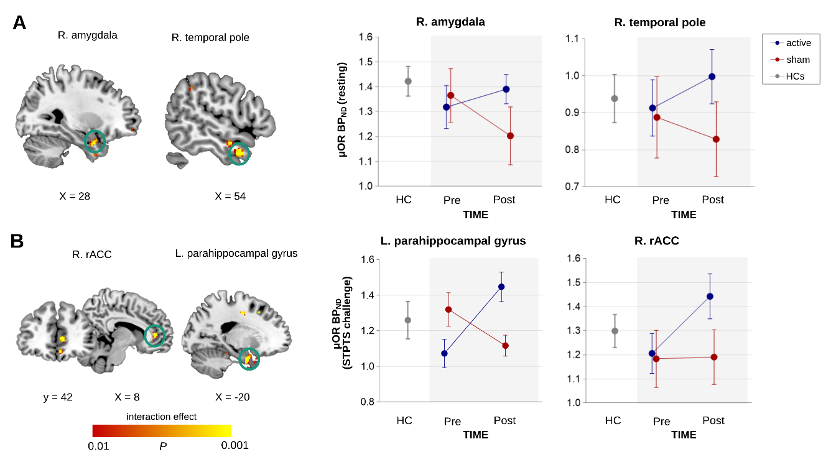
Figure S4 Changes in voxel-wise µOR BP_{ND} in higher-frequency patients (active, n=8; sham, n=6). A. Results shows statistically significant interaction effect of treatment group (active vs. sham) and time (pre- vs. post-treatment) in the right amygdala (peak xyz coordinates in Montreal Neurological Institute (MNI) space = 28, 4, -28; k = 33) and right temporal pole (peak xyz = 54, 8, -30; k=49) during the resting-state (5-40 mins after radiotracer injection) and B. in the right rostral anterior cingulate (rACC) (peak xyz = 8, 42, 6; k=36) and left parahippocampal gyrus (peak xyz = -20, 0, -28; k=67) during sustained thermal pain threshold stimulus challenge (STPTS) (45-90 mins after radiotracer injection) phase. The significance threshold for small-volume correction (SVC) was set to voxel-level p < 0.005 (uncorrected), combined with a cluster-level family-wise error (FWE)-corrected p < 0.05. Data represents means ± SEM.

References
1. Koeppe RA, Frey KA, Kume A, Albin R, Kilbourn MR, Kuhl DE. Equilibrium versus compartmental analysis for assessment of the vesicular monoamine transporter using (+)-α-[11C]dihydrotetrabenazine (DTBZ) and positron emission tomography. J Cereb Blood Flow Metab. Nature Publishing Group; 1997;17:919–931. doi:10.1097/00004647-199709000-00001.
2. Nascimento TD, DosSantos MF, Lucas S, et al. μ -Opioid activation in the midbrain during migraine allodynia - brief report II. Ann Clin Transl Neurol. Wiley-Blackwell; 2014;1:445–450. doi:10.1002/acn3.66.
3. DaSilva AF, Nascimento TD, DosSantos MF, et al. μ -Opioid activation in the prefrontal cortex in migraine attacks - brief report I. Ann Clin Transl Neurol. 2014;1:439–444. doi:10.1002/acn3.65.
4. Jassar H, Nascimento TD, Kaciroti N, et al. Impact of chronic migraine attacks and their severity on the endogenous μ-opioid neurotransmission in the limbic system. NeuroImage Clin. 2019;23:101905. doi:10.1016/j.nicl.2019.101905.
5. Logan J, Fowler JS, Volkow ND, Wang GJ, Ding YS, Alexoff DL. Distribution volume ratios without blood sampling from graphical analysis of PET data. J Cereb Blood Flow Metab. SAGE PublicationsSage UK: London, England; 1996;16:834–840. doi:10.1097/00004647-199609000-00008.
6. Carson RE. Precision and accuracy considerations of physiological quantitation in PET. J Cereb Blood Flow Metab. SAGE PublicationsSage UK: London, England; 1991;11:A45-50. doi:10.1038/jcbfm.1991.36.

