Figure Legends
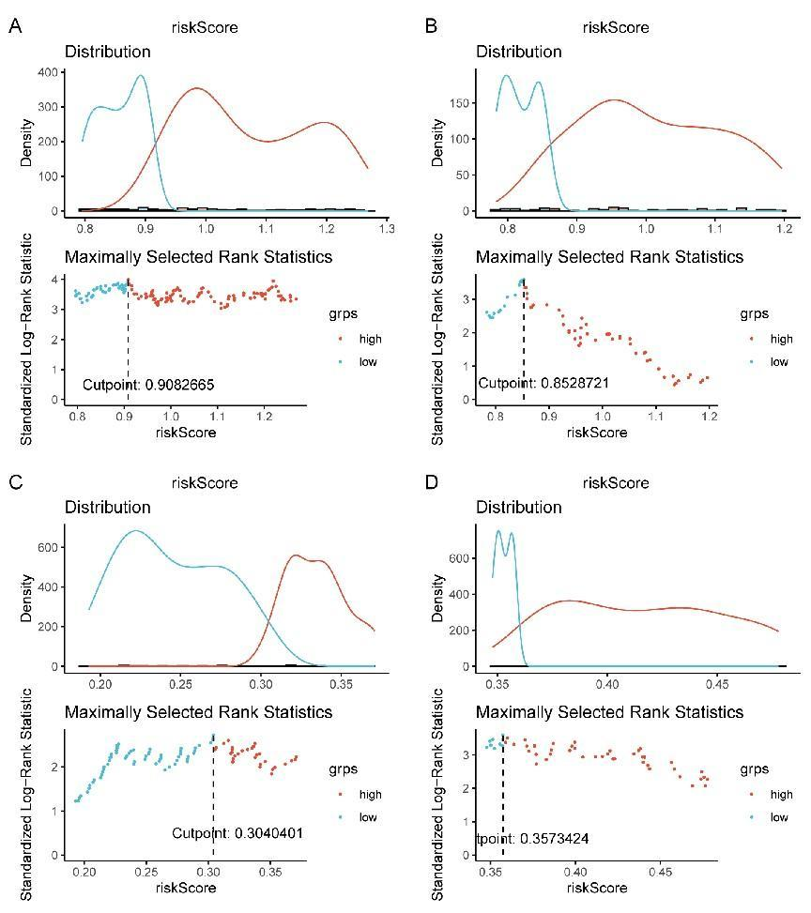
Supplementary Figure 1 The optimal cut-off value calculated by surv_cutpoint function in “survminer” package.
- 0.9082665 for TCGA training set. (B) 0.8528721 for testing set. (C) 0.3040401 for GSE31210 dataset. (D) 0.3573424 for GSE50081 dataset.
Supplementary Figure 2 Validation of the risk score model in testing set, GSE31210 dataset, and GSE50081 dataset.
- The risk curve and survival status of patients in testing set; (B) Kaplan-Meier curves of survival in low- and high-risk; (C) Heatmap of the expressions of LINC00857, RP5-1102E8.3, RP3525N10.2 in low- and high-risk score; (D) ROC curves of the risk score model for predicting the survival of 1-, 3- and 5-year. (E) The risk curve and survival status of patients in GSE31210 dataset; (F) Kaplan-Meier curves of survival in low- and high-risk; (G) Heatmap of the expressions of LINC00857, RP5-1102E8.3, RP3525N10.2 in low- and high-risk score; (H) ROC curves of the risk score model for predicting the survival of 1-, 3- and 5-year. (I) The risk curve and survival status of patients in GSE50081 dataset; (J) Kaplan-Meier curves of survival in low- and high-risk; (K) Heatmap of the expressions of LINC00857, RP5-1102E8.3, RP3525N10.2 in low- and high-risk score; (L) ROC curves of the risk score model for predicting the survival of 1-, 3- and 5-year. ROC, receiver operating characteristic.

