Supplementary materials
Table S1 Details of the GSEA analysis of P4HA3 correlated genes.
ID | setSize | enrichmentScore | NES | pvalue | p.adjust | qvalue
WP_MITOCHONDRIAL_COMPLEX_I_ASSEMBLY_MODEL_OXPHOS_SYSTEM | 31 | -0.8545334 | -5.942728 | 1e-10 | 5.77e-09 | 4.46e-09
REACTOME_SARS_COV_2_MODULATES_HOST_TRANSLATION_MACHINERY | 26 | -0.8445968 | -5.127324 | 1e-10 | 5.77e-09 | 4.46e-09
REACTOME_CRISTAE_FORMATION | 21 | -0.8562226 | -4.625019 | 1e-10 | 5.77e-09 | 4.46e-09
WP_MITOCHONDRIAL_COMPLEX_IV_ASSEMBLY | 19 | -0.9106467 | -4.371340 | 1e-10 | 5.77e-09 | 4.46e-09
REACTOME_FORMATION_OF_ATP_BY_CHEMIOSMOTIC_COUPLING | 13 | -0.8915573 | -3.777676 | 1e-10 | 5.77e-09 | 4.46e-09
WP_MITOCHONDRIAL_COMPLEX_III_ASSEMBLY | 13 | -0.8811970 | -3.733777 | 1e-10 | 5.77e-09 | 4.46e-09
WP_MIRNA_TARGETS_IN_ECM_AND_MEMBRANE_RECEPTORS | 21 | 0.8705921 | 2.604338 | 1e-10 | 5.77e-09 | 4.46e-09
REACTOME_ELASTIC_FIBRE_FORMATION | 41 | 0.7542078 | 2.459516 | 1e-10 | 5.77e-09 | 4.46e-09
REACTOME_ASSEMBLY_OF_COLLAGEN_FIBRILS_AND_OTHER_MULTIMERIC_STRUCTURES | 53 | 0.7298686 | 2.456011 | 1e-10 | 5.77e-09 | 4.46e-09
REACTOME_INTEGRIN_CELL_SURFACE_INTERACTIONS | 73 | 0.6999891 | 2.422398 | 1e-10 | 5.77e-09 | 4.46e-09
Notes: WP, WikiPathways; OXPHOS, oxidative phosphorylation; NES, normalize enrichment score; ATP, adenosine triphosphate; ECM, extracellular matrix.
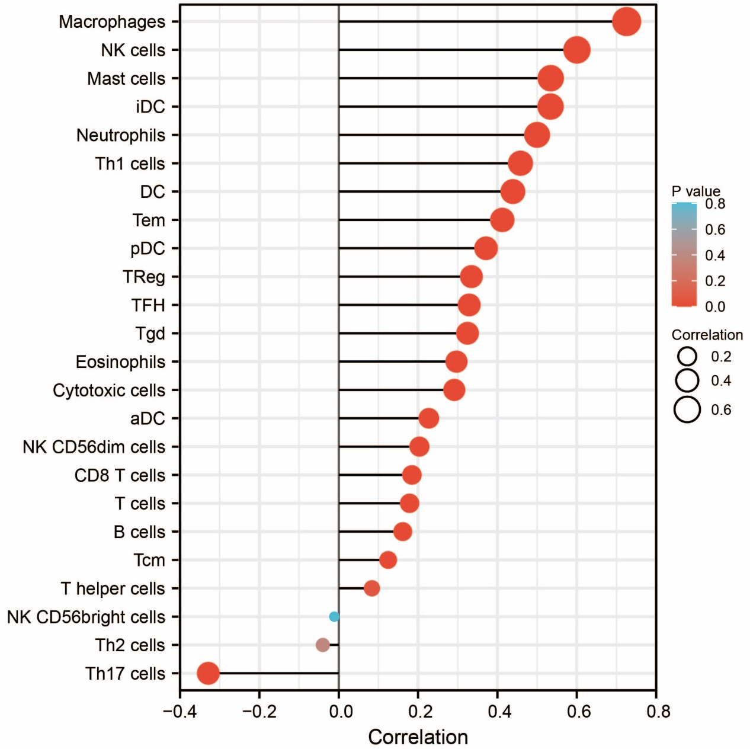
Figure S1 Relationships Among Infiltration Levels of 24 Immune Cell Types and P4HA3 Expression levels by Spearman’s Analysis.
Notes: NK, natural killer; DC, dendritic cells; aDC, activated DC; iDC, immature DC; pDC, plasmacytoid DC; Th, T helper cells; Th1, type 1 Th cells; Th2, type 2 Th cells; Th17, type 17 Th cells; Treg, regulatory T cells; Tgd, T gamma delta; Tcm, T central memory; Tem, T effector memory; Tfh, T follicular helper.

