Supplementary description
Table S1: Basic clinicopathological features of patients included in IHC
(IHC) | Age | Gender | Pathology | Vascular/Nerve invasion
sample1 | 52 | Female | Nonspecific invasion carcinoma | (-)/(-)
sample2 | 40 | Female | Nonspecific invasion carcinoma | (+)/(-)
sample3 | 59 | Female | Nonspecific invasion carcinoma | (-)/(-)
sample4 | 55 | Female | Nonspecific invasion carcinoma | (-)/(-)
sample5 | 55 | Female | Nonspecific invasion carcinoma | (+)/(-)
sample6 | 68 | Female | Nonspecific invasion carcinoma | (+)/(-)

Figure S1:
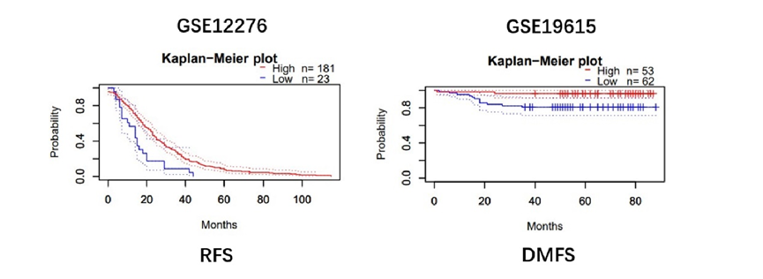
Relationship between CES2, RFS, and DMFS in the PrognoScan database.
Figure S2:
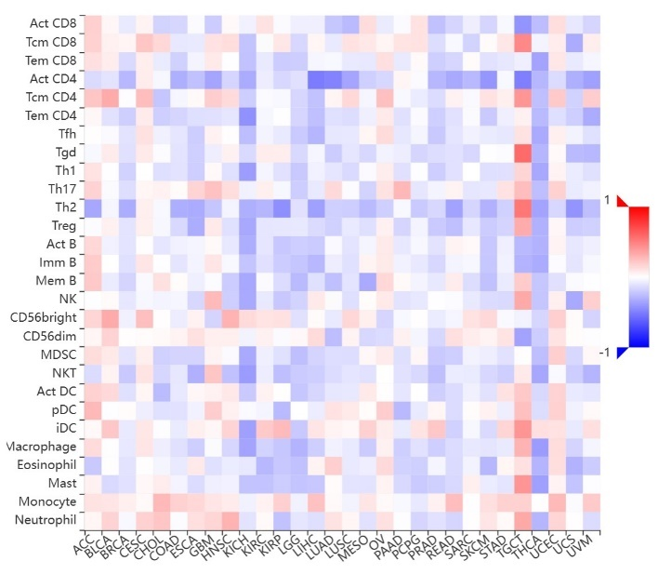
Correlations between the abundance of tumor-infiltrating lymphocytes (TILs) and CES2 in the TISIDB database.

