Supplementary material
ROS generative black phosphorus-tamoxifen nanosheets for targeted endocrine-sonodynamic synergistic breast cancer therapy
Jing Wang^{1,#}, Weijian Chen ^{1,2,#}, Wenxiang Du ², Hongjie Zhang² , Matthias Ilmer³，Lei Song ² ,Yuan Hu^{2,*} , Xiaopeng Ma ^{1,*}

¹ Department of General Surgery, The First Affiliated Hospital of USTC, Division of Life Sciences and Medicine, University of Science and Technology of China, Hefei, Anhui, 230001, P.R. China.
² State Key Laboratory of Fire Science, University of Science and Technology of China, Hefei 230026, Anhui, P.R. China.
³ Department of General, Visceral, and Transplantation Surgery, Ludwig-Maximilians-University (LMU), Campus Grosshadern, 81377 Munich, Germany

# These authors contributed equally to this study.

*Corresponding Authors:
Yuan Hu, Email: yuanhu@ustc.edu.cn
Xiaopeng Ma, Email: XiaopengMa@fsyy.ustc.edu.cn

Table. S1 The primer sequence for qPCR
c-myc
Forward Sequence | CCTGGTGCTCCATGAGGAGAC
Reverse Sequence | CAGACTCTGACCTTTTGCCAGG
cyclinD1
Forward Sequence | TCTACACCGACAACTCCATCCG
Reverse Sequence | TCTGGCATTTTGGAGAGGAAGTG
ESR
Forward Sequence | GCTTACTGACCAACCTGGCAGA
Reverse Sequence | GGATCTCTAGCCAGGCACATTC
GAPDH
Forward Sequence | GTCTCCTCTGACTTCAACAGCG
Reverse Sequence | ACCACCCTGTTGCTGTAGCCAA

Table. S2 TAM drug loading capacity with various TAM/BP mass ratio
Primary TAM/BP ratio | Free TAM (mg) | Loading TAM  (mg) | Loading TAM/BP mass ratio (%) | Loading efficiency (%)
0.25 : 1 | 0.423 | 0.327 | 10.91 | 43.60
0.5 : 1 | 0.899 | 0.601 | 20.03 | 40.07
1 : 1 | 2.018 | 0.982 | 32.72 | 32.73
2 : 1 | 4.040 | 1.960 | 65.34 | 32.67
4 : 1 | 8.834 | 3.166 | 105.52 | 26.38

Table. S3 Top 10 pathways enrichment of KEGG. Count: number of genes enriched in the corresponding pathway
ID | Description | qvalue | Count
hsa04110 | Cell cycle | 3.60E-11 | 26
hsa03440 | Homologous recombination | 1.37E-06 | 12
hsa03460 | Fanconi anemia pathway | 2.61E-05 | 12
hsa04115 | p53 signaling pathway | 0.00057063 | 12
hsa04218 | Cellular senescence | 0.001984592 | 17
hsa05210 | Colorectal cancer | 0.008817501 | 11
hsa01524 | Platinum drug resistance | 0.008817501 | 10
hsa00140 | Steroid hormone biosynthesis | 0.008887059 | 9
hsa04210 | Apoptosis | 0.031184406 | 13
hsa03030 | DNA replication | 0.038662338 | 6
hsa00980 | Metabolism of xenobiotics by cytochrome P450 | 0.039924269 | 9
hsa04114 | Oocyte meiosis | 0.045245797 | 12
hsa00030 | Pentose phosphate pathway | 0.073209214 | 5

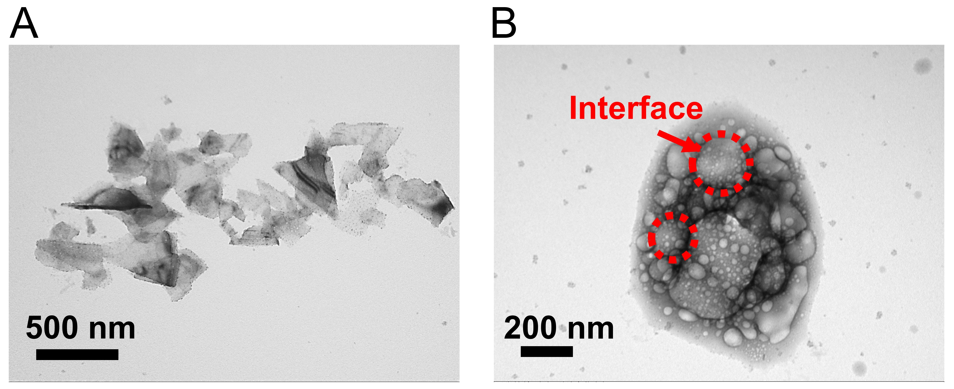
Fig. S1 TEM image of exfoliated black phosphorus nanosheets (A) and oxidative TAM@BP-FA after five ultrasonic treatments for 48 h in the process of in vitro drug release.

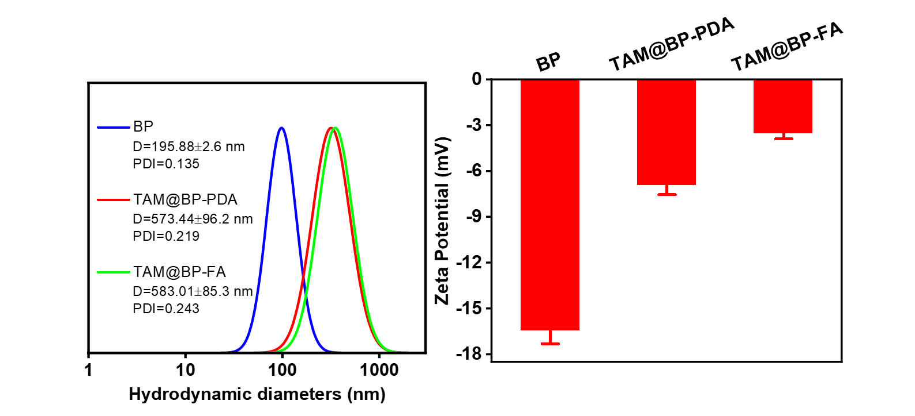
Fig. S2 (A) Hydrodynamic diameter and (B) Zeta potential of black phosphorus nanosheets (BPS), TAM@BP-PDA and TAM@BP-FA.
B
A
Fig. S3 (A) UV-vis spectrum of TAM with various concentrations. (B) The standard curve at 278nm with various concentrations.

Fig. S4 Cell viability of MCF7 and TMR cells treated with increased dosage of free TAM.

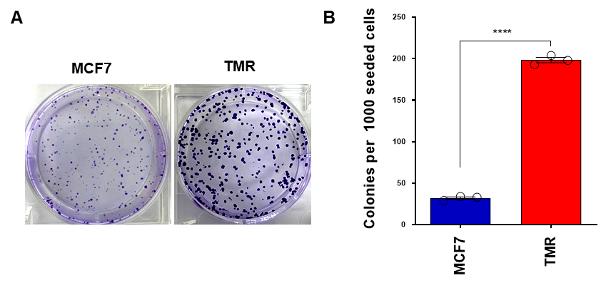
Fig. S5 (A) Images of colony formation assays performed in MCF7 and TMR cells. (B) Quantification of colony number in Fig S2B. Data are means ± SD (n = 3).，****p < 0.0001.

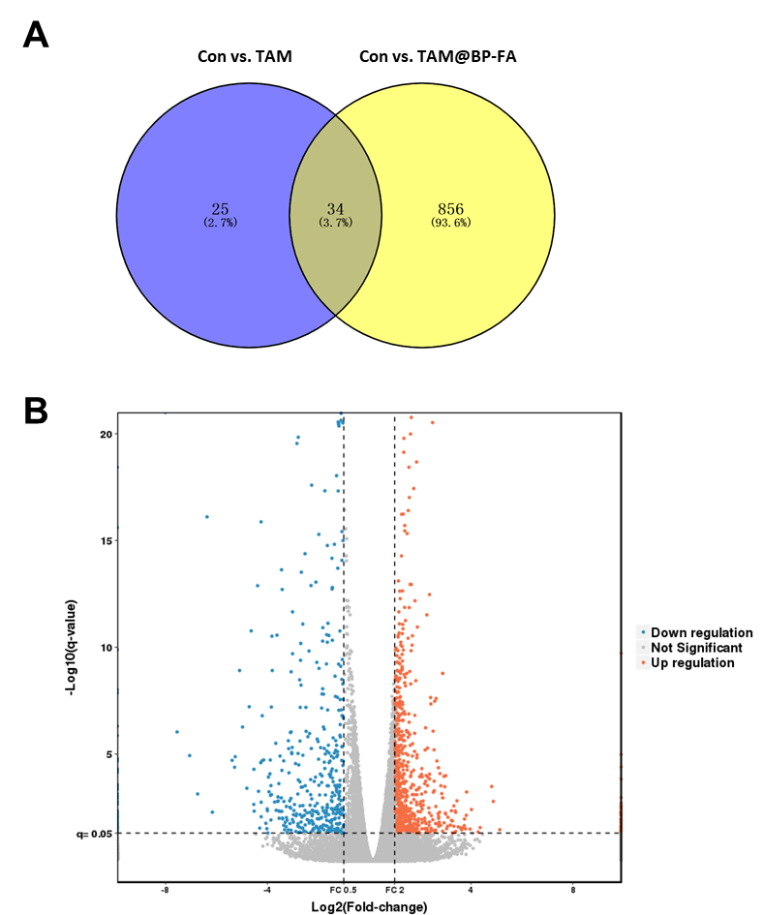
Fig. S6 (A) Venn diagram for intergroup comparison (Con vs. TAM, Con vs. TAM@BP-FA) overlap of differentially expressed genes using an online tool. (B) Volcano plots for intergroup comparison (Con vs. TAM, Con vs. TAM@BP-FA) overlap of differentially expressed genes.

Fig. S7 The gene expression of the CCND1, MYC and ESR in MCF7 cells treated with free TAM or TAM@BP-FA. NS no significance, *p < 0.05, **p < 0.01, and ****p < 0.0001.

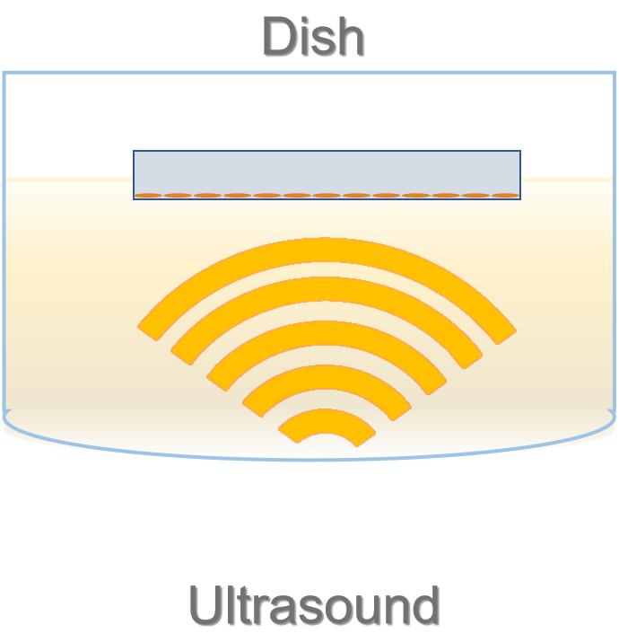
Fig. S8 Schematic illustration of the SDT setting

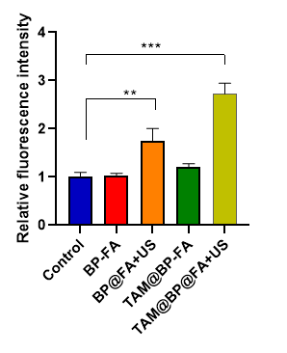
Fig. S9 Relative fluorescence intensity of ROS detection in TMR cells following BP-FA, BP-FA and US, TAM@BP-FA and US treatments. **p < 0.01, ***p < 0.001 .

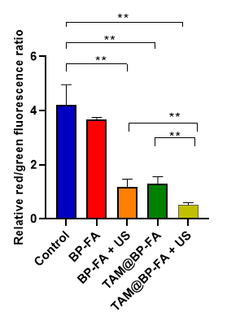
Fig. S10 Relative red/green ratio of MMP detection in TMR cells following BP-FA, BP-FA and US, TAM@BP-FA and US treatments. **p < 0.01.

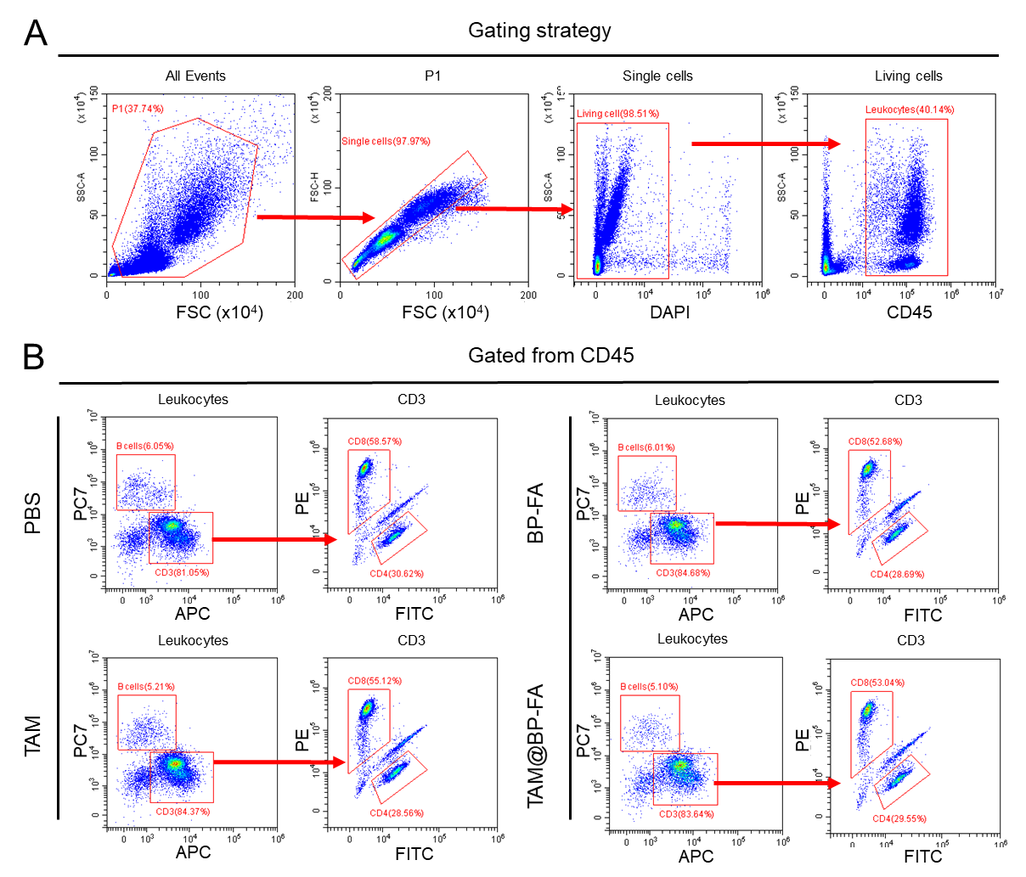
Fig. S11 (A) Gating strategy. (B) Representation of B cells, CD4+, CD8+ cells distributions among the cohorts by FACS analysis.

Fig. S12 Body weight in various groups during the treatment process. G1-G7 represent mice treated with PBS, TAM, BP+US, BP-FA+US, TAM@BP+US, TAM@BP-FA and TAM@BP-FA+US respectively.

