Table S1 Main compounds in AR extract characterized by UPLC-Q/TOF-MS
NO | Retention time (min) | Molecular formula | Identification | CAR | ARP | ACB
1 | 0.88 | C3H7NO2 | Alanine | + | + | +
2 | 4.67 | C9H11NO2 | Phenylalanine | + | + | +
3 | 9.21 | C17H26O4 | Gingerol | - | + | -
4 | 11.18 | C26H43NO6 | Glycocholic acid | - | - | +
5 | 12.54 | C15H10O5 | Apigenin | + | + | +
6 | 12.89 | C24H40O4 | Ursodeoxycholic acid | - | - | +
7 | 14.11 | C24H40O5 | Cholic Acid | - | - | +
8 | 14.85 | C26H43NO4 | Glycolithocholic acid | - | - | +
9 | 16.82 | C24H40O4 | Chenodeoxycholic acid | - | - | +
10 | 17.22 | C24H40O4 | Deoxycholic acid | + | + | +
11 | 17.82 | C24H50NO7P | LysoPC(14:0) | + | + | -
12 | 18.74 | C26H54NO7P | LysoPC(16:0) | + | + | -
13 | 19.22 | C23H46NO7P | LysoPE(18:1) | + | + | -
14 | 23.81 | C18H30O2 | Linolenic acid | + | + | +
15 | 25.43 | C18H32O2 | Linoleic acid | + | + | +
Abbreviations: UPLC-Q/TOF-MS, ultra-high performance liquid chromatography- quadrupole/ time-of-flight mass spectrometry; CAR, crude Arisaematis Rhizome; ARP, Arisaematis Rhizome Praeparatum; ACB, Arisaema Cum Bile; LysoPE, lysophosphatidylethanolamine; LysoPC, lysophosphatidylcholine

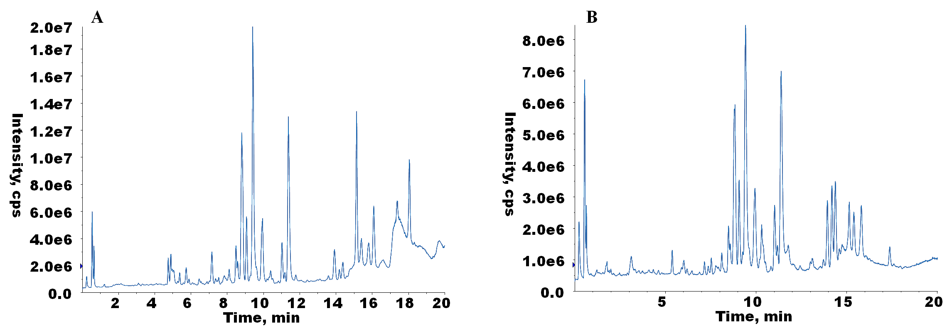
Figure S1. The overlaid total ion chromatograms of QC samples analyzed throughout the analytical run. (A) chromatograms acquired in ESI (+), (B) chromatograms acquired from ESI (-).
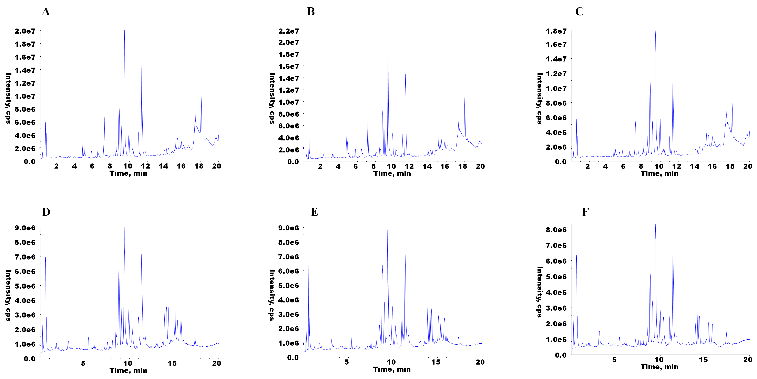
Figure S2. The typical chromatographs obtained from CAR- (A), ARP- (B) and ACB- (C) treated rats in ESI (+) mode; the typical chromatographs obtained from CAR- (D), ARP- (E) and ACB- (F) treated rats in ESI (-) mode.

Figure S3. Permutation plots for the OPLS-DA model of N vs CAR in ESI (+) mode (A), N vs ARP in ESI (+) mode (B), N vs ACB in ESI (+) mode (C), N vs CAR in ESI (-) mode (D), N vs ARP in ESI (-) mode (E), N vs ACB in ESI (-) mode (F).

Figure S4. Heat map of correlations between differential metabolites and biochemical parameters.

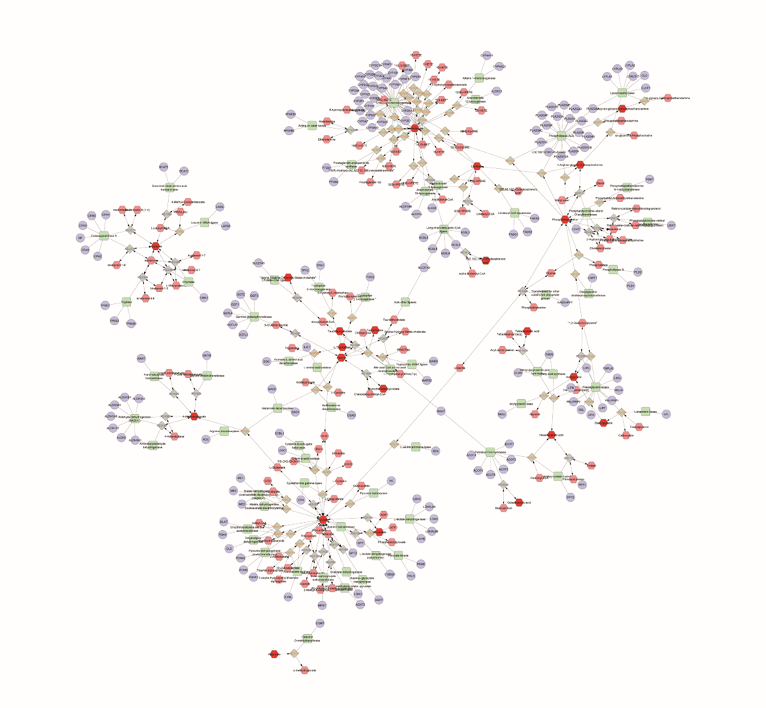
Figure S5. Metabolite-reaction-enzyme-gene network related to the exposure of AR. Red hexagons: input metabolites; green squares: enzyme; grey diamonds: reaction; purple circle: target; pink hexagon: related metabolites

Figure S6. Molecular docking showing lysoPC(16:0) -PLA2G4A (PDB ID: 1CJY) interactions (A), and lysoPC(16:0)-FASN (PDB ID: 2PX6) interactions (B).
Abbreviations: PLA2G4A, phospholipase A2 group Ⅳ A; FASN, fatty acid synthase

