Supplementary Appendix

Contents
Pre-analyses 2
Figure S1- PCA plot for analysis 3A and 3B 2
Added information on main analyses 4
Table S1- Detailed description of analyses 1 4
Table S2- Baseline characteristics of participants in treatment groups and categories of subgroup. 4
Sensitivity analyses 5
Figure S2A- Multivariable fractional polynomial interaction assessing non-linear relationship of principal component 1 in analysis 3A 6
Figure S2B- Multivariable fractional polynomial interaction assessing non-linear relationship of principal component 1 in analysis 3B 7
References: 7

Pre-analyses

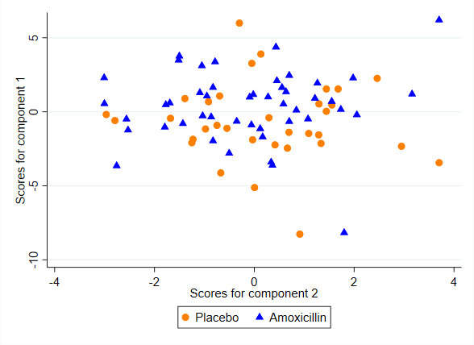
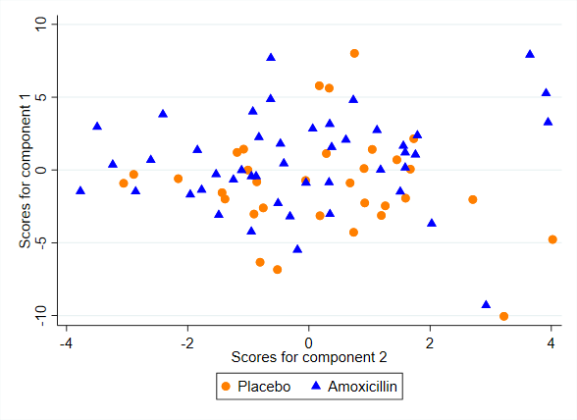
Principal Component Analyses of log-transformed serum cytokine levels in included patients (n=78). Figure A refers to analysis 3A and Figure B refers to analysis 3B. Each circle (placebo) and triangle (Amoxicillin) represent one patient. The plot shows that there was little difference between the amoxicillin and the placebo group in serum cytokine levels at baseline. The proportion of variance explained by principal component 1 was 26.9% in analysis A and 30.2% in analysis B.

Figure S1- PCA plot for analysis 3A and 3B
A
B

Added information on main analyses

Table S1- Detailed description of analyses 1
Algorithm parameters for analyses 1A, 1B and 1C, presented as R code
algorithm_parameters = list(min_subgroup_size = 5
,criterion_type = 1
,depth = 2
,width = 2
,gamma = c(NA,NA)
,local_mult_adj = 0.1 # Apply local multiplicity adjustment (1-max, 0 no adjustment)
,n_perms_mult_adjust = 1000
,subgroup_search_algorithm = "Adaptive SIDEScreen procedure"
,multiplier = 0.1
,n_perms_vi_score = 100 # number of permutations to compute max VI threshold
)

Table S2- Baseline characteristics of participants in treatment groups and categories of subgroup.
Baseline characteristic | Comparable cluster category subgroup (Analysis 2, category 3+4) |  | Cluster category subgroup of interest (Analysis 2, category 1+2)
 | Amoxicillin (N=22) | Placebo  (N=19) | Amoxicillin  (N=24) | Placebo  (N=13)
Age (mean (SD)) | 41 (7.9), n=22 | 43 (10), n=19 | 45 (8.9), n=24 | 47 (8.3), n=13
Women | 14/22 (64%) | 14/19 (74%) | 13/24 (54%) | 6/13 (46%)
Body mass index (mean (SD)) | 25 (2.7), n=22 | 25 (3.8), n=19 | 25 (3.7), n=24 | 27 (5.7), n=12
Smoking, yes | 3/22 (14%) | 3/19 (16%) | 12/24 (50%) | 6/13 (46%)
Educational level
Primary school (9 years) | 0/22 (0%) | 3/19 (16%) | 3/23 (13%) | 2/13 (15%)
High school (12 years) | 9/22 (41%) | 11/19 (58%) | 8/23 (35%) | 5/13 (38%)
College or university (<4 years) | 8/22 (36%) | 2/19 (11%) | 9/23 (39%) | 3/13 (23%)
University (≥4 years) | 5/22 (23%) | 3/19 (16%) | 3/23 (13%) | 3/13 (23%)
Comorbidity*
Score 1 (back pain only) | 19/22 (86%) | 12/19 (63%) | 16/24 (67%) | 7/13 (54%)
Score 2 | 3/22 (14%) | 5/19 (26%) | 7/24 (29%) | 5/13 (38%)
Score >2 | 0/22 (0%) | 2/19 (11%) | 1/24 (4%) | 1/13 (8%)
Other comorbidity
Arthritis/osteoarthrosis | 0/22 (0%) | 1/19 (5.3%) | 3/24 (13%) | 0/13 (0%)
Diabetes | 0/22 (0%) | 0/19 (0%) | 0/24 (0%) | 1/13 (8%)
COPD | 0/22 (0%) | 0/19 (0%) | 0/24 (0%) | 0/13 (0%)
Cardiac disease | 0/22 (0%) | 0/19 (0%) | 0/24 (0%) | 0/13 (0%)
Psychiatric disease | 2/22 (9.1%) | 2/19 (11%) | 1/24 (4%) | 2/13 (15%)
Former disc surgery | 4/22 (18%) | 5/19 (26%) | 3/24 (13%) | 4/13 (31%)
Emotional distress  (HSCL-25 ≥ 1.75) § | 7/22 (32%) | 6/19 (32%) | 5/24 (21%) | 3/13 (23%)
FABQ physical activity (0-24) (mean (SD))¶ | 11 (7.1), n=22 | 12 (5.7), n=19 | 12 (6), n=24 | 12 (4.7), n=13
FABQ work (0-24) (mean (SD))¶ | 17 (14), n=22 | 19 (13), n=19 | 19 (11), n=24 | 20 (15), n=12
Duration of back pain (years) (median (IQR)) | 2.6(1.5-5.2) | 3(1.5-7) | 3.5(1.6-8) | 2.8(1.3-5)
Physical work load
Mostly sitting | 7/19 (37%) | 7/15 (47%) | 8/20 (40%) | 5/10 (50%)
Job requires a lot of walking | 7/19 (37%) | 3/15 (20%) | 7/20 (35%) | 1/10 (10%)
Job requires a lot of walking and lifting | 5/19 (26%) | 5/15 (33%) | 4/20 (20%) | 4/10 (40%)
Job requires physically heavy work | 0/19 (0%) | 0/15 (0%) | 1/20 (5%) | 0/10 (0%)
Presence of leg pain | 17/22 (77%) | 14/19 (74%) | 16/24 (67%) | 10/13 (77%)
Sleep disturbance
No sleep disturbance | 7/22 (32%) | 5/19 (26%) | 1/24 (4%) | 2/13 (15%)
Minor sleep disturbance | 5/22 (23%) | 8/19 (42%) | 11/24 (46%) | 3/13 (23%)
Moderate sleep disturbance | 9/22 (41%) | 4/19 (21%) | 8/24 (33%) | 3/13 (23%)
Major sleep disturbance | 1/22 (4.5%) | 2/19 (11%) | 4/24 (17%) | 5/13 (38%)
Modic type I group | 12/22 (55%) | 9/19 (47%) | 16/24 (67%) | 6/13 (46%)
STIR composite group†
STIR 1 | 6/22 (27%) | 8/19 (42%) | 8/24 (33%) | 3/13 (23%)
STIR 2 | 11/22 (50%) | 7/19 (37%) | 10/24 (42%) | 8/13 (62%)
STIR 3 | 5/22 (23%) | 4/19 (21%) | 6/24 (25%) | 2/13 (15%)
Values are No/total No (%) unless stated otherwise. N refers to the number of patients providing data.
* Functional Comorbidity Index(1) – Score increased by 1 for each of 18 diagnoses associated with decreased physical function.
§ Emotional distress (Hopkins Symptom Checklist–25), values ≥1.75 associated with psychiatric diagnosis.(2)
¶ Fear-Avoidance Beliefs Questionnaire), higher values indicating more fear-avoidance beliefs.
† A composite variable measuring the abundance of MC oedema assessed using short tau inversion recovery (STIR) images, higher number meaning more abundant MC oedema (7).

Sensitivity analyses
Graph shows how the estimated treatment effect, measured by the difference between Roland-Morris Disability Questionnaire score at one year follow-up in the antibiotic group and the placebo group (y-axis), varies with the principal component 1 used in regression analysis 3A (x-axis). The grey area represent the 95% confidence interval. We used a fractional polynomial with degree 2 (FP2) with flex(1) (least flexible) as recommended for possible non-monotonic relationship (3). The principal component analysis used for analysis 3A was based on cytokines with levels that were significantly different from the healthy controls (CCL11, CCL22, CCL21, IL4, CCL26, IL6, CXCL13, CX3CL1, CCL27, CXCL6, CCL20, IFNγ, CCL19, IL2, CCL17, IL16, CCL25, CCL7, CCL13, MIF, CCL3, CCL15, CCL23, CXCL16). The graph shows no statistically significant treatment effect (95% confidence interval includes 0) for any value of the principal component 1 and no clear trend of non-linear relationships.

Figure S2A- Multivariable fractional polynomial interaction assessing non-linear relationship of principal component 1 in analysis 3A
Graph shows how the estimated treatment effect, measured by the difference between Roland-Morris Disability Questionnaire score at one year follow-up in the antibiotic group and the placebo group (y-axis), varies with the principal component 1 used in regression analysis 3B (x-axis). The grey area represent the 95% confidence interval. We used a fractional polynomial with degree 2 (FP2) with flex(1) (least flexible) as recommended for possible non-monotonic relationship (3). The principal component analysis used for analysis 3B was based on all cytokines. The graph shows no statistically significant treatment effect (95% confidence interval includes 0) for any value of the principal component 1 and no clear trend of non-linear relationships.

Figure S2B- Multivariable fractional polynomial interaction assessing non-linear relationship of principal component 1 in analysis 3B

References:
1. Groll DL, To T, Bombardier C, Wright JG. The development of a comorbidity index with physical function as the outcome. Journal of Clinical Epidemiology. 2005;58(6):595-602.
2. Sandanger I, Moum T, Ingebrigtsen G, Dalgard OS, Sorensen T, Bruusgaard D. Concordance between symptom screening and diagnostic procedure: the Hopkins Symptom Checklist-25 and the Composite International Diagnostic Interview I. Social psychiatry and psychiatric epidemiology. 1998;33(7):345-54.
3. Sauerbrei W, Royston P. Investigating treatment-effect modification by a continuous covariate in IPD meta-analysis: an approach using fractional polynomials. BMC Medical Research Methodology. 2022;22(1):98.

