Supplementary Figure 1. Overview of the modified Delphi process

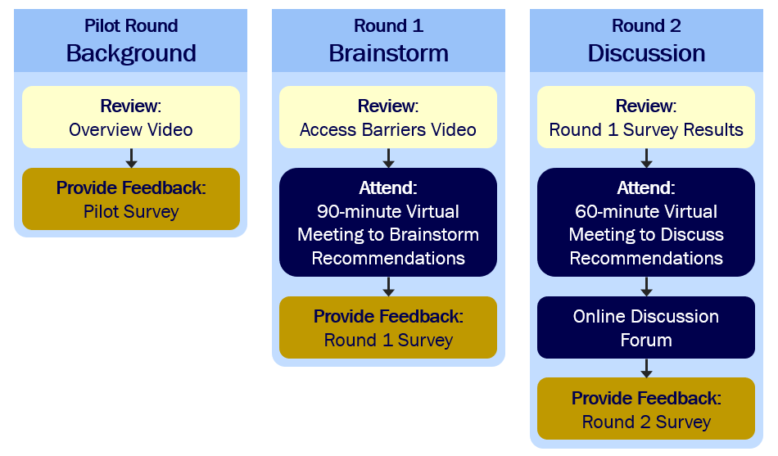
Supplementary Table 1. Definitions of scored metrics
Metric | Definition
Feasibility | The extent to which a proposed recommendation is within stakeholder control and could attract the political and financial support necessary for implementation
Impact | The extent to which, if implemented, a proposed recommendation would improve access to effective pain care for patients taking opioids for chronic pain
Importance | The extent to which stakeholders should prioritize implementing this recommendation

Supplementary Table 2. Final Recommendations: Detailed descriptions and discussion summaries
Recommendations are described in greater detail below, including a one-sentence overview, a more detailed recommendation description that panelists collaboratively generated, and a researcher-written summary of the panel’s discussion. The language of each recommendation summary and description was developed through iterative discussions and reflects the collective perspective and expertise of the panel. The “Discussion Notes” for each recommendation is a synthesis of notes captured during the discussion meetings, and is intended to provide information about the main topics considered by the panelists while creating and reviewing the recommendation.

Recommendation | Theme | Detailed Description | Discussion Notes
1. Establish reimbursement models for chronic pain to provide appropriate compensation for all care providers, such as psychologists, physical therapists, physician assistants, nurse practitioners, social workers, and physicians, who treat and manage patients with complex pain. | Restructuring reimbursement models | Visits for chronic pain are often complex and require significantly more clinical time than other conditions. Currently, members of pain-related care teams (e.g. clinical pharmacists, nurses, social workers) do not receive reimbursement specifically for their services, and physicians and other billable providers can be reluctant to manage patients with chronic pain because it is so time-intensive. Different reimbursement models, such as value-based reimbursement and billing modifiers, may incentivize the provision of time-intensive and personnel-intensive care, from both physicians and other care team members, and lead to increased access to quality, full-team care. | During the panel discussion, there was some concern about the difficulty of reaching a common understanding of what types of coverage increased “value” and that the meaning of “value” could differ between stakeholder groups (e.g. patients and insurers). Similarly, some panelists thought insurers might be reluctant to increase reimbursement due to the cost or would want robust evidence of cost-effectiveness. Interestingly, panelists with insurance expertise were more confident than other panelists that insurers would, in fact, be willing to shift their existing reimbursement structures to drive provider behavior change.
2. Create a collaborative/integrated care model expanding upon the existing Michigan  Medicaid Health Home model to include patients with chronic pain who are publicly and privately insured. | Restructuring reimbursement models | Currently, patients may not be encouraged to pursue non-pharmacologic treatment modalities or be counseled on whether opioid medications are effective or safe long term (tolerance/dependence). In the existing Michigan Medicaid Opioid Health Home model, which is funded through Michigan Medicaid and focused on treating patients with opioid use disorder (OUD), patients are provided intensive support, including case management (for more information on Michigan Opioid Health Homes, click on this link). Patients are presented with all available resources and treatment options at one time and provided support in navigating integrated care across multidisciplinary providers (e.g. transitional care and referral to community and social services). Interested health systems and providers can apply for Health Home designation status to receive funding to support these staff, such as a director, behavioral health specialist, and peer recovery coach. The panel recommended expanding the existing model in Michigan to include patients with chronic pain, which has been included as a qualifying condition for Medicaid-funded health home care models in at least 5 states (Iowa, Missouri, New York, South Dakota, and Washington).37,38 This would ensure that these multimodal therapies are easily accessible before the patient becomes physically dependent on opioids. | Panelists noted that private payers could fund similar structures to expand this care model further. Noted challenges with this recommendation included securing funding from public or private insurers, having an adequate workforce to staff the model, and needing different types of providers in a care team (e.g., physical therapists) to provide pain-focused care that the current OUD-focused model does not utilize.
3. Train members of the clinical team, such as social workers, to help address biopsychosocial factors and ongoing management of chronic pain treatment. | Enhancing provider education | This would address prescriber concerns about being unable to adequately support and monitor patients using long-term opioid therapy from a physical and mental health perspective. These additional staff would provide support for ongoing pharmacologic treatments, such as opioid therapy, as well as non-pharmacologic treatments, such as behavioral interventions. When appropriate, these team members could also identify and refer patients to address issues such as housing and behavioral health concerns. | Panelists did note that training and, where necessary, hiring these staff members could pose a challenge to implementation, particularly within existing reimbursement models that do not typically cover such assistance. Therefore, this recommendation is closely related to Recommendation #1 in that the staff, once trained in managing biopsychosocial factors, must also be reimbursed for their time.
4. Improve dissemination of evidence related to multimodal and non-pharmacological treatments for pain and their effectiveness to encourage expanded insurance coverage. | Restructuring reimbursement models | Insurers are more likely to provide coverage and increase reimbursement for services that are evidence-based and cost-effective. Therefore, the objective of this recommendation is to disseminate information regarding the efficacy of multimodal and non-pharmacologic treatments to insurers to potentially improve coverage for such treatments. | Initially, there was some disagreement among panelists as to whether evidence of treatment effectiveness already exists in systematic reviews and whether the existing data is robust. However, upon further discussion, there was agreement that the existing evidence base needs to be conveyed to insurance companies to inform coverage changes. There was some concern that some non-pharmacological treatment modalities can be quite expensive, and insurers may be unwilling to cover these high-cost treatments even with evidence of effectiveness. Similarly, panelists voiced hesitancy about the transparency of insurers’ cost-effectiveness determinations. Finally, several panelists brought up persistent disbelief among providers as to the effectiveness of these treatments, which could potentially limit engagement even with increased coverage. Ultimately panelists felt that there may be a knowledge gap more so than a lack of evidence for such treatments, and the evidence therefore needs to be relayed to insurers to encourage expanded coverage.
5. Deliver an educational curriculum that explains the continuum between addiction and physical dependency on long-term opioid therapy for chronic pain to all personnel who interact with patients (providers, clerical staff, etc.) in order to encourage appropriate patient-centered care and reduce stigma. | Enhancing provider education | Providers, staff, and even patients may equate prescribed opioid treatment with addiction because of a lack of knowledge about the differences between addiction and physical dependence. Some providers who prescribe opioids appropriately have suggested that they feel stigmatized or judged by their colleagues. Within electronic medical records systems, patients prescribed long-term opioid therapy may incorrectly be labeled as having an opioid use disorder (OUD). An educational intervention that explains the differences between physical dependence and addiction and the harms of incorrect assumptions can address these stigmatizing ideas. This could also clarify best practices for patients who have comorbid OUD and chronic pain. | There was some concern among panelists that this type of educational intervention could be too simplistic, and, in trying to categorize patients as having either pain or OUD, ultimately further stigmatize patients with OUD. This stigma could then potentially manifest, counterproductively, as worse pain care for patients who have both pain and OUD. Furthermore, panelists acknowledged that it can be challenging to develop and implement effective educational campaigns that reduce provider stigma and change behavior.
6. Improve education on multimodal and non-pharmacological therapies for chronic pain management (and chronic pain in general) for healthcare providers, including both at the level of health professional school and continuing medical education. | Enhancing provider education | Providers may not have a solid understanding of the efficacy of non-pharmacological treatments and how to guide patients towards these treatments. By educating providers on how to diagnose chronic pain, the treatment options, and how to use them effectively, more treatment modalities could be provided in more care settings outside of specialty pain clinics. This educational intervention would not only apply to physicians but to all members of the care team. This could help address misconceptions and stigma about patients with chronic pain, especially around disbelief of pain or assumptions of addiction. | Panelists did note that these existing attitudes and misconceptions are deeply entrenched and could be difficult to overcome. Also, it could be difficult to design effective and comprehensive curricula because pain management is often quite complex and individualized.
7. Implement standardized pain management protocols that include mandatory reporting to provide more objective data on pain management across races and ethnicities. | Addressing racial inequities in care | Systematic protocols, such as screening and management checklists, may reduce individual provider biases in pain treatment and variation across providers. Mandatory reporting of treatment data may increase data transparency with respect to racial outcomes and demonstrate potential areas for improvement. | Panelists noted that developing and implementing these protocols would require financial resources, and it can be challenging to design protocols that are directive enough to provide consistent care without being so rigid as to be misapplied in inappropriate treatment situations.
8. Increase recruitment and retention of providers from underrepresented racial and ethnic minorities across clinical duties (e.g., physicians, nurse practitioners, social workers) including by providing appropriate financial compensation and incentives if practicing in under-resourced communities. | Addressing racial inequities in care | Patients from minority racial and ethnic groups often feel more comfortable and experience less racial discrimination when treated by a provider of the same race. However, there is concern about the limited representation of racial minorities among providers who treat this patient population. This problem is multifactorial and includes both recruitment of people from underrepresented racial minority groups into health professional programs and retention of health professionals from underrepresented racial minorities working in areas with limited healthcare resources. This would be addressed by first recruiting more providers from underrepresented racial minorities into health professional programs. Once trained, it would also be important to support and incentivize these providers to practice in communities that face racial bias and disparities in care. | Panelists noted that it could be challenging to secure consistent funding for incentive programs, and the effectiveness of recruitment efforts could be limited by ongoing disputes over affirmative action.
9. Make providers aware of how Michigan's prescription drug monitoring program data is used in investigating and disciplining providers. | Enhancing provider education | Michigan’s prescription drug monitoring program is an online database providers use to keep track of prescriptions for controlled substances. There is currently confusion about how and when prescription data are used to investigate and possibly sanction providers. Both physicians and patients have noted that providers are fearful of being sanctioned for prescribing opioids. By clarifying when and how prescription data are actually used in licensing investigations, an awareness campaign may reduce provider fears of sanction, and therefore reduce inappropriate under-prescribing. This awareness intervention will focus specifically on how this data is monitored with respect to legal consequences for providers and not be focused on general use of the platform. Reducing provider reluctance to treat this population will consequently increase access to providers for patients receiving long-term opioid therapy. | Some panelists felt that this would not be effective because there has already been extensive provider training about how to use Michigan's prescription drug monitoring program, and additional efforts to clarify its use could add administrative burdens to prescribing, further limiting patient access to care. It is also unclear whether increased awareness around actual data use would change provider perceptions about the legal ramifications of opioid prescribing or consequent willingness to prescribe.
10. Develop implicit bias training to improve patient-provider communication around pain. | Addressing racial inequities in care | Implicit bias training would help address cultural barriers in patient-provider communication. Reducing provider bias and improving communication may make health services seem more accessible to patients from racial and ethnic minority groups and may thereby improve treatment outcomes. | Panelists recognized that these trainings can become a “checkbox” for organizations, and may not be effective in their implementation or intended outcomes. Also, developing and implementing these trainings would require an investment of health system resources.
11. Evaluate and describe where individuals belonging to minority racial and ethnic groups prefer to receive health-related information and community institutions they look to for support in healthcare decisions. | Addressing racial inequities in care | As a first step to improve healthcare engagement with racial and ethnic minority communities with limited access to healthcare resources, more research is needed to identify trusted anchor institutions and preferred information delivery mechanisms. With this data, community outreach and treatment education efforts can then be tied to and focused on these trusted institutions (e.g., churches). | Panelists noted this type of data could be challenging to collect, and both the initial research and any resulting implementation strategies would require funding. There was some disagreement among panelists as to whether the initial evaluation of how to disseminate healthcare-related information was necessary. Some argued that funding should instead be invested directly into engagement efforts, and that there was already sufficient information about effective engagement channels.

Supplementary Video 1. Pilot Round Background - https://www.youtube.com/watch?v=4CRs_5VUv2E

Supplementary Video 2. Round 1 Background - https://www.youtube.com/watch?v=_DzBFAo-3EE

