Additional File

Table of Contents

Additional Table 1. Search Strategies

Additional Figure 1. Description of Newcastle Ottawa Scale

Additional Table 2. Newcastle Ottawa Scale study quality assessment
Additional Table 3 Univariate Meta-Regression results for the association between PM2.5 and PEF of children
Additional Figure 2. Funnel plot of changes in PEF (L/min) estimates associated with a 10µg/m³ increases in PM2.5

Additional Figure 3. Funnel plot of changes in FVC (L) estimates associated with a 10µg/m³ increases in PM2.5

Additional Figure 4. Funnel plot of changes in FEV1 (L) estimates associated with a 10µg/m³ increases in PM2.5

Additional Table 1. Search Strategies

Additional Table 1. Search Strategies used in PUBMED, EMBASE to identify studies examining the relationship between exposure to PM2.5 and Lung function in children. PUBMED searches used MeSH terms and EMBASE searches used Emtree terms .

Search queries for PUBMED |  | Search queries for EMBASE
1 | (PM2.5[Title/Abstract]) OR (Ultrafine Fibers[Title/Abstract])) OR (Ultrafine Fiber[Title/Abstract])) OR (Fiber, Ultrafine[Title/Abstract])) OR (Airborne Particulate Matter[Title/Abstract])) OR (Particulate Matter, Airborne[Title/Abstract])) OR (Air Pollutants, Particulate[Title/Abstract])) OR (Particulate Air Pollutants[Title/Abstract])) OR (Ambient Particulate Matter[Title/Abstract])) OR (Particulate Matter, Ambient[Title/Abstract])) OR("Particulate Matter"[Mesh]) | (pm2.5:ab,ti OR 'ultrafine fibers':ab,ti OR 'ultrafine fiber':ab,ti OR 'fiber, ultrafine':ab,ti OR 'airborne particulate matter':ab,ti OR 'particulate matter, airborne':ab,ti OR 'air pollutants, particulate':ab,ti OR 'particulate air pollutants':ab,ti OR 'ambient particulate matter':ab,ti OR 'particulate matter, ambient':ab,ti OR particulate matter 2.5'/exp)
2 | AND(children[Title/Abstract]) OR ("Child"[Mesh]) | AND (children OR child'/exp)
3 | AND (Function Test, Respiratory[Title/Abstract]) OR (Function Tests, Respiratory[Title/Abstract])) OR (Test, Respiratory Function[Title/Abstract])) OR (Tests, Respiratory Function[Title/Abstract])) OR (Pulmonary Function Tests[Title/Abstract])) OR (Function Test, Pulmonary[Title/Abstract])) OR (Function Tests, Pulmonary[Title/Abstract])) OR (Test, Pulmonary Function[Title/Abstract])) OR (Tests, Pulmonary Function[Title/Abstract])) OR (Lung Function Tests[Title/Abstract])) OR (Function Test, Lung[Title/Abstract])) OR (Function Tests, Lung[Title/Abstract])) OR (Lung Function Test[Title/Abstract])) OR (Test, Lung Function[Title/Abstract])) OR (Tests, Lung Function[Title/Abstract])) OR (Pulmonary Function Test[Title/Abstract])) OR ("Respiratory Function Tests"[Mesh]) | AND(function test, respiratory':ab,ti OR 'test, respiratory function':ab,ti OR 'tests, respiratory function':ab,ti OR 'pulmonary function tests':ab,ti OR 'function test, pulmonary':ab,ti OR 'function tests, pulmonary':ab,ti OR 'test, pulmonary function':ab,ti OR 'tests, pulmonary function':ab,ti OR 'lung function?tests':ab,ti OR 'function test, lung':ab,ti OR 'function tests, lung':ab,ti OR 'test,lung function':ab,ti OR 'tests,?lung function':ab,ti OR 'pulmonary function test':ab,ti OR lung function test'/exp)

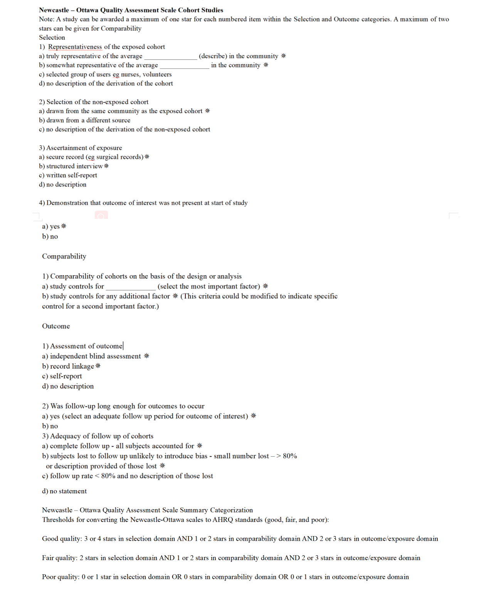
Additional Figure 1. Description of Newcastle Ottawa Scale

Newcastle Ottawa Scale study quality assessment

Author | Representative | Non-Exposed | Exposure | Outcome not present | Control for confounding ª | Outcome | Follow up | Adequate Follow up ^{b} | Score ^{c} | Overall Quality^{d}
Lu Ma/2008^{[23]} | 1 | 1 | 1 | 1 | 2 | 1 | 1 | 0 | 8 | Good
Bing-Yu Chen/2010^{[24]} | 1 | 1 | 1 | 1 | 2 | 1 | 1 | 0 | 8 | Good
Shin Yamazaki/2011^{[25]} | 0 | 1 | 1 | 1 | 2 | 1 | 1 | 1 | 8 | Good
Ludmilla/2012^{[26]} | 1 | 1 | 1 | 1 | 2 | 1 | 1 | 1 | 9 | Good
Ludmilla/2014^{[27]} | 0 | 1 | 1 | 1 | 2 | 1 | 1 | 1 | 8 | Good
Masanari/2016^{[28]} | 0 | 1 | 1 | 1 | 2 | 1 | 1 | 1 | 8 | Good
Dandan Xu/2018^{[29]} | 1 | 1 | 1 | 1 | 1 | 1 | 1 | 0 | 7 | Fair
Liu Weiyan/2019^{[11]} | 1 | 1 | 1 | 1 | 1 | 1 | 1 | 1 | 8 | Good
Dandan Xu/2020^{[30]} | 1 | 1 | 1 | 1 | 2 | 1 | 1 | 0 | 8 | Good
YANG Xiao Yan/2020^{[12]} | 0 | 1 | 1 | 1 | 1 | 1 | 1 | 0 | 6 | Fair
WU Xingbin/2020^{[31]} | 1 | 1 | 1 | 1 | 1 | 1 | 1 | 0 | 7 | Fair
Additional Table 2. Newcastle Ottawa Scale study quality assessment

All categories were scored based on the Newcastle Ottawa Scale (NOS) with the exception of the category ―Control for confounding, see Supplemental Materials, Newcastle Ottawa Scale Assessment Score Cohort Studies. Studies may appear more than once in separate analyses.
ªAdjustment for confounding considered: i)asthma status, asthmatic medicinal usage, passive smoking (excluded or adjusted) ii)environmental parameters such as temperature and humidity, and iii)individual factors such as age, gender, BMI, height, weight.
^{b}Adequate follow-up defined as >80%
^{c}The summary score for each study was calculated by summing the scores from each category
^{d}Studies were categorized for overall study quality based on the Newcastle Ottawa Scale categorization, see Supplemental Materials, Newcastle Ottawa Scale Summary Categorization

Additional Table 3 Univariate Meta-Regression results for the association between PM2.5 and PEF of children
 | PEF
Covariate | # of  Studies | Beta ± SE | CI (95%) | P-value | R²
Countryª | 10 |  |  | 0.0713 | 26.79%
China vs Brazil | 10 | -1.6226±0.9065 | -3.3993 to 0.1541 | 0.0735
Japan vs Brazil | 10 | -2.2519±0.9973 | -4.2066 to -0.2971 | 0.0240 *
Brazil vs others | 10 | 1.8522±0.8328 | 0.2201 to 3.4844 | 0.0261 * | 30.99%
Severe asthma statusª | 10 | -1.5829±0.9354 | -3.4163 to 0.2505 | 0.0906 | 16.71%
Sample size | 10 | 1.6164±0.8868 | -0.1218 to 3.3546 | 0.0684 | 21.71%
Statistic methods | 10 | 0.5349±0.9127 | -1.2539 to 2.3238 | 0.5578 | 0%
Publication year | 10 | 0.0285±0.1042 | -0.1758 to 0.2328 | 0.7842 | 0%
Statistic methods: Liner mixed models vs Others
Severe asthma status:Severe asthma vs non-severe asthma
Sample size:Sample size≥500 vs Sample size<500
Publication year:The year research in which research was published
ª, Factors assessed using sub-group as the study of analysis instead of study as the unit of analysis
*, P＜0.05 , Statistically significant results.

Additional Figure 2. Funnel plot of changes in PEF (L/min) estimates associated with a 10µg/m³ increases in PM2.5

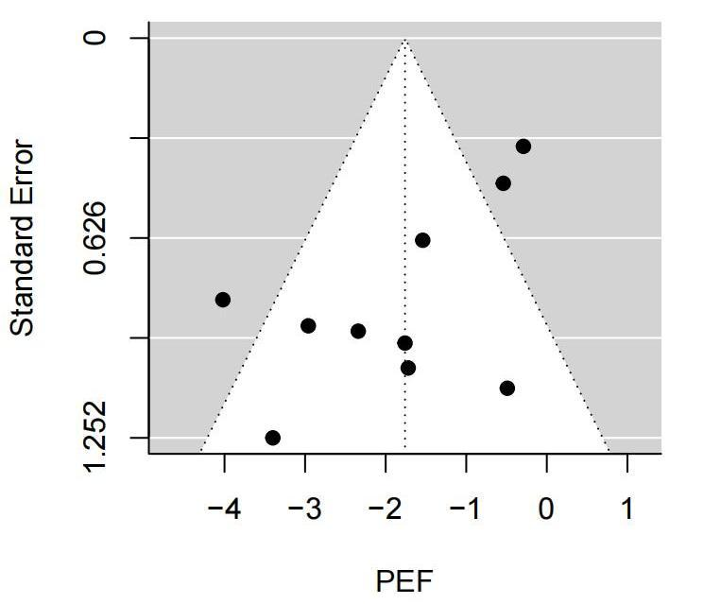

Additional Figure 3. Funnel plot of changes in FVC (L) estimates associated with a 10µg/m³ increases in PM2.5

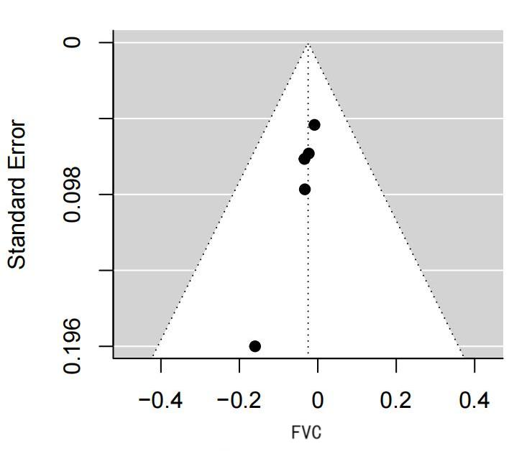

Additional Figure 4. Funnel plot of changes in FEV1 (L) estimates associated with a 10µg/m³ increases in PM2.5.

