Appendices

Appendix A: Immunohistochemical staining protocols for oestrogen receptors (ER), progesterone receptors (PR), the human epidermal growth factor receptor 2 (HER2) and androgen receptors (AR).

Tissue preparation for staining
The triple negative breast cancer specimens from our study cohort, which were prepared as formalin-fixed, paraffin-embedded tissues, were cut into approximately 4μm thick sections. These sections were then picked up and centred onto individual, positively charged glass slides. The tissue slides, that were to be stained for ER, PR and HER2, were dried in an oven at 60˚C for 30 minutes. The slides that were to be stained for AR were placed in a 53-65˚C oven for at least two hours (but no longer than 24 hours). Slides were then stained promptly, as the quality of antigen expression in cut tissue specimens may deteriorate over time¹⁵⁻¹⁷.

Staining procedure for ER, PR and HER2
The ‘Benchmark Ultra’ instrument (Roche Diagnostics, Basel, Switzerland, https://www.roche.com; 2021) was used to deparaffinise and rehydrate the tissue slides. The slides were then incubated at 95˚C for 36 minutes to unmask the target antigens (ER, PR and HER2). The ‘Benchmark Ultra’ instrument applied primary antibodies for either ER (VENTANA anti-Estrogen Receptor [SP1] Rabbit Monoclonal Antibody), PR (VENTANA anti-Progesterone Receptor [1E2] Rabbit Monoclonal Primary Antibody) or HER2 (VENTANA anti-HER2/neu [4B5] Rabbit Monoclonal Primary Antibody) onto individual slides as appropriate¹⁵⁻¹⁷. These slides containing the primary antibodies were then incubated for 16 minutes at 36˚C. The ‘ultraView Universal DAB Detection Kit’ (Roche Diagnostics, Basel, Switzerland, https://www.roche.com; 2021) provided all the appropriate reagents required for staining. The counterstain (Haematoxylin) and post-counterstain (bluing reagent) were applied onto the tissue slides. The slides were then rinsed with a wash buffer and a cover slip was applied.

Staining procedure for AR
The ‘Benchmark Ultra’ instrument was used to deparaffinise and rehydrate the tissue slides. The slides were then incubated at 95˚C for 36 minutes to unmask the target antigen (AR). The ‘Benchmark Ultra’ instrument applied primary antibodies for AR (anti-Androgen receptor [SP107] Rabbit Monoclonal Primary Antibody) onto the slides¹⁸. These tissue slides containing the AR primary antibody were then incubated for 32 minutes at 37˚C. The ‘ultraView Universal DAB Detection Kit’ provided all the appropriate reagents required for staining. The counterstain (Haematoxylin II) and post-counterstain (bluing reagent) were applied onto the tissue slides. The slides were then rinsed with a wash buffer and a cover slip was applied.

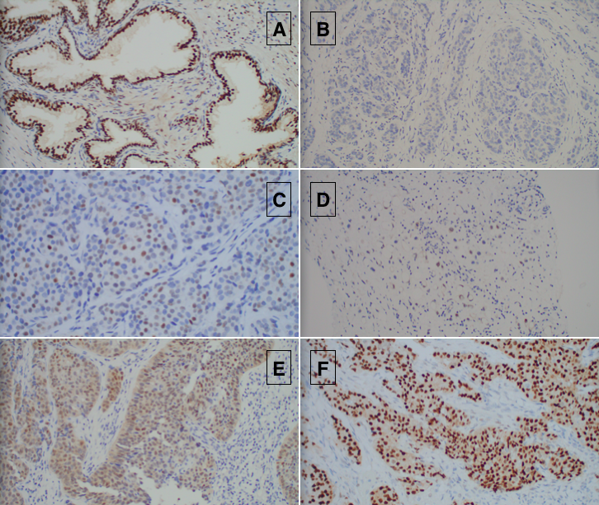
Appendix B: Photos taken from this study of androgen receptor immunohistochemical staining. This figure shows six different androgen receptor (AR) stained slides (labelled A-F) at 400x magnification. The tumour area is scored according to the number of stained tumour nuclei (%) and their respective staining intensity (0, 1+, 2+, 3+) (AR stains as ‘brown’). The photo labelled ‘A’= AR-stained prostatic tissue as a positive control; ‘B’= Negative AR staining (0% of tumour nuclei are stained for AR, zero staining intensity); ‘C’= 20%, 2+; ‘D’= 30%, 1+; ‘E’= 60%, 2+; ‘F’= 100%, 3+.

Appendix C: Comparison of triple negative breast cancer studies investigating its relationship with androgen receptor status and overall survival

Study | Number of participants (n) | AR Staining Threshold | AR expression | Significant TNBC Findings | TNBC Overall Survival (OS)
Astvatsaturyan et al.⁸ | n = 135 | 1% | 41% | The mean and median age at TNBC diagnosis were 58 and 57 years old respectively  AR+ patients were more associated with a greater tumour size than AR- patients (p = 0.027)  AR+ patients were more likely to have axillary lymph node metastases than AR- patients (p = 0.009)  AR- patients had a greater association with a high Ki-67 score than AR+ patients (p = 0.014) | No OS data
Teoh et al.²⁹ | n = 97 | 1% | 31% | The mean age at TNBC diagnosis = 58.4 years  AR- patients with TNBC were more likely to have a higher tumour grade (p = 0.016) | No OS data
Sunar et al.³⁰ | n = 84 | 1% | 29.8% | The median age of the TNBC patients in the study = 51 years  AR+ patients were less likely to have grade III tumours (p = <0.001)  Invasive ductal carcinomas were more prevalent in AR- patients than AR+ patients (p = <0.002) | No difference in OS between AR+ and AR- patients
McGhan et al.³¹ | n = 94 | 10% | 23% | Mean TNBC patient age = 58 years  AR+ patients are more likely have lymph node metastases than AR- patients (p = 0.033) | No statistically significant differences in OS between AR+ and AR- patients
Liu et al.³³ | n = 188 | 1% | 21.8% | The mean age of the patient group = 49.42 years  AR+ patients were more likely to have a smaller tumour size than AR- patients (p = 0.042)  No lymph node involvement was more common in AR+ patients than AR- patients (p = 0.032) | No correlation between AR expression and OS  AR+ patients with stage III TNBC were more likely to have poorer OS outcomes than AR- patients (p = 0.035)
Riaz et al.³⁴ | n = 197 | Not specified | 18.8% | The median age of the TNBC patients in the study = 49.5 years  AR+ patients were more likely to present with a lower tumour grade (p = <0.001) | AR+ patients demonstrate better OS than AR- patients  AR+ patients with axillary lymph node metastases have longer OS times compared to AR- patients with axillary lymph node metastases (p = 0.005)
Jam et al.³⁵ | n = 77 | 10% | 34% | Mean age at TNBC diagnosis = 45.3 years  AR+ patients had a greater association with a higher tumour grade and lymphovascular space invasion than AR- patients (p = 0.029 and p = 0.01 respectively) | No OS data
Payandeh et al.³⁶ | n = 41 | 10% | 24.4% | Mean age at TNBC diagnosis = 46.8 years  No significant differences between AR status and TNBC clinicopathological characteristics | The mean OS was greater in AR+ patients than AR- patients (26.3 months vs 23.2 months respectively
Cabezas-Quintario et al.³⁷ | n = 101 | 1% | 40% | The median age for patients in this study = 60 years  AR- patients had greater rates of high Ki-67 scores than AR+ patients (p = 0.001)  AR- patients were more associated with a high tumour grade than AR+ patients (p = 0.008) | 3- and 5-year OS rates were worse in AR- patients than in AR+ patients (86% and 80% vs 100% vs 96% respectively; p = 0.034)  Axillary lymph node involvement was associated with poorer OS (p = 0.046)
Lyalkin et al.³⁸ | n = 116 | 10% | 38% | The mean age of patients at the inclusion of the study = 51.7 years  AR- tumours were more common in older patients than AR+ tumours (p = 0.001)  AR- patients were more likely to present with later stage TNBC than AR+ patients (p = 0.005)  AR- patients were more correlated with axillary lymph node involvement than AR+ patients (p = 0.01) | The median OS was higher in AR+ patients than AR- patients (57 months vs 27 months respectively; p = <0.0001)  AR+ patients had a higher 5-year OS probability than AR- patients (47.6% vs 20.0% respectively; p = <0.05)
Zakaria et al.³⁹ | n = 77 | 10% | 27.27% | The median age of patients = 35.6 years  AR- patients were more likely to have a bigger tumour size (p = 0.001), axillary lymph node metastases (p = 0.007), higher tumour grade (p = <0.001) and higher tumour stage (p = <0.001) | The median OS for the TNBC cohort was 46.58 months  5-year OS was 63% for the TNBC cohort
Hu et al.⁴¹ | n = 360 | 10% | 31.4% | The median age for the patient group = 52 years  AR+ patients were more likely to present with grade III tumours than AR- patients (p = 0.007)  AR+ patients were more associated with a lower Ki-67 score than AR- patients (p = 0.007) | 5-year OS for entire cohort was 80%  AR was an independent prognostic factor for OS (p = 0.020)  Better survival was more associated with AR+ patients
This table compares different studies which investigate the relationship between androgen receptor status in triple negative breast cancer with patient clinicopathological characteristics. It presents the number of triple negative breast cancer patients included in the study, staining threshold used to define androgen receptor positive/negative tumours, percentage of patients who have androgen receptor positive tumours and key findings from the results in the study, including overall survival data.

Abbreviations: AR = androgen receptor; ‘AR+’ = androgen receptor positive; ‘AR-’ = androgen receptor negative; OS = overall survival; TNBC= triple negative breast cancer

