Comparative effectiveness of umeclidinium/vilanterol versus inhaled corticosteroid/long-acting β₂-agonist in patients with chronic obstructive pulmonary disease in a primary care setting in England
Authors: Alexandrosz Czira¹, Gema Requena¹, Victoria Banks²*, Robert Wood², Theo Tritton², Catherine M Castillo², Jie Yeap²*, Rosie Wild², Chris Compton¹, Kieran J Rothnie¹, Felix Herth^{3,4}, Jennifer K Quint⁵, Afisi S. Ismaila^{6,7}
Affiliations: ¹R&D Global Medical, GSK, Brentford, Middlesex, UK; ²Real-world Evidence, Adelphi Real World, Bollington, Cheshire, UK; ³Department of Pulmonology and Respiratory Care Medicine, Thoraxklinik at the University of Heidelberg, Heidelberg, Germany; ⁴Translational Lung Research Center Heidelberg, Member of the German Center for Lung Research DZL, Heidelberg, Germany; ⁵National Heart and Lung Institute, Imperial College London, London, UK; ⁶Value Evidence and Outcomes, GSK, Collegeville, PA, USA; ⁷Department of Health Research Methods, Evidence and Impact, McMaster University, Hamilton, ON, Canada
*At the time of the study

Supplementary material
Supplementary Figure 1. Sample attrition
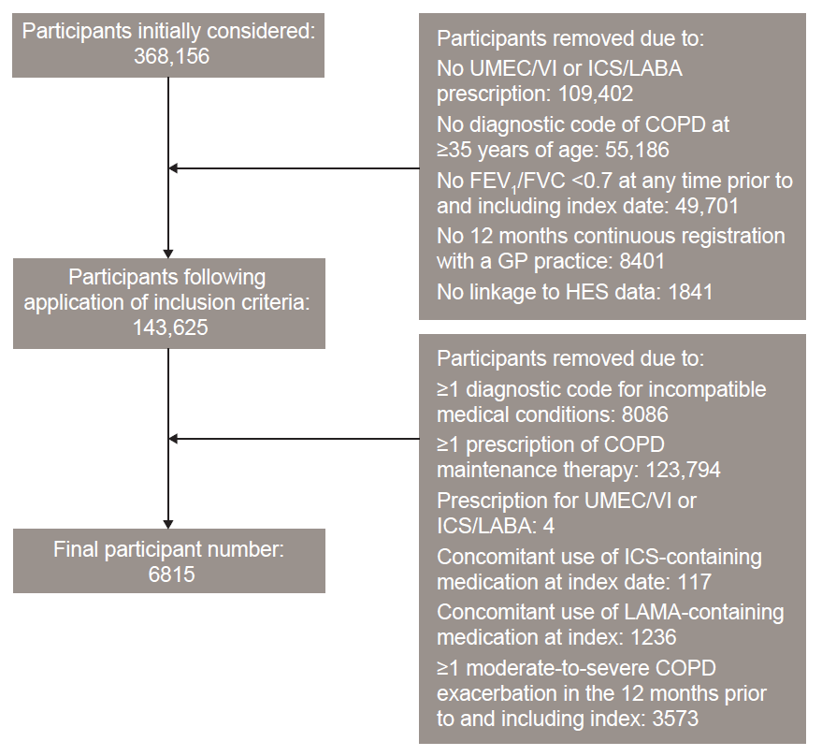
COPD, chronic obstructive pulmonary disease; FEV₁, forced expiratory volume in 1 second; FVC, forced vital capacity; GP, general practitioner; HES, Health Episode Statistics; ICS, inhaled corticosteroid; LABA, long-acting β₂-agonist; LAMA, long-acting muscarinic antagonist; UMEC, umeclidinium; VI, vilanterol.

Supplementary Figure 2. Kaplan–Meier plots of time-to-first triple therapy for A) unweighted and B) weighted analyses

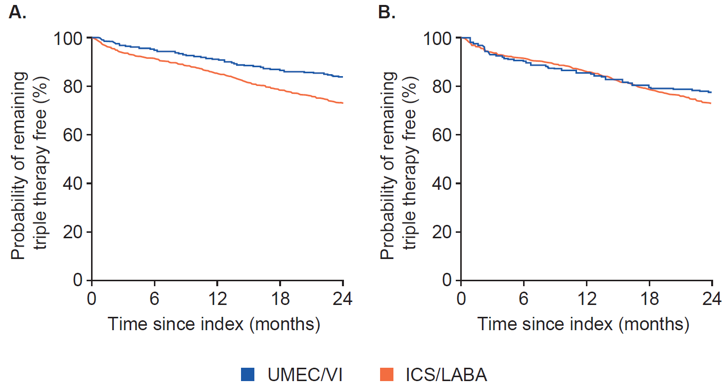
ICS, inhaled corticosteroid; LABA, long-acting β₂-agonist; UMEC, umeclidinium; VI, vilanterol.

Supplementary Figure 3. Kaplan–Meier plots of time-to-first moderate-to-severe COPD exacerbation for A) unweighted and B) weighted analyses
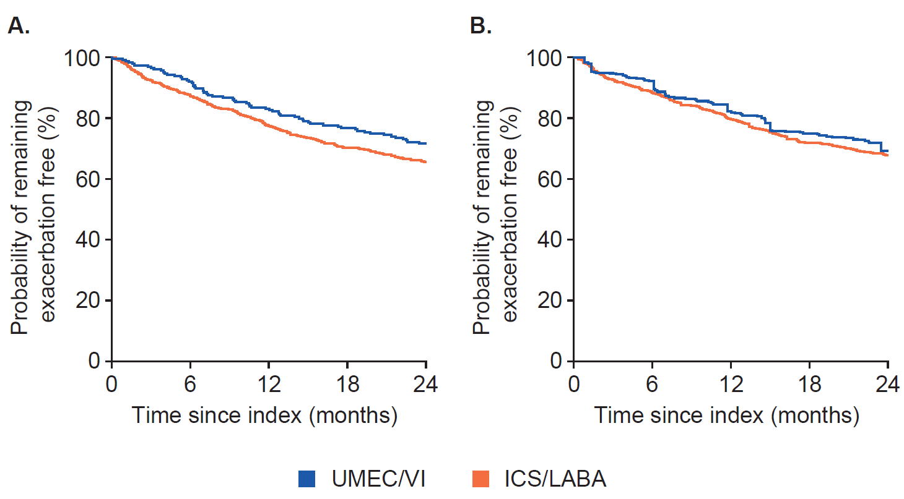
COPD, chronic obstructive pulmonary disease. ICS, inhaled corticosteroid; LABA, long-acting β₂-agonist; UMEC, umeclidinium; VI, vilanterol.

Supplementary Table 1. PS model balance: Number (%) covariates with insufficient balance for models for each outcome
 | Unweighted  (number [%] of imbalanced covariates) |  | Weighted  (number [%] of imbalanced covariates)
Adherenceª
6 months | 28/43 (65.1) |  | 9/43 (20.9)
12 months | 25/43 (58.1) |  | 10/43 (23.3)
18 months | 27/43 (62.8) |  | 11/43 (25.6)
24 months | 17/39 (43.6) |  | 6/39 (15.4)
Time-to-first triple therapy | 25/46 (54.3) |  | 14/46 (30.4)
Time-to-first on-treatment COPD exacerbation
Moderate-to-severe | 38/60 (63.3) |  | 19/60 (31.7)
Moderate | 24/47 (51.1) |  | 12/47 (25.5)
Severe | 21/48 (43.8) |  | 4/48 (8.3)
HCRU at 12 months | COPD-related | All-cause | COPD-related | All-cause
Number of prescriptions | 26/51 (51.0) | 36/58 (62.1) | 16/51 (31.4) | 18/58 (31.0)
Number of consultations | 37/55 (67.3) | 26/60 (43.3) | 17/55 (30.9) | 19/60 (31.2)
Number of inpatient stays | 23/47 (48.9) | 13/41 (31.7) | 5/47 (10.6) | 1/41 (2.4)
Number of A&E visits | 29/47 (61.7) | 29/51 (56.9) | 3/47 (6.4) | 23/51 (45.1)
Medical costs at 12 months | COPD-related | All-cause | COPD-related | All-cause
Number of prescriptions | 33/51 (64.7) | 37/60 (61.7) | 16/51 (31.4) | 18/60 (30.0)
Number of GP consultations | 36/54 (66.7) | 36/52 (69.2) | 17/54 (31.5) | 16/52 (30.8)
Number of inpatients stays | 12/36 (33.3) | 25/44 (56.8) | 1/36 (2.8) | 2/44 (4.5)
Number of A&E visits | 17/45 (37.8) | 28/49 (57.1) | 1/45 (2.2) | 18/49 (36.7)
Total medical costs | COPD-related | All-cause | COPD-related | All-cause
6 months | 21/42 (50.0) | 23/45 (51.1) | 5/42 (11.9) | 4/45 (8.9)
12 months | 21/42 (50.0) | 23/46 (50.0) | 5/42 (11.9) | 6/46 (13.0)
18 months | 21/43 (48.8) | 24/48 (50.0) | 5/43 (11.6) | 5/48 (10.4)
24 months | 21/42 (50.0) | 24/48 (50.0) | 5/42 (11.9) | 5/48 (10.4)
ªCovariates varied between timepoints. A&E, Accident and Emergency; COPD, chronic obstructive pulmonary disease; GP, general practitioner; HCRU, healthcare resource utilization; PS, propensity score.

Supplementary Table 2. Sensitivity analyses for all outcomes
 | Unweighted |  | Weighted
 | Average treatment effect (95% CI) | p-value | Average treatment effect (95% CI) | p-value
Adherence
Stockpiling (ordering early prescriptions for later use)
6 months | 1.49 (1.09, 2.04) | 0.0131 | 1.52 (0.99, 2.36) | 0.0581
12 months | 1.59 (1.13, 2.24) | 0.0080 | 1.71 (1.08, 2.69) | 0.0210
18 months | 1.61 (1.09, 2.38) | 0.0167 | 1.75 (1.13, 2.72) | 0.0119
24 months | 1.50 (1.23, 1.82) | 0.0001 | 1.47 (1.16, 1.87) | 0.0017
PDC≥50%
6 months | 1.41 (1.02, 1.94) | 0.0373 | 1.46 (0.94, 2.27) | 0.0952
12 months | 1.75 (1.23, 12.48) | 0.0016 | 1.78 (1.12, 2.82) | 0.0145
18 months | 1.75 (1.18, 2.59) | 0.0052 | 1.84 (1.17, 2.91) | 0.0089
24 months | Model convergence not achieved
Sensitivity analyses for adherence at 12 monthsª
PDC≥80% where subgroup histograms are trimmed where they do not overlap | 1.87 (1.34, 2.60) | 0.0002 | 1.95 (0.82, 4.64) | 0.1294
PDC ≥80% where current asthma patients are excluded | 1.93 (1.38, 2.69) | 0.0001 | 2.12 (1.33, 3.41) | 0.0017
PDC ≥80% where ethnicity covariate was removed from IPTW | 1.94 (1.68, 2.24) | <0.0001 | 1.74 (1.40, 2.17) | <0.0001
PDC ≥80% where ethnicity covariate was removed from IPTW and current asthma patients excluded | 1.83 (1.57, 2.13) | <0.0001 | 1.54 (1.23, 1.93) | 0.0002
Imbalanced covariates added back into final weighted model | 2.17 (1.59, 2.95) | <0.0001 | 2.37 (1.45, 3.87) | 0.0005
Time-to-first triple therapy | 0.43 (0.25, 0.75) | 0.0028 | 0.90 (0.47, 1.73) | 0.7481
Time-to-first on-treatment COPD exacerbation
Moderate-to-severe | 0.89 (0.76, 1.05) | 0.1639 | 0.91 (0.73, 1.13 | 0.3921
Moderate | 0.88 (0.74, 1.05) | 0.1461 | 0.86 (0.67, 1.11) | 0.2434
Severe | 1.04 (0.78, 1.39) | 0.8005 | 1.15 (0.80, 1.66) | 0.4462
COPD-related HCRU at 12 months
Number of prescriptions | 0.85 (0.83, 0.88) | <0.0001 | 0.90 (0.86, 0.93) | <0.0001
Number of GP visits | 0.55 (0.45, 0.68) | 0 | 0.67 (0.50, 0.89) | 0.0054
Number of inpatients stays | 0.97 (0.37, 2.56) | 0.9567 | 0.72 (0.29, 1.77) | 0.4741
Number of A&E visits | 1.12 (0.24, 5.25) | 0.8840 | 1.17 (0.25, 5.45) | 0.8400
All-cause HCRU at 12 months
Number of prescriptions | 0.84 (0.68, 1.05) | 0.1235 | 0.86 (0.69, 1.05) | 0.1412
Number of GP visits | 0.73 (0.61, 0.88) | 0.0007 | 0.74 (0.60, 0.91) | 0.0051
Number of inpatients stays | 0.88 (0.53, 1.45) | 0.6149 | 0.74 (0.36, 1.53) | 0.4188
Number of A&E visits | 0.70 (0.42, 1.15) | 0.1597 | 0.59 (0.35, 0.99) | 0.0472
COPD-related medical costs at 12 months^{b}
Prescriptions | 0.91 (0.78, 1.07) | 0.2394 | 1.01 (0.90, 1.15) | 0.8214
GP visits | 0.50 (0.39, 0.63) | 0 | 0.72 (0.50, 1.05) | 0.0867
Inpatients stays | 1.03 (0.33, 3.15) | 0.9649 | 0.63 (0.21, 1.89) | 0.4115
A&E visits | 1.17 (0.28, 4.92) | 0.8263 | 1.18 (0.27, 5.15) | 0.8268
All-cause medical costs at 12 months^{b}
Prescriptions | 0.88 (0.75, 1.05) | 0.1523 | 0.93 (0.77, 1.13) | 0.4809
GP visits | 0.71 (0.60, 0.85) | 0.0002 | 0.82 (0.62, 1.09) | 0.1774
Inpatients stays | 1.37 (0.85, 2.21) | 0.1935 | 1.26 (0.77, 2.06) | 0.3610
A&E visits | 0.62 (0.35, 1.10) | 0.1043 | 0.47 (0.25, 0.89) | 0.0213
COPD-related total medical costs
6 months | 0.89 (0.50, 1.57) | 0.6782 | 0.78 (0.47, 1.30) | 0.3444
12 months | 0.94 (0.54, 1.62) | 0.8192 | 0.77 (0.50, 1.17) | 0.2184
18 months | 1.10 (0.66, 1.82) | 0.7163 | 0.88 (0.59, 1.32) | 0.5345
24 months | 1.13 (0.69, 1.85) | 0.6168 | 0.93 (0.62, 1.38) | 0.7042
All-cause total medical costs
6 months | 1.18 (0.85, 1.65) | 0.3287 | 1.19 (0.84, 1.69) | 0.3238
12 months | 1.09 (0.79, 1.50) | 0.5972 | 0.97 (0.71, 1.33) | 0.8622
18 months | 1.23 (0.91, 1.66) | 0.1770 | 1.08 (0.80, 1.46) | 0.6233
24 months | 1.26 (0.95, 1.69) | 0.1106 | 1.14 (0.85, 1.53) | 0.3813
ªPost hoc analyses; ^{b}Per patient per year. A&E, Accident and Emergency; COPD, chronic obstructive pulmonary disease; CI, confidence interval; GP, general practitioner; HCRU, healthcare resource utilization; IPTW, inverse probability of treatment weighting; PDC, proportion of days covered.

Supplementary Table 3. Proportion of patients adherent (PDC≥80%) at 6, 18, and 24 months post-index
Patients with  PCD ≥80% (%) | Unweighted |  | Weighted
Patients with  PCD ≥80% (%) | UMEC/VI | ICS/LABA | UMEC/VI | ICS/LABA
6 months | 62.2 | 51.0 | 64.3 | 52.4
18 months | 49.6 | 37.9 | 51.4 | 39.5
24 months | 41.1 | 33.3 | 41.1 | 33.8

ICS, inhaled corticosteroid; LABA, long-acting β₂-agonist; PDC, proportion of days covered; UMEC, umeclidinium; VI, vilanterol.

Supplementary Table 4. Incidence of COPD-related and all-cause HCRU use at 12 months post-index
 | HCRU, mean per person per day
 | Unweighted |  | Weighted
 | UMEC/VI | ICS/LABA | UMEC/VI | ICS/LABA
COPD-related
Prescriptions | 0.03 | 0.04 | 0.03 | 0.03
GP visits | <0.01 | <0.01 | <0.01 | 0.01
Inpatient stays | <0.01 | <0.01 | <0.01 | <0.01
A&E visits | <0.01 | <0.01 | <0.01 | <0.01
All-cause
Prescriptions | 0.22 | 0.21 | 0.21 | 0.20
GP visits | 0.03 | 0.04 | 0.03 | 0.04
Inpatient stays | <0.01 | <0.01 | <0.01 | <0.01
A&E visits | <0.01 | <0.01 | <0.01 | <0.01
A&E, Accident and Emergency; COPD, chronic obstructive pulmonary disease; GP, general practitioner; HCRU, healthcare resource utilization; ICS, inhaled corticosteroid; LABA, long-acting β₂-agonist; UMEC, umeclidinium; VI, vilanterol.
Supplementary Table 5. COPD-related and all-cause HCRU costs at 12 months post-index
 | Mean (SD) costs (GBP), per person per year
 | Unweighted |  | Weighted
 | UMEC/VI | ICS/LABA | UMEC/VI | ICS/LABA
COPD-related
Prescriptions | 331 (164.7) | 280 (198.9) | 365 (171.0) | 269 (200.8)
GP visits | 58 (81.5) | 75 (90.4) | 75 (110.3) | 67 (81.5)
Inpatient stays | 478 (3299.9) | 379 (3146.8) | 421 (2970.7) | 422 (3387.8)
A&E visits | 10 (78.8) | 9 (58.9) | 13 (106.6) | 10 (62.4)
All-cause
Prescriptions | 643 (445.8) | 586 (523.7) | 631 (404.3) | 551 (475.0)
GP visits | 429 (471.4) | 479 (447.4) | 456 (468.7) | 476 (406.3)
Inpatient stays | 2136 (6136.5) | 1592 (5307.0) | 2525 (7489.7) | 1609 (5269.9)
A&E visits | 103 (246.0) | 102 (274.7) | 97 (224.8) | 94 (256.6)
A&E, Accident and Emergency; COPD, chronic obstructive pulmonary disease; GBP, British Pound Sterling; GP, general practitioner; HCRU, healthcare resource utilization; ICS, inhaled corticosteroid; LABA, long-acting β₂-agonist; SD, standard deviation; UMEC, umeclidinium; VI, vilanterol.
Supplementary Table 6. COPD-related and all-cause total HCRU costs
 | Mean (SD) costs, per person per year (GBP)
 | Unweighted |  | Weighted
 | UMEC/VI | ICS/LABA | UMEC/VI | ICS/LABA
Total COPD-related costs
6 months | 960 (3511.1) | 792 (4223.3) | 758 (2666.4) | 785 (4138.8)
12 months | 1134 (3611.8) | 822 (4174.0) | 1037 (3046.2) | 808 (4089.2)
18 months | 1243 (3754.2) | 889 (4245.7) | 1260 (3530.7) | 862 (4125.7)
24 months | 1313 (3758.7) | 906 (4244.1) | 1368 (3566.0) | 882 (4140.9)
Total all-cause costs
6 months | 3066 (6606.5) | 2551 (5925.8) | 3475 (7730.1) | 2539 (5828.1)
12 months | 3307 (6517.4) | 2759 (5679.2) | 4013 (8296.1) | 2770 (5558.8)
18 months | 3626 (6617.4) | 2888 (5685.7) | 4310 (8410.4) | 2878 (5515.3)
24 months | 3718 (6543.3) | 2963 (5739.8) | 4525 (8380.8) | 2949 (5583.0)
COPD, chronic obstructive pulmonary disease; GBP, British Pound Sterling; HCRU, healthcare resource utilization; ICS, inhaled corticosteroid; LABA, long-acting β₂-agonist; SD, standard deviation; UMEC, umeclidinium; VI, vilanterol.
Supplementary Table 7. Rescue medication prescriptions 6, 12, 18, and 24 months post-index
 | Mean (SD) number of prescriptions per person
 | UMEC/VI | ICS/LABA
6 months | 1.9 (2.3) | 2.4 (2.7)
12 months | 3.8 (4.5) | 5.0 (5.1)
18 months | 5.6 (6.5) | 7.6 (7.4)
24 months | 7.1 (8.1) | 10.3 (9.8)
COPD, chronic obstructive pulmonary disease; ICS, inhaled corticosteroid; LABA, long-acting β₂-agonist; SD, standard deviation; UMEC, umeclidinium; VI, vilanterol.

Supplementary Table 8. Proportion of patients with rescue medication prescriptions at 6, 12, 18, and 24 months post-index
 | UMEC/VI | ICS/LABA
6 months | n=1450 | n=4924
0 | 39.1 | 31.6
1–2 | 30.6 | 29.3
3–4 | 15.9 | 18.9
5–6 | 9.0 | 12.7
7+ | 5.4 | 7.5
12 months | n=1172 | n=4482
0 | 28.8 | 20.1
1–4 | 39.2 | 36.6
5–8 | 16.6 | 21.2
9–12 | 10.0 | 13.5
13+ | 5.5 | 8.7
18 months | n=932 | n=4041
0 | 22.1 | 13.8
1–6 | 45.1 | 41.0
7–12 | 17.7 | 22.2
13–18 | 9.8 | 14.2
19+ | 5.4 | 8.8
24 months | n=723 | n=3646
0 | 17.8 | 10.4
1–8 | 50.8 | 43.0
9–16 | 17.3 | 23.0
17–24 | 9.0 | 14.5
25+ | 5.1 | 9.2

ICS, inhaled corticosteroid; LABA, long-acting β₂-agonist; UMEC, umeclidinium; VI, vilanterol.

