Supplementary Materials

Effect of independent variables on response variables
Optimal mixture designs are straight optimisations based on a chosen criterion and the model fit. Table 2 shows that the maximum droplet size was 112.67 nm, where the PDI value was 0.65 (run 1). The actual droplet size values mainly agreed with the predicted values (Figure S1-a). The final model determined to predict the droplet size and PDI value of CTNE in terms of the actual factors of mixture components can be expressed by the following quadratic equations:
$$Size=+1962.81A+75.65B+78.79C-2700.59AB-2268.16AC-224.00BC+735.86ABC$$
Eq. S1
$$PDI=+38.69A-0.06B+0.58C-65.50AB-57.56AC+0.08BC+44.24ABC-30.90AB(A-B)-15.33AC(A-C) +0.48BC(B-C)$$
Eq. S2
where A(CSO), B (Tween 80), and C (TSWE: HPW)
Statistical analysis of the models obtained is summarised in Table 3.
Table S1. Analysis of variance (ANOVA) for the D-optimal Mixture design (DMD).
Source / Parameters | Size | Polydispersity Index
R² | 0.9971 | 0.9513
Adjusted R² | 0.9946 | 0.9208
Predicted R² | 0.9231 | 0.7278
Lack of fit, p-value | 0.0875, Not significant, | 0.2015, Not significant
Model, p-value | 0.0001, Significant | 0.0001, Significant
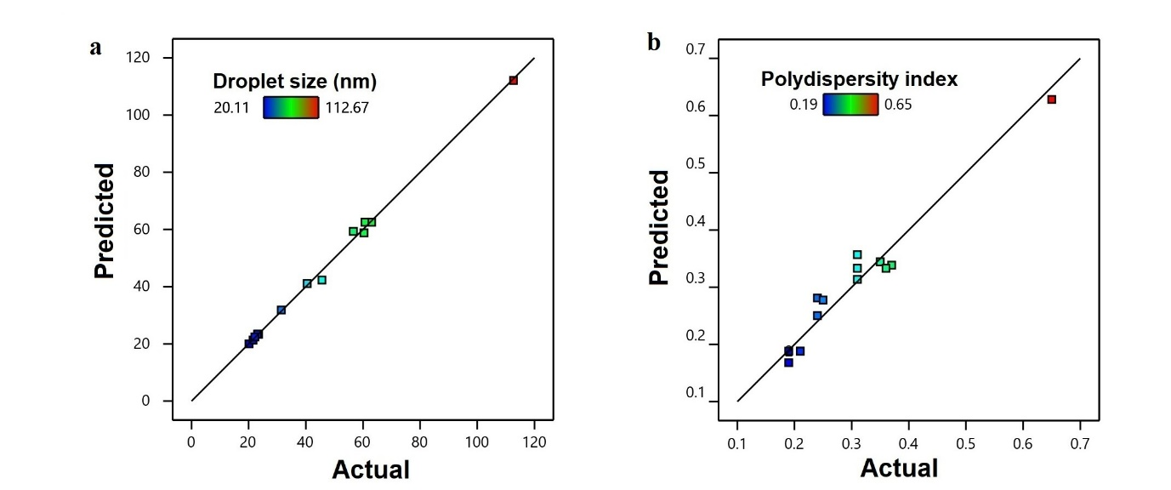 Figure S1. Predicted vs Actual value of a: Droplet size (nm) and b: Polydispersity index.

Droplet size
Analysis of variance (ANOVA) for the droplet size (Table S1) determined that the resultant special cubic patterns described the experimental data well with the coefficients of various determinations, with an R² of 0.9971. The special cubic model showed the predicted R² of 0.9231, which is in reasonable agreement with the adjusted R² of 0.9946 (Equation S1). Furthermore, the special cubic term size significantly affected nanoemulsion droplet size (P < 0.05).
The droplet size of CTNE is dependent on Tween 80, CSO and HPW: TSWE at the special cubic model (p < 0.0001). The smallest droplet size was achieved when the Tween 80 to CSO ratio was greater than 2.5. For example, if the concentration of Tween 80 was 18% w/w and CSO approximately 6.7%, the average nanoemulsion size was 63.02 nm. The droplet size also depended on the water phase's ratio to the oil phase. For instance, when the water phase was 73.2% and the total oil phase was 26.8%, the largest droplet size of 112.67 nm was obtained. The smallest size of 20.11 nm was observed when the water phase was 69.6% and the oil phase was 30.3% (Figure S1-a and Table 2).

Polydispersity index
The ANOVA of the PDI value indicated that the resultant quadratic model (Equation S2) adequately described the experimental data with the coefficients of multiple determinations (R²) of 0.9513 (Table S1). In addition, the lack of fit was non-significant (P ≤ 0.05) and related to net error for all variables, which expressed that the model was statistically precise for PDI value. The predicted R² was 0.7278, and the adjusted R² was 0.9208, and these values were in reasonable agreement as they were not close to each other. The R2 and adjusted R2 were close to 1, which indicates a high correlation between the predicted and observed values. The higher values of predicted R² also support a model that is highly significant.
The PDI value of CTNE was dependent on all three component factor ratios due to the significant effect on droplet size at linear term (p < 0.0001). The results indicate that the PDI of the NE systems increased with increasing the mean droplet size. The NE system has the smallest size, while the most uniform and homogeneous systems with a lower PDI were achieved. The increase in the Tween 80 concentration showed lower PDI values (p < 0.05). The PDI value decreased when the Tween 80: CSO ratio was greater than 2.5. For example, the lowest PDI value was observed when the amount of Tween 80 was 24% and CSO was 6.3%. Lower Tween 80: CSO ratios produced polydispersed nanoemulsions with PDI values of 0.65. The PDI value also correlated to the oil and water phase ratio. Once the water phase (TSWE: HPW) was lower than 70% and the total oil phase was 30%, the nanoemulsion was monodispersed with a PDI value of 0.19.

Verification of the CTNE optimisation results
The final model was verified in terms of a validation set to study the adequacy of the predicted response value. Random formulations with different conditions were considered to validate the model. The optimum parameters for prepared CTNE were 7% of CSO, 21% of Tween 80 and 72% of TSWE: HPW. The experimental results for CTNE gave a particle size of 21.87 nm and a PDI value of 0.19. These results confirmed the reliability of the experimental models, and the experimental values were determined to be close to the predicted value of 23 nm particle size and 0.19 PDI value of CTNE with 0.8 desirabilities.

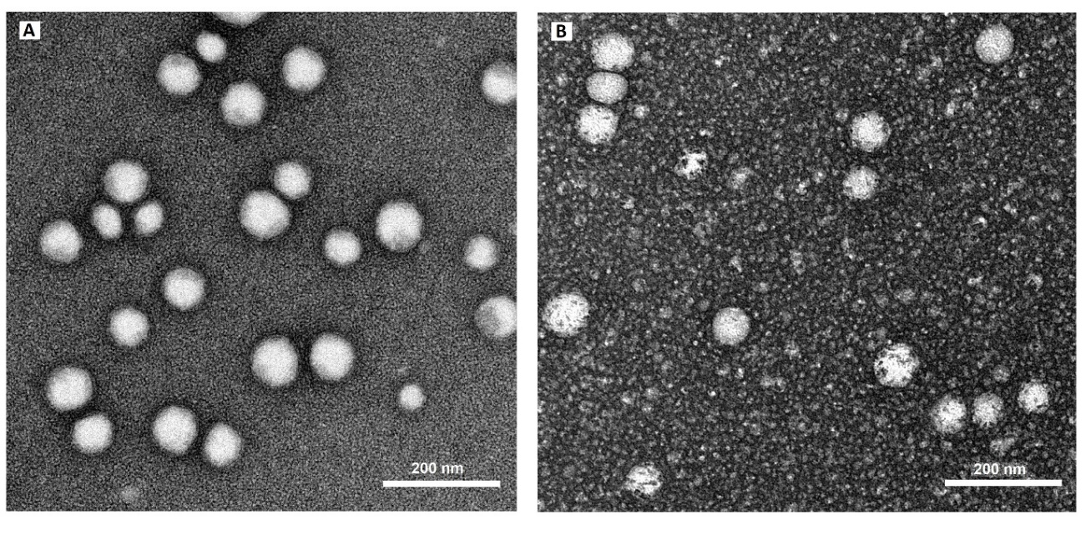
Figure S2. Transmission electron microscopy of droplets in the A: Calophyllum inophyllum seed oil nanoemulsion (CSONE) and B: Tinospora smilacina water extract (TSWE) and CSO nanoemulsion (CTNE). Scale bar 200 nm.
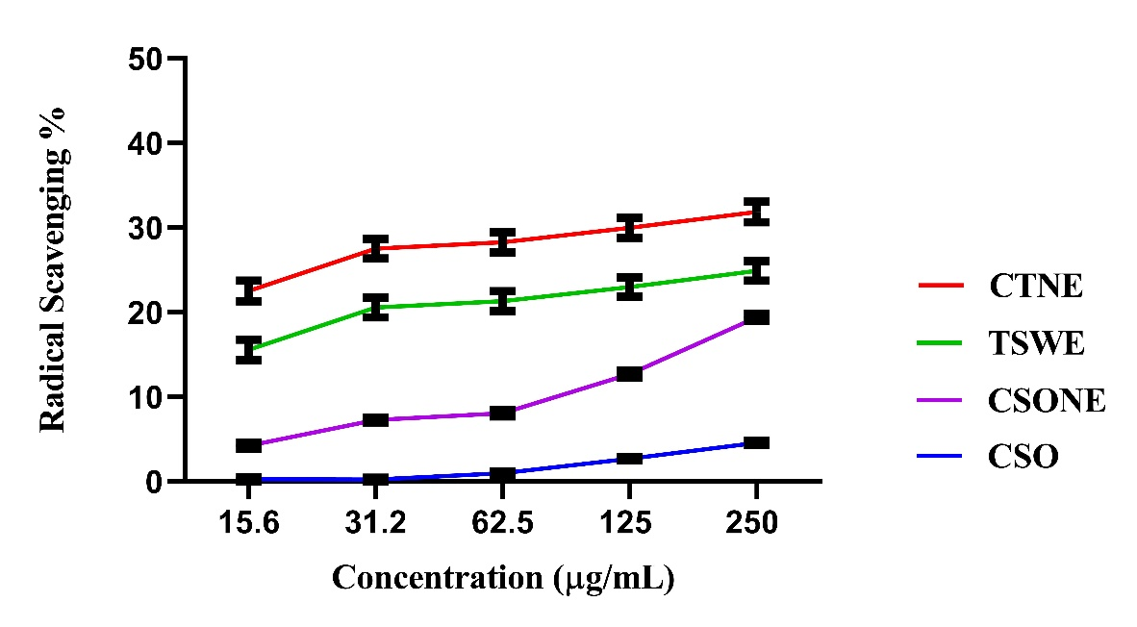
Figure S3. DPPH radical scavenging of Calophyllum inophyllum seed oil (CSO), Calophyllum inophyllum seed oil nanoemulsion (CSONE), Tinospora smilacina water extract (TSWE) and CSO nanoemulsion (CTNE) and TSWE.The DPPH results are the mean of three independent experiments with error bars ±2SD. The x-axis indicates the NE concentration matched with the equivalent TSWE and CSO concentrations available in NE.

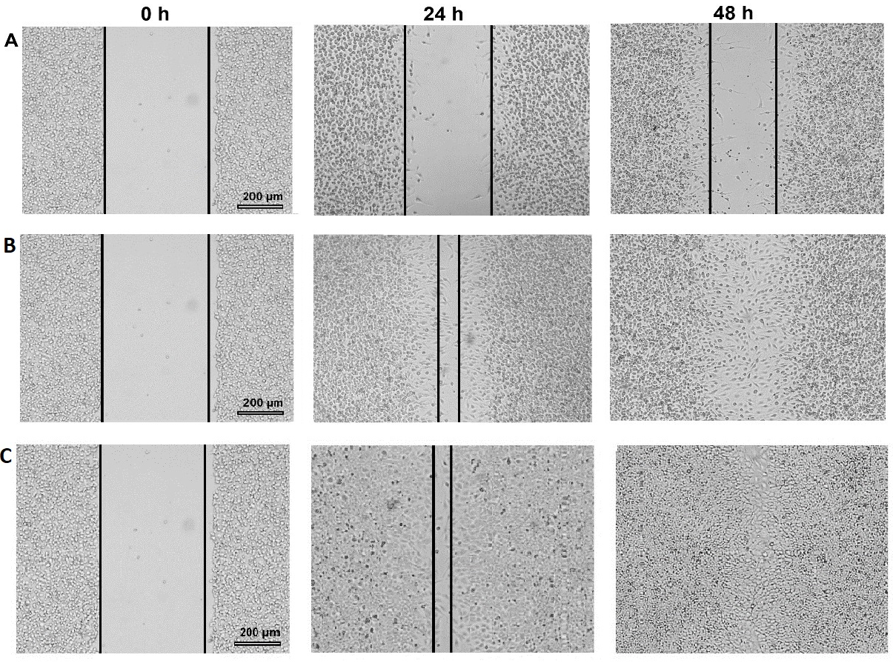
Figure S4. Wound closure photomicrograph of Calophyllum inophyllum seed oil (CSO) nanoemulsion (CSONE), Tinospora smilacina water extract (TSWE) and CSO nanoemulsion (CTNE) and FGF (control) at 24 h and 48 h in BSR cells.(A) Untreated control. (B) CTNE:62.5 µg/mL. (C) CSONE: 62.5 µg/mL. Black solid lines represent the wound size (μm) of the BSR cell line monolayer. FGF: Fibroblast Growth Factor

