Patient ID : ___________________________

Surname : ____________________________ Name : _______________________ DOB : ___________

Satisfaction with vision after surgery

- Over the last 7 days, while seeing at distance (more than 1.5 meters) (e.g. while driving) have you:
- Felt the need to wear glasses or contact lenses?
    - Yes
    - No
- Has it been comfortable for you to see at this distance without glasses or contact lenses?
    - Always
    - Almost always
    - Sometimes
    - Almost never
    - Never

- Over the last 7 days, while seeing at intermediate distance (60 centimeters to 1.5 meters) (e.g. when cooking or at the computer) have you :
- Felt the need to wear glasses or contact lenses?
    - Yes
    - No
- Has it been comfortable for you to see at this distance without glasses or contact lenses?
    - Always
    - Almost always
    - Sometimes
    - Almost never
    - Never

- Over the last 7 days, while seeing up close (under 60 centimeters) (e.g. when reading a book) have you :
- Felt the need to wear glasses or contact lenses?
    - Yes
    - No
- How often have you worn them?
    - Always
    - Almost always
    - Sometimes
    - Almost never
    - Never
- Has it been comfortable for you to see at this distance without glasses or contact lenses?
    - Immer
    - Always
    - Almost always
    - Sometimes
    - Almost never
    - Never

- When you are exposed to artificial lights (e.g. neon lights, car headlights, street lamps), do you see any unusual light effects? (multiple answers possible)

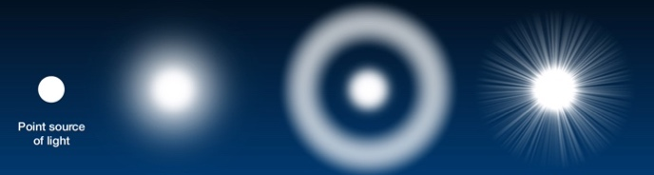

Normal Glare Halos Starbursts

- How often do you see these light effects?
    - Always
    - Almost always
    - Sometimes
    - Almost never
    - Never

Date: _______________________________

Examining physician: _______________________________

