Supplementary Information
Contents
1.1 Comparison of ICD-9-CM and ICD-10-CM/PCS Terminologies 2
1.2 Definition of Gastrointestinal Bleeding 3
1.3 Density and Histogram Plots for Propensity Scores After Trimming in Various Data scenarios (B, C1, C2, C4) 4
1.4 Role of Prevalence Filter in High-Dimensional Propensity Score Procedure 8

1.1 Comparison of ICD-9-CM and ICD-10-CM/PCS Terminologies
The Centers for Medicaid and Medicare Services and the Center for Disease Control and Prevention developed a U.S. version of the ICD-10 terminology. This new terminology went into effect in October 2015 in the U.S. healthcare system. The following table provides a contrast between this terminology and its predecessor (ICD-9-CM).
Differences between ICD-9-CM and ICD-10 Code Sets
 | ICD-9-CM | ICD-10-CM/PCS
Diagnosis | 14,025 codes | 69,823 codes
Procedure | 3,824 codes | 71,927 codes
Structure Changes (selected details)
 | ICD-9-CM | ICD-10-CM/PCS
Diagnosis | - 3-5 characters  - 1st character is numeric or alpha  - Character 2-5 are numeric | - 3-7 characters  - 1st character is alpha  - 2nd character is numeric  - 3rd – 7th positions can be alpha or numeric
Procedure | - 3-4 characters  - All characters are numeric  - All codes have at least 3 characters | - 7 characters  - Each can be alpha or numeric  - Numbers 0-9; letters A-H, J-N, P-Z
Adapted from “The ICD-10 Transition and Public Health Surveillance - What You Need to Know” available at https://www.cdc.gov/nchs/icd/icd10cm_pcs_background.htm (Accessed 31/03/2021)

1.2 Definition of Gastrointestinal Bleeding
This code algorithm was defined by the Food and Drug Administration (Sentinel Initiative) in a study to evaluate the safety of anticoagulant drugs.¹

ICD era | Code Set
ICD-9-CM | 455, 455.1, 455.2, 455.3, 455.4, 455.5, 455.6, 455.7, 455.8, 456, 456.2, 459, 530.1, 530.7, 530.82, 531, 531.01, 531.1, 531.2, 531.21, 531.3, 531.4, 531.41, 531.5, 531.6, 531.61, 531.7, 531.9, 532, 532.01, 532.1, 532.2, 532.21, 532.3, 532.4, 532.41, 532.5, 532.6, 532.61, 532.7, 532.9, 533, 533.01, 533.1, 533.2, 533.21, 533.3, 533.4, 533.41, 533.5, 533.6, 533.61, 533.7, 533.9, 534, 534.01, 534.1, 534.2, 534.21, 534.3, 534.4, 534.41, 534.5, 534.6, 534.61, 534.7, 534.9, 535, 535.01, 535.1, 535.11, 535.2, 535.21, 535.3, 535.31, 535.4, 535.41, 535.5, 535.51, 535.6, 535.61, 537.83, 562, 562.01, 562.02, 562.03, 562.1, 562.11, 562.12, 562.13, 568.81, 569.3, 569.85, 578, 578.1, 578.9
ICD-10-CM | I85.01 ,I85.11 ,K22.6 ,K22.8 ,K25.0 ,K25.2 ,K25.4 ,K25.6 ,K26.0 ,K26.2 ,K26.4 ,K26.6 ,K27.0 ,K27.2 ,K27.4 ,K27.6 ,K28.0 ,K28.2 ,K28.4 ,K28.6 ,K29.00 ,K29.01 ,K29.20 ,K29.21 ,K29.30 ,K29.31 ,K29.40 ,K29.41 ,K29.50 ,K29.51 ,K29.60 ,K29.61 ,K29.70 ,K29.71 ,K29.80 ,K29.81 ,K29.90 ,K29.91 ,K31.811 ,K55.21 ,K56.699 ,K57.00 ,K57.01 ,K57.10 ,K57.11 ,K57.12 ,K57.13 ,K57.20 ,K57.21 ,K57.30 ,K57.31 ,K57.32 ,K57.33 ,K57.40 ,K57.41 ,K57.50 ,K57.51 ,K57.52 ,K57.53 ,K57.80 ,K57.81 ,K57.90 ,K57.91 ,K57.92 ,K57.93 ,K62.5 ,K64.0 ,K64.0 ,K64.1 ,K64.1 ,K64.2 ,K64.2 ,K64.3 ,K64.3 ,K64.4 ,K64.4 ,K64.5 ,K64.8 ,K64.8 ,K64.9 ,K66.1 ,K92.0 ,K92.1 ,K92.2 ,R58

U.S. Food and Drug Administration - Sentinel Initiative. Gastrointestinal Bleeding Algorithm Defined in "Thromboembolic Stroke, Intracranial Hemorrhage, Gastrointestinal Bleeding, and Major Extracranial Bleeding following Dabigatran, Rivaroxaban, and Apixaban Use in Patients with Atrial Fibrillation: A Propensity score matched analysis. Published online 2020. https://www.sentinelinitiative.org/methods-data-tools/health-outcomes-interest/gastrointestinal-bleeding-algorithm-defined
(Accessed 31/03/2021)

1.3 Density and Histogram Plots for Propensity Scores After Trimming in Various Data scenarios (B, C1, C2, C4)

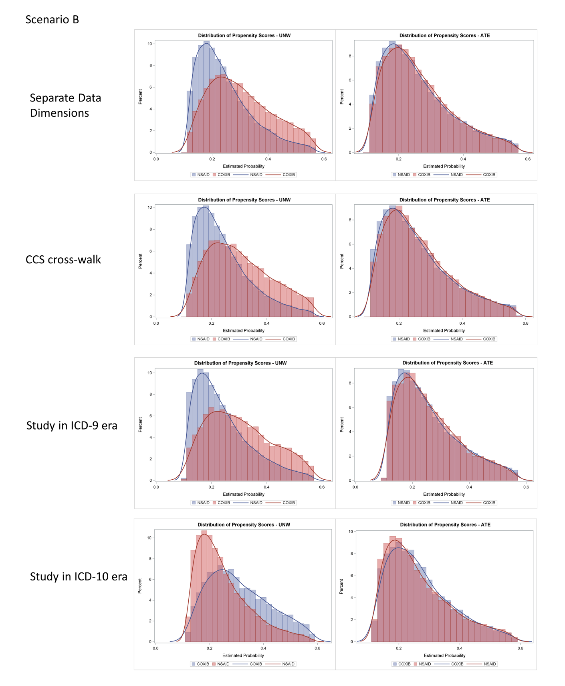

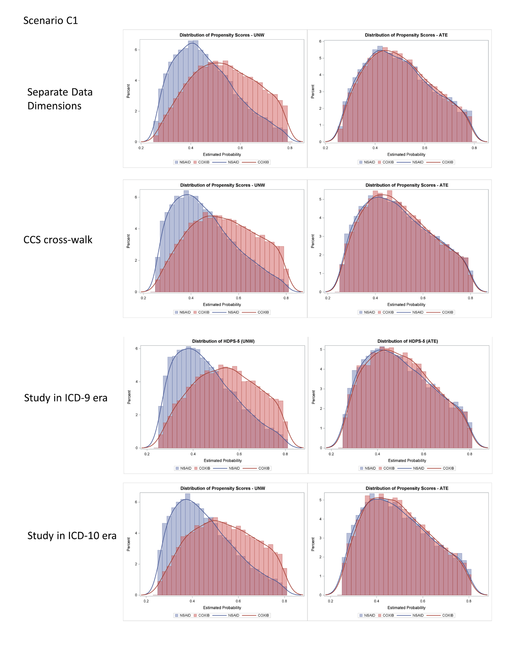

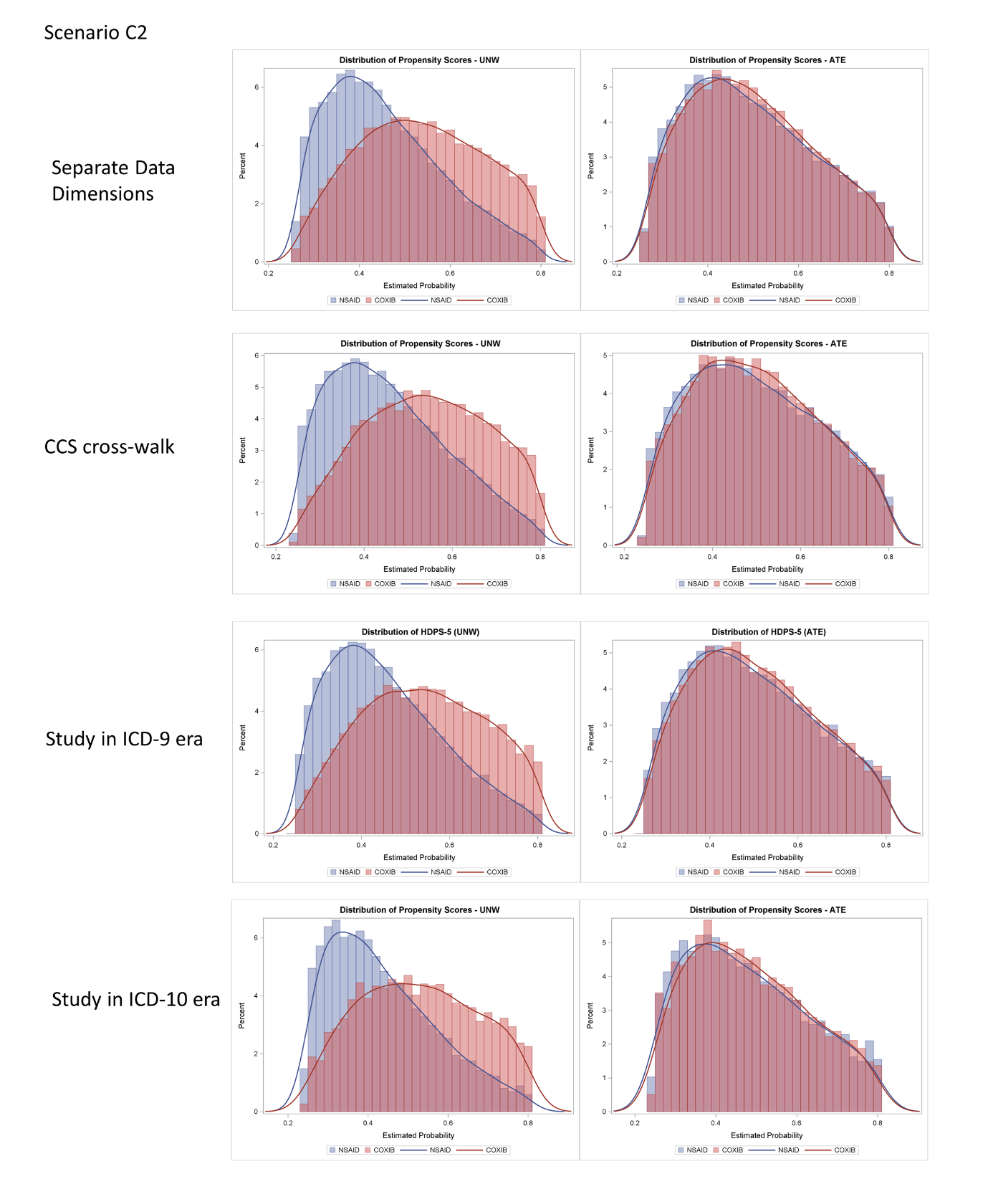

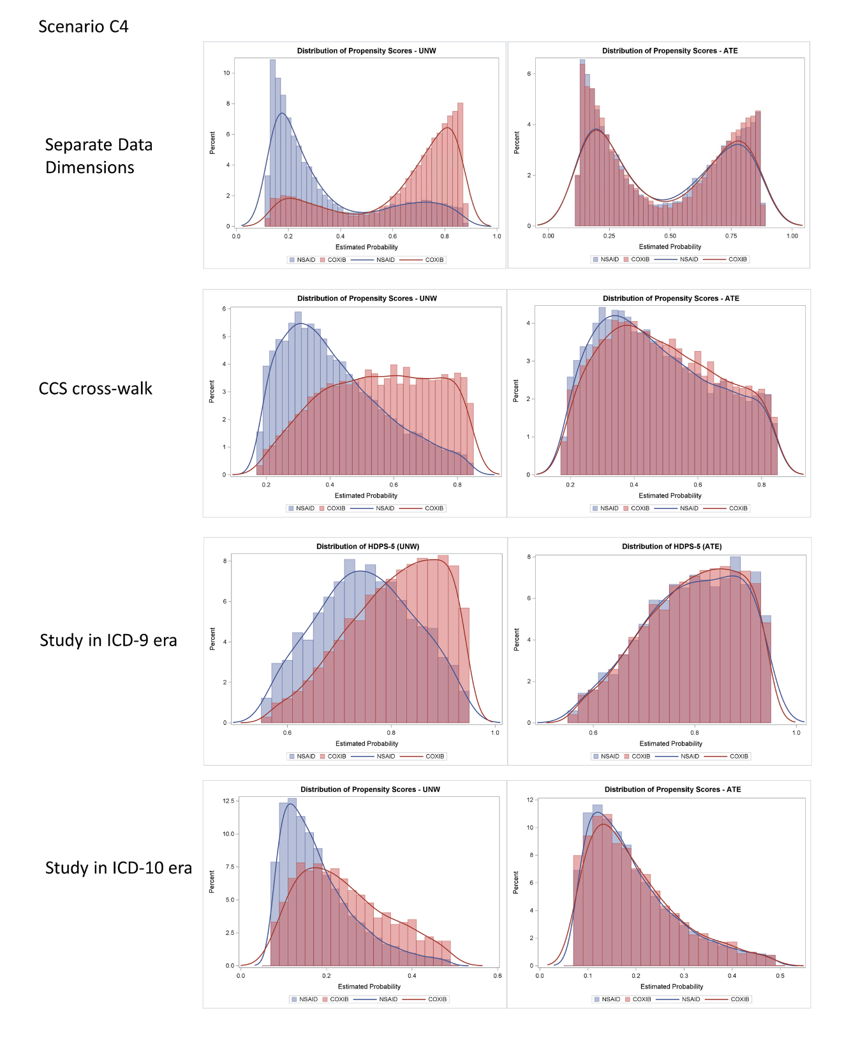

1.4 Role of Prevalence Filter in High-Dimensional Propensity Score Procedure

 | Scenario 1  (NSAID: N=25,000)  (COXIB: N=25,000) | Scenario 2  (NSAID: N=45,000)  (COXIB: N=5,000) | Scenario 3  (NSAID: N=5,000)  (COXIB: N=45,000)
Original Sample | 1.21 (1.04-1.41) | 1.18 (0.92-1.51) | 1.27 (0.97-1.67)
Relative Risk – ATE – No Trim
Prevalence Filter (N=50) | 1.02 (0.87-1.18) | 1.28 (1.00-1.63) | 1.13 (0.89-1.44)
Prevalence Filter (N=100) | 1.01 (0.87-1.18) | 0.92 (0.69-1.21) | 1.23 (0.96-1.57)
Prevalence Filter (N=200) | 0.98 (0.84-1.13) | 0.96 (0.73-1.26) | 1.19 (0.92-1.52)
Prevalence Filter (N=300) | 1.00 (0.86-1.16) | 1.14 (0.88-1.46) | 1.24 (0.96-1.61)
Prevalence Filter (N=400) | 1.00 (0.86-1.16) | 1.05 (0.81-1.36) | 1.34 (1.02-1.74)
Relative Risk – ATE – 5% Trim
Prevalence Filter (N=50) | 0.95 (0.81-1.12) | 0.86 (0.63-1.19) | 1.00 (0.76-1.33)
Prevalence Filter (N=100) | 0.96 (0.82-1.14) | 0.85 (0.61-1.17) | 0.90 (0.68-1.18)
Prevalence Filter (N=200) | 0.92 (0.78-1.08) | 0.82 (0.59-1.14) | 0.73 (0.57-0.95)
Prevalence Filter (N=300) | 0.96 (0.81-1.13) | 0.79 (0.57-1.11) | 0.90 (0.68-1.19)
Prevalence Filter (N=400) | 0.93 (0.78-1.10) | 0.76 (0.54-1.07) | 0.82 (0.63-1.08)
All numbers in the table are relative risk (95% confidence interval). Three random samples with different selection patterns were drawn from the parent cohort (2012-2015, ICD-9 era).

