Section | Content
Introduction  - About the program  - What is frailty | Information about the program, the team working on this research and contact details of the liaison officer. Information about the structure of intervention program i.e., dedicated space to record scheduled visits.  Information about pre-frailty and frailty; compiled by the research physician
Exercise | Written information and diagrams about exercise and its relation to frailty/prefrailty. Also contain guided activities with pictorials i.e., warm up, exercise from the STAND-Cph trial, Otago program; compiled by research physiotherapist.
Nutrition | Information on nutrition and its role in pre-frailty and frailty. Information explaining the importance of sufficient energy and protein, maintaining hydration and the Australia guide to healthy eating; compiled by the research dietitian.
Self-management | Guided activities to help participants to think about and understand their concerns surrounding frailty/pre-frailty. Activities include understanding their strengths, needs and worries, what they see as their main worry, and a section on goal setting, using the Flinders chronic condition management model. Contains exercise and diet monitoring diaries where participants can self-monitor actual physical activities done and diet records.
Supplementary material
Supplementary Table 1. Content of program resource booklet for intervention participants of the INDEPENDENCE pilot randomized controlled trial

Supplementary Figure 1. Sample pages from the program resource booklet for intervention participants of the INDEPENDENCE pilot randomized controlled trial
Introduction sample
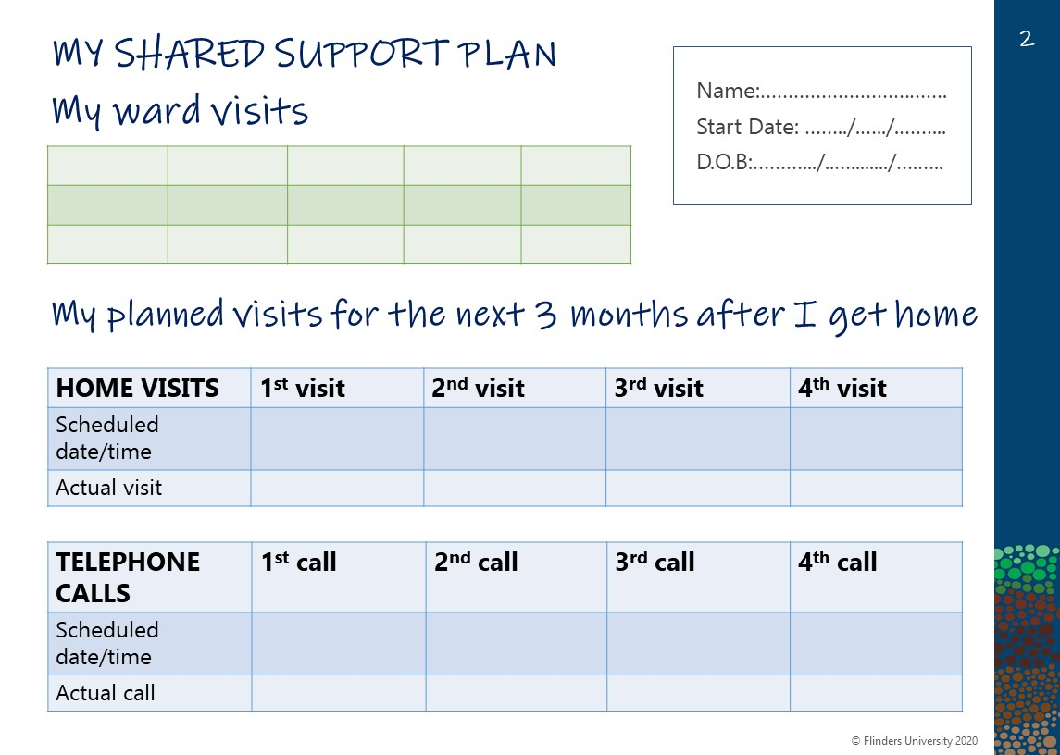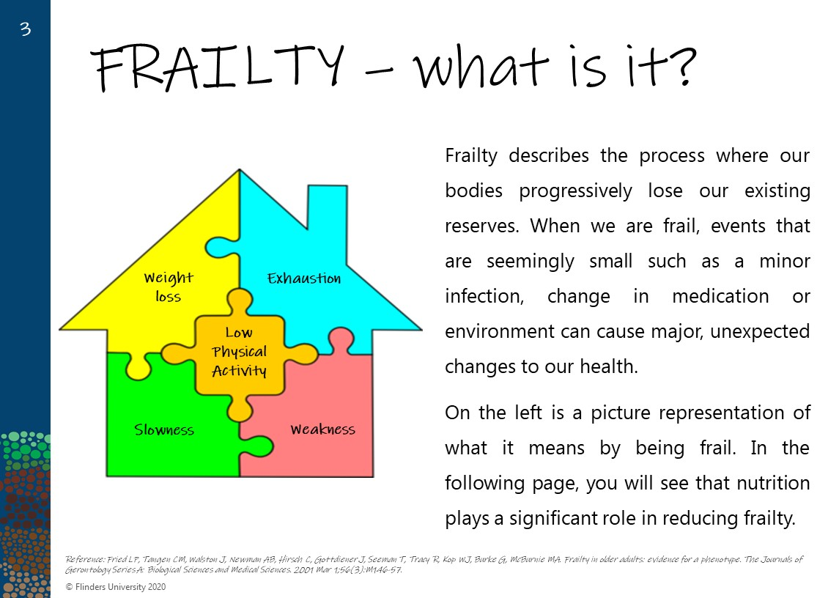
Exercise resource sample
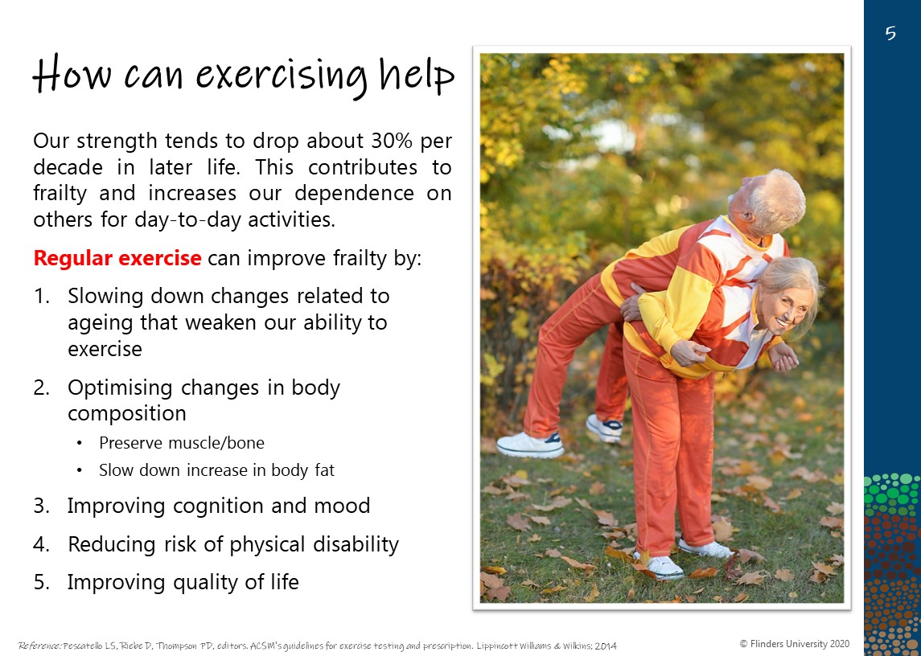
Photo of two older adults exercising
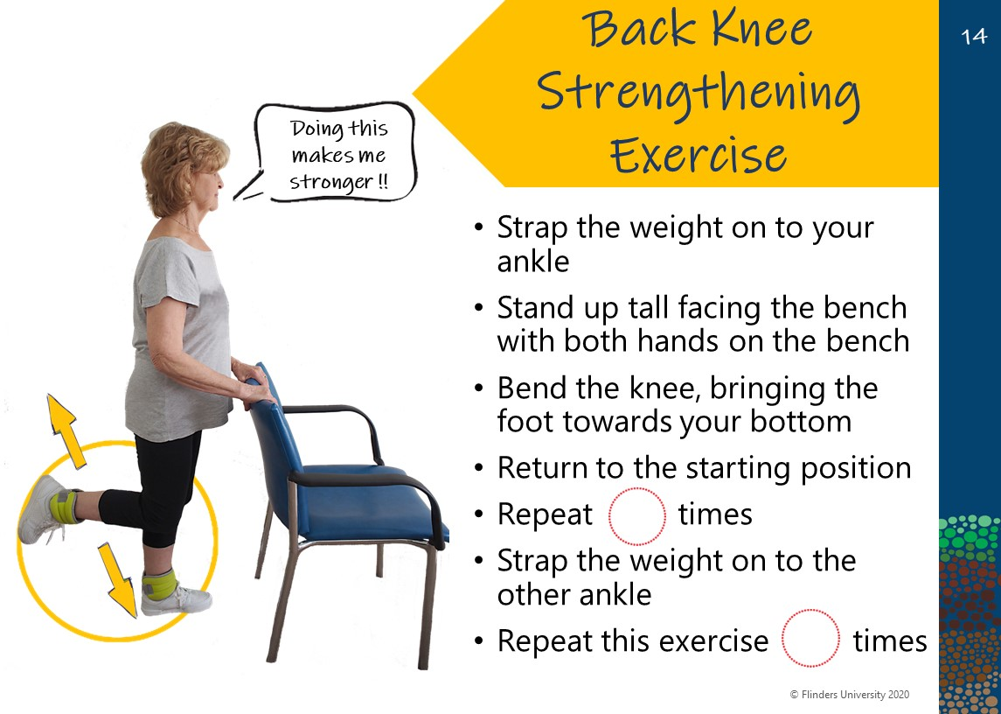

Nutrition resource sample
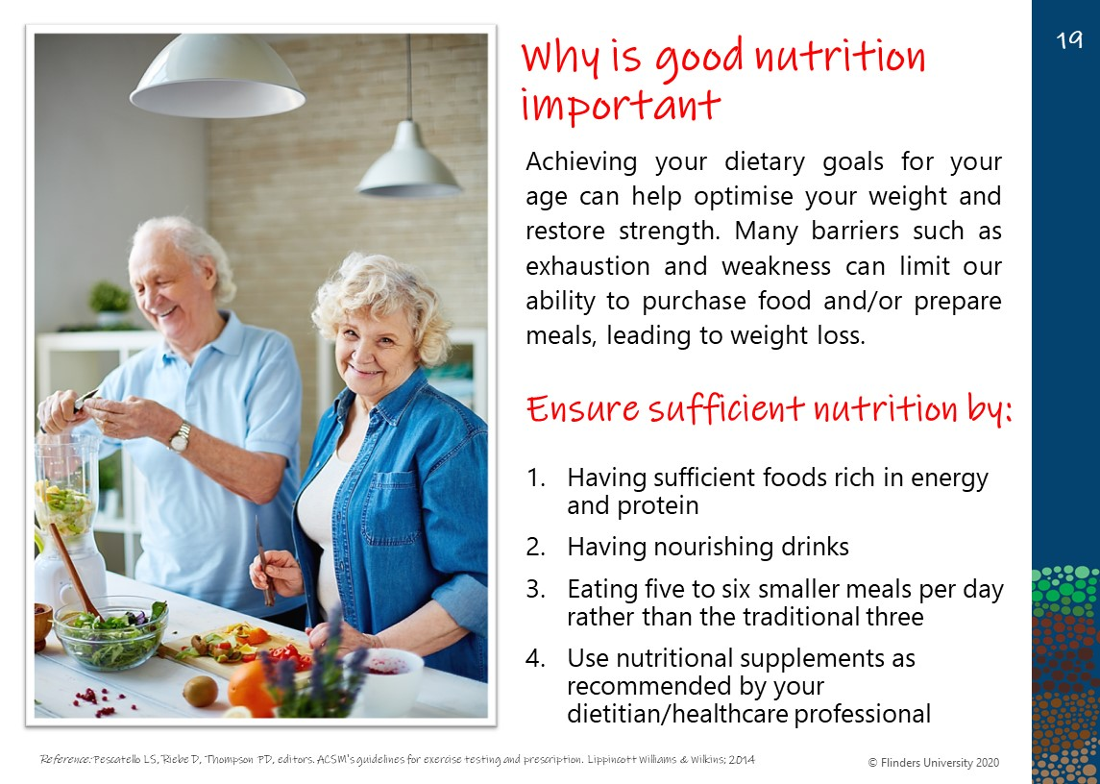
Photo of two older adults cooking
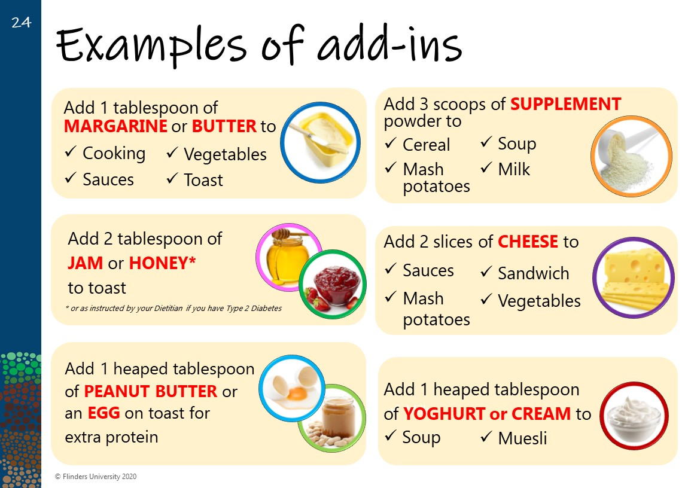

Motivation and self-monitoring resource sample
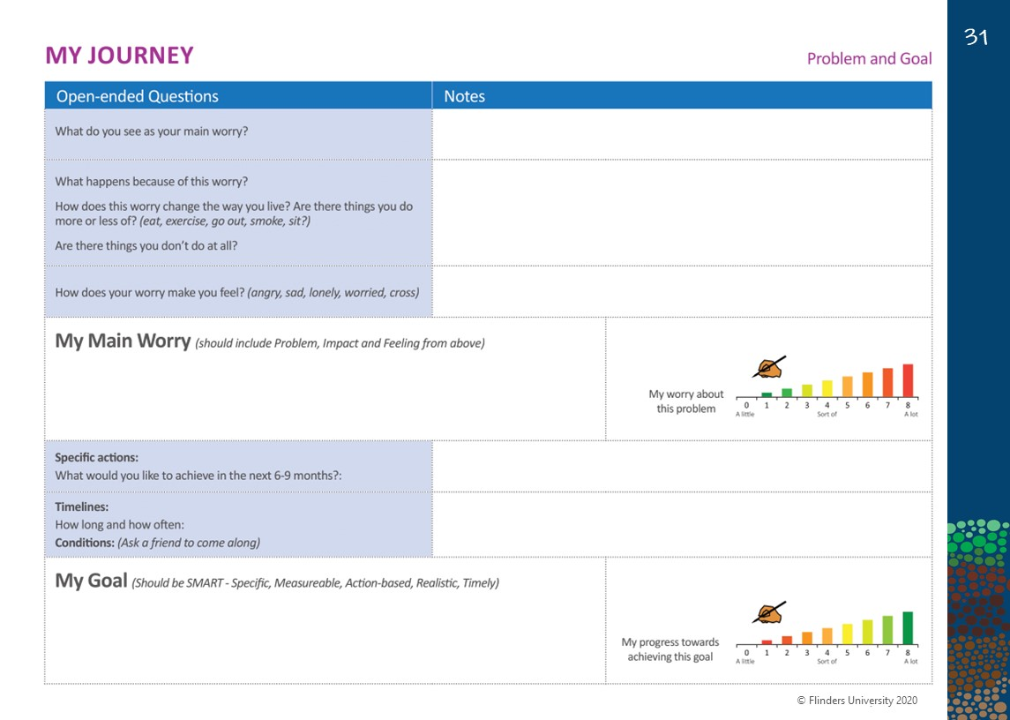
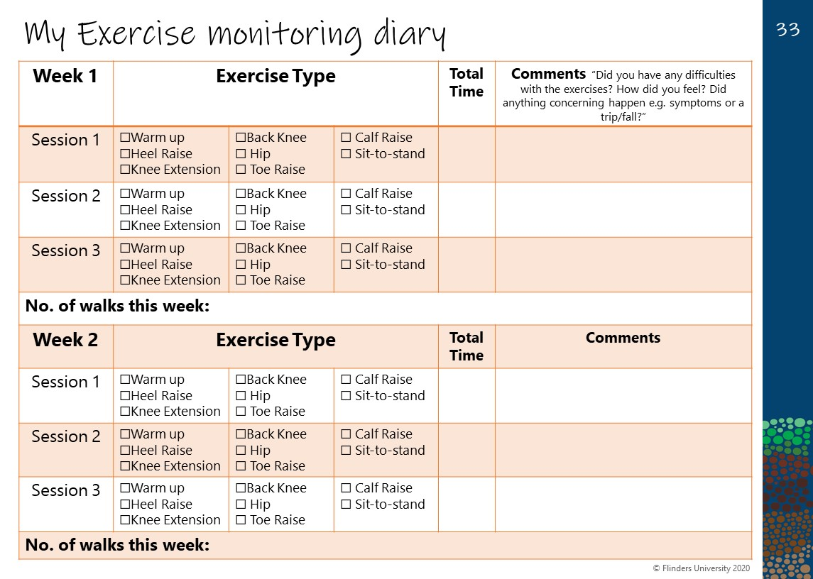
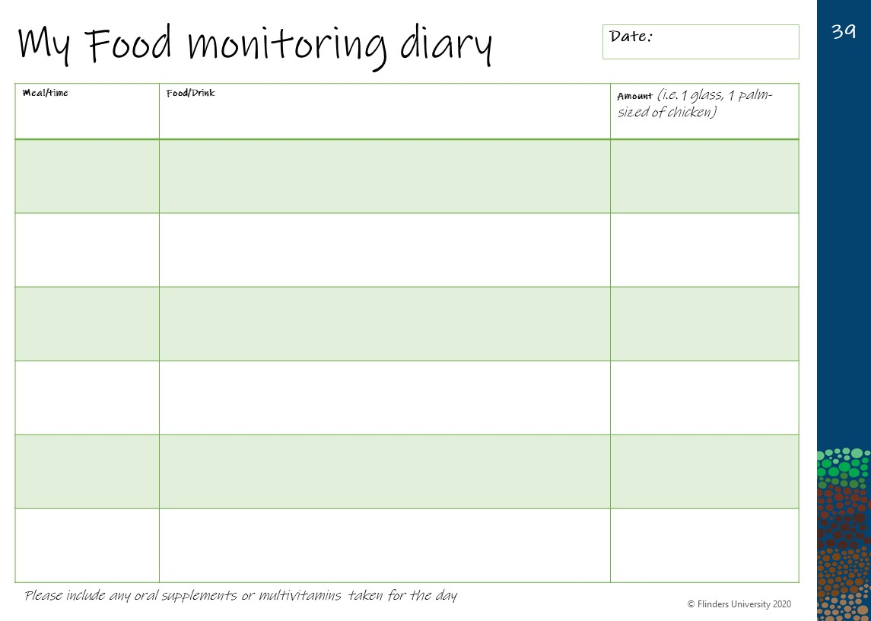
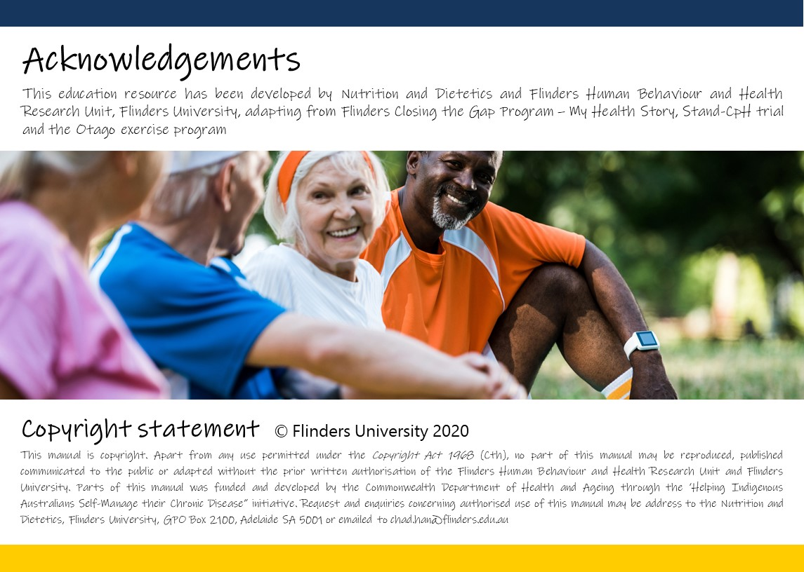
Photo of four older adults after exercising

