Supplemental Table. Baseline characteristics of covariates in the IPTW cohort of 339 eligible patients
Covariates^{b} | General Cohort |  |  |  | Propensity Score IPTW Cohort ª
Covariates^{b} | targeted | nontargeted | P | SMD | targeted | nontargeted | p | SMD
N | 255 | 84 |  |  | 342.54 | 320.26
Age (mean (SD)) | 67.53 (16.82) | 62.37 (15.88) | 0.014 | 0.316 | 65.69 (17.83) | 64.75 (16.08) | 0.698 | 0.055
Heart failure (N,%) | 113 (44.3) | 48 (57.1) | 0.055 | 0.259 | 163.0 (47.6) | 144.6 (45.2) | 0.734 | 0.049
Respiratory failure (N,%) | 108 (42.4) | 47 (56.0) | 0.041 | 0.275 | 160.2 (46.8) | 154.0 (48.1) | 0.854 | 0.027
Gastrointestinal bleeding (N,%) | 69 (27.1) | 35 (41.7) | 0.017 | 0.311 | 107.8 (31.5) | 102.8 (32.1) | 0.923 | 0.013
Renal failure (N,%) | 83 (32.5) | 32 (38.1) | 0.425 | 0.116 | 119.3 (34.8) | 114.3 (35.7) | 0.9 | 0.018
Malignancy (N,%) | 49 (19.2) | 12 (14.3) | 0.392 | 0.132 | 59.3 (17.3) | 61.0 (19.0) | 0.784 | 0.144
Cultured for C. striatum only （N，%） | 161 (63.1) | 52 (61.9) | 0.942 | 0.025 | 211.8 (61.8) | 198.8 (62.1) | 0.971 | 0.005
Other antibacterial drugs (N,%) | 246 (96.5) | 74 (88.1) | 0.009 | 0.318 | 324.7 (94.8) | 303.5 (94.8) | 0.991 | 0.001
Antifungal (N,%) | 50 (19.6) | 20 (23.8) | 0.503 | 0.102 | 70.9 (20.7) | 66.8 (20.8) | 0.981 | 0.003
APACHEII  (mean (SD)) | 14.32 (5.77) | 16.11 (6.14) | 0.016 | 0.301 | 14.76 (5.83) | 15.42 (5.73) | 0.401 | 0.113
SOFA  (mean (SD)) | 4.58 (3.23) | 5.57 (3.14) | 0.014 | 0.311 | 4.89 (3.42) | 5.28 (2.85) | 0.352 | 0.123
NLP  (mean (SD)) | 11.55 (9.79) | 14.40 (11.49) | 0.027 | 0.268 | 12.59 (11.04) | 13.63 (11.05) | 0.54 | 0.094
Supplemental Table: Abbreviations: SMD standardized mean difference; IPTW: inverse probability of treatment weighting; C. striatum: Corynebacterium striatum; APACHE II: Acute Physiological and Chronic Health Evaluation II; SOFA: Sequential Organ Failure Assessment; NLP: neutrophil:lymphocyte ratio.
ª All of the numbers of patients in the inverse probability of treatment weighted cohort are rounded to the nearest whole number; some categories may not add up to 100%.
^{b} All on the day of the first sample culture collection.

Supplemental Figure Legends
Supplemental Figure. 1 Flowchart of included patients
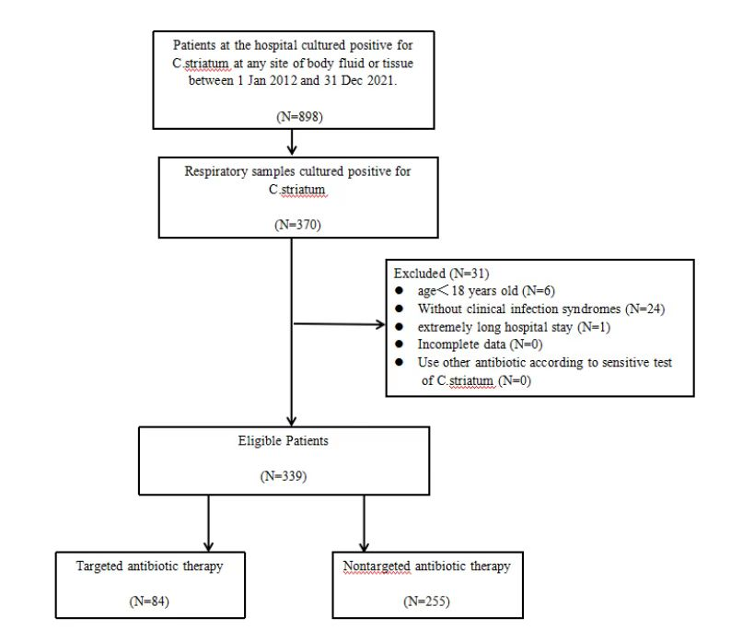
Supplemental Figure. 1: showed flowchart of included patients. Finally, the numbers of patients in the targeted antibiotic therapy group and nontargeted antibiotic therapy group were 84 and 255, respectively.

Supplemental Figure. 2 Comparison of day 1 and day 7 of laboratory testing in 339 patients

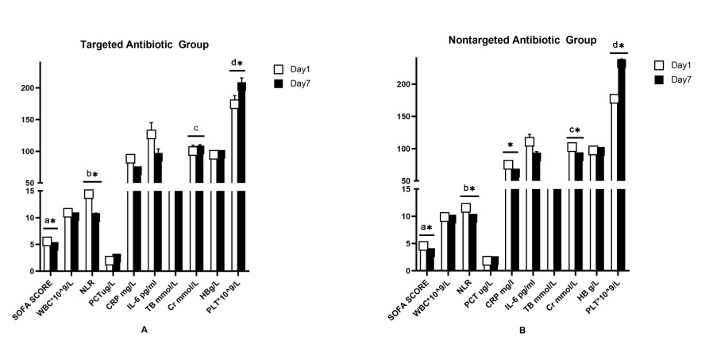
Supplemental Figure. 2: Abbreviations: SOFA: Sequential Organ Failure Assessment; WBC: white blood count; NLR: neutrophil:lymphocyte ratio; PCT: procalcitonin; CRP: C-reactive protein; IL-6: interleukin-6; TB: total bilirubin; Cr: creatinine; HB: hemoglobin; PLT: platelet.
Figure. 2A showed Comparison of day 1 and day 7 of laboratory testing in targeted antibiotic group, Figure. 2B showed Comparison of day 1 and day 7 of laboratory testing in nontargeted antibiotic group,
*a: The SOFA score was significantly decreased in both groups after 7 days, P≤0.05.
*b: NLR was significantly decreased in both groups after 7 days, P≤0.05.
c: Cr was was not significantly decreased after 7 days in figure 2A;
*c: Cr was was significantly decreased after 7 days in figure 2B, P≤0.05.
*d: PLT was significantly increased in both groups after 7 days, P≤0.05.

Supplemental Figure. 3 Degree of change in laboratory testing (day 7 vs. day 1) between the two groups
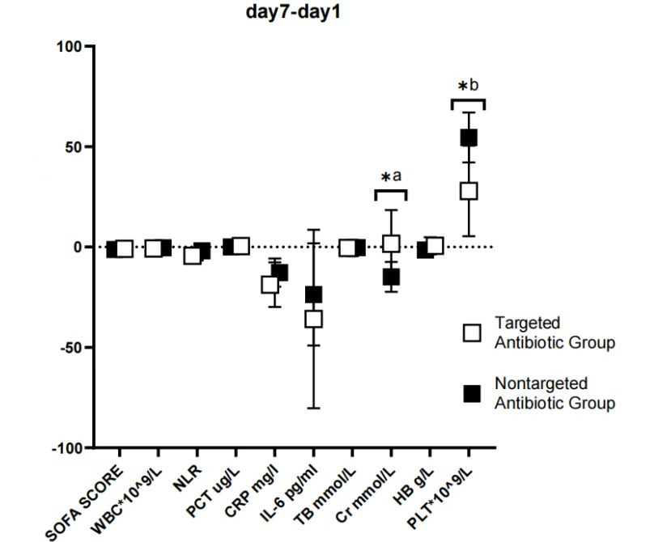
Supplemental Figure. 3: Abbreviations: SOFA: Sequential Organ Failure Assessment; WBC: white blood count; NLR: neutrophil:lymphocyte ratio; PCT: procalcitonin ; CRP: C-reactive protein; IL-6: interleukin-6; TB: total bilirubin; Cr: creatinine; HB: hemoglobin; PLT: platelet.
*a: The decreased degree of serum Cr was significantly higher in the nontargeted group, P≤0.05.
*b: The increased degree of blood PLT was significantly higher in the nontargeted group, P≤0.05.

