Supplementary Materials

Disulfide bond-based SN38 prodrug nanoassemblies with high drug loading and reduction-triggered drug release for pancreatic cancer therapy

Zhi-Xin Zhong^{1,}*, Xu-Zhao Li^{1,}*, Jin-Tao Liu¹, Nan Qin¹, Hong-Quan Duan^{1,2,3,#}, Xiao-Chuan Duan^{1,4,#}

¹ School of Pharmacy, Tianjin Medical University, Tianjin 300070 (P.R. China)
² Research Center of Basic Medical Sciences, Tianjin Medical University, Tianjin 300070 (P.R. China)
³ Key Laboratory of Immune Microenvironment and Disease (Ministry of Education), Tianjin Medical University, Tianjin 300070 (P.R. China)
⁴ School of Biomedical Engineering and Technology, Tianjin Medical University, Tianjin 300070 (P.R. China)

* These authors contributed equally to this work.
# Corresponding author.
Tel: +86-22-83336680
Fax: +86-22-83336560
Email address: duanhq@tmu.edu.cn, duanxc@tmu.edu.cn

- Chemistry
1.1 General instrumentation
All reagents and solvents were obtained from commercial sources and used without purification unless mentioned. Reactions were monitored by thin-layer chromatography (TLC) using precoated silica gel glass plates containing a fluorescence indicator. The column chromatography was carried out on silica gel (300-400 mesh) (Qingdao Haiyang Chemical Co. Ltd., Qingdao, Shandong province, China). ¹H and ¹³C NMR spectra were taken using a Bruker AVANCE III 400 instrument (Bruker Biospin AG, Fallanden, Switzerland). The high-resolution mass spectra were recorded on an Agilent 1200 LC-MS in ESI mode (Agilent, Palo Alto, CA, USA).
1.2 Comnpoud 1
Yield: 40.5%. ¹H NMR, (400 MHz, CDCl₃) δ: 0.95 (3H, t, J = 7.2 Hz, H-a) , 1.43 (2H, m, H-b), 1.67 (2H, m, H-c), 2.72 (2H, t, J = 7.2 Hz,H-d), 2.85 (2H, t, J = 6.0 Hz, H-e), 3.90 (2H, t, J = 5.6 Hz, H-f)。
1.3 Compound 2
Yield: 84.8%. ¹H NMR, (400 MHz, CDCl₃) δ: 0.86 (3H, t, J = 7.3 Hz), 0.94 (3H, t, J = 7.3 Hz), 1.01 (3H, t, J = 7.3 Hz), 1.39 (7H, m), 1.58 (2H, m), 1.70 (2H, m), 2.23 (2H, m), 2.65 (2H, t, J = 7.3 Hz), 2.76 (2H, t, J = 7.3 Hz), 2.90 (2H, t, J = 6.9 Hz), 3.05 (2H, t, J = 6.6 Hz), 3.16 (2H, q, J = 7.3 Hz), 4.36 (2H, m), 4.59 (2H, t, J = 6.6 Hz), 5.25 (2H, s), δ 5.40 (1H, d, J = 17.2 Hz), 5.71 (1H, d, J = 17.2 Hz, 1H), 7.32 (1H, s), 7.68, 8.26 (each 1H, d, J = 9.2 Hz), 7.94 (1H, s). ¹³C NMR (100 MHz, CDCl₃) δ: 167.3, 157.3, 153.4, 153.2, 151.9, 149.9, 147.3, 146.8, 145.7, 145.6, 132.1, 127.4, 127.3, 124.8, 120.3, 114.2, 78.0, 77.4, 67.9, 66.9, 66.8, 49.3, 38.9, 36.7, 36.3, 31.9, 31.2, 31.1, 23.2, 21.6, 21.5, 14.0, 13.7, 13.6, 7.6. HR-ESIMS: m/z 775.1946 [M-H]⁻, C₃₆H₄₄N₂O₉S₄, calcd. 776.1930.
2. Purity analysis of SN38-diSS
The purity of SN38-diSS (93.93%) was analyzed using Agilent Technologies 1200 series (Agilent, Palo Alto, CA, USA) and calculated according to the peak area normalization method (subtracted the solvent peak of methanol).

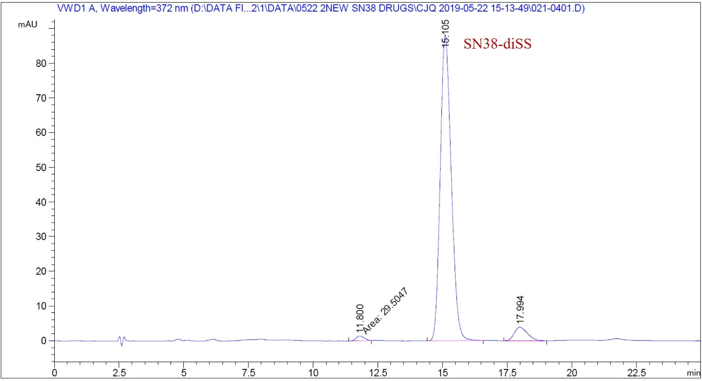
Figure S1. HPLC spectrum of compound SN38-diSS.

Table S1. Calculating of Hansen solubility parameter of SN38 according to the group contribution method (GCM).
Structural group | Number | ∑F_{d} | ∑F_{p} | ∑F²_{p} | ∑E_{h} | ∑V
Structural group | of groups | J^{1/2} cm^{3/2} mol⁻¹ | J^{1/2} cm^{3/2} mol⁻¹ |  | J/mol
-CH3 | 2 | 838 | 0 | 0 | 0 | 63.4
-CH₂- | 4 | 1080 | 0 | 0 | 0 | 66.4
>C< | 1 | -70 | 0 | 0 | 0 | -19.2
=CH- | 1 | 223 | 70 | 4900 | 143 | 12.4
=C< | 6 | 270 | 420 | 29400 | 858 | -34.2
5 or 6 member ring | 4 | 760 | 0 | 0 | 0 | 54
-N= | 1 | 164 | 1323 | 1750329 | 1759 | 4
-CON< | 1 | 301 | 1229 | 1510441 | 4772 | 13.2
-OH | 2 | 422 | 998 | 498002 | 19546 | 20.94
-COO-ester | 1 | 667 | 511 | 261121 | 2557 | 8.2
Phenyl< | 1 | 1319 | 133 | 17689 | 205 | 60.4
SUM |  | 5974 |  | 4071882 | 29840 | 249.54

Table S2. Calculating of Hansen solubility parameter of SN38-diSS according to the group contribution method (GCM).
Structural group | Number | ∑F_{d} | ∑F_{p} | ∑F²_{p} | ∑E_{h} | ∑V
Structural group | of groups | J^{1/2} cm^{3/2} mol⁻¹ | J^{1/2} cm^{3/2} mol⁻¹ |  | J/mol
-CH3 | 4 | 1676 | 0 | 0 | 0 | 126.8
-CH₂- | 14 | 3780 | 0 | 0 | 0 | 232.4
>C< | 1 | -70 | 0 | 0 | 0 | -19.2
=CH- | 1 | 223 | 70 | 4900 | 143 | 12.4
=C< | 6 | 270 | 420 | 29400 | 858 | -34.2
5 or 6 member ring | 4 | 760 | 0 | 0 | 0 | 54
-N= | 1 | 164 | 1323 | 1750329 | 1759 | 4
-CON< | 1 | 301 | 1229 | 1510441 | 4772 | 13.2
-COO-ester | 3 | 2001 | 1533 | 783363 | 7671 | 24.6
-O- | 1 | 235 | 409 | 167281 | 2352 | 3.6
-O- aromatic | 1 | 100 | 401 | 160801 | 1467 | 3.8
-S- | 4 | 1816 | 1448 | 524176 | 884 | 32
Phenyl< | 1 | 1319 | 133 | 17689 | 205 | 60.4
SUM |  | 12575 |  | 4948380 | 20111 | 513.8

Table S3. Types and concentrations of inhibitors used in the research
Inhibitors | Function | Concentration (μM)
EIPA | Inhibitor of macropinocytosis | 20 μM
CPZ | Inhibitor of clathrin | 30 μM
Hypertonic sucrose | Inhibitor of clathrin | 0.4 M
Filipin | Inhibitor of lipid raft | 0.5 μg ml⁻¹

Table S4. Size and polydispersity index (PDI) of SNSS NAs with different amount of DSPE-PEG_{2k}.
DSPE-PEG_{2k}  (wt %) | 0 | 5 | 10 | 20 | 30 | 40 | 50
Size (nm) | 81.7  ±5.11 | 84.5  ±3.02 | 85.9  ±2.18 | 89.1  ±1.99 | 91.7  ±5.00 | 95.7  ±2.89 | 103.2  ±7.35
PDI | 0.088  ±0.004 | 0.097  ±0.020 | 0.136  ±0.020 | 0.161  ±0.017 | 0.155  ±0.041 | 0.170  ±0.039 | 0.186  ±0.074

