An explainable machine learning model to predict acute kidney injury after cardiac surgery: a retrospective cohort study
Supplementary Material

Methods
Xgboost
XGBoost is an optimized distributed gradient boosting library designed for efficient and scalable training of machine learning models. It is an ensemble learning method that combines the predictions of multiple weak models to produce a stronger prediction. XGBoost stands for “Extreme Gradient Boosting” and it has become one of the most popular and widely used machine learning algorithms due to its ability to handle large datasets and its ability to achieve state-of-the-art performance in many machine learning tasks such as classification and regression. XGBoost can be used in a variety of applications, including Kaggle competitions, recommendation systems, and click-through rate prediction, among others. It is also highly customizable and allows for fine-tuning of various model parameters to optimize performance.

Table S1. Details of missing values
Variable names | Percent (%)
BMI | 0.3% (43)
Smoker | 2.1% (341)
NYHA | 1.2% (189)
Heart failure | 5.2% (822)
LVEF | 0.1% (17)
Anemia | < 0.1% (2)
LVRWT | 10.1% (1604)
Preoperative NT-proBNP | 14.3% (2272)
Glu | 0.6% (101)
Albumin | 0.2% (39)
Hs-CRP | 6.0% (953)
AST | 0.1% (22)
ALP | 0.1% (22)
TBil | 1.9% (299)
Na | < 0.1% (2)
Cl | < 0.1% (2)
LDL-C | 6.0% (950)
TG | 6.0% (950)
Apolipoprotein A1 | 6.3% (994)
WBC | < 0.1% (1)
PLT | < 0.1% (1)
Postoperative NT-proBNP | 4.3% (679)
BMI, body mass index; NYHA, New York Heart Association; LVEF, left ventricular ejection fraction; NT-proBNP, N-terminal pro-B-type natriuretic peptide; Glu, glucose; HsCRP, hypersensitive C reactive protein; AST, aspartate aminotransferase; ALP, alkaline phosphatase; TBil, total bilirubin; LDL-C, low-density lipoprotein-cholesterol; TG, triglyceride; WBC, white blood cell; PLT, platelet;

Table S2. Hyperparameters and optimal result
Model | Hyperparameter | Description | Optimal
Xgboost | nrouds | Total number of boosted trees | 464
 | max_depth | Max depth per tree | 5
 | eta | Learning rate | 0.01561834
 | gamma | Min loss reduction to create new tree split | 0.9718064
 | colsample_bytree | % Features used per tree | 0.5321122
 | min_child_weight | Minimum sum of instance weight (hessian) needed in a child | 17
 | subsample | % Samples used per tree | 0.7380101

Table S3. Variance inflation factor of the LR model
Variable names | VIF
Sex | 2.441
Age | 1.975
Smoker | 1.111
Hypertension | 1.274
Diabetes | 1.325
Cerebrovascular disease | 1.133
Previous heart surgery | 1.077
Chronic kidney disease | 1.540
Atrial fibrillation | 1.376
Infective endocarditis | 1.047
LVEF | 1.321
Anemia | 1.214
Albumin | 1.427
Hs-CRP | 1.274
AST | 1.058
ALP | 1.143
TBil | 1.268
Na | 1.704
Cl | 1.885
Ca | 1.515
Apolipoprotein A1 | 1.379
TG | 1.138
PLT | 1.253
CPB or not | 2.650
CPB time | 3.020
Operation time | 1.597
RBC use | 1.280
Plasma use | 1.184
Corticosteroids | 1.022
Levosimendan | 1.134
eGFR ICU arrival | 3.525
Creatinine ICU arrival | 5.035
Postoperative NT-proBNP | 1.224

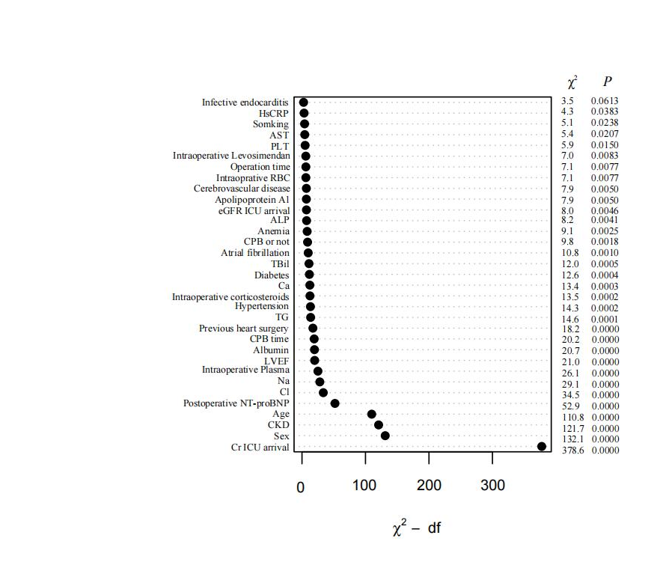

Figure legend
Figure S1. The variable contribution of logistic regression model in predicting AKI.

