The procedure for separating the skin of a tonguefish is shown below.
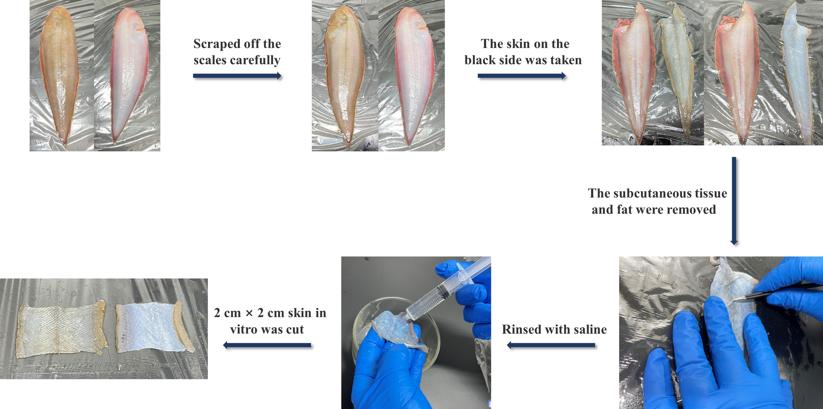
Figure S1. Procedure of skin separation of tonguefishes.

